Supporting Information for

Biomimetic Mineralized Hydroxyapatite Nanofiber-Incorporated Methacrylated Gelatin Hydrogel with Improved Mechanical and Osteoinductive Performances for Bone Regeneration
He Wang^{1,*}
Bo Hu^{1,*}
Hong Li²
Ge Feng¹
Shengyuan Pan¹
Ziqi Chen¹
Bo Li²
Jinlin Song¹
¹ Stomatological Hospital of Chongqing Medical University, Chongqing Key Laboratory of Oral Diseases and Biomedical Sciences, Chongqing Municipal Key Laboratory of Oral Biomedical Engineering of Higher Education, Chongqing, China; ² Chongqing Engineering Laboratory of Nano/Micro Biomedical Detection Technology, Chongqing University of Science and Technology, Chongqing, China.
* These authors contributed equally to this work

Correspondence: Bo Li; Jinlin Song.
Chongqing Engineering Laboratory of Nano/Micro Biomedical Detection Technology, Chongqing University of Science and Technology, Chongqing 401331, P.R. China; College of Stomatology, Chongqing Medical University. 426# Songshibei Road, Yubei District, Chongqing 401147, P.R. China.
Tel +86-23-8886-0026
Fax +86-23-8886-0222
Email Libo@cqust.edu.cn; songjinlin@hospital.cqmu.edu.cn.

Figure S1：Digital photo of the mixture was transferred to a homemade resin mold to form the m-HANFs/GelMA hydrogel with different m-HANFs contents.
Figure S2: Digital photo of m-HANFs/GelMA composite hydrogels in a 7 mL PBS buffer for degradation test after 7 days.
Figure S3: Top view of the micro-CT 3D reconstruction of m-HANFs/GelMA. A. 5m-HANFs/GelMA; B. 15m-HANFs/GelMA; C. 25m-HANFs/GelMA.

Figure S4: Proliferation of rat bone marrow
mesenchymal stem cells (rBMSCs) cocultured with m-HANFs/GelMA hydrogels of different m-HANF contents after culturing for 1, 3, 5, and 7 days. Data are presented as the mean ± SD (n = 3).
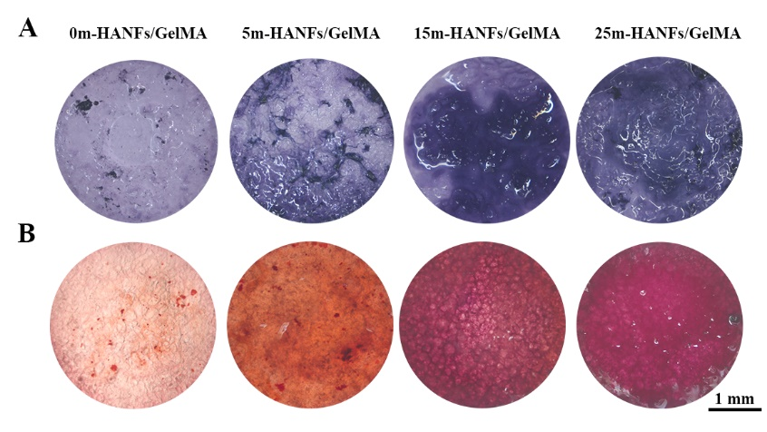
Figure S5: (A) ALP and (B) alizarin red staining images of rBMSCs cultured on m-HANFs/GelMA hydrogels with different m-HANF contents for 7 and 21 days, respectively.

