Supplemental 1. Flowchart of the participants enrollment.
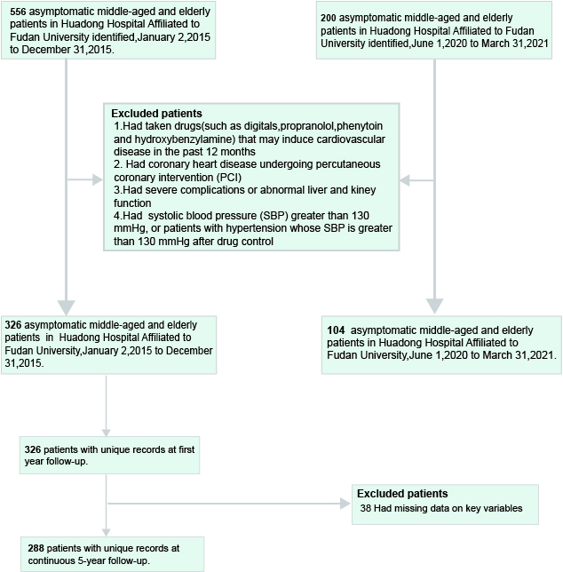

Supplement 2. Primers for real-time PCR
Gene | Forward Primer | Reverse Primer
β-actin | CGTAAAGACCTCTATGCCAACA | AGCCACCAATCCACACAGAG
IL6 | GGTGTTGCCTGCTGCCTTCC | GTTCTGAAGAGGTGAGTGGCTGTC
CXCL8 | GGACCACACTGCGCCAACAC | CCCTCTGCACCCAGTTTTCCTTG
TNF | TGGCGTGGAGCTGAGAGATAACC | CGATGCGGCTGATGGTGTGG
STAT3 | CACCAAGCGAGGACTGAGCATC | AGCCAGACCCAGAAGGAGAAGC
CASP3 | GTGGAGGCCGACTTCTTGTATGC | TGGCACAAAGCGACTGGATGAAC

Supplement 3. Receiver Operator Curve (ROC) shows the predictive ability of ALP in asymptomatic participants.

Supplement 4. K-M analysis demonstrated that high uric acid level was associated with CACS score. P<0.05 means statistically significance between two groups.

Supplement 5. Binary cox regression for CACS among asymptomatic participants
Model | Univariate Cox regression
 | HR 95%CI P-value
Gender | 1.181 | 0.846-1.648 | 0.328
Age | 1.020 | 0.997-1.044 | 0.091
BMI | 1.046 | 0.992-1.104 | 0.097
Smoke
Reference | - | - | -
Ex-smoker | 0.834 | 0.472-1.476 | 0.534
Smoker | 1.412 | 0.578-3.451 | 0.449
HBP | 0.584 | 0.307-1.111 | 0.101
Diabetes | 1.351 | 0.711-2.569 | 0.358
Alcohol | 1.216 | 0.688-2.150 | 0.501
eGFR | 0.995 | 0.984-1.007 | 0.428
Scr | 1.006 | 0.992-1.020 | 0.416
HBAC1 | 1.055 | 0.835-1.334 | 0.653
TC | 0.951 | 0.873-1.037 | 0.256
TG | 1.076 | 0.963-1.202 | 0.198
LDL | 0.904 | 0.708-1.154 | 0.418
HDL | 1.011 | 0.980-1.044 | 0.486
FBG | 1.498 | 1.275-1.760 | <0.001
ALP | 1.003 | 0.995-1.011 | 0.437
SUA | 5.856 | 4.178-8.208 | <0.001
Abbreviations: SE, standard error; HR, hazard ratio;95%CI,95% confidence interval; BMI, body mass index; HBP, high blood pressure; Scr, serum creatinine; eGFR, estimated glomerular filtration rate; FBG, fasting blood-glucose; ALP, alkaline phosphatase; TC, total cholesterol; TG, triglycerides; HDL, high-density lipoprotein; LDL, low-density lipoprotein; HBA1C, hemoglobin A1C; SUA, serum uric acid. The P value in red means that the p value <0.05 and is considered to be significantly important.

Supplemental 6. Clinical characteristic of 104 patients included in the observational study
Parameters | NC | HUA | CAC | HUA-CAC | P-value
Gender  (Male/Female) | 15/11 | 19/7 | 15/11 | 21/5
BMI | 24.19±5.02 | 24.37±3.80 | 25.11±3.55 | 24.21±4.17 | 0.8397
SUA | 285.24±45.58 | 480.61±44.23 | 325.31±57.04 | 475.63±38.04 | <0.0001
BUN | 5.49±1.11 | 5.86±1.07 | 5.92±1.57 | 6.24±1.37 | 0.2239
Scr | 75.52±10.46 | 79.44±15.26 | 75.22±19.09 | 88.30±13.09 | 0.0059
eGFR | 83.17±12.81 | 83.63±12.53 | 79.85±13.55 | 76.87±11.75 | 0.1905
TC | 4.51±0.90 | 4.83±1.03 | 4.14±1.03 | 3.80±0.91 | 0.0023
TG | 1.55±0.98 | 1.91±1.09 | 1.70±0.73 | 1.84±1.14 | 0.6011
Abbreviations: BMI, body mass index; SUA, serum uric acid; BUN, blood urea nitrogen; Scr, serum creatinine; eGFR, estimated glomerular filtration rate; TC, total cholesterol; TG, triglycerides. The continuous were presented as mean±SD. The P value in red means that the p value <0.05 and is considered to be significantly important.

