Description of supplementary figure legends
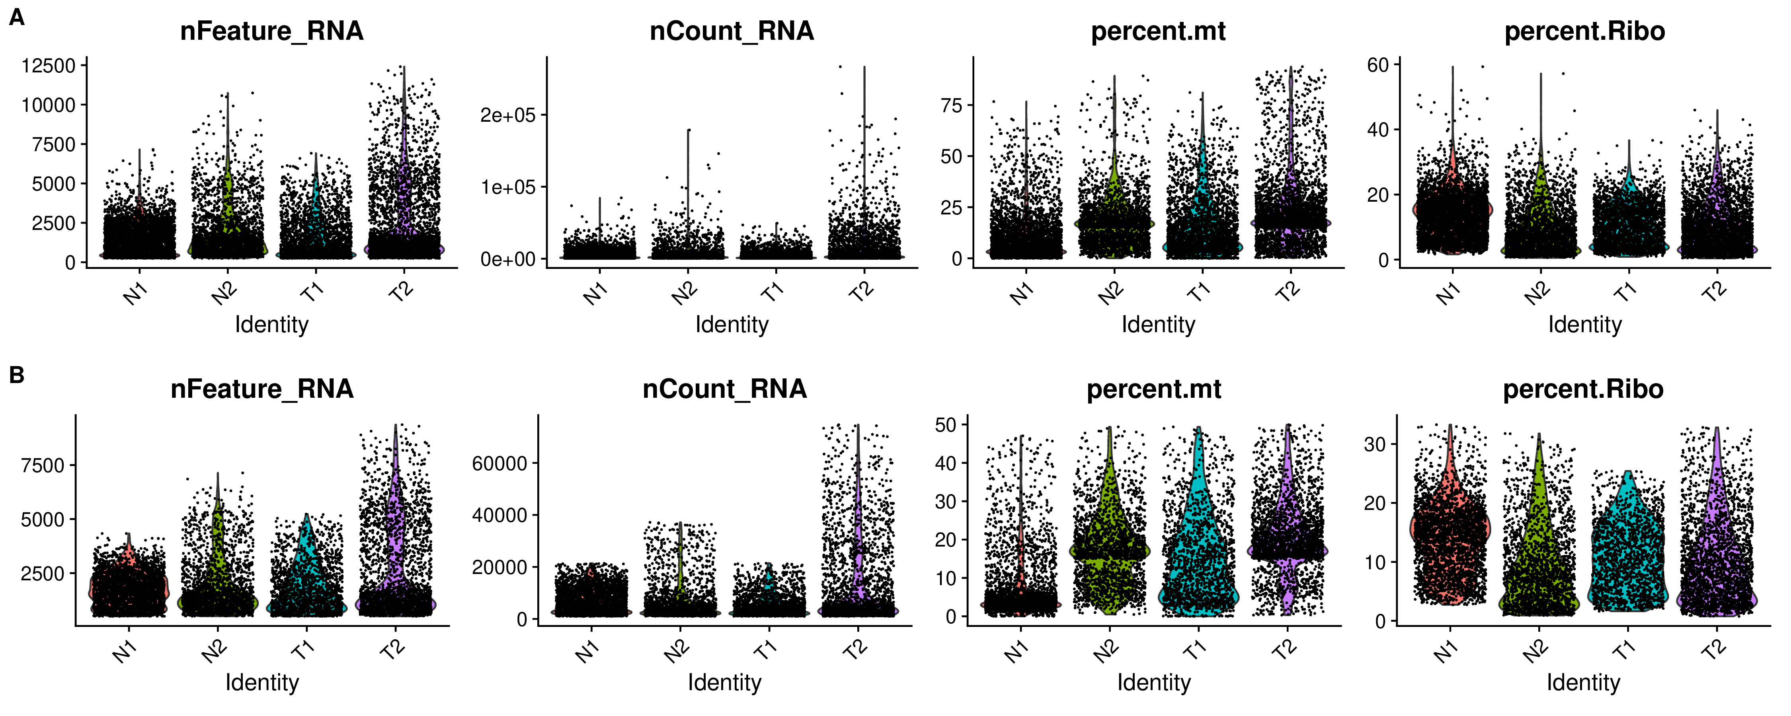
Supplementary Figure S1. Quality control of scRNA-seq data for tumor and para cancerous tissues. A: Number of RNAs and percentages of mitochondrial genes in each cell before quality control. B: Number of RNAs and percentages of mitochondrial genes in each cell after filtration for quality. scRNA-seq, single-cell RNA sequencing.
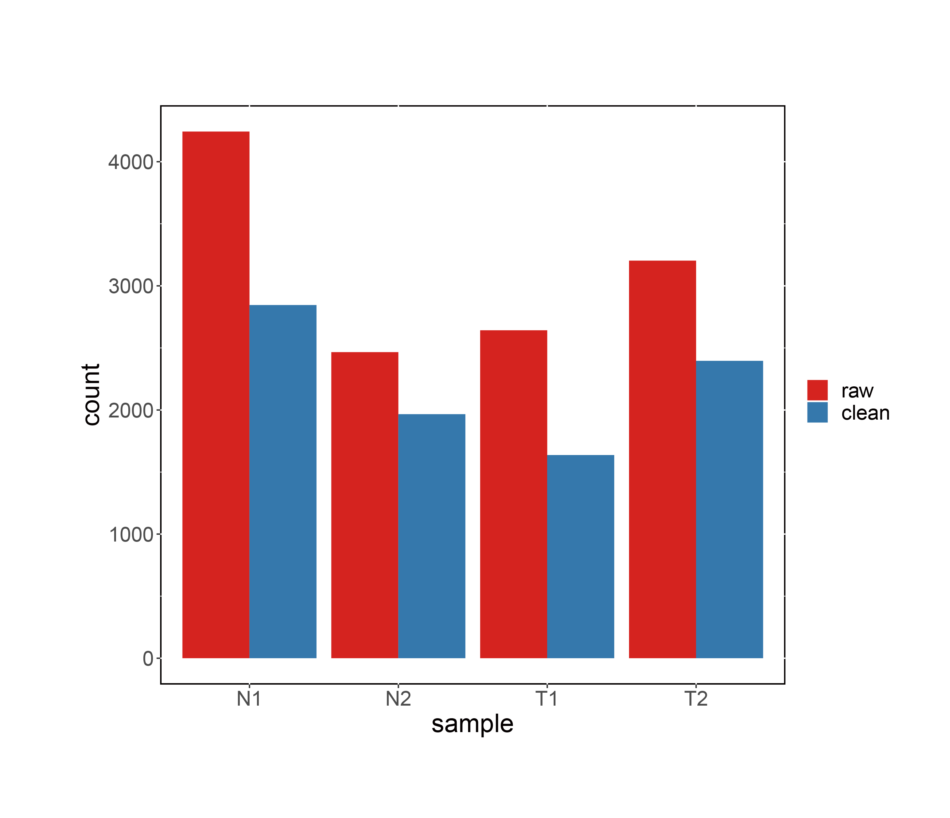
Supplementary Figure S2. Number of cells per sample before- and after-quality filtration.
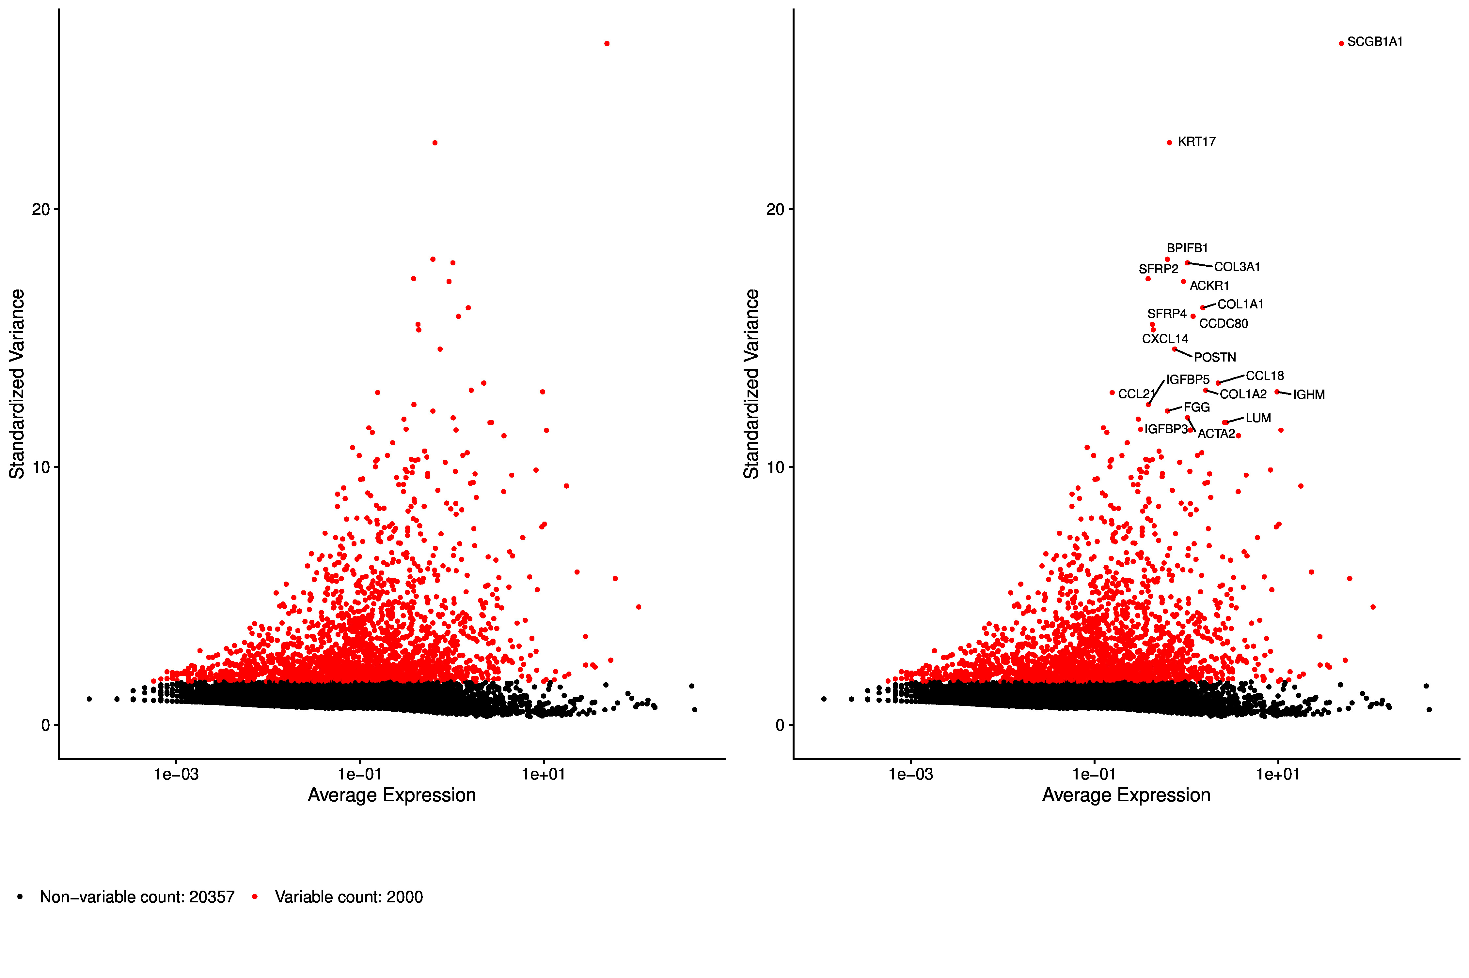
Supplementary Figure S3. Highly variable gene expressions across cells.
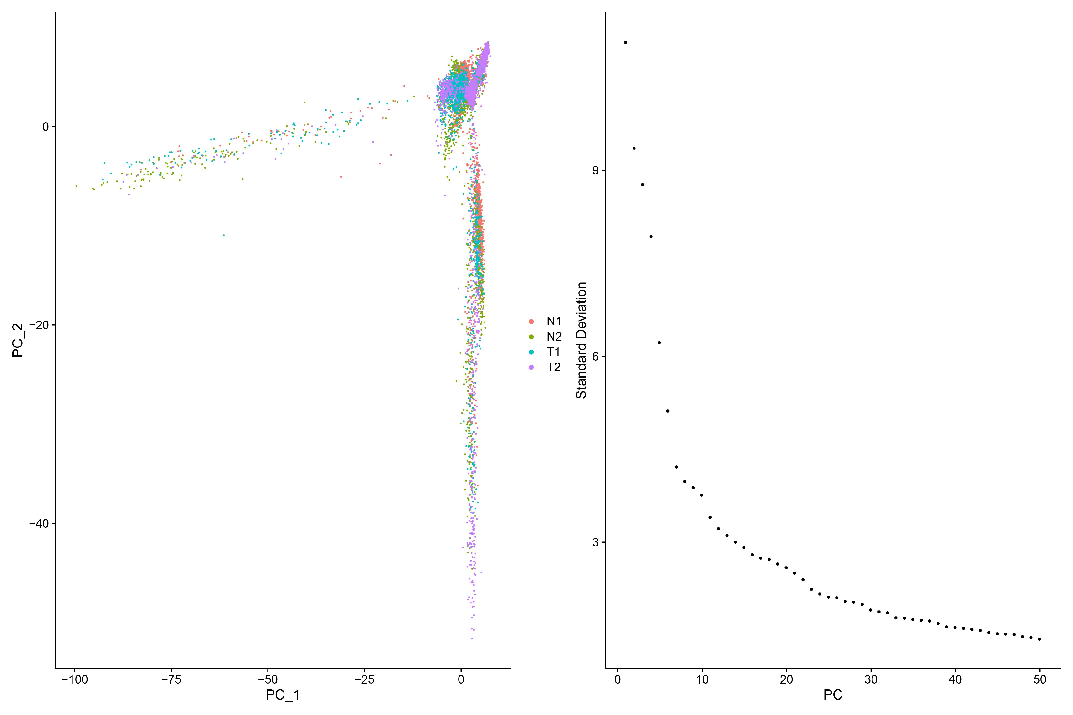
Supplementary Figure S4. PCA and ranking of the principal components thus obtained according to standard deviations using the ElbowPlot function. PCA, principal component analysis.

