ONLINE SUPPLEMENTARY MATERIAL

Development and validation of a Nordic Multimorbidity Index based on hospital diagnoses and filled prescriptions

Kristensen et al

Figure S1 Flowchart of selection of the development cohort and temporal validation cohort
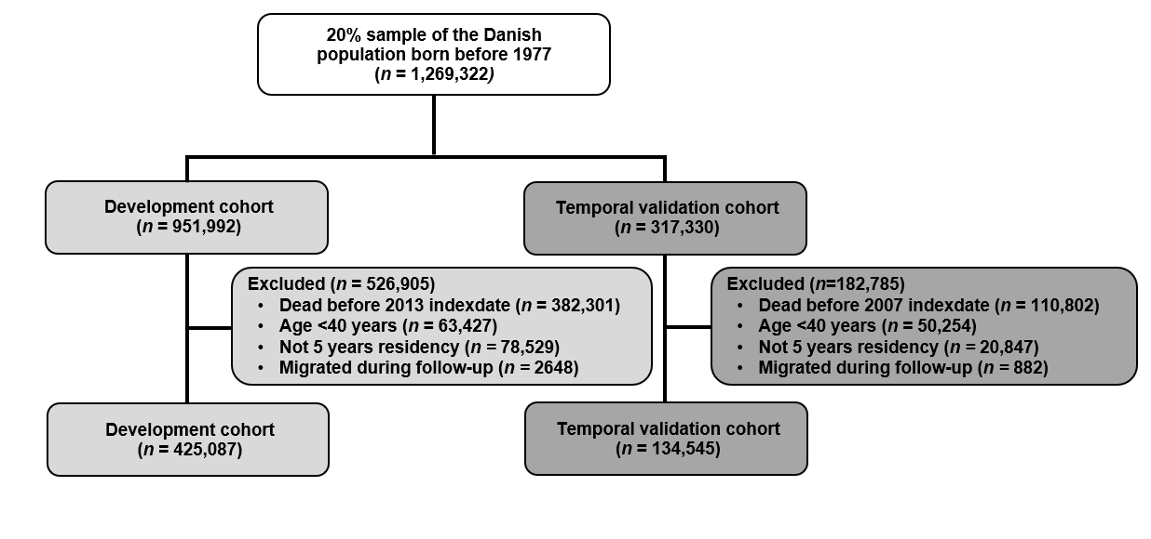

Figure S2 Flowchart of selection of the six new-user validation cohorts
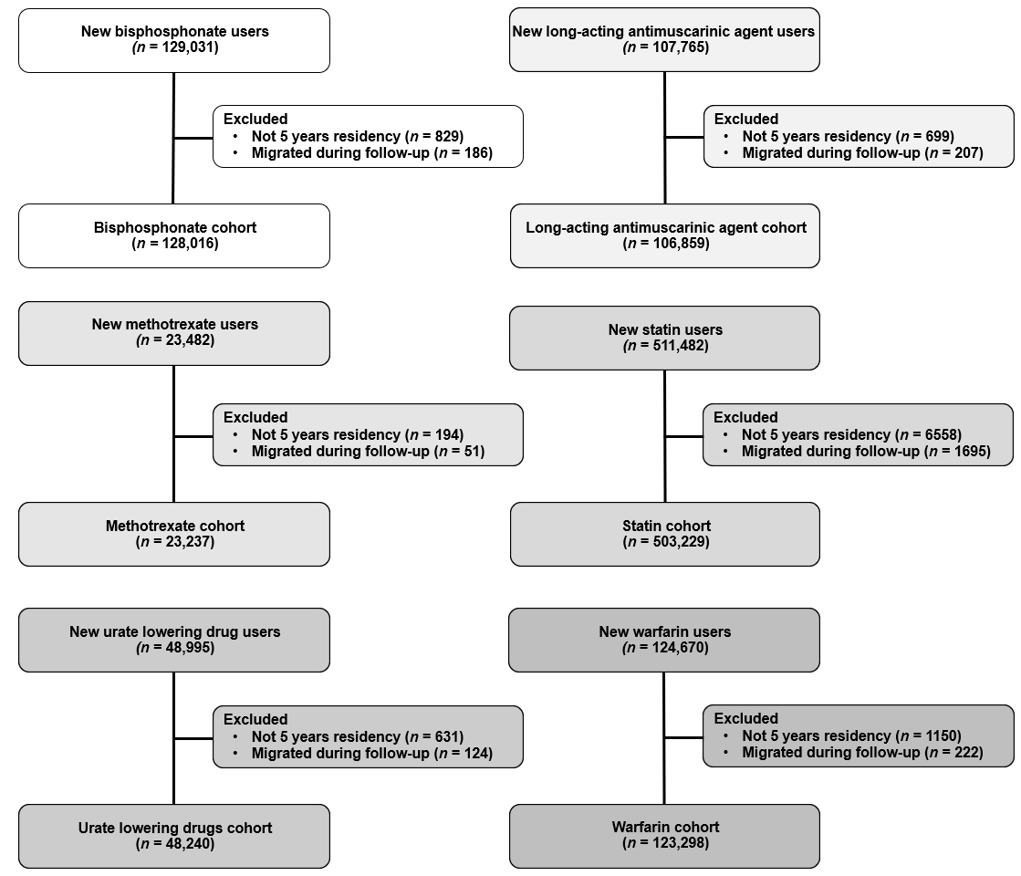

Figure S3 c-statistic for each candidate predictor according to the strength of association with age
For all candidate predictors the c-statistic (from a logistic regression model with the predictor and age as independent variables) to predict 5-year mortality and the strength of association of the predictor with age expressed by the Pearson’s correlation coefficient is shown.

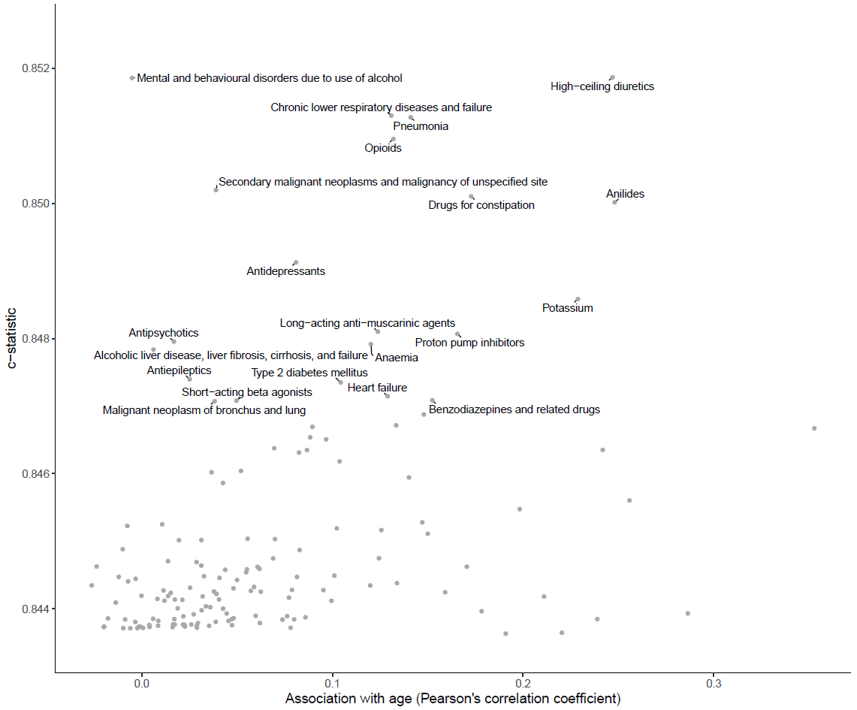
Figure S4 Relationship between the c-statistic and the number of predictors remaining in the backwards elimination procedure besides age, sex, and the intercept

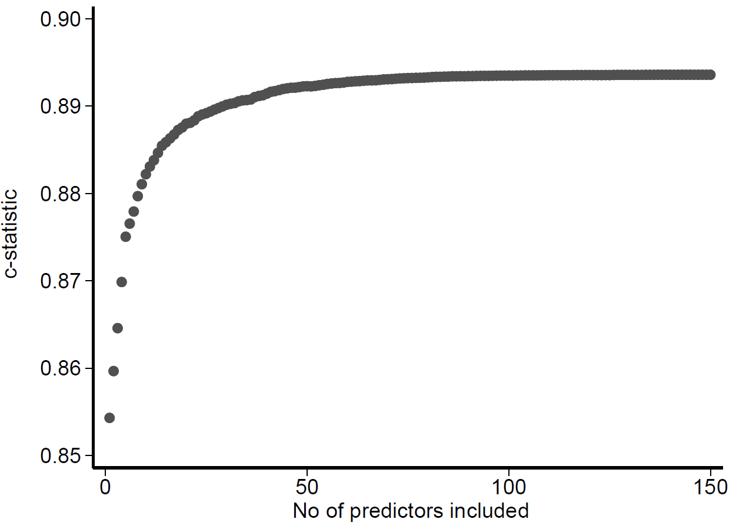

Figure S5 ROC curves for 5-year mortality for the Charlson Comorbidity Index (CCI), the Elixhauser Comorbidity Index (ECI), and the Nordic Multimorbidity Index (NMI) with and without the base model (age and sex) in the new-user validation cohorts

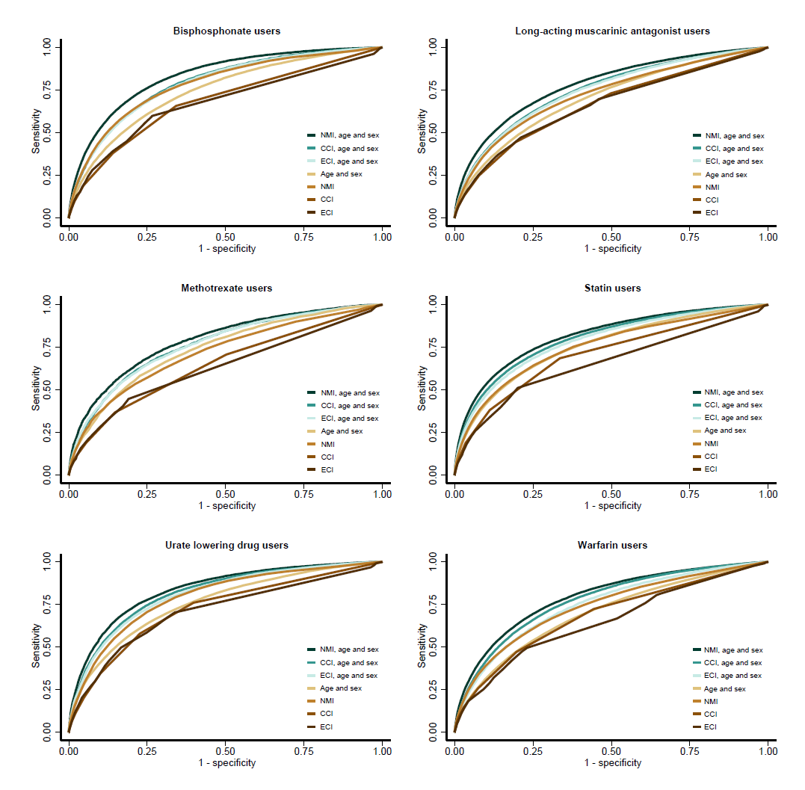

Table S1 Baseline characteristics of the new user validation cohorts

Characteristic (%) | Bisphosphonates | LAMA | Methotrexate | Statins | ULD | Warfarin
 | n = 128,016 | n = 106,859 | n = 23,237 | n = 503,229 | n = 48,240 | n = 123,298
Age median, (p25-p75) | 72 (65-79) | 71 (64-77) | 66 (60-73) | 66 (61-73) | 71 (63-78) | 73 (65-79)
Male | 23,970 (18.7%) | 51,309 (48.0%) | 8538 (36.7%) | 242,344 (48.2%) | 30,945 (64.1%) | 68,761 (55.8%)
1-year mortality | 7527 (5.9%) | 9957 (9.3%) | 564 (2.4%) | 13,163 (2.6%) | 4648 (9.6%) | 11,588 (9.4%)
2-year mortality | 13,850 (10.8%) | 17,418 (16.3%) | 1129 (4.9%) | 25,045 (5.0%) | 7630 (15.8%) | 19,062 (15.5%)
5-year mortality | 32,737 (25.6%) | 37,211 (34.8%) | 3012 (13.0%) | 64,927 (12.9%) | 15,110 (31.3%) | 38,739 (31.4%)
Selected common diagnoses (within 5 years)
Essential (primary) hypertension | 21,425 (16.7%) | 19,488 (18.2%) | 3334 (14.3%) | 89,742 (17.8%) | 12,734 (26.4%) | 36,948 (30.0%)
Type 2 diabetes mellitus | 5513 (4.3%) | 6953 (6.5%) | 1220 (5.3%) | 32,640 (6.5%) | 5636 (11.7%) | 11,189 (9.1%)
Atrial fibrillation and flutter | 8755 (6.8%) | 10,167 (9.5%) | 1102 (4.7%) | 31,658 (6.3%) | 7857 (16.3%) | 55,153 (44.7%)
Chronic ischaemic heart disease | 8119 (6.3%) | 11,099 (10.4%) | 1264 (5.4%) | 31,834 (6.3%) | 7688 (15.9%) | 17,930 (14.5%)
Heart failure | 5744 (4.5%) | 9311 (8.7%) | 697 (3.0%) | 20,969 (4.2%) | 7372 (15.3%) | 17,313 (14.0%)
Cerebrovascular disease | 7877 (6.2%) | 6826 (6.4%) | 813 (3.5%) | 53,529 (10.6%) | 3766 (7.8%) | 14,102 (11.4%)
Chronic lower respiratory diseases and failure | 15,926 (12.4%) | 41,499 (38.8%) | 1281 (5.5%) | 23,431 (4.7%) | 4589 (9.5%) | 12,621 (10.2%)
Pneumonia | 12,006 (9.4%) | 19,325 (18.1%) | 1136 (4.9%) | 20,883 (4.1%) | 4896 (10.1%) | 14,354 (11.6%)
Osteoporosis | 45,369 (35.4%) | 6270 (5.9%) | 1280 (5.5%) | 12,744 (2.5%) | 1301 (2.7%) | 4631 (3.8%)
Anemia | 6896 (5.4%) | 4967 (4.6%) | 860 (3.7%) | 8938 (1.8%) | 3857 (8.0%) | 6029 (4.9%)
Selected common drug fills (within 6 months)
Platelet aggregation inhibitors excl. heparin | 33,891 (26.5%) | 35,584 (33.3%) | 5026 (21.6%) | 119,221 (23.7%) | 19,720 (40.9%) | 54,374 (44.1%)
HMG CoA reductase inhibitors (statins) | 29,557 (23.1%) | 30,417 (28.5%) | 5151 (22.2%) | - | 17,975 (37.3%) | 37,234 (30.2%)
ACE inhibitors incl. combinations | 20,875 (16.3%) | 22,479 (21.0%) | 3836 (16.5%) | 110,911 (22.0%) | 15,626 (32.4%) | 30,132 (24.4%)
ARBs incl. combinations | 14,470 (11.3%) | 14,522 (13.6%) | 2908 (12.5%) | 71,107 (14.1%) | 9569 (19.8%) | 19,407 (15.7%)
Low-ceiling diuretics | 22,979 (18.0%) | 19,968 (18.7%) | 4217 (18.1%) | 105,496 (21.0%) | 11,414 (23.7%) | 26,441 (21.4%)
High-ceiling diuretics | 18,356 (14.3%) | 22,955 (21.5%) | 2423 (10.4%) | 41,832 (8.3%) | 20,040 (41.5%) | 26,576 (21.6%)
Blood glucose lowering drugs, excl. insulins | 5495 (4.3%) | 7618 (7.1%) | 1630 (7.0%) | 47,523 (9.4%) | 5924 (12.3%) | 10,584 (8.6%)
Anilides (paracetamol) | 39,543 (30.9%) | 25,575 (23.9%) | 6149 (26.5%) | 62,011 (12.3%) | 11,800 (24.5%) | 23,402 (19.0%)
Benzodiazepines and related drugs | 30,805 (24.1%) | 26,534 (24.8%) | 4161 (17.9%) | 78,023 (15.5%) | 9098 (18.9%) | 24,608 (20.0%)
Antidepressives | 21,889 (17.1%) | 20,294 (19.0%) | 2756 (11.9%) | 54,629 (10.9%) | 5642 (11.7%) | 14,981 (12.2%)
Potassium | 16,859 (13.2%) | 17,809 (16.7%) | 2000 (8.6%) | 37,149 (7.4%) | 12,783 (26.5%) | 21,123 (17.1%)
LAMA, Long-acting muscarinic antagonists; ULD, urate lowering drugs; ACE, Angiotensin converting enzyme; ARB, angiotensin receptor blockers

Table S2 Candidate predictors
Predictor name | N (%) | ICD-10 or ATC code
Intestinal infectious diseases | 3615 (0.85%) | A00-A09
Sepsis | 3304 (0.78%) | A40-A41
Erysipelas | 2671 (0.63%) | A46
Chronic viral hepatitis | 896 (0.21%) | B18
HIV | 470 (0.11%) | B20-B24
Candidiasis | 707 (0.17%) | B37
Colorectal cancer | 2485 (0.58%) | C18-C20
Malignant neoplasm of bronchus and lung | 1130 (0.27%) | C34
Malignant melanoma of skin | 1264 (0.30%) | C43
Malignant neoplasm of breast | 4953 (1.17%) | C50
Malignant neoplasm of corpus uteri | 538 (0.13%) | C54
Malignant neoplasm of prostate | 3706 (0.87%) | C61
Malignant neoplasm of kidney, except renal pelvis | 453 (0.11%) | C64
Malignant neoplasm of bladder | 537 (0.13%) | C67
Tumor of brain or meninges | 987 (0.23%) | C70, C71, C751-C753, D32, D330-D332, D352-D354, D42, D430-D432, D443-D445
Secondary malignant neoplasms and malignancy of unspecified site | 2301 (0.54%) | C76-C79, C80
Lymphoma | 1055 (0.25%) | C81-C86
Leukemia | 733 (0.17%) | C91-C95
Anaemia | 7604 (1.79%) | D50-D59, D60-D64
Coagulation defects | 1603 (0.38%) | D65-D69
Connective tissue disease | 7008 (1.65%) | M05-M06, M08-M09, M30-M36, D86
Other hypothyroidism | 3358 (0.79%) | E03
Other nontoxic goitre | 3138 (0.74%) | E04
Thyrotoxicosis [hyperthyroidism] | 2969 (0.70%) | E05
Thyroiditis | 503 (0.12%) | E06
Type 1 diabetes mellitus | 5462 (1.28%) | E10
Type 2 diabetes mellitus | 14,650 (3.45%) | E11
Unspecified diabetes mellitus | 2402 (0.57%) | E14
Hyperparathyroidism and other disorders of parathyroid gland | 850 (0.20%) | E21
Vitamin D deficiency | 1105 (0.26%) | E55
Volume depletion | 4331 (1.02%) | E86
Dementia | 3300 (0.78%) | F00-F03, G30
Mental and behavioural disorders due to use of alcohol | 5523 (1.30%) | F10
Mental and behavioural disorders due to use of tobacco | 3413 (0.80%) | F17
Schizophrenia | 526 (0.12%) | F20
Depression | 3780 (0.89%) | F32-F33
Parkinson's disease and other parkinsonism | 1204 (0.28%) | G20-G22
Multiple sclerosis | 1283 (0.30%) | G35
Epilepsy | 3031 (0.71%) | G40-G41
Transient cerebral ischaemic attacks and related syndromes | 4142 (0.97%) | G45
Polyneuropathies | 2196 (0.52%) | G60-G63
Cerebral palsy and other paralytic syndromes | 814 (0.19%) | G80-G83
Aortic and mitral valve disease | 5310 (1.25%) | I05-I06, I34-I35
Essential (primary) hypertension | 39,383 (9.26%) | I10
Heart failure | 7099 (1.67%) | I110, I130, I132, I420, I426-I429, I50
Secondary hypertension | 1257 (0.30%) | I15
Acute myocardial infarction and other acute ischemic heart diseases | 5557 (1.31%) | I21-I24
Chronic ischaemic heart disease | 12,529 (2.95%) | I25
Pulmonary embolism | 1706 (0.40%) | I26
Other pulmonary heart diseases | 457 (0.11%) | I27
Atrioventricular and left bundle-branch block | 1641 (0.39%) | I44
Atrial fibrillation and flutter | 14,143 (3.33%) | I48
Cerebrovascular disease | 11,825 (2.78%) | I60-I69
Predictor name | N (%) | ICD-10 or ATC code
Ateroschlerosis, thrombosis, embolism, and other peripheral arterial disease | 6270 (1.47%) | I70, I73-I74, I77
Aneurysm and dissection of aorta and other arteries | 2024 (0.48%) | I71-I72
Deep venous thrombosis | 2920 (0.69%) | I801-I803
Pneumonia | 12,455 (2.93%) | J12-J18
Chronic lower respiratory diseases and failure | 11,822 (2.78%) | J41-J44, J47, J961, J969
Other interstitial pulmonary diseases | 567 (0.13%) | J84
Pneumothorax | 585 (0.14%) | J93
Diseases of teeth and supporting structures | 2589 (0.61%) | K02-K06, K08
Peptic ulcer | 3567 (0.84%) | K221, K25-K28
Acute appendicitis | 1558 (0.37%) | K35
Crohn disease [regional enteritis] | 1179 (0.28%) | K50
Ulcerative colitis | 2243 (0.53%) | K51
Paralytic ileus and intestinal obstruction without hernia | 1701 (0.40%) | K56
Peritonitis | 575 (0.14%) | K65
Alcoholic liver disease, liver fibrosis, cirrhosis, and failure | 1488 (0.35%) | K70, K72, K74, K766-K667
Cholelithiasis | 6376 (1.50%) | K80
Cholecystitis | 943 (0.22%) | K81
Other diseases of biliary tract | 594 (0.14%) | K83
Pancreatitis, acute or chronic | 1648 (0.39%) | K85-K86
Psoriasis or psoriatic artritis | 1967 (0.46%) | L40, M070-M073
Decubitus ulcer and pressure area | 523 (0.12%) | L89
Infectious athropathies | 899 (0.21%) | M00-M03
Gout | 1740 (0.41%) | M10
Osteoporosis | 10,994 (2.59%) | M80-M82
Glomerular and tubulo-intestitial renal diseases | 2744 (0.65%) | N00-N08, N10-N16
Acute renal failure | 783 (0.18%) | N17
Chronic kidney disease and unspecified kidney failure | 3425 (0.81%) | N18-N19
Calculus of kidney and ureter | 3698 (0.87%) | N20
Cystic kidney disease | 565 (0.13%) | Q61
Magnesium compounds | 3064 (0.72%) | A02AA
Proton pump inhibitors | 49,977 (11.76%) | A02BC
Propulsives | 4166 (0.98%) | A03FA
Drugs for constipation | 8966 (2.11%) | A06A
Antipropulsives | 1259 (0.30%) | A07DA
Intestinal antiinflammatory agents | 2927 (0.69%) | A07E
Insulins and analogues | 8417 (1.98%) | A10A
Blood glucose lowering drugs, excl. insulins | 24,607 (5.79%) | A10B
Calcium | 953 (0.22%) | A12A
Potassium | 19,410 (4.57%) | A12BA
Vitamin k antagonists | 11,614 (2.73%) | B01AA
Platelet aggregation inhibitors excl. heparin | 58,600 (13.79%) | B01AC
Direct thrombin and factor Xa inhibitors | 2980 (0.70%) | B01AE, B01AF
Iron preparations | 1955 (0.46%) | B03A
Vitamin b12 and folic acid | 10,540 (2.48%) | B03B
Digitalis glycosides | 5014 (1.18%) | C01AA
Antiarrhythmics, class i and iii | 1273 (0.30%) | C01B
Organic nitrates | 6254 (1.47%) | C01DA
Antiadrenergic agents, centrally acting | 929 (0.22%) | C02A
Antiadrenergic agents, peripherally acting | 1288 (0.30%) | C02C
Low-ceiling diuretics | 37,330 (8.78%) | C03A, C03B, C03EA
High-ceiling diuretics | 20,669 (4.86%) | C03C, C03EB
Aldosterone antagonists | 5854 (1.38%) | C03DA
Beta blocking agents | 47,222 (11.11%) | C07A
Selective calcium channel blockers with mainly vascular effects | 48,098 (11.31%) | C08C
Selective calcium channel blockers with direct cardiac effects | 3532 (0.83%) | C08D
ACE inhibitors incl. combinations | 53,473 (12.58%) | C09A, C09B
ARBs incl. combinations | 41,065 (9.66%) | C09C, C09D
HMG CoA reductase inhibitors (statins) | 80,026 (18.83%) | C10AA
Predictor name | N (%) | ICD-10 or ATC code
Fibrates | 627 (0.15%) | C10AB
Other lipid modifying agents | 1856 (0.44%) | C10AX
Antipsoriatics for topical use | 2094 (0.49%) | D05A
Glucocorticoids for systemic use | 12,839 (3.02%) | H02AB
Thyroid hormones | 15,353 (3.61%) | H03AA
Antithyroid preparations | 2469 (0.58%) | H03B
Tetracyclines | 2672 (0.63%) | J01AA
Beta-lactam antibacterials, penicillins | 61,588 (14.49%) | J01C
Sulfonamides and trimethoprim | 8714 (2.05%) | J01E
Macrolides, lincosamides and streptogramins | 16,118 (3.79%) | J01F
Quinolone antibacterials | 5400 (1.27%) | J01M
Nitrofuran derivatives | 2930 (0.69%) | J01XE
Antimycotics for systemic use | 6148 (1.45%) | J02A
Immunosuppressants | 3660 (0.86%) | L04A
Muscle relaxants, centrally acting agents | 3938 (0.93%) | M03B
Antigout preparations | 6131 (1.44%) | M04A
Bisphosphonates incl. combinations | 12,271 (2.89%) | M05BA, M04BB
Opioids | 36,418 (8.57%) | N02A
Anilides | 41,763 (9.82%) | N02BE
Antiepileptics | 13,817 (3.25%) | N03A
Anti-parkinson drugs | 4339 (1.02%) | N04
Antipsychotics | 10,221 (2.40%) | N05A excl. N05AN
Lithium | 993 (0.23%) | N05AN
Benzodiazepines and related drugs | 33,026 (7.77%) | N05BA, N05CD, N05CF
Melatonin receptor agonists | 1594 (0.37%) | N05CH
Antidepressants | 42,605 (10.02%) | N06A
Anti-dementia drugs | 2534 (0.60%) | N06D
Drugs used in alcohol dependence | 1592 (0.37%) | N07BB
Drugs used in opioid dependence | 980 (0.23%) | N07BC
Nitroimidazole derivatives | 4074 (0.96%) | P01AB
Short-acting beta agonists | 15,401 (3.62%) | R03AC02-05
Long-acting beta agonists | 4109 (0.97%) | R03AC12-13, R03AC18-19
LABA, LAMA, ICS combinations | 15,047 (3.54%) | R03AK06-08, R03AK10-11, R03AK14, R03AL03-09
Glucocorticoids, inhalants | 8149 (1.92%) | R03BA
Long-acting anti-muscarinic agents | 8938 (2.10%) | R03BB04-07
Adrenergics for systemic use | 459 (0.11%) | R03C
Leukotriene receptor antagonists | 1535 (0.36%) | R03DC
Mucolytics | 1481 (0.35%) | R05CB
Cough suppressants | 13,622 (3.20%) | R05D, R05F

Appendix A

Coding algorithms and weights for the Charlson comorbidities.

Comorbidities | ICD-10, Quan 2005 | Weight, Charlson 1987 | Weight, Quan 2011
Myocardial infarction | I21.x, I22.x, I25.2 | 1 | 0
Congestive heart failure | I09.9, I11.0, I13.0, I13.2, I25.5, I42.0, I42.5–I42.9, I43.x, I50.x, P29.0 | 1 | 2
Peripheral vascular disease | I70.x, I71.x, I73.1, I73.8, I73.9, I77.1, I79.0, I79.2, K55.1, K55.8, K55.9, Z95.8, Z95.9 | 1 | 0
Cerebrovascular disease | G45.x, G46.x, H34.0, I60.x–I69.x | 1 | 0
Dementia | F00.x–F03.x, F05.1, G30.x, G31.1 | 1 | 2
Chronic pulmonary disease | I27.8, I27.9, J40.x–J47.x, J60.x–J67.x, J68.4, J70.1, J70.3 | 1 | 1
Rheumatic disease | M05.x, M06.x, M31.5, M32.x–M34.x, M35.1, M35.3, M36.0 | 1 | 1
Peptic ulcer disease | K25.x–K28.x | 1 | 0
Mild liver disease | B18.x, K70.0–K70.3, K70.9, K71.3–K71.5, K71.7, K73.x, K74.x,  K76.0, K76.2–K76.4, K76.8, K76.9, Z94.4 | 1 | 2
Diabetes without chronic complication | E10.0, E10.1, E10.6, E10.8, E10.9,  E11.0, E11.1, E11.6, E11.8, E11.9,  E12.0, E12.1, E12.6, E12.8, E12.9,  E13.0, E13.1, E13.6, E13.8, E13.9,  E14.0, E14.1, E14.6, E14.8, E14.9 | 1 | 0
Diabetes with chronic complication | E10.2–E10.5, E10.7, E11.2–E11.5,  E11.7, E12.2–E12.5, E12.7, E13.2–  E13.5, E13.7, E14.2–E14.5, E14.7 | 2 | 1
Hemiplegia or paraplegia | G04.1, G11.4, G80.1, G80.2, G81.x, G82.x, G83.0–G83.4, G83.9 | 2 | 2
Renal disease | I12.0, I13.1, N03.2–N03.7, N05.2– N05.7, N18.x, N19.x, N25.0, Z49.0–Z49.2, Z94.0, Z99.2 | 2 | 1
Any malignancy, including lymphoma and leukemia, except malignant neoplasm of skin | C00.x–C26.x, C30.x–C34.x, C37.x– C41.x, C43.x, C45.x–C58.x, C60.x–C76.x, C81.x–C85.x, C88.x, C90.x–C97.x | 2 | 2
Moderate or severe liver disease | I85.0, I85.9, I86.4, I98.2, K70.4,  K71.1, K72.1, K72.9, K76.5, K76.6, K76.7 | 3 | 4
Metastatic solid tumor | C77.x–C80.x | 6 | 6
AIDS/HIV | B20.x–B22.x, B24.x | 6 | 4
The same comorbidities with different severity were mutually exclusive: diabetes with chronic complications and diabetes without chronic complications; mild liver disease and moderate or severe liver disease; and any malignancy and metastatic solid tumor.

Charlson, 1987: Charlson ME, Pompei P, Ales KL, MacKenzie CR. A new method of classifying prognostic comorbidi-ty in longitudinal studies: development and validation. J Chronic Dis. 1987;40(5):373-383. doi:10.1016/0021-9681(87)90171-8

Quan, 2005: Quan H, Sundararajan V, Halfon P, et al. Coding Algorithms for Defining Comorbidities in ICD-9-CM and ICD-10 Administrative Data. Medical Care. 2005;43(11):1130-1139. doi:10.1097/01.mlr.0000182534.19832.83

Quan, 2011: Quan H, Li B, Couris CM, et al. Updating and Validating the Charlson Comorbidity Index and Score for Risk Adjustment in Hospital Discharge Abstracts Using Data From 6 Countries. American Journal of Epidemiology. 2011;173(6):676-682. doi:10.1093/aje/kwq433
Appendix B
Coding algorithms and weights for the Elixhauser comorbidities.
Comorbidities | ICD-10, Quan 2005 | Weight, van Walraven 2009
Congestive heart failure | I09.9, I11.0, I13.0, I13.2, I25.5, I42.0, I42.5–I42.9, I43.x, I50.x, P29.0 | 7
Cardiac arrhythmias | I44.1–I44.3, I45.6, I45.9, I47.x–I49.x, R00.0, R00.1, R00.8, T82.1, Z45.0, Z95.0 | 5
Valvular disease | A52.0, I05.x–I08.x, I09.1, I09.8, I34.x–I39.x, Q23.0–Q23.3, Z95.2–Z95.4 | -1
Pulmonary circulation disorders | I26.x, I27.x, I28.0, I28.8, I28.9 | 4
Peripheral vascular disorders | I70.x, I71.x, I73.1, I73.8, I73.9, I77.1, I79.0, I79.2, K55.1, K55.8, K55.9, Z95.8, Z95.9 | 2
Hypertension, uncomplicated | I10.x | 0
Hypertension, complicated | I11.x - I13.x, I15.x | 0
Paralysis | G04.1, G11.4, G80.1, G80.2, G81.x, G82.x, G83.0–G83.4, G83.9 | 7
Other neurological disorders | G10.x–G13.x, G20.x–G22.x, G25.4, G25.5, G31.2, G31.8, G31.9, G32.x, G35.x - G37.x, G40.x, G41.x, G93.1, G93.4, R47.0, R56.x | 6
Chronic pulmonary disease | I27.8, I27.9, J40.x–J47.x, J60.x–J67.x, J68.4, J70.1, J70.3 | 3
Diabetes, uncomplicated | E10.0, E10.1, E10.9, E11.0, E11.1, E11.9, E12.0, E12.1, E12.9, E13.0, E13.1, E13.9, E14.0, E14.1, E14.9 | 0
Diabetes, complicated | E10.2–E10.8, E11.2–E11.8, E12.2–E12.8, E13.2–E13.8, E14.2–E14.8 | 0
Hypothyroidism | E00.x - E03.x, E89.0 | 0
Renal failure | I12.0, I13.1, N18.x, N19.x, N25.0, Z49.0–Z49.2, Z94.0, Z99.2 | 5
Liver disease | B18.x, I85.x, I86.4, I98.2, K70.x, K71.1, K71.3–K71.5, K71.7, K72.x - K74.x, K76.0, K76.2 - K76.9, Z94.4 | 11
Peptic ulcer disease, excl. bleeding | K25.7, K25.9, K26.7, K26.9, K27.7, K27.9, K28.7, K28.9 | 0
AIDS/HIV | B20.x–B22.x, B24.x | 0
Lymphoma | C81.x–C85.x, C88.x, C96.x, C90.0, C90.2 | 9
Metastatic cancer | C77.x–C80.x | 12
Solid tumor without metastasis | C00.x–C26.x, C30.x–C34.x, C37.x–C41.x, C43.x, C45.x–C58.x, C60.x–C76.x, C97.x | 4
Rheumatoid arthritis/collagen vascular diseases | L94.0, L94.1, L94.3, M05.x, M06.x, M08.x, M12.0, M12.3, M30.x, M31.0–M31.3, M32.x–M35.x, M45.x, M46.1, M46.8, M46.9 | 0
Coagulopathy | D65–D68.x, D69.1, D69.3–D69.6 | 3
Obesity | E66.x | -4
Weight loss | E40.x–E46.x, R63.4, R64 | 6
Fluid and electrolyte disorders | E22.2, E86.x, E87.x | 5
Blood loss anemia | D50.0 | -2
Deficiency anemia | D50.8, D50.9, D51.x–D53.x | -2
Alcohol abuse | F10, E52, G62.1, I42.6, K29.2, K70.0, K70.3, K70.9, T51.x, Z50.2, Z71.4, Z72.1 | 0
Drug abuse | F11.x–F16.x, F18.x, F19.x, Z71.5, Z72.2 | -7
Psychoses | F20.x, F22.x–F25.x, F28.x, F29.x, F30.2, F31.2, F31.5 | 0
Depression | F20.4, F31.3–F31.5, F32.x, F33.x, F34.1, F41.2, F43.2 | -3
Quan, 2005: Quan H, Sundararajan V, Halfon P, et al. Coding Algorithms for Defining Comorbidities in ICD-9-CM and ICD-10 Administrative Data. Medical Care. 2005;43(11):1130-1139. doi:10.1097/01.mlr.0000182534.19832.83
van Walraven, 2009: van Walraven C, Austin PC, Jennings A, Quan H, Forster AJ. A Modification of the Elixhauser Comorbidity Measures Into a Point System for Hospital Death Using Administrative Data. Medical Care. 2009;47(6):626-633. doi:10.1097/MLR.0b013e31819432e5

