Association between serum total bilirubin and COPD: results from a cross-sectional study and a bidirectional Mendelian Randomization analysis
Cuiqiong Dai¹*; Zihui Wang¹*; Huajing Yang¹*; Shan Xiao¹; Jianwu Xu¹; Zhishan Deng¹; Fan Wu¹²; Xiang Wen¹; Youlan Zheng¹; Lifei Lu¹; Ningning Zhao¹; Peiyu Huang¹; Yumin Zhou¹²; Pixin Ran¹²
*These authors contributed equally to this work
Correspondence: Pixin Ran; Yumin Zhou
Tel +86-020 3710 3616
Fax +86-020 81340482
Email pxran@gzhmu.edu.cn; zhouyumin410@126.com
e-Table 1. Details of GWAS associated with exposure and outcome included in Mendelian randomization analysis
Phenotype | First author | Consortium | Number of participants | Number of variants | Population | Year | PubMed ID
Exposure & Outcome
Total bilirubin | Neale Lab | Neale Lab Consortium | 342829 | 13585986 | European | 2018 | ——
Outcome & Exposure
FEV1/FVC | Shrine N | UK Biobank | 321047 | 19671887 | European | 2019 | 30804560
——,unknown

e-Table 2. Details of SNPs (used as genetic instruments) in MR analyses associated with TB with FEV1/FVC.
Chrom-osome | Position | SNP | Effect value | Beta coefficient | Standard error | P-value | Effect allele frequency
4 | 175086079 | rs10003923 | C | 0.014443 | 0.0023415 | 6.91E-10 | 0.41903
5 | 111013695 | rs10478063 | T | -0.013596 | 0.0024694 | 3.68E-08 | 0.3244
2 | 211540507 | rs1047891 | A | 0.022955 | 0.0024728 | 1.65E-20 | 0.31574
2 | 46353166 | rs10495928 | G | -0.013791 | 0.0024345 | 1.47E-08 | 0.33575
11 | 75459841 | rs10793128 | A | 0.035004 | 0.0039888 | 1.71E-18 | 0.092331
12 | 20651995 | rs10841556 | G | 0.013817 | 0.0024046 | 9.15E-09 | 0.35896
12 | 53261822 | rs10876376 | A | 0.014429 | 0.0023213 | 5.11E-10 | 0.5479
12 | 21437227 | rs11045932 | T | -0.049057 | 0.0025392 | 4.03E-83 | 0.29405
2 | 234497554 | rs111459884 | A | 0.28406 | 0.010139 | 1.64E-172 | 0.015112
2 | 233979178 | rs112715011 | G | 0.094268 | 0.0079722 | 2.96E-32 | 0.021969
2 | 234256623 | rs115035012 | T | 0.12721 | 0.0090036 | 2.58E-45 | 0.019918
12 | 21362819 | rs11519274 | T | 0.17122 | 0.0031203 | 1.00E-200 | 0.16061
2 | 234424542 | rs115700531 | C | -0.12074 | 0.0090166 | 6.99E-41 | 0.016558
2 | 234724254 | rs115871533 | G | -0.12971 | 0.011685 | 1.27E-28 | 0.010372
2 | 234700867 | rs116635982 | T | -0.064262 | 0.0087585 | 2.19E-13 | 0.019263
3 | 195838613 | rs11917973 | T | 0.013364 | 0.0023178 | 8.14E-09 | 0.46343
4 | 175126378 | rs12651414 | A | 0.014868 | 0.0027023 | 3.76E-08 | 0.23785
17 | 57934995 | rs1292042 | G | -0.024714 | 0.0028816 | 9.82E-18 | 0.19815
17 | 27149900 | rs12938360 | C | 0.017978 | 0.0029528 | 1.14E-09 | 0.19197
3 | 196516288 | rs13092376 | C | 0.013718 | 0.002338 | 4.43E-09 | 0.41903
5 | 122814733 | rs13171367 | G | -0.019283 | 0.0029279 | 4.53E-11 | 0.19125
2 | 234886430 | rs13421820 | C | 0.23689 | 0.012182 | 3.50E-84 | 0.0093476
2 | 234201509 | rs142458770 | G | -0.26175 | 0.010015 | 1.96E-150 | 0.015111
6 | 126851160 | rs1490384 | T | -0.016416 | 0.0023005 | 9.63E-13 | 0.49816
12 | 21158963 | rs150266178 | T | 0.19989 | 0.0067186 | 2.98E-194 | 0.030936
10 | 5266874 | rs150754448 | A | 0.017943 | 0.003177 | 1.63E-08 | 0.15553
19 | 45425175 | rs157594 | G | 0.018193 | 0.0024468 | 1.05E-13 | 0.61588
11 | 2942593 | rs1661052 | A | -0.051709 | 0.0039988 | 3.07E-38 | 0.908848
4 | 110825634 | rs17316633 | A | 0.016561 | 0.0026065 | 2.10E-10 | 0.26445
11 | 61600342 | rs174574 | C | 0.021419 | 0.0024093 | 6.15E-19 | 0.647
10 | 71094504 | rs17476364 | C | 0.08285 | 0.0036765 | 2.27E-112 | 0.10984
9 | 137106964 | rs17567190 | T | -0.019101 | 0.0031181 | 9.02E-10 | 0.16525
1 | 107627697 | rs1762486 | A | 0.017215 | 0.0024527 | 2.24E-12 | 0.65639
2 | 234653039 | rs17864702 | T | -0.23692 | 0.0083433 | 3.66E-177 | 0.021561
6 | 26093141 | rs1800562 | A | 0.062845 | 0.0042714 | 5.50E-49 | 0.078833
4 | 100065509 | rs1800759 | G | -0.01631 | 0.0023692 | 5.83E-12 | 0.6139
20 | 43042364 | rs1800961 | T | 0.062367 | 0.0065873 | 2.88E-21 | 0.031428
16 | 28513530 | rs181207 | T | -0.019901 | 0.0024424 | 3.72E-16 | 0.3362
1 | 220969049 | rs1874121 | T | 0.020992 | 0.0024332 | 6.31E-18 | 0.33965
10 | 65365385 | rs1896995 | T | -0.030001 | 0.0023131 | 1.85E-38 | 0.485
2 | 101575474 | rs1992769 | A | -0.012968 | 0.0023086 | 1.94E-08 | 0.5051
4 | 88018991 | rs2035403 | G | -0.017384 | 0.0023454 | 1.25E-13 | 0.39977
2 | 32883197 | rs2053799 | G | 0.014446 | 0.0023318 | 5.82E-10 | 0.57547
10 | 94839642 | rs2068888 | A | 0.030821 | 0.0023091 | 1.25E-40 | 0.44882
10 | 122857596 | rs2245095 | T | -0.042957 | 0.0040543 | 3.16E-26 | 0.088059
3 | 48556339 | rs2267846 | A | 0.016361 | 0.0026054 | 3.40E-10 | 0.27281
22 | 44340904 | rs2294915 | T | 0.014959 | 0.0027269 | 4.12E-08 | 0.23109
9 | 136141870 | rs2519093 | T | -0.021101 | 0.0029735 | 1.28E-12 | 0.18402
5 | 131797578 | rs2522051 | C | -0.015356 | 0.0023086 | 2.90E-11 | 0.45369
17 | 15868225 | rs2535613 | G | -0.015543 | 0.0024877 | 4.17E-10 | 0.6299
12 | 56866962 | rs2657878 | T | 0.017541 | 0.0030115 | 5.73E-09 | 0.17899
10 | 113936855 | rs2792759 | T | -0.019301 | 0.0025782 | 7.11E-14 | 0.72584
2 | 234258615 | rs28571093 | G | -0.20439 | 0.0066226 | 1.00E-200 | 0.031174
8 | 42324760 | rs2978457 | C | -0.013338 | 0.0023029 | 6.98E-09 | 0.48175
6 | 32343369 | rs3117106 | C | -0.025849 | 0.0031222 | 1.24E-16 | 0.16181
8 | 23407178 | rs33963055 | T | 0.018481 | 0.0030572 | 1.50E-09 | 0.17089
15 | 60883281 | rs339969 | A | -0.024403 | 0.0023599 | 4.66E-25 | 0.61486
9 | 119255297 | rs34979631 | T | 0.01548 | 0.0027584 | 2.00E-08 | 0.22557
1 | 40035928 | rs3768321 | T | -0.019732 | 0.0028972 | 9.72E-12 | 0.19677
16 | 79432671 | rs4129887 | C | -0.012777 | 0.0023142 | 3.37E-08 | 0.5633
16 | 79703829 | rs4243177 | G | 0.014842 | 0.0023673 | 3.63E-10 | 0.62495
7 | 17284577 | rs4410790 | C | -0.030102 | 0.0023888 | 2.12E-36 | 0.63423
2 | 234603619 | rs45521138 | T | -0.31053 | 0.012398 | 2.54E-138 | 0.010615
2 | 64887382 | rs4671605 | T | 0.020434 | 0.0026198 | 6.23E-15 | 0.73446
17 | 65852907 | rs4790908 | G | -0.01836 | 0.0029084 | 2.75E-10 | 0.19444
19 | 17255734 | rs4808579 | C | -0.01835 | 0.0023574 | 7.06E-15 | 0.39175
1 | 247602968 | rs4925546 | G | -0.015625 | 0.0023838 | 5.58E-11 | 0.63035
4 | 124770793 | rs5023357 | G | -0.02414 | 0.0036977 | 6.66E-11 | 0.10882
7 | 21605973 | rs55696093 | G | 0.023521 | 0.0027796 | 2.64E-17 | 0.21972
15 | 63789186 | rs56094562 | C | 0.02555 | 0.0024229 | 5.39E-26 | 0.34479
19 | 19379549 | rs58542926 | T | 0.039609 | 0.0043551 | 9.52E-20 | 0.075479
20 | 39746403 | rs6129760 | G | 0.017471 | 0.0024611 | 1.26E-12 | 0.32286
9 | 91495135 | rs61750929 | T | 0.048545 | 0.0050544 | 7.71E-22 | 0.055055
15 | 43237414 | rs62020698 | T | -0.022923 | 0.0039805 | 8.48E-09 | 0.091708
2 | 113841030 | rs6734238 | G | -0.021759 | 0.0023418 | 1.53E-20 | 0.40203
19 | 49211969 | rs676388 | C | 0.019056 | 0.0023135 | 1.77E-16 | 0.53588
3 | 12391207 | rs6802898 | T | -0.020301 | 0.0035028 | 6.81E-09 | 0.12224
3 | 135932359 | rs687339 | T | -0.048774 | 0.0027422 | 9.74E-71 | 0.77192
12 | 121415293 | rs7139079 | A | 0.01424 | 0.0023474 | 1.31E-09 | 0.5949
17 | 59188325 | rs7214175 | T | -0.016883 | 0.0030631 | 3.56E-08 | 0.17075
17 | 7806529 | rs7222046 | G | 0.016736 | 0.0023357 | 7.78E-13 | 0.4314
14 | 50960170 | rs72679504 | A | 0.042097 | 0.0058785 | 8.02E-13 | 0.040234
6 | 12811955 | rs72835688 | T | -0.028875 | 0.0050224 | 8.97E-09 | 0.059428
6 | 6971753 | rs730551 | T | 0.014236 | 0.0023116 | 7.34E-10 | 0.48002
1 | 63167984 | rs7526446 | A | 0.019909 | 0.0024179 | 1.82E-16 | 0.63709
4 | 145083342 | rs7667722 | A | -0.014574 | 0.0022997 | 2.34E-10 | 0.50439
12 | 4384844 | rs76895963 | G | 0.053505 | 0.0088231 | 1.33E-09 | 0.021083
10 | 96418778 | rs7894137 | T | -0.02425 | 0.0031842 | 2.63E-14 | 0.15371
9 | 94044272 | rs79170239 | T | 0.033344 | 0.002937 | 7.26E-30 | 0.18799
11 | 13356030 | rs7947951 | G | -0.022265 | 0.0024863 | 3.41E-19 | 0.69118
3 | 154679652 | rs79485702 | G | 0.014758 | 0.0026028 | 1.43E-08 | 0.28916
15 | 73982556 | rs8041523 | T | 0.013006 | 0.0023256 | 2.24E-08 | 0.42586
22 | 37462936 | rs855791 | G | 0.028692 | 0.0023248 | 5.48E-35 | 0.56166
1 | 158611797 | rs857720 | C | -0.032157 | 0.0025969 | 3.29E-35 | 0.26657
14 | 65230059 | rs873642 | T | -0.019433 | 0.0035084 | 3.04E-08 | 0.12251
2 | 234668570 | rs887829 | T | 0.74665 | 0.0021202 | 1.00E-200 | 0.31492
1 | 25584976 | rs9438901 | A | 0.018061 | 0.0032906 | 4.06E-08 | 0.85781
3 | 114464858 | rs9826148 | T | -0.023983 | 0.0037076 | 9.91E-11 | 0.10871

e-Table 3. Details of SNPs (used as genetic instruments) in reverse-MR analyses associated with TB with FEV1/FVC.
Chromosome | Position | SNP | Effect allele | Beta coefficient | Standard error | P-value | Effect allele frequency
5 | 170901463 | rs10059996 | G | 0.0352 | 0.0026 | 1.53E-42 | 0.645
2 | 66915694 | rs10175428 | A | -0.0193 | 0.0029 | 1.65E-11 | 0.228
15 | 51034423 | rs10400826 | A | -0.0192 | 0.003 | 1.92E-10 | 0.189
2 | 42494354 | rs10460533 | A | 0.0211 | 0.0026 | 5.93E-16 | 0.285
2 | 238232752 | rs1050785 | A | -0.0182 | 0.0025 | 3.00E-13 | 0.602
10 | 13918753 | rs10508468 | C | -0.015 | 0.0024 | 8.70E-10 | 0.379
5 | 52248291 | rs1054085 | C | 0.0155 | 0.0025 | 2.96E-10 | 0.624
10 | 105530086 | rs10748849 | T | 0.0178 | 0.0024 | 2.88E-13 | 0.393
18 | 19820252 | rs10775456 | G | -0.0141 | 0.0026 | 4.19E-08 | 0.681
11 | 13168598 | rs10831984 | G | 0.0234 | 0.0024 | 7.25E-23 | 0.454
11 | 35308988 | rs10836366 | C | -0.0191 | 0.0027 | 2.33E-12 | 0.251
9 | 119234058 | rs10983184 | T | 0.0273 | 0.0025 | 9.05E-28 | 0.64
9 | 129416317 | rs10987386 | T | -0.0259 | 0.0031 | 4.51E-17 | 0.187
11 | 10410316 | rs11042775 | A | 0.0145 | 0.0025 | 5.59E-09 | 0.356
12 | 115925719 | rs11067615 | G | 0.0162 | 0.0024 | 1.15E-11 | 0.513
4 | 79403952 | rs11098196 | T | -0.0196 | 0.0024 | 2.42E-16 | 0.508
6 | 142554046 | rs111231071 | T | 0.0343 | 0.0046 | 1.24E-13 | 0.0717
1 | 25226208 | rs111628829 | A | 0.0335 | 0.0058 | 7.70E-09 | 0.0438
12 | 57527283 | rs11172113 | C | 0.0227 | 0.0024 | 7.04E-21 | 0.411
11 | 86448839 | rs11234768 | C | -0.0303 | 0.0033 | 5.07E-20 | 0.154
14 | 54343736 | rs112731178 | T | 0.04 | 0.0041 | 5.76E-23 | 0.0958
6 | 32574575 | rs113315602 | C | 0.0792 | 0.0046 | 6.74E-66 | 0.093
7 | 73420195 | rs113336697 | T | 0.0262 | 0.0042 | 7.01E-10 | 0.0887
4 | 36271840 | rs115503647 | G | -0.038 | 0.0053 | 1.20E-12 | 0.052
1 | 239897705 | rs1155612 | C | -0.0285 | 0.0024 | 6.50E-33 | 0.509
6 | 56239955 | rs115830429 | A | 0.0586 | 0.008 | 1.93E-13 | 0.0237
10 | 104391034 | rs11596235 | T | -0.0143 | 0.0026 | 3.47E-08 | 0.309
13 | 99665512 | rs11620380 | A | -0.027 | 0.0039 | 4.60E-12 | 0.105
15 | 40387728 | rs11637595 | T | 0.0174 | 0.0027 | 8.24E-11 | 0.273
16 | 58063513 | rs11648508 | T | 0.0332 | 0.0026 | 9.86E-39 | 0.683
17 | 62686730 | rs11653958 | A | 0.0197 | 0.0028 | 9.17E-13 | 0.743
17 | 77082174 | rs117014247 | T | -0.0445 | 0.0079 | 2.09E-08 | 0.024
3 | 169265705 | rs11709963 | C | -0.0178 | 0.0032 | 3.68E-08 | 0.163
3 | 98834901 | rs117162763 | A | 0.0478 | 0.0083 | 9.31E-09 | 0.0212
5 | 662547 | rs11738281 | C | -0.0183 | 0.003 | 7.85E-10 | 0.201
6 | 7569326 | rs11755954 | T | 0.0203 | 0.0033 | 5.47E-10 | 0.156
11 | 110501926 | rs11824553 | A | -0.0247 | 0.0044 | 1.68E-08 | 0.0815
2 | 36714954 | rs11888819 | C | 0.0255 | 0.0027 | 6.87E-22 | 0.274
1 | 92077097 | rs1192415 | A | 0.044 | 0.003 | 2.28E-47 | 0.812
1 | 198859198 | rs12023835 | C | -0.02 | 0.0024 | 2.55E-16 | 0.398
1 | 6681275 | rs12034227 | C | -0.0248 | 0.0025 | 3.81E-23 | 0.336
1 | 185951134 | rs12134019 | T | 0.0311 | 0.0035 | 2.44E-19 | 0.14
1 | 219926009 | rs12134534 | C | 0.0249 | 0.0024 | 6.96E-25 | 0.591
5 | 34627666 | rs12189242 | A | 0.0185 | 0.0027 | 1.21E-11 | 0.247
10 | 123432476 | rs1219514 | G | -0.0251 | 0.0044 | 1.47E-08 | 0.9211
6 | 45530471 | rs12202314 | C | 0.0209 | 0.0025 | 2.17E-16 | 0.325
7 | 155598145 | rs1233553 | A | -0.0286 | 0.0051 | 2.82E-08 | 0.934
1 | 217022881 | rs12402871 | T | -0.017 | 0.003 | 1.75E-08 | 0.194
2 | 64882414 | rs12466865 | T | -0.0189 | 0.0025 | 6.69E-14 | 0.362
2 | 102926362 | rs12470864 | A | -0.0203 | 0.0024 | 1.04E-16 | 0.385
5 | 52187038 | rs12522114 | A | -0.0367 | 0.0027 | 1.47E-41 | 0.265
6 | 35004819 | rs12525532 | T | 0.015 | 0.0025 | 1.07E-09 | 0.37
11 | 95750175 | rs12575589 | T | 0.0205 | 0.0037 | 2.68E-08 | 0.121
18 | 20016299 | rs12607689 | G | 0.0158 | 0.0024 | 6.83E-11 | 0.409
19 | 52298281 | rs12609373 | C | -0.0172 | 0.0029 | 1.83E-09 | 0.224
21 | 35368402 | rs12627254 | T | 0.0357 | 0.0035 | 6.85E-24 | 0.128
7 | 156127246 | rs12698403 | A | -0.0236 | 0.0024 | 1.48E-22 | 0.442
7 | 106410777 | rs12705390 | A | -0.0173 | 0.003 | 6.18E-09 | 0.201
3 | 55152319 | rs12715478 | G | -0.025 | 0.0024 | 1.35E-24 | 0.406
10 | 34480582 | rs1274475 | A | 0.0168 | 0.0025 | 8.30E-12 | 0.392
10 | 123194321 | rs12781987 | T | -0.0201 | 0.0029 | 5.88E-12 | 0.217
16 | 11219041 | rs12935657 | A | 0.0154 | 0.0027 | 1.89E-08 | 0.247
1 | 186244720 | rs1293994 | G | -0.0154 | 0.0024 | 1.80E-10 | 0.558
17 | 17716531 | rs12941356 | G | -0.0139 | 0.0024 | 8.74E-09 | 0.587
6 | 6741932 | rs1294417 | C | 0.0311 | 0.0024 | 3.93E-39 | 0.542
2 | 174037397 | rs13030866 | C | 0.015 | 0.0025 | 1.95E-09 | 0.649
3 | 73572544 | rs13069228 | C | -0.0138 | 0.0025 | 3.20E-08 | 0.361
17 | 79974731 | rs13087 | C | 0.0136 | 0.0025 | 3.72E-08 | 0.588
16 | 67549170 | rs13332450 | C | 0.0385 | 0.0046 | 3.55E-17 | 0.075
5 | 156926442 | rs13361953 | C | -0.0412 | 0.0025 | 6.45E-60 | 0.336
7 | 26896236 | rs1391805 | A | -0.019 | 0.0028 | 7.54E-12 | 0.761
1 | 155137395 | rs141942982 | T | -0.0362 | 0.0039 | 9.57E-21 | 0.106
15 | 49712097 | rs1429555 | T | 0.0508 | 0.0047 | 2.10E-27 | 0.0689
15 | 71612514 | rs1441358 | G | -0.0642 | 0.0025 | 4.12E-145 | 0.336
7 | 134566071 | rs1452909 | A | -0.0185 | 0.0028 | 2.17E-11 | 0.251
8 | 13112976 | rs1528628 | G | 0.0142 | 0.0024 | 2.39E-09 | 0.545
3 | 25520582 | rs1529672 | A | 0.0423 | 0.0031 | 1.73E-41 | 0.174
4 | 13173258 | rs1566834 | C | -0.015 | 0.0025 | 2.18E-09 | 0.338
9 | 4120648 | rs1570203 | A | 0.0246 | 0.0024 | 5.78E-25 | 0.53
9 | 88978867 | rs1593438 | C | 0.0171 | 0.0025 | 1.11E-11 | 0.348
11 | 72388934 | rs163694 | C | -0.0166 | 0.0024 | 4.98E-12 | 0.539
9 | 98265901 | rs16909922 | G | -0.0514 | 0.0041 | 3.31E-36 | 0.095
14 | 94341752 | rs17129265 | T | 0.0195 | 0.0032 | 1.57E-09 | 0.167
15 | 67468285 | rs17294280 | G | -0.0199 | 0.0028 | 1.70E-12 | 0.254
6 | 90951239 | rs17513531 | T | 0.0162 | 0.0025 | 1.25E-10 | 0.344
14 | 84338431 | rs1756281 | G | -0.0237 | 0.0026 | 1.38E-19 | 0.301
3 | 29469675 | rs17666332 | G | -0.0267 | 0.0027 | 9.22E-24 | 0.276
5 | 171008174 | rs17681353 | G | -0.0353 | 0.0062 | 9.41E-09 | 0.039
14 | 73720873 | rs177392 | T | 0.0137 | 0.0025 | 3.84E-08 | 0.595
3 | 165548529 | rs1799807 | C | -0.0598 | 0.0088 | 8.59E-12 | 0.019
10 | 89824247 | rs1855971 | A | 0.0191 | 0.0032 | 2.74E-09 | 0.835
15 | 84274591 | rs1896797 | A | 0.0292 | 0.0024 | 2.48E-34 | 0.49
6 | 22006676 | rs1928160 | A | -0.0296 | 0.0024 | 5.78E-36 | 0.515
7 | 116431427 | rs193686 | T | -0.0178 | 0.0026 | 4.07E-12 | 0.684
14 | 93507197 | rs1956028 | C | -0.0306 | 0.0036 | 2.37E-17 | 0.126
9 | 23585035 | rs201191 | A | 0.0221 | 0.0024 | 1.55E-20 | 0.486
15 | 41840238 | rs2012453 | G | -0.0239 | 0.0024 | 4.26E-23 | 0.589
1 | 183194619 | rs2021956 | G | -0.0167 | 0.003 | 3.68E-08 | 0.189
11 | 73036179 | rs2027761 | T | 0.0369 | 0.0038 | 1.31E-22 | 0.113
6 | 32151443 | rs2070600 | T | 0.145 | 0.0049 | 3.00E-189 | 0.0629
12 | 54418857 | rs2077177 | C | -0.0187 | 0.0024 | 1.21E-14 | 0.409
2 | 187530520 | rs2084448 | C | -0.0197 | 0.0026 | 4.65E-14 | 0.294
10 | 82208192 | rs2168721 | G | 0.0198 | 0.0024 | 6.89E-16 | 0.612
17 | 28072327 | rs2244592 | G | 0.0323 | 0.0024 | 4.60E-42 | 0.547
8 | 16922013 | rs2285261 | A | 0.0191 | 0.0024 | 4.90E-15 | 0.384
21 | 46945340 | rs2297291 | G | 0.0136 | 0.0024 | 2.14E-08 | 0.592
4 | 24027226 | rs2324154 | A | 0.0157 | 0.0024 | 2.52E-11 | 0.509
8 | 97508421 | rs2452995 | C | 0.0167 | 0.0026 | 9.66E-11 | 0.691
14 | 76585234 | rs2543350 | C | 0.0202 | 0.0034 | 4.27E-09 | 0.141
2 | 15906854 | rs2544536 | C | 0.0239 | 0.0024 | 4.15E-24 | 0.512
2 | 218683154 | rs2571445 | G | 0.0199 | 0.0024 | 3.08E-16 | 0.603
10 | 78318879 | rs2579762 | C | -0.0205 | 0.0024 | 9.26E-18 | 0.473
4 | 89854961 | rs2609280 | G | -0.0537 | 0.0029 | 1.83E-76 | 0.785
3 | 70924971 | rs2687199 | A | -0.0188 | 0.0026 | 1.93E-13 | 0.676
12 | 20386656 | rs274995 | C | -0.0163 | 0.0024 | 1.47E-11 | 0.42
17 | 2028106 | rs2760751 | G | -0.0191 | 0.0027 | 6.30E-13 | 0.728
1 | 3427485 | rs2794360 | A | 0.033 | 0.0039 | 2.27E-17 | 0.104
6 | 109268050 | rs2798641 | T | -0.045 | 0.0031 | 3.89E-48 | 0.183
1 | 219572573 | rs2802544 | C | 0.0162 | 0.0027 | 1.81E-09 | 0.721
6 | 32633638 | rs281861363 | A | 0.0753 | 0.0047 | 4.47E-57 | 0.0937
15 | 96296264 | rs28490195 | C | -0.0142 | 0.0025 | 1.88E-08 | 0.337
1 | 51218695 | rs28787109 | A | 0.0193 | 0.0024 | 1.29E-15 | 0.399
4 | 1804276 | rs3135877 | A | 0.0378 | 0.0061 | 5.41E-10 | 0.044
6 | 31321657 | rs3177747 | A | 0.0485 | 0.008 | 1.67E-09 | 0.0235
8 | 9018590 | rs330939 | G | -0.0232 | 0.0025 | 4.46E-21 | 0.379
5 | 76767564 | rs335651 | C | -0.0146 | 0.0024 | 1.61E-09 | 0.42
4 | 89948897 | rs34624010 | A | 0.0243 | 0.0027 | 2.06E-19 | 0.266
4 | 106819053 | rs34712979 | A | -0.0682 | 0.0028 | 4.18E-134 | 0.256
14 | 54419106 | rs35107139 | C | -0.0315 | 0.0025 | 3.40E-36 | 0.404
2 | 67078619 | rs35195586 | T | -0.0408 | 0.0048 | 1.77E-17 | 0.0662
17 | 36915540 | rs35246838 | C | -0.0386 | 0.0036 | 1.40E-27 | 0.132
12 | 27901052 | rs35320030 | C | -0.0183 | 0.0032 | 8.40E-09 | 0.168
16 | 53935407 | rs35420030 | C | 0.045 | 0.0053 | 3.08E-17 | 0.053
19 | 46374916 | rs35506173 | T | 0.0256 | 0.0027 | 1.79E-21 | 0.275
8 | 17842500 | rs36049816 | C | 0.0189 | 0.0024 | 1.21E-14 | 0.624
3 | 8586502 | rs3732986 | G | -0.0157 | 0.0024 | 3.35E-11 | 0.538
22 | 18437043 | rs374597 | T | 0.0225 | 0.0024 | 2.38E-21 | 0.477
19 | 1054060 | rs3752243 | G | -0.0136 | 0.0024 | 1.27E-08 | 0.43
1 | 17309718 | rs3754512 | T | -0.039 | 0.0024 | 4.35E-61 | 0.523
5 | 98332239 | rs377731 | A | -0.0185 | 0.0025 | 5.13E-14 | 0.379
7 | 20405265 | rs3779505 | A | 0.0277 | 0.0039 | 1.73E-12 | 0.101
11 | 65319986 | rs4099470 | T | 0.0287 | 0.0053 | 4.94E-08 | 0.0545
9 | 16030960 | rs4247294 | A | -0.0135 | 0.0024 | 1.58E-08 | 0.44
1 | 46219803 | rs4353138 | T | 0.0146 | 0.0024 | 7.61E-10 | 0.456
8 | 109389370 | rs4478547 | G | -0.0194 | 0.0025 | 8.00E-15 | 0.647
7 | 15872324 | rs4721457 | C | -0.0244 | 0.0033 | 1.73E-13 | 0.151
2 | 120965567 | rs4848578 | T | -0.0173 | 0.0029 | 2.83E-09 | 0.788
2 | 638107 | rs4854343 | A | 0.018 | 0.0031 | 8.16E-09 | 0.828
13 | 81267090 | rs4884168 | G | -0.0139 | 0.0025 | 2.57E-08 | 0.361
15 | 77354847 | rs4886509 | A | 0.0251 | 0.0025 | 6.10E-23 | 0.669
14 | 23403728 | rs4982712 | G | 0.0189 | 0.0024 | 6.52E-15 | 0.603
8 | 131421581 | rs5027392 | A | 0.0147 | 0.0025 | 2.11E-09 | 0.389
12 | 95541202 | rs55703445 | T | -0.0275 | 0.0029 | 1.70E-21 | 0.219
2 | 18287623 | rs55884799 | C | 0.0415 | 0.0031 | 4.01E-40 | 0.173
1 | 205297880 | rs55966786 | A | -0.029 | 0.0046 | 3.85E-10 | 0.0723
15 | 78899003 | rs56077333 | A | -0.0143 | 0.0026 | 2.22E-08 | 0.324
11 | 126008910 | rs567508 | A | 0.0224 | 0.0033 | 1.58E-11 | 0.842
7 | 68945647 | rs56919232 | C | 0.0176 | 0.0029 | 1.63E-09 | 0.214
6 | 121762088 | rs57347370 | T | 0.016 | 0.0027 | 4.97E-09 | 0.257
22 | 40945070 | rs5758000 | T | 0.0152 | 0.0025 | 7.30E-10 | 0.645
10 | 32669119 | rs58095595 | A | 0.0192 | 0.0032 | 2.11E-09 | 0.172
4 | 140208215 | rs58769314 | C | -0.0174 | 0.0027 | 1.14E-10 | 0.266
9 | 109472166 | rs60568503 | A | 0.0247 | 0.0025 | 1.27E-23 | 0.376
20 | 33187130 | rs6059938 | A | 0.0159 | 0.0024 | 1.87E-11 | 0.486
20 | 30864592 | rs6119231 | A | -0.0237 | 0.0032 | 6.30E-14 | 0.169
20 | 25723599 | rs6132863 | A | -0.0175 | 0.0031 | 1.33E-08 | 0.18
20 | 13562481 | rs6134919 | T | -0.0137 | 0.0024 | 9.46E-09 | 0.416
16 | 30134679 | rs61764202 | T | 0.0164 | 0.0025 | 1.10E-10 | 0.327
13 | 111051120 | rs61963203 | G | 0.0517 | 0.0084 | 9.46E-10 | 0.021
18 | 42829025 | rs62092156 | A | 0.0254 | 0.0041 | 4.06E-10 | 0.0942
2 | 229502197 | rs62201738 | C | 0.0743 | 0.0044 | 9.45E-63 | 0.078
3 | 171817325 | rs62283793 | T | 0.034 | 0.0053 | 2.07E-10 | 0.053
4 | 7879027 | rs62289340 | T | 0.0167 | 0.0024 | 2.36E-12 | 0.436
4 | 75676529 | rs62316310 | A | 0.0272 | 0.0027 | 2.24E-23 | 0.26
4 | 124819607 | rs62321845 | G | -0.0229 | 0.003 | 3.33E-14 | 0.194
5 | 178698421 | rs62394997 | A | 0.0298 | 0.0051 | 4.90E-09 | 0.0598
18 | 8800723 | rs631126 | C | 0.0256 | 0.0027 | 7.24E-21 | 0.75
20 | 61040313 | rs6421437 | T | -0.0179 | 0.0025 | 1.73E-12 | 0.363
2 | 169496652 | rs6433079 | C | 0.0223 | 0.0028 | 1.50E-15 | 0.239
8 | 123405077 | rs6470085 | A | 0.0142 | 0.0024 | 2.88E-09 | 0.464
8 | 103131300 | rs659398 | C | 0.0254 | 0.0027 | 5.08E-21 | 0.728
1 | 92939217 | rs6676141 | C | 0.0264 | 0.003 | 4.17E-19 | 0.205
6 | 117257018 | rs674621 | C | -0.0161 | 0.0026 | 3.02E-10 | 0.319
3 | 112951348 | rs6769798 | G | -0.0194 | 0.0033 | 4.20E-09 | 0.168
3 | 53712910 | rs6809164 | G | -0.0232 | 0.0027 | 5.26E-18 | 0.271
5 | 156821622 | rs6880851 | T | 0.0253 | 0.0031 | 1.45E-16 | 0.189
9 | 84744273 | rs7048006 | C | -0.0141 | 0.0024 | 7.00E-09 | 0.413
10 | 5662119 | rs7093310 | T | 0.034 | 0.004 | 2.14E-17 | 0.902
11 | 131970313 | rs7118465 | T | -0.0249 | 0.0026 | 2.09E-22 | 0.681
12 | 15266796 | rs7139311 | T | 0.0152 | 0.0024 | 1.45E-10 | 0.535
14 | 54785892 | rs7155530 | A | -0.0144 | 0.0024 | 2.61E-09 | 0.398
15 | 84300727 | rs7162245 | G | 0.0159 | 0.0025 | 1.72E-10 | 0.646
1 | 19724874 | rs72651496 | A | -0.0169 | 0.0027 | 2.79E-10 | 0.263
1 | 60948125 | rs72673442 | C | -0.0517 | 0.0055 | 8.80E-21 | 0.049
1 | 149910775 | rs72692823 | C | 0.0205 | 0.0034 | 9.35E-10 | 0.149
2 | 157083697 | rs72907878 | A | -0.0334 | 0.0035 | 1.96E-21 | 0.134
12 | 96237570 | rs7307510 | C | -0.0439 | 0.0031 | 1.44E-46 | 0.813
7 | 99610127 | rs73158411 | A | 0.023 | 0.0025 | 1.41E-20 | 0.368
3 | 186083483 | rs73182224 | A | -0.0197 | 0.0029 | 2.01E-11 | 0.239
14 | 36718441 | rs7401714 | G | -0.0161 | 0.0024 | 1.68E-11 | 0.574
2 | 56095010 | rs7426380 | G | 0.0216 | 0.0024 | 2.01E-19 | 0.449
1 | 39995074 | rs755249 | T | -0.0239 | 0.0028 | 9.82E-18 | 0.233
1 | 205908867 | rs7555534 | T | 0.0174 | 0.0025 | 1.71E-12 | 0.631
16 | 4283042 | rs75928020 | A | -0.0173 | 0.0029 | 1.70E-09 | 0.219
17 | 12541629 | rs764688 | C | 0.0151 | 0.0026 | 8.34E-09 | 0.714
11 | 57371192 | rs76525968 | T | -0.0175 | 0.0027 | 8.03E-11 | 0.268
2 | 43672508 | rs77059113 | G | 0.0306 | 0.0046 | 1.80E-11 | 0.073
5 | 131788334 | rs7713065 | C | 0.0285 | 0.0027 | 8.21E-26 | 0.735
5 | 147856522 | rs7733410 | A | 0.0505 | 0.0024 | 1.56E-96 | 0.441
6 | 142745883 | rs7753012 | G | 0.0712 | 0.0026 | 4.71E-165 | 0.305
7 | 14856115 | rs7784940 | G | -0.0174 | 0.0029 | 3.16E-09 | 0.204
5 | 128774097 | rs78227763 | T | 0.047 | 0.0069 | 8.65E-12 | 0.0315
10 | 65104500 | rs7896518 | G | -0.0161 | 0.0024 | 3.71E-11 | 0.427
12 | 1513912 | rs7974933 | G | 0.023 | 0.0034 | 2.54E-11 | 0.143
5 | 179598771 | rs79898473 | C | 0.0308 | 0.0026 | 2.31E-33 | 0.329
13 | 50269093 | rs7997798 | A | 0.0171 | 0.0025 | 9.84E-12 | 0.328
15 | 99686951 | rs8039637 | T | -0.0264 | 0.0035 | 2.99E-14 | 0.137
17 | 69210354 | rs8067145 | T | -0.0158 | 0.0024 | 5.28E-11 | 0.576
17 | 47513711 | rs8080108 | C | -0.0158 | 0.0026 | 1.00E-09 | 0.311
18 | 10078071 | rs8089099 | A | 0.0235 | 0.0027 | 1.52E-18 | 0.275
12 | 114939288 | rs838327 | G | -0.0151 | 0.0028 | 4.29E-08 | 0.25
5 | 121415899 | rs840467 | C | -0.0301 | 0.0031 | 1.62E-22 | 0.812
5 | 142634708 | rs864354 | G | 0.0142 | 0.0024 | 3.53E-09 | 0.566
3 | 168709843 | rs879394 | T | -0.0298 | 0.0028 | 4.71E-26 | 0.235
11 | 115408679 | rs898614 | T | 0.0151 | 0.0025 | 1.56E-09 | 0.648
9 | 101698416 | rs911930 | G | 0.0167 | 0.0026 | 1.30E-10 | 0.694
6 | 22713651 | rs9295562 | T | -0.0159 | 0.0026 | 5.38E-10 | 0.306
6 | 130397238 | rs9321207 | G | 0.0153 | 0.0024 | 2.40E-10 | 0.581
10 | 15702362 | rs9333118 | A | -0.0275 | 0.004 | 1.05E-11 | 0.094
6 | 127246737 | rs9401921 | G | -0.0139 | 0.0025 | 1.72E-08 | 0.38
6 | 140301947 | rs9403133 | G | 0.017 | 0.0028 | 1.51E-09 | 0.758
14 | 32918460 | rs941747 | T | -0.0139 | 0.0024 | 4.56E-09 | 0.468
6 | 6832811 | rs943613 | T | -0.0132 | 0.0024 | 3.30E-08 | 0.446
13 | 44820608 | rs9533803 | T | -0.0261 | 0.0029 | 2.92E-19 | 0.213
13 | 74899633 | rs9600261 | A | 0.0207 | 0.0031 | 2.11E-11 | 0.184
13 | 109918493 | rs9634470 | C | 0.0208 | 0.0027 | 2.73E-14 | 0.265
19 | 31829613 | rs9636166 | C | -0.0355 | 0.0036 | 3.66E-23 | 0.126
1 | 78387270 | rs9661687 | T | -0.0271 | 0.0035 | 6.11E-15 | 0.863
5 | 150594802 | rs979455 | C | -0.0173 | 0.0025 | 9.22E-12 | 0.325
3 | 56130392 | rs9850438 | C | 0.019 | 0.0032 | 2.06E-09 | 0.172
2 | 201208692 | rs985256 | C | -0.0179 | 0.0029 | 5.86E-10 | 0.782
3 | 13919309 | rs9874847 | T | 0.0278 | 0.0034 | 6.04E-16 | 0.143
17 | 3881345 | rs9912501 | T | 0.0239 | 0.0024 | 6.07E-24 | 0.522
4 | 145478201 | rs995758 | T | 0.0707 | 0.0024 | 1.48E-185 | 0.398
17 | 69371318 | rs996865 | T | -0.0475 | 0.0046 | 1.82E-25 | 0.0752
1 | 111737398 | rs9970286 | A | 0.0236 | 0.0025 | 1.92E-20 | 0.329

e-Table 4. The assessment of horizontal pleiotropy with MR-Egger and reverse MR-Egger.
MR-Egger |  |  | Reverse MR-Egger
Intercept | 95%CI | P-value for intercept | Intercept | 95%CI | P-value for intercept
0.00043 | --0.00128~0.00214 | 0.622 | 9.5e-07 | --0.00128~0.00127 | 0.999

e-Figure 1. Flowchart for study participants recruited.
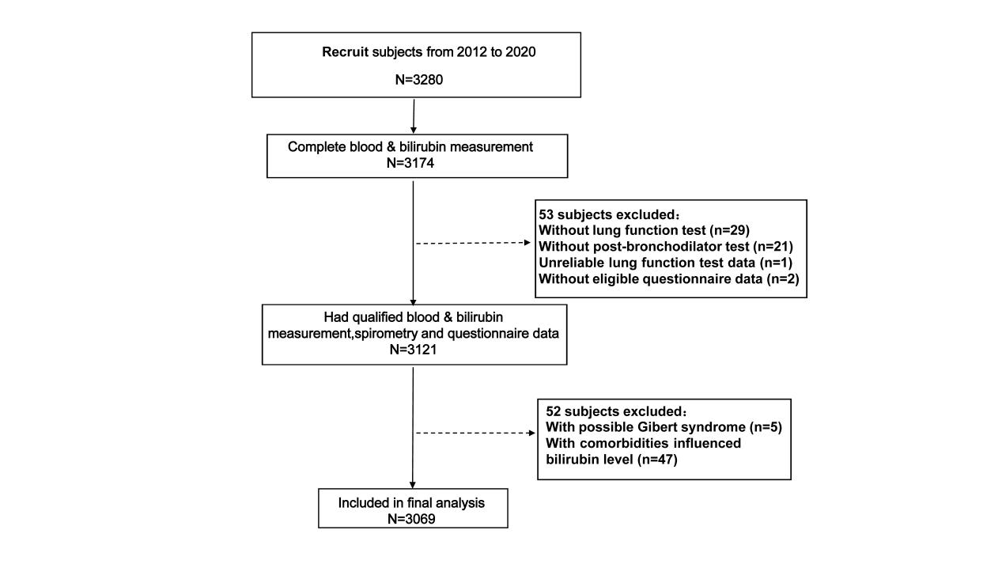

e-Figure 2. Leave−one−out sensitivity analysis of MR for the associations of TB on FEV1/FVC.
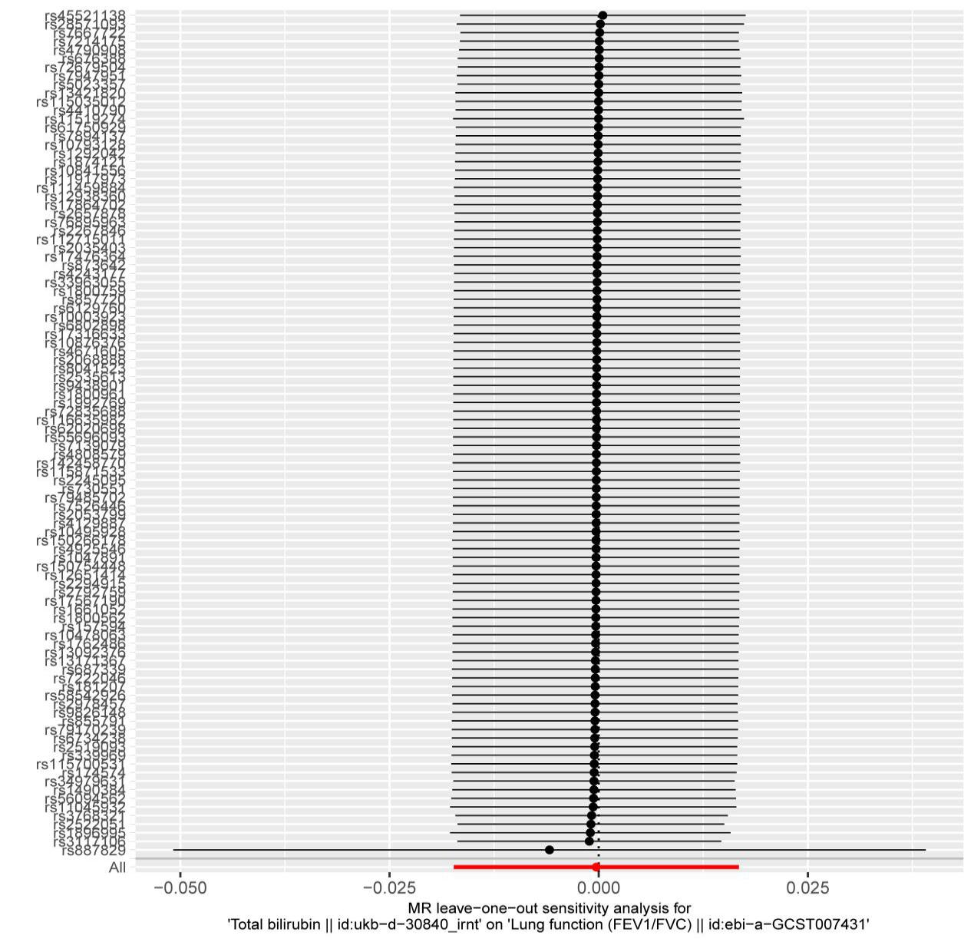

e-Figure 3. Funnel plot of Mendelian randomization analysis.
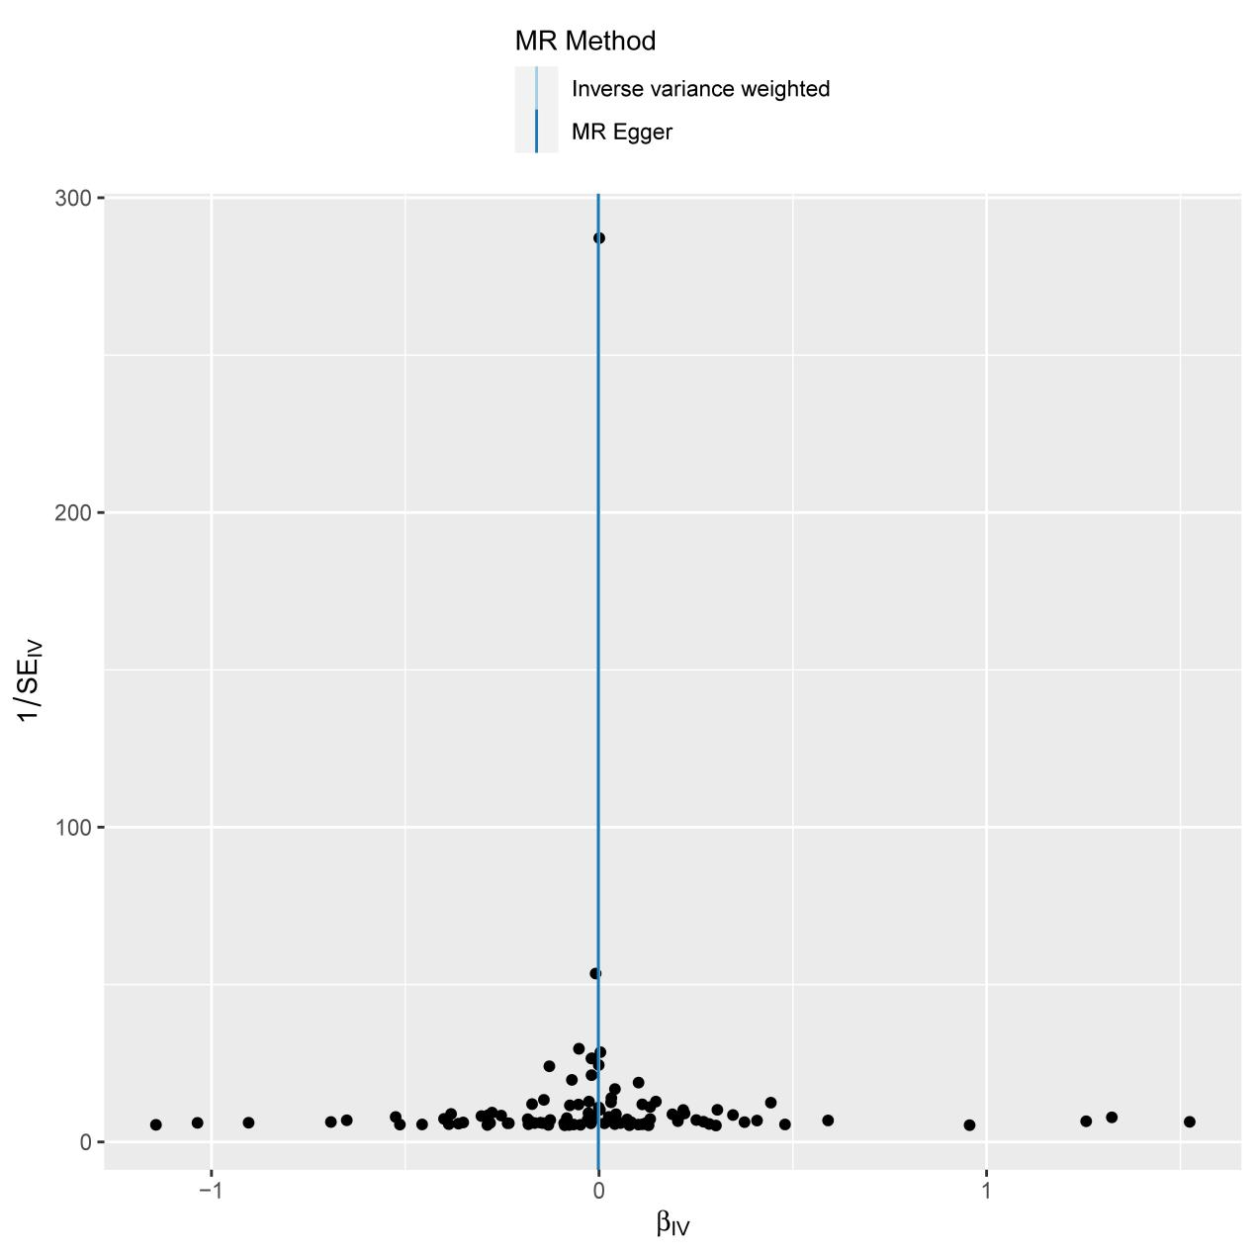

e-Figure 4.Leave−one−out sensitivity analysis of Reverse MR for the associations of FEV1/FVC on TB.
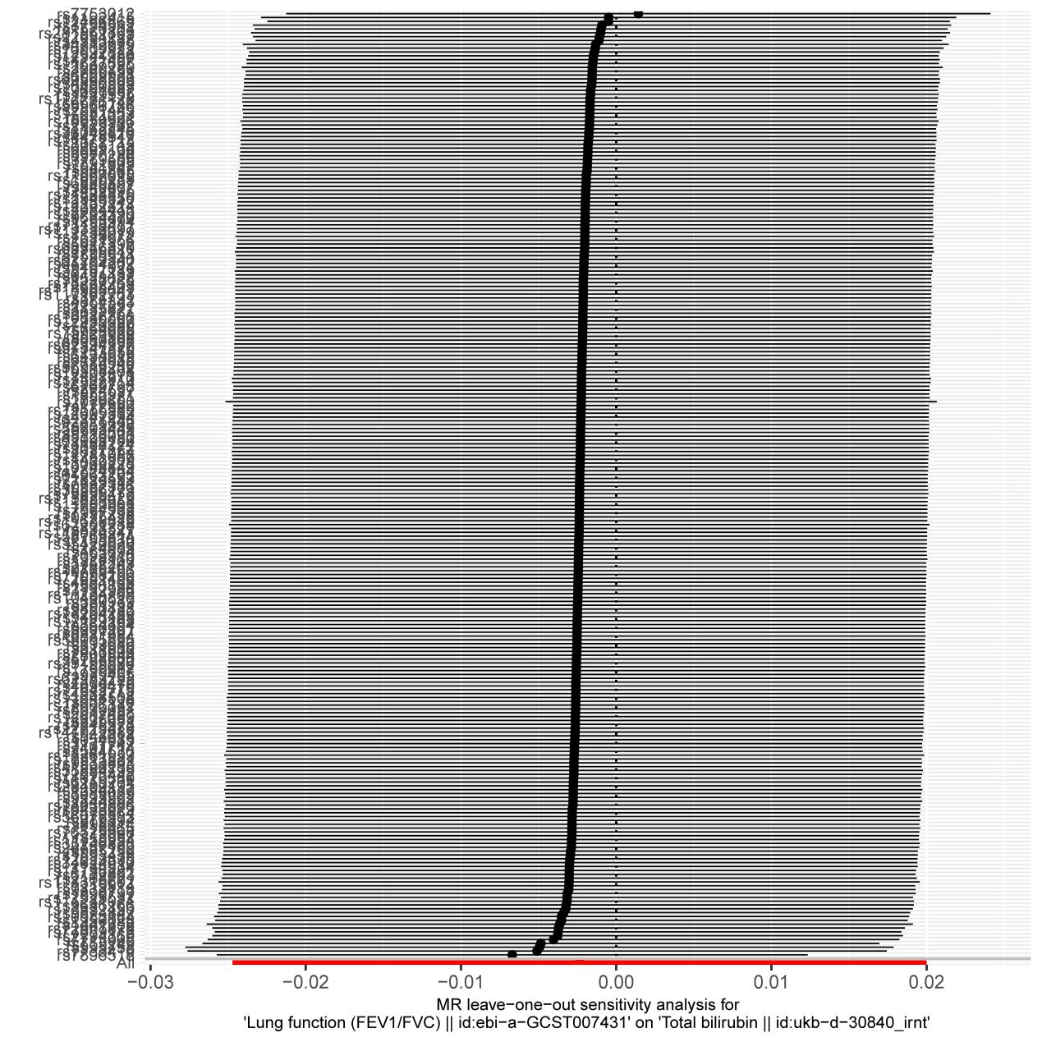

e-Figure 5. Funnel plot of Reverse Mendelian randomization analysis.
