SUPPLEMENTAL MATERIALS

Supplemental Table S1. CYP2D6 and CYP3A genotype-phenotype translation table of variants observed in PhACS participants.

Gene | Allele | Rs number | PM | IM | EM | UM
CYP3A | *3  *22 | rs776746  rs35599367 | *3/*3, *1/*22  *3/*3, *22/*22 | *3/*3  *1/*3,*1/*22 | *1/*1,  *1/*3 | -
CYP2D6 | *3  *4  *9  *10  *41  *5  xN | rs35742686  rs3892097  rs5030656  rs1065852  rs28371725  Deletion  Duplication | *3/*4/*10  *4/*4, *10/*10  *4/*5/*10  *4/*5 | *1/*3  *3/*10  *3/*41  *4/*10  *4/*10/*10  *4/*41/*10  *41/*10  *41/*41  *1/*5  *5/*41  *5/*41/*9  *5/*9  *5/*9  *9/*4/*10 | *1/*1  *1/*10  *1/*9  *1/*41  xN/*4/*10 | xN  xN/*10  xN/*41  xN/*4/*10
PM, poor metabolizers; IM, intermediate metabolizers; EM, extensive metabolizers; UM, ultrarapid metabolizer. * Allele nomenclature are per PharmVar at https://www.pharmvar.org/genes.

Supplemental Table S2. Steady-state plasma drug levels in study participants.

Daily dose (mg) | Number of subjects | Plasma concentration in ng/mL  (median (IQR))
1.25 | 125 | 5.90 (4.55-7.65)
2.5 | 294 | 10.94 (8.61-14.14)
3.75 | 20 | 18.17 (14.55-22.95)
5 | 151 | 23.77 (18.33-29.29)
6.25 | 2 | 55.34
7.5 | 16 | 33.97 (30.65-40.46)
10 | 42 | 46.22 (29.36-53.02)
20 | 3 | 105.49
IQR, interquartile range.

Supplemental Table S3. Comparison of the goodness of fit for the different pharmacokinetic models.

Model No. | Model | -2LL | BIC
1 | Basic Model | 4108.36 | 4147.25
2 | 1 + AGE (mean centred) on CL | 4012.09 | 4057.46
3 | 2 + WEIGHT (mean centred) on CL | 3975.07 | 4026.92
4 | 3 + DIURETICS on CL | 3954.12 | 4012.45
5 | 4 + SMOKING on CL | 3945.36 | 4010.18
6 | 5 + SEX on CL | 3939.39 | 4010.69
7 | 6 + CRF on CL | 3955.33 | 4039.59
-2LL, -2.log likelihood; BIC, Bayes information criterion; CRF, chronic renal failure.
Supplemental Table S4. CYP2D6 and CYP3A genotype frequencies in PhACS patients.

CYP2D6
Variation | Star (*) Allele | WT/WT  (N) | WT/Variant  (N) | Variant/Variant  (N) | Variant Allele Frequency | Info score
rs35742686 | *3 | 560 | 31 | 0 | 0.026 | 0.854
rs3892097 | *4 | 371 | 199 | 20 | 0.202 | 0.979
rs5030656 | *9 | 580 | 10 | 0 | 0.008 | 0.711
rs1065852 | *10 | 364 | 202 | 24 | 0.212 | 0.980
rs28371725 | *41 | 492 | 93 | 5 | 0.087 | 0.992
Copy number variation |  | 2 copies | < 2 copies  (N, %) | >2 copies  (N, %)
Deletion | *5 | 529 | 40 (7.6) |  |  | -
Duplication | - | 529 |  | 20 (3.8) |  | -
CYP3A
rs35599367 | 3A4*22 | 557 | 48 | 2 | 0.082 | 0.895
rs776746 | 3A5*3 | 2 | 65 | 555 | 0.945 | 1.00
WT, wild-type; N, number of alleles. * Allele nomenclature are per PharmVar at https://www.pharmvar.org/genes.

Supplemental Table S5. Bisoprolol clearance in different CYP2D6 and CYP3A genotype-based metaboliser phenotypes.

CYP2D6 Phenotype | N | % | Clearance (median, IQR) | P value
Poor metabolizers | 31 | 5.2 | 10.8 [9.9-12.0] | 0.83
Intermediate metabolizers | 246 | 41.6 | 11.2 [9.6-13.0] | 0.83
Extensive metabolizers | 300 | 50.8 | 11.4 [9.7-13.1] | 0.83
Ultrarapid metabolizers | 14 | 2.4 | 11.6 [9.0-13.3] | 0.83
CYP3A Phenotype | N | % | Clearance (median, IQR) | P value
Poor metabolizers | 45 | 7.2 | 10.7 [9.1-12.2] | 0.19
Intermediate metabolizers | 516 | 83.0 | 11.4 [9.7-13.2] | 0.19
Extensive metabolizers | 61 | 9.8 | 11.1 [9.6-12.7] | 0.19
PM, poor metabolizer; IM, intermediate metabolizer; EM, extensive metabolizer; UM, ultrarapid metabolizer. Analysis has been undertaken using ANOVA.

Supplemental Table S6. Association results for variants with p values ≤ 5x10⁻⁶ in PhACS observed in both cohorts analysed.

 |  |  |  |  | PhACS study |  |  |  |  | GENRES study
 |  |  |  |  | Estimated clearance of bisoprolol |  |  |  |  |  | HR change on bisoprolol in office measurements |  |  |  | HR change on bisoprolol in ambulatory 24-hour measurements
rsid | chr | Position (build 38) | Reference  allele | Variant allele | Imputation quality | Variant allele frequency | n | Beta (variant allele) | P | Imputation quality (all were imputed) | Variant allele frequency | n | beta (variant allele) | P | Variant allele frequency | n | beta (variant allele) | P
rs11029955 | 11 | 27332940 | G | T | 0.997 | 0.316 | 622 | 2.22 | 7.17E-09 | 0.911 | 0.312 | 216 | -1.06 | 4.86E-02 | 0.320 | 206 | -1.78 | 9.31E-05
rs7935021 | 11 | 27351889 | C | T | 1.000 | 0.314 | 622 | -2.18 | 1.12E-08 | 0.912 | 0.688 | 216 | 1.06 | 4.83E-02 | 0.680 | 206 | 1.77 | 9.29E-05
rs61887779 | 11 | 27342713 | G | A | 0.992 | 0.276 | 622 | 2.28 | 1.17E-08 | 0.931 | 0.289 | 216 | -1.60 | 3.01E-03 | 0.296 | 206 | -1.62 | 4.38E-04
rs1871254 | 11 | 27348359 | T | C | 0.996 | 0.277 | 622 | 2.27 | 1.20E-08 | 0.931 | 0.290 | 216 | -1.60 | 3.00E-03 | 0.296 | 206 | -1.63 | 4.12E-04
rs2291022 | 11 | 27349041 | T | C | 0.996 | 0.277 | 622 | 2.27 | 1.21E-08 | 0.931 | 0.289 | 216 | -1.60 | 3.01E-03 | 0.296 | 206 | -1.62 | 4.38E-04
rs116702638 | 2 | 100298868 | G | T | 0.568 | 0.010 | 622 | 12.54 | 2.54E-08 | 0.942 | 0.022 | 216 | 0.92 | 5.85E-01 | 0.023 | 206 | 0.61 | 6.66E-01
rs73605166 | 16 | 75277831 | G | C | 0.823 | 0.035 | 622 | 5.56 | 1.13E-07 | 0.826 | 0.007 | 216 | 2.54 | 4.19E-01 | 0.007 | 206 | -5.77 | 2.82E-02
rs182390658 | 11 | 25552958 | A | G | 0.485 | 0.012 | 622 | 12.16 | 1.40E-07 | 0.874 | 0.046 | 216 | -0.36 | 7.70E-01 | 0.048 | 206 | 2.22 | 3.01E-02
rs78706212 | 11 | 25989371 | G | A | 0.770 | 0.014 | 622 | 8.92 | 1.89E-07 | 0.934 | 0.068 | 216 | -0.45 | 6.46E-01 | 0.062 | 206 | 0.33 | 7.19E-01
rs111560531 | 16 | 75400055 | C | G | 0.798 | 0.012 | 622 | 9.01 | 4.43E-07
rs147630895 | 12 | 13319429 | T | G | 0.591 | 0.017 | 622 | 8.97 | 5.99E-07 | 0.948 | 0.019 | 216 | -0.53 | 7.67E-01 | 0.020 | 206 | 1.07 | 4.81E-01
rs72911572 | 2 | 174213632 | T | C | 0.959 | 0.012 | 622 | 8.01 | 6.01E-07 | 0.988 | 0.002 | 216 | -1.98 | 6.90E-01 | 0.002 | 206 | -2.35 | 5.74E-01
rs113291240 | 5 | 170772293 | G | A | 0.848 | 0.019 | 622 | 6.87 | 7.19E-07 | 0.956 | 0.042 | 216 | -1.63 | 1.82E-01 | 0.044 | 206 | 0.60 | 5.57E-01
rs142946966 | 11 | 35951773 | A | G | 0.530 | 0.017 | 622 | 9.19 | 7.64E-07 | 0.515 | 0.005 | 216 | -6.61 | 1.42E-01 | 0.006 | 206 | -4.99 | 1.89E-01
rs150674165 | 11 | 35952297 | G | A | 0.529 | 0.017 | 622 | 9.19 | 7.76E-07 | 0.516 | 0.005 | 216 | -6.62 | 1.42E-01 | 0.006 | 206 | -5.02 | 1.87E-01
rs73107290 | 12 | 51831842 | A | T | 0.781 | 0.021 | 622 | 6.89 | 7.82E-07 | 0.897 | 0.024 | 216 | -2.21 | 1.79E-01 | 0.025 | 206 | -0.96 | 4.91E-01
rs139592416 | 2 | 174260683 | A | G | 0.955 | 0.013 | 622 | 7.84 | 8.51E-07 | 0.978 | 0.002 | 216 | -2.00 | 6.90E-01 | 0.002 | 206 | -2.38 | 5.74E-01
rs41287484 | 10 | 103286975 | G | A | 0.809 | 0.014 | 622 | 8.18 | 9.56E-07 | 0.957 | 0.033 | 216 | 1.87 | 1.71E-01 | 0.034 | 206 | 0.79 | 4.93E-01
rs201842061 | 11 |  | AAAAAT | A | 0.813 | 0.011 | 622 | 9.15 | 1.34E-06
rs75641511 | 16 | 75424962 | C | T | 0.888 | 0.041 | 622 | 4.49 | 1.55E-06 | 0.985 | 0.005 | 216 | 3.21 | 3.64E-01 | 0.005 | 206 | -6.74 | 2.28E-02
rs113262361 | 16 | 75427646 | T | G | 0.887 | 0.041 | 622 | 4.49 | 1.57E-06 | 0.985 | 0.005 | 216 | 3.21 | 3.64E-01 | 0.005 | 206 | -6.74 | 2.28E-02
rs6859992 | 5 | 170770116 | T | A | 0.786 | 0.031 | 622 | 5.54 | 1.58E-06 | 1.036 | 0.053 | 216 | -1.65 | 1.14E-01 | 0.056 | 206 | 0.86 | 3.29E-01
rs147435903 | 12 | 13349465 | T | C | 0.540 | 0.016 | 622 | 9.24 | 1.74E-06 | 0.937 | 0.016 | 216 | 0.32 | 8.69E-01 | 0.017 | 206 | 1.04 | 5.24E-01
rs143792050 | 7 | 7883100 | GGAA | G | 0.808 | 0.046 | 622 | 4.24 | 1.80E-06
rs142464277 | 16 | 75307311 | G | C | 0.894 | 0.039 | 622 | 4.54 | 2.01E-06 | 0.902 | 0.005 | 216 | 2.99 | 3.86E-01 | 0.006 | 206 | -6.73 | 1.95E-02
rs5858910 | 4 | 64711470 | AT | A | 0.966 | 0.052 | 622 | -3.88 | 2.06E-06 | 1.182 | 0.979 | 216 | -3.78 | 1.23E-02 | 0.978 | 206 | -2.93 | 2.14E-02
rs75469826 | 1 | 1254826 | G | A | 0.866 | 0.015 | 622 | 7.32 | 2.07E-06 | 0.960 | 0.005 | 216 | 1.12 | 7.50E-01 | 0.005 | 206 | -2.56 | 3.87E-01
rs146919335 | 1 | 29794629 | ATATACATATG | A | 0.883 | 0.188 | 622 | 2.18 | 2.08E-06
rs12069094 | 1 | 1260213 | G | A | 0.859 | 0.015 | 622 | 7.33 | 2.09E-06 | 0.986 | 0.005 | 216 | 0.98 | 7.80E-01 | 0.005 | 206 | -2.51 | 3.97E-01
rs111357358 | 1 | 1274102 | G | A | 0.876 | 0.016 | 622 | 6.99 | 2.11E-06 | 0.995 | 0.005 | 216 | 0.94 | 7.90E-01 | 0.005 | 206 | -2.49 | 4.01E-01
rs11260568 | 1 | 1260310 | G | C | 0.884 | 0.016 | 622 | 6.94 | 2.48E-06 | 0.986 | 0.005 | 216 | 0.98 | 7.80E-01 | 0.005 | 206 | -2.51 | 3.97E-01
rs72894077 | 1 | 1260994 | C | T | 0.887 | 0.016 | 622 | 6.93 | 2.51E-06 | 0.986 | 0.005 | 216 | 0.98 | 7.80E-01 | 0.005 | 206 | -2.51 | 3.97E-01
rs144550187 | 12 | 115478312 | G | A | 0.874 | 0.015 | 622 | 6.67 | 2.63E-06 | 0.813 | 0.006 | 216 | -2.09 | 5.41E-01 | 0.006 | 206 | 1.17 | 6.83E-01
rs7552460 | 1 | 1278550 | T | C | 0.863 | 0.017 | 622 | 6.89 | 2.97E-06 | 0.751 | 0.003 | 216 | 1.68 | 7.25E-01 | 0.004 | 206 | -3.82 | 3.40E-01
rs112909007 | 6 | 170055783 | C | T | 0.961 | 0.034 | 622 | 4.53 | 3.00E-06
rs75958385 | 16 | 75369599 | G | A | 0.743 | 0.024 | 622 | 6.28 | 3.04E-06 | 0.995 | 0.005 | 216 | 3.09 | 3.79E-01 | 0.005 | 206 | -6.75 | 2.21E-02
rs57834430 | 1 | 1279882 | T | C | 0.859 | 0.017 | 622 | 6.88 | 3.06E-06 | 0.704 | 0.003 | 216 | 1.82 | 7.20E-01 | 0.003 | 206 | -4.12 | 3.37E-01
rs7547316 | 1 | 1280416 | A | G | 0.858 | 0.017 | 622 | 6.88 | 3.08E-06 | 0.685 | 0.003 | 216 | 1.89 | 7.19E-01 | 0.003 | 206 | -4.25 | 3.35E-01
rs144072398 | 12 | 23208095 | C | T | 0.798 | 0.010 | 622 | 9.11 | 3.16E-06 | 0.858 | 0.012 | 216 | -1.26 | 5.94E-01 | 0.013 | 206 | 1.01 | 6.12E-01
rs144247165 | 16 | 75180019 | G | A | 0.865 | 0.014 | 622 | 7.52 | 3.17E-06 | 0.893 | 0.033 | 216 | 0.82 | 5.61E-01 | 0.034 | 206 | -1.73 | 1.48E-01
rs7547329 | 1 | 1280469 | A | T | 0.795 | 0.018 | 622 | 6.81 | 3.28E-06
rs144223751 | 4 | 65034248 | G | T | 0.966 | 0.022 | 622 | 5.71 | 3.30E-06 | 0.974 | 0.023 | 216 | -1.26 | 4.33E-01 | 0.024 | 206 | -0.95 | 4.81E-01
rs146550601 | 4 | 65034255 | A | G | 0.966 | 0.022 | 622 | 5.71 | 3.30E-06 | 0.974 | 0.023 | 216 | -1.26 | 4.33E-01 | 0.024 | 206 | -0.95 | 4.81E-01
rs190282934 | 4 | 82172089 | A | G | 0.737 | 0.159 | 622 | 2.52 | 3.49E-06
rs12073801 | 1 | 1284551 | G | T | 0.850 | 0.017 | 622 | 6.82 | 3.55E-06 | 0.545 | 0.002 | 216 | 2.77 | 6.85E-01 | 0.002 | 206 | -5.62 | 3.28E-01
rs74742580 | 6 | 170051397 | G | A | 0.964 | 0.034 | 622 | 4.51 | 3.61E-06 | 0.933 | 0.101 | 216 | 0.81 | 3.23E-01 | 0.101 | 206 | 0.93 | 1.86E-01
rs78964579 | 7 | 7860959 | G | C | 0.967 | 0.032 | 622 | 4.60 | 4.00E-06 | 0.948 | 0.034 | 216 | -0.72 | 5.96E-01 | 0.033 | 206 | -0.75 | 5.23E-01
rs10835164 | 11 | 27333395 | C | T | 0.999 | 0.247 | 622 | 1.87 | 4.07E-06 | 1.012 | 0.211 | 216 | -0.39 | 4.98E-01 | 0.214 | 206 | -1.59 | 1.22E-03
rs3929244 | 11 | 27333484 | C | T | 1.000 | 0.248 | 622 | 1.87 | 4.12E-06 | 1.012 | 0.211 | 216 | -0.39 | 4.98E-01 | 0.214 | 206 | -1.59 | 1.22E-03
rs12277574 | 11 | 27333295 | C | G | 1.000 | 0.248 | 622 | 1.87 | 4.12E-06 | 1.012 | 0.211 | 216 | -0.39 | 4.98E-01 | 0.214 | 206 | -1.59 | 1.22E-03
rs11029954 | 11 | 27332902 | C | T | 0.999 | 0.248 | 622 | 1.87 | 4.13E-06 | 1.012 | 0.211 | 216 | -0.39 | 4.98E-01 | 0.214 | 206 | -1.59 | 1.22E-03
rs11029953 | 11 | 27332839 | T | G | 0.999 | 0.248 | 622 | 1.87 | 4.13E-06 | 1.012 | 0.211 | 216 | -0.39 | 4.98E-01 | 0.214 | 206 | -1.59 | 1.22E-03
rs11753156 | 6 | 170050020 | C | T | 0.962 | 0.033 | 622 | 4.49 | 4.14E-06 | 0.933 | 0.101 | 216 | 0.81 | 3.24E-01 | 0.101 | 206 | 0.93 | 1.86E-01
rs10835163 | 11 | 27331762 | A | G | 0.998 | 0.248 | 622 | 1.87 | 4.15E-06 | 1.011 | 0.211 | 216 | -0.39 | 4.98E-01 | 0.214 | 206 | -1.59 | 1.22E-03
rs11759102 | 6 | 19837543 | C | T | 0.804 | 0.137 | 622 | 2.56 | 4.15E-06
rs1564243 | 11 | 27333735 | C | T | 0.999 | 0.248 | 622 | 1.87 | 4.15E-06 | 1.012 | 0.211 | 216 | -0.39 | 4.98E-01 | 0.214 | 206 | -1.59 | 1.22E-03
rs77361612 | 6 | 170050094 | G | A | 0.961 | 0.034 | 622 | 4.49 | 4.16E-06 | 0.969 | 0.108 | 216 | 0.67 | 3.90E-01 | 0.108 | 206 | 1.02 | 1.29E-01
rs10767638 | 11 | 27330940 | A | G | 0.997 | 0.248 | 622 | 1.87 | 4.16E-06 | 1.011 | 0.211 | 216 | -0.39 | 4.98E-01 | 0.214 | 206 | -1.59 | 1.23E-03
rs11029951 | 11 | 27330510 | T | C | 0.996 | 0.248 | 622 | 1.87 | 4.16E-06 | 1.011 | 0.211 | 216 | -0.39 | 4.98E-01 | 0.214 | 206 | -1.59 | 1.23E-03
rs72756295 | 5 | 54299824 | G | C | 0.969 | 0.024 | 622 | 5.39 | 4.48E-06 | 0.967 | 0.016 | 216 | -0.63 | 7.46E-01 | 0.017 | 206 | 2.09 | 1.99E-01
rs10835166 | 11 | 27334415 | C | T | 0.997 | 0.248 | 622 | 1.87 | 4.50E-06 | 1.012 | 0.211 | 216 | -0.39 | 4.98E-01 | 0.214 | 206 | -1.59 | 1.22E-03
rs72756291 | 5 | 54299018 | C | A | 0.969 | 0.024 | 622 | 5.38 | 4.57E-06 | 0.971 | 0.016 | 216 | -0.63 | 7.46E-01 | 0.017 | 206 | 2.08 | 2.01E-01
rs10767639 | 11 | 27336931 | C | G | 0.994 | 0.211 | 622 | 1.99 | 4.62E-06 | 1.012 | 0.188 | 216 | -1.07 | 7.70E-02 | 0.189 | 206 | -1.50 | 3.63E-03
rs111372870 | 12 | 51699955 | T | C | 0.507 | 0.011 | 622 | 10.65 | 4.73E-06 | 0.881 | 0.025 | 216 | -2.12 | 1.94E-01 | 0.026 | 206 | -0.82 | 5.52E-01
rs2352924 | 14 | 49007342 | A | G | 1.000 | 0.168 | 622 | 2.09 | 4.74E-06 | 0.956 | 0.211 | 216 | -0.92 | 1.22E-01 | 0.214 | 206 | -1.21 | 1.88E-02
rs77433444 | 6 | 170048945 | G | A | 0.958 | 0.033 | 622 | 4.48 | 4.76E-06 | 0.933 | 0.101 | 216 | 0.81 | 3.25E-01 | 0.101 | 206 | 0.93 | 1.86E-01
rs11607287 | 11 | 27342943 | T | C | 0.995 | 0.211 | 622 | 1.99 | 4.88E-06 | 1.012 | 0.188 | 216 | -1.07 | 7.70E-02 | 0.189 | 206 | -1.50 | 3.63E-03
rs11029961 | 11 | 27345473 | C | T | 0.995 | 0.211 | 622 | 1.98 | 4.95E-06 | 1.012 | 0.188 | 216 | -1.07 | 7.70E-02 | 0.189 | 206 | -1.50 | 3.63E-03
Only variants with p values ≤ 5x10⁻⁶ in PhACS. Empty cells represent variants that are not available in GENRES genetic dataset.

Supplemental Figures

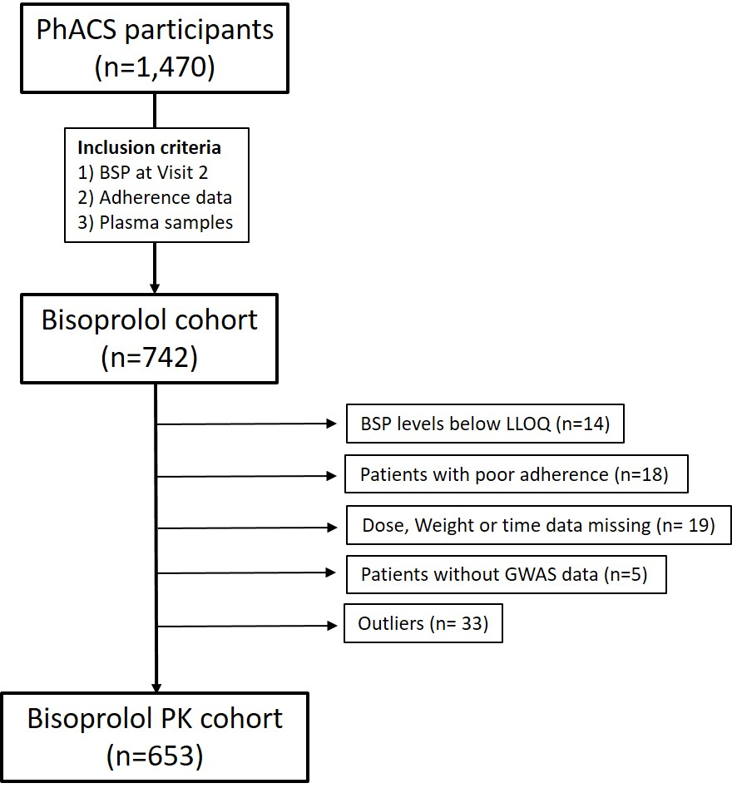
Figure S1. PhACS participants included in the pharmacokinetics analysis.

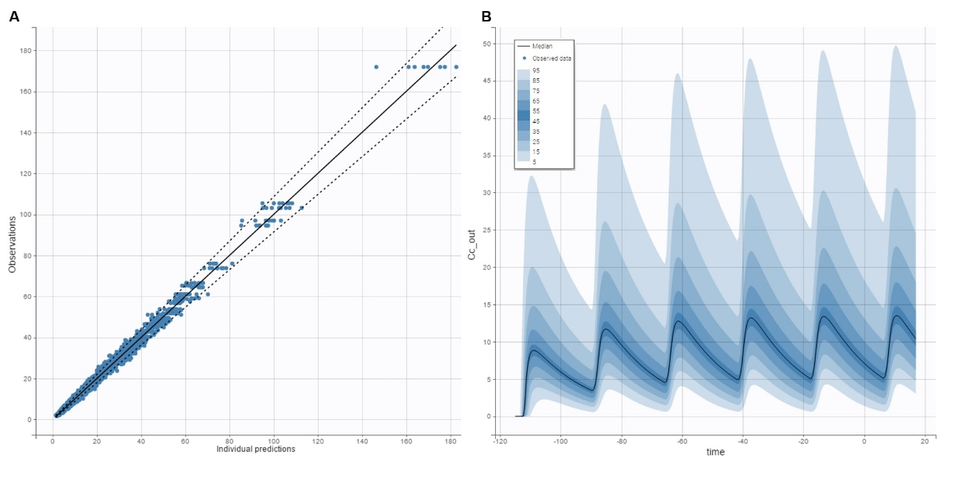
Figure S2. Individual predictions versus observations (A), and prediction distribution (B) of the final pharmacokinetic model.

