Supplementary materials

Figure S1 The whole process of tumor resection surgery including an established orthotopic model of breast cancer (A), resection of breast tumor (90%~95%) (B) and suture of wound after surgery (C) in BALB/c nude mice. Places pointed by the black arrow represented tumor site, residual tumors after surgery and sutured wound in the surgical site.

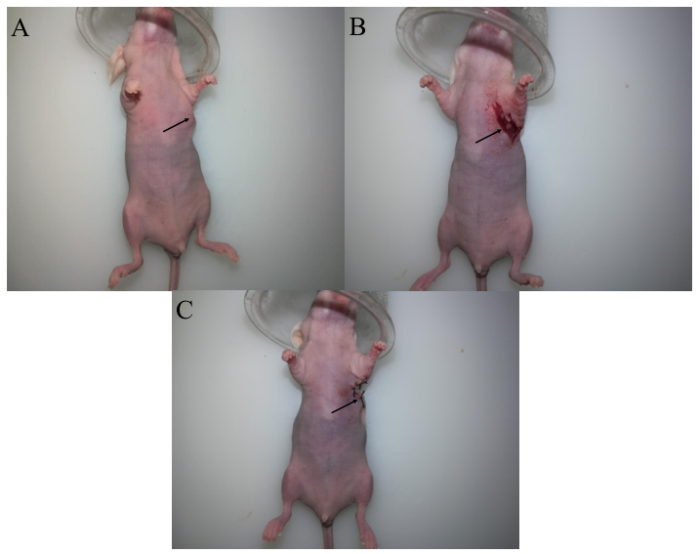

Figure S2 Morphology of jejunum was from HTPM orally administered (A) and HTPM administered orally combined with surgery on orthotopic TNBC in nude mice (B). Places pointed by the black arrow in the jejunum picture of HF group and TRS+HF group represent the phenomenon of jejunum hemorrhage.

