Supplemental Material

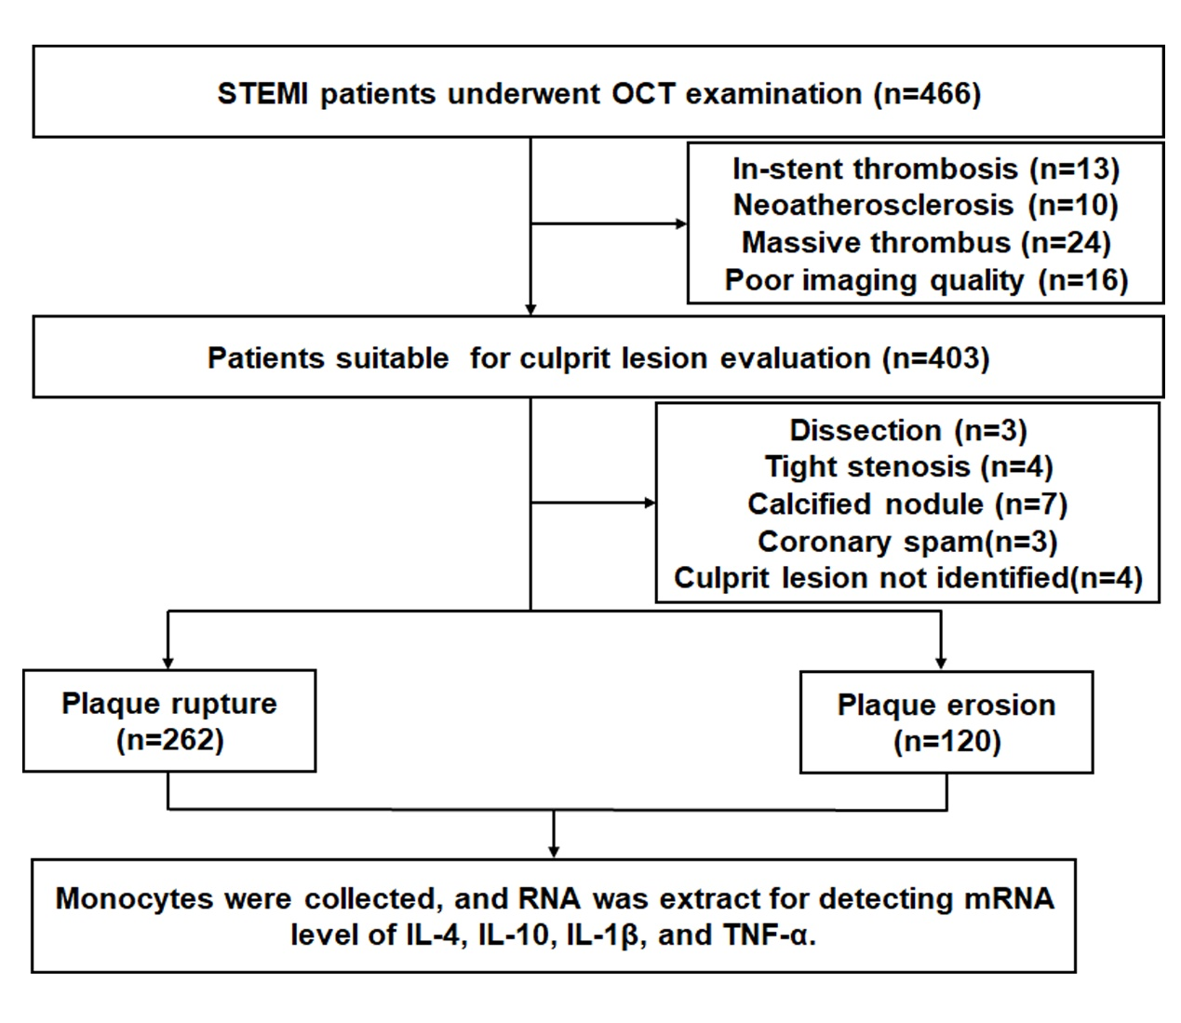
Supplemental Figure.1 Study flow chart
STEMI, ST-segment elevation myocardial infarction; OCT, Optical
Coherence Tomography.
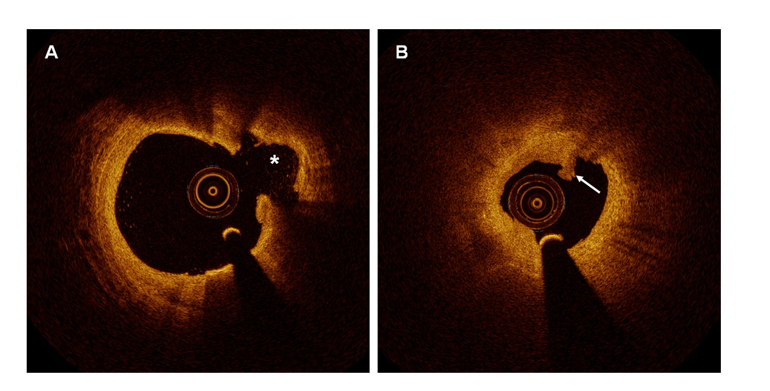
Supplemental Figure 2. Typical Optical coherence tomography images of PR and PE
(A). OCT-rupture was identified by disruption of fibrous cap (asterisk) and cavity formation in the plaque. (B). OCT-erosion was identified by the presence of attached thrombus (white arrow) overlying an intact and visualized plaque.
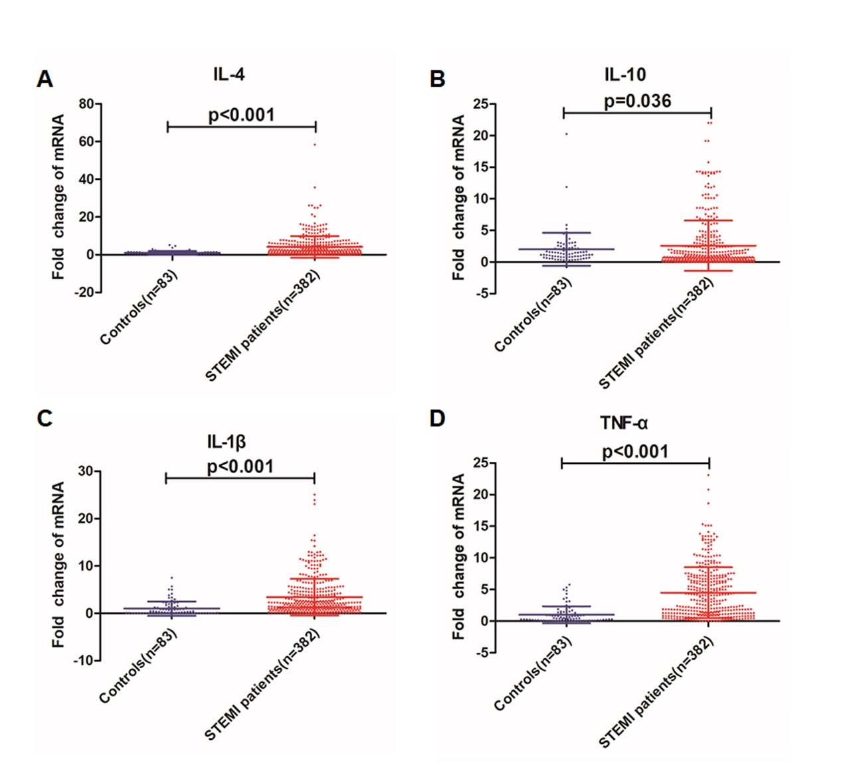
Supplemental Figure 3. Comparison of IL-4, IL-10, IL-1β and TNF-α mRNA levels between coronary artery diseases controls (coronary angiographic stenosis was less than 50%) and STEMI patients.
(A). IL-4 mRNA level in controls and STEMI (fold change). (B). IL-10 mRNA level in controls and STEMI (fold change). (C). IL-1β mRNA level in controls and STEMI (fold change). (D). TNF-α mRNA level in controls and STEMI (fold change). The data shown as mean ± SD.
Supplemental Figure 4. Hot map of IL-4, IL-10, IL-1β and TNF-α mRNA in PR and PE
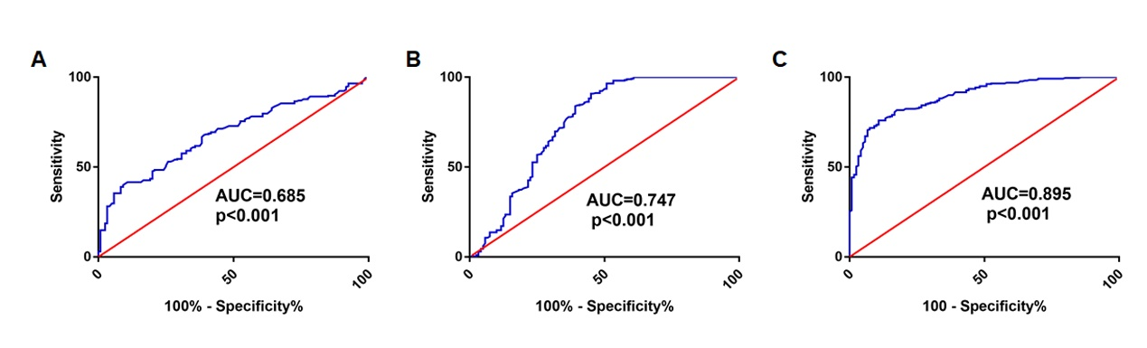
Supplemental Figure 5. Receiver-operating characteristic curves of IL-4, IL-1β and TNF-α for predicting PR
(A). Receiver-operating characteristic curves of IL-4. (B). Receiver-operating characteristic curves of IL-1β. (C). Receiver-operating characteristic curves of TNF-α.
AUC, area under the curve.
Supplemental Table 1. Information of PCR Primer
Gene | Forward | Reverse
IL-4 | 5’- CACCGAGTTGACCGTAACAG-3’ | 5’- GCCCTGCAGAAGGTTTCC-3’
IL-10 | 5′- TGCCTTCAGCAGAGTGAAGA-3 | 5′- GCAACCCAGGTAACCCTTAAA-3′
IL-1β | 5’- TACCTGTCCTGCGTGTTGAA-3’ | 5’- TCTTTGGGTAATTTTTGGGATCT-3’
TNF-α | 5′- CCAGGGACCTCTCTCTAATCA-3′ | 5′-CCATCTTTGGAAGGTTCAGGTTG-3′
β-actin | 5′-ACGGATTTGGTCGTATTGGGC-3’ | 5′- TCAGCTTGAGGGTTTGCTAC-3′

Supplemental Table 2. Baseline line of CAD controls
Subject | CAD controls (n=83)
Age, year | 55.1±9.5
Men, (%) | 47 (56.6)
Diabetes mellitus, (%) | 1 (1.2)
Hypertension, (%) | 17 (20.5)
Previous MI, (%) | 0 (0.0)
Previous stroke, (%) | 0 (0.0)
Current smoker, (%)  Former smoker, (%)  Non-smoker, (%) | 20 (24.1)  7 (8.4)  56 (64.5)
WBC, 10^9/L | 6.7±2.1
Neutrophil, 10^9/L | 4.2±1.4
Lymphocyte, 10^9/L | 2.0±0.6
Hemoglobin, g/L | 139.8±14.1
Platelet, 10^9/L | 212.7±50.9
Creatinine, umol/L | 67.1±18.3
Triglyceride, mg/dL | 117.0(75.3-140.1)
TC, mg/dL | 132.5±29.5
LDL-C, mg/dL | 96.1±46.6
HDL-C, mg/dL | 50.2±12.2
hs-CRP, mg/L | 0.7 (0.3-2.0)
Values are presented as n (%), mean ± SD or median (25th–75th percentiles).
CAD, coronary artery disease; MI, myocardial infarction; WBC, white bold cell; hs-CRP, high-sensitivity C-reactive protein; LDL-C, low-density lipoprotein cholesterol; SD, standard deviation; TC, total cholesterol.
Supplemental Table 3: Optical coherence tomography finding
 | PR(n=262) | PE(n=120) | P-value
Lesion Length, mm | 21.4±6.8 | 19.3±6.5 | 0.003
MLA, mm² | 1.3(0.9-1.8) | 1.5(1.2-2.4) | <0.001
FCT, μm | 45.8±14.3 | 74.9±32.4 | <0.001
TCFA, (%) | 222(84.7) | 29(24.2) | <0.001
Lipid-rich plaque, (%) | 260(99.2) | 53(44.2) | <0.001
Mean lipid arc degree, ° | 203.2±54.5 | 159.1±62.5 | <0.001
Lipid length, mm | 16.3±7.4 | 11.8±7.3 | <0.001
Calcification, (%) | 115(43.8) | 26(21.7) | <0.001
Macrophage, (%) | 201(76.7) | 60(50.0) | <0.001
Microchannel, (%) | 114(43.5) | 41(34.2) | <0.001
Values are presented as n (%) or mean ± SD. FCT, fibrous-cap thickness; MLA, minimal lumen area; SD, standard deviation; TCFA, thin-cap fibroatheroma. PE, plaque erosion; PR, plaque rupture.
Supplemental Table 4. Diagnostic performance of TNF-α in distinguishing PR from PE
Cut off value (fold change) | Sensitivity % | 95%Cl | Specificity % | 95%Cl | Likelihood ratio
2.52 | 70.61 | 64.69%-76.06% | 93.33 | 87.29%-97.08% | 10.59
CI; confidence interval; cut off value was the threshold leading to the maximum summation of sensitivity and specificity.
Supplemental Table 5. Logistic regression analysis of PR
Variables | Unadjusted |  |  | Adjusted
Variables | OR | 95% Cl | P value | OR | 95% Cl | P value
Age | 1.04 | 1.02 to 1.07 | <0.001 | 1.01 | 0.98 to 1.05 | 0.533
Diabetes mellitus | 4.12 | 2.10 to 8.10 | <0.001 | 3.23 | 1.20 to 8.70 | 0.020
Hypertension | 5.03 | 2.97 to 8.49 | <0.001 | 4.61 | 2.12 to 10.03 | <0.001
Non-current smoker | 3.74 | 2.33 to 6.00 | <0.001 | 3.94 | 1.84 to 8.42 | <0.001
Hemoglobin < 140g/L | 2.38 | 1.49 to 3.79 | <0.001 | 2.04 | 0.94 to 4.47 | 0.073
Platelet < 270 | 1.68 | 1.05 to 2.71 | 0.032 | 1.76 | 0.75 to 4.15 | 0.197
Renal dysfunction | 0.89 | 0.57 to 1.40 | 0.615
WBC | 0.86 | 0.82 to 0.91 | <0.001 | 0.92 | 0.85 to 1.00 | 0.039
hs-CRP | 1.04 | 0.99 to 1.08 | 0.098 | 1.08 | 1.00 to 1.18 | 0.054
Dyslipidemia | 2.42 | 1.55 to 3.76 | <0.001 | 2.15 | 1.01 to 4.23 | 0.006
TNF-α | 2.92 | 2.27 to 3.76 | <0.001 | 2.77 | 2.07 to 3.71 | <0.001
IL-4 | 1.36 | 1.18 to 1.56 | <0.001 | 1.19 | 1.02 to1.39 | 0.031
IL-1β | 1.36 | 1.14 to 1.67 | 0.001 | 1.20 | 0.93 to 1.58 | 0.155
Hemoglobin and platelet count were transformed to binary variables based on above-median or below-median cutoff values. WBC, white bold cell; hs-CRP, high-sensitivity C-reactive protein; OR, odds ratio; CI; confidence interval; PR, plaque rupture.
Supplemental Table 6. Baseline characteristics and OCT finding stratified by TNF-α level
 | Low TNF-α  (n=191) | High TNF-α  (n=191) | p-value
Age, y | 54.2±11.1 | 55.9±10.8 | 0.058
Men, (%) | 144(75.4) | 140(73.3) | 0.639
Diabetes mellitus, (%) | 34(17.8) | 54(28.3) | 0.015
Hypertension, (%) | 57(29.8) | 102(53.4) | <0.001
Previous MI, (%) | 5(2.6) | 2(1.0) | 0.252
Previous stroke, (%) | 10(5.2) | 13(6.8) | 0.519
Current smoker, (%)  Former smoker, (%)  Non-smoker, (%) | 109(57.1)  13(6.8)  69(36.1) | 90(47.1)  21(11.0)  80(41.9) | 0.105
WBC, 10^9/L | 12.4±6.1 | 10.3±4.4 | <0.001
Hemoglobin, g/L | 143.8±19.5 | 139.8±19.2 | <0.027
Platelet, 10^9/L | 247.8±73.9 | 233.6±51.6 | 0.016
Creatinine, umol/L | 76.5±22.8 | 78.3±23.1 | 0.226
Triglyceride, mg/dL | 115.1(86.1-147.6) | 125.0(97.4-165.9) | 0.011
TC, mg/dL | 158.7±55.0 | 180.2±47.9 | <0.001
LDL-C, mg/dL | 103.6±45.9 | 111.7±30.9 | 0.017
HDL-C, mg/dL | 48.0±13.6 | 47.7±10.5 | 0.409
hs-CRP, mg/L | 5.6(2.4-11.2) | 5.1(2.5-10.0) | 0.248
Lesion Length, mm | 20.2±6.9 | 21.2±6.6 | 0.064
MLA, mm² | 1.4(1.1-1.9) | 1.3(0.9-1.6) | <0.001
FCT, μm | 61.6±29.6 | 48.2±18.3 | <0.001
TCFA, (%) | 97(50.8) | 154(80.6) | <0.001
Lipid-rich plaque, (%) | 130(68.1) | 183(95.8) | <0.001
Mean lipid arc degree, ° | 184.8±59.9 | 197.3±55.2 | 0.019
Lipid length, mm | 14.3±7.8 | 16.1±7.2 | 0.008
Calcification, (%) | 58(30.3) | 83(43.5) | 0.008
Macrophage, (%) | 134(70.2) | 142(74.3) | 0.361
Microchannel, (%) | 72(37.7) | 83(43.5) | 0.252
Values are presented as n (%), mean ± SD or median (25th–75th percentiles). SD, standard deviation;
MI, myocardial infarction; WBC, white bold cell; CRP, high-sensitivity C-reactive protein; LDL-C, low-density lipoprotein cholesterol; HDL-C, high-density lipoprotein cholesterol; TC, total cholesterol; PE, plaque erosion; PR, plaque rupture. FCT, fibrous-cap thickness; MLA, minimal lumen area; TCFA, thin-cap fibroatheroma.

