Supplementary information

Postoperative adjuvant transarterial chemoembolization plus tyrosine kinase inhibitor for hepatocellular carcinoma
a multicentre retrospective study

Contents
Table S1: Uni- and multivariate Cox regression analysis of risk factors of DFS in the primary cohort. 2
Table S2: Uni- and multivariate Cox regression analysis of risk factors of DFS in the PSM cohort. 3
Table S3: Uni- and multivariate Cox regression analysis of risk factors of DFS in the IPW cohort. 4
Table S4: Uni- and multivariate Cox regression analysis of risk factors of DFS with additional adjustment for propensity score from primary cohort. 5
FigureS1. Selection of the study population. 6
FigureS2. Disease-free survival according to various TKI agents. 7
FigureS3. Disease-free survival according to tumor characteristics (A) Tumor diameter smaller than 5cm; (B) Tumor diameter larger than or equal to 5cm; (C) Tumor number less than 3; (D) Tumor number more than or equal to 3; (E) MVI: M1; (F) MVI: M2; (G) PVTT negative; (H) PVTT positive; (I) HVTT negative; (J) HVTT positive; (K) BDTT negative; (L) BDTT positive; (M) Rupture negative; (N) Rupture positive; (O) TNM II; (P) TNM IIIA; (Q) TNM IIIB. 8

Table S1: Uni- and multivariate Cox regression analysis of risk factors of DFS in the primary cohort.
Characteristics | Univariate |  | Multivariate
Characteristics | HR (95%CI) | P-value | HR (95%CI) | P-value
Age, years | 0.996(0.983-1.01) | 0.59
Gender, Female vs Male | 0.748(0.462-1.21) | 0.237
HBsAg, Positive vs Negative | 1.966(1.002-3.857) | 0.049 | 1.761(0.89-3.482) | 0.104
Liver cirrhosis, Present vs Absent | 1.046(0.737-1.486) | 0.801
Platelets, 10⁹/L | 1.000(0.998-1.002) | 0.954
Total bilirubin, umol/L | 0.998(0.995-1.002) | 0.389
Albumin, g/L | 0.984(0.953-1.016) | 0.337
ALT, U/L | 0.999(0.996-1.002) | 0.504
AST, U/L | 1.002(0.999-1.006) | 0.161 | 1.000(0.996-1.003) | 0.897
GGT, U/L | 1.000(0.999-1.001) | 0.451
AFP, ng/ml, ≥400 vs <400 | 1.123(0.816-1.546) | 0.476
Intraoperative blood loss, ml, ≥800 vs <800 | 1.345(0.761-2.376) | 0.308
Intraoperative transfusion, Yes vs No | 1.178(0.81-1.713) | 0.391
Anatomic hepatectomy, Yes vs No | 1.307(0.942-1.813) | 0.108 | 0.782(0.500-1.223) | 0.281
Major hepatectomy, Major vs Minor | 1.745(1.253-2.431) | 0.001 | 1.615(1.004-2.597) | 0.048
Tumor number, ≥3 vs <3 | 1.305(0.865-1.968) | 0.204
Tumor diameter, cm | 1.067(1.028-1.108) | 0.001 | 1.057(1.012-1.103) | 0.012
MVI, M2 vs M1/M0 | 1.168(0.841-1.623) | 0.353
Capsule
None | ref | ref
Incomplete | 0.878(0.6210-1.241) | 0.461
Complete | 0.801(0.475-1.352) | 0.407
Satellite nodules, Present vs Absent | 1.288(0.936-1.773) | 0.12 | 1.14(0.821-1.582) | 0.434
Rupture, Yes vs No | 0.627(0.320-1.230) | 0.174 | 1.197(0.571-2.507) | 0.634
PVTT, Yes vs No | 1.641(1.191-2.263) | 0.002 | 1.509(1.067-2.134) | 0.02
HVTT, Yes vs No | 0.804(0.376-1.717) | 0.573
BDTT, Yes vs No | 0.741(0.441-1.245) | 0.257
Treatment, TACE + TKI vs TACE | 0.605(0.416-0.880) | 0.009 | 0.611(0.408-0.915) | 0.017
Abbreviations: HBsAg, Hepatitis B virus surface antigen; ALT: alanine aminotransferase; AST, aspartate aminotransferase; GGT, gamma-glutamyl transpeptidase; AFP, alpha fetoprotein; MVI, microvascular invasion; PVTT, portal vein tumor thrombus; HVTT, hepatic vein tumor thrombus; BDTT, bile duct tumor thrombus; AJCC, American Joint Committee on Cancer; TACE, transcatheter arterial chemoembolization; TKI, Tyrosine Kinase Inhibitor; HR, hazard ratio; CI, confidence interval; DFS, disease-free survival.
Note: the bold P-value means P<0.05.

Table S2: Uni- and multivariate Cox regression analysis of risk factors of DFS in the PSM cohort.
Characteristics | Univariate |  | Multivariate
Characteristics | HR (95%CI) | P-value | HR (95%CI) | P-value
Age, years | 0.979(0.959-0.999) | 0.037 | 0.986(0.964-1.009) | 0.22
Gender, Female vs Male | 0.745(0.408-1.357) | 0.336
HBsAg, Positive vs Negative | 1.589(0.640-3.943) | 0.318
Liver cirrhosis, Present vs Absent | 0.709(0.435-1.156) | 0.168 | 0.812(0.435-1.518) | 0.514
Platelets, 10⁹/L | 1.001(0.999-1.003) | 0.505
Total bilirubin, umol/L | 0.990(0.970-1.010) | 0.326
Albumin, g/L | 0.983(0.932-1.036) | 0.516
ALT, U/L | 0.999(0.994-1.003) | 0.525
AST, U/L | 1.001(0.997-1.005) | 0.709
GGT, U/L | 1.000(0.998-1.002) | 0.990
AFP, ng/ml, ≥400 vs <400 | 0.905(0.568-1.442) | 0.674
Intraoperative blood loss, ml, ≥800 vs <800 | 1.675(0.673-4.170) | 0.268
Intraoperative transfusion, Yes vs No | 1.306(0.687-2.482) | 0.416
Anatomic hepatectomy, Yes vs No | 1.157(0.719-1.862) | 0.549
Major hepatectomy, Major vs Minor | 1.927(1.202-3.090) | 0.006 | 1.806(1.066-3.061) | 0.028
Tumor number, ≥3 vs <3 | 1.161(0.638-2.115) | 0.625
Tumor diameter, cm | 1.061(1.01-1.115) | 0.019 | 1.021(0.956-1.090) | 0.533
MVI, M2 vs M1/M0 | 1.400(0.880-2.229) | 0.156 | 1.114(0.663-1.871) | 0.684
Capsule
None | ref | ref
Incomplete | 0.873(0.527-1.447) | 0.599
Complete | 0.977(0.492-1.939) | 0.946
Satellite nodules, Present vs Absent | 1.210(0.766-1.911) | 0.413
Rupture, Yes vs No | 0.932(0.375-2.312) | 0.878
PVTT, Yes vs No | 1.238(0.780-1.964) | 0.365
HVTT, Yes vs No | 1.079(0.340-3.429) | 0.897
BDTT, Yes vs No | 0.458(0.184-1.138) | 0.093 | 0.462(0.175-1.220) | 0.119
Treatment, TACE + TKI vs TACE | 0.548(0.345-0.871) | 0.011 | 0.503(0.306-0.826) | 0.007
Abbreviations: PSM, propensity score matching; HBsAg, Hepatitis B virus surface antigen; ALT: alanine aminotransferase; AST, aspartate aminotransferase; GGT, gamma-glutamyl transpeptidase; AFP, alpha fetoprotein; MVI, microvascular invasion; PVTT, portal vein tumor thrombus; HVTT, hepatic vein tumor thrombus; BDTT, bile duct tumor thrombus; AJCC, American Joint Committee on Cancer; TACE, transcatheter arterial chemoembolization; TKI, Tyrosine Kinase Inhibitor; HR, hazard ratio; CI, confidence interval; DFS, disease-free survival.
Note: the bold P-value means P<0.05.

Table S3: Uni- and multivariate Cox regression analysis of risk factors of DFS in the IPW cohort.
Characteristics | Univariate |  | Multivariate
Characteristics | HR (95%CI) | P-value | HR (95%CI) | P-value
Age, years | 0.989(0.973-1.005) | 0.160 | 0.995(0.982-1.009) | 0.513
Gender, Female vs Male | 0.516(0.256-1.042) | 0.065 | 0.804(0.494-1.307) | 0.378
HBsAg, Positive vs Negative | 1.594(0.872-2.911) | 0.130 | 1.814(0.915-3.594) | 0.088
Liver cirrhosis, Present vs Absent | 1.067(0.665-1.713) | 0.789
Platelets, 10⁹/L | 1.000(0.997-1.002) | 0.733
Total bilirubin, umol/L | 0.994(0.984-1.003) | 0.188 | 0.999(0.995-1.004) | 0.783
Albumin, g/L | 1.014(0.968-1.061) | 0.563
ALT, U/L | 0.997(0.992-1.002) | 0.220
AST, U/L | 0.997(0.991-1.004) | 0.458
GGT, U/L | 0.999(0.998-1.001) | 0.315
AFP, ng/ml, ≥400 vs <400 | 1.013(0.637-1.611) | 0.957
Intraoperative blood loss, ml, ≥800 vs <800 | 0.810(0.239-2.746) | 0.735
Intraoperative transfusion, Yes vs No | 0.898(0.416-1.940) | 0.785
Anatomic hepatectomy, Yes vs No | 0.983(0.595-1.625) | 0.948
Major hepatectomy, Major vs Minor | 1.210(0.705-2.079) | 0.489
Tumor number, ≥3 vs <3 | 1.196(0.730-1.959) | 0.477
Tumor diameter, cm | 1.021(0.947-1.102) | 0.588
MVI, M2 vs M1/M0 | 1.216(0.780-1.895) | 0.388
Capsule
None | ref | ref
Incomplete | 0.833(0.536-1.295) | 0.417
Complete | 0.592(0.253-1.386) | 0.227
Satellite nodules, Present vs Absent | 1.265(0.808-1.980) | 0.304
Rupture, Yes vs No | 0.945(0.501-1.780) | 0.860
PVTT, Yes vs No | 1.466(0.932-2.304) | 0.098 | 1.513(1.087-2.108) | 0.014
HVTT, Yes vs No | 0.622(0.154-2.508) | 0.504
BDTT, Yes vs No | 0.562(0.271-1.167) | 0.122 | 0.839(0.447-1.574) | 0.584
Treatment, TACE + TKI vs TACE | 0.564(0.361-0.884) | 0.012 | 0.668(0.453-0.984) | 0.041
Abbreviations: IPW, inverse probability weights; HBsAg, Hepatitis B virus surface antigen; ALT: alanine aminotransferase; AST, aspartate aminotransferase; GGT, gamma-glutamyl transpeptidase; AFP, alpha fetoprotein; MVI, microvascular invasion; PVTT, portal vein tumor thrombus; HVTT, hepatic vein tumor thrombus; BDTT, bile duct tumor thrombus; AJCC, American Joint Committee on Cancer; TACE, transcatheter arterial chemoembolization; TKI, Tyrosine Kinase Inhibitor; HR, hazard ratio; CI, confidence interval; DFS, disease-free survival.
Note: the bold P-value means P<0.05.

Table S4: Uni- and multivariate Cox regression analysis of risk factors of DFS with additional adjustment for propensity score from primary cohort.
Characteristics | Univariate |  | Multivariate
Characteristics | HR (95%CI) | P-value | HR (95%CI) | P-value
Age, years | 0.996(0.983-1.01) | 0.59
Gender, Female vs Male | 0.748(0.462-1.21) | 0.237
HBsAg, Positive vs Negative | 1.966(1.002-3.857) | 0.049 | 1.74(0.879-3.446) | 0.112
Liver cirrhosis, Present vs Absent | 1.046(0.737-1.486) | 0.801
Platelets, 10⁹/L | 1.000(0.998-1.002) | 0.954
Total bilirubin, umol/L | 0.998(0.995-1.002) | 0.389
Albumin, g/L | 0.984(0.953-1.016) | 0.337
ALT, U/L | 0.999(0.996-1.002) | 0.504
AST, U/L | 1.002(0.999-1.006) | 0.161 | 1.000(0.996-1.004) | 0.966
GGT, U/L | 1.000(0.999-1.001) | 0.451
AFP, ng/ml, ≥400 vs <400 | 1.123(0.816-1.546) | 0.476
Intraoperative blood loss, ml, ≥800 vs <800 | 1.345(0.761-2.376) | 0.308
Intraoperative transfusion, Yes vs No | 1.178(0.81-1.713) | 0.391
Anatomic hepatectomy, Yes vs No | 1.307(0.942-1.813) | 0.108 | 0.794(0.507-1.242) | 0.312
Major hepatectomy, Major vs Minor | 1.745(1.253-2.431) | 0.001 | 1.615(1.003-2.599) | 0.049
Tumor number, ≥3 vs <3 | 1.305(0.865-1.968) | 0.204
Tumor diameter, cm | 1.067(1.028-1.108) | 0.001 | 1.056(1.011-1.103) | 0.014
MVI, M2 vs M1/M0 | 1.168(0.841-1.623) | 0.353
Capsule
None | ref | ref
Incomplete | 0.878(0.6210-1.241) | 0.461
Complete | 0.801(0.475-1.352) | 0.407
Satellite nodules, Present vs Absent | 1.288(0.936-1.773) | 0.12 | 1.159(0.833-1.612) | 0.38
Rupture, Yes vs No | 0.627(0.320-1.230) | 0.174 | 0.884(0.317-2.467) | 0.814
PVTT, Yes vs No | 1.641(1.191-2.263) | 0.002 | 1.617(1.101-2.375) | 0.014
HVTT, Yes vs No | 0.804(0.376-1.717) | 0.573
BDTT, Yes vs No | 0.741(0.441-1.245) | 0.257
Treatment, TACE + TKI vs TACE | 0.605(0.416-0.880) | 0.009 | 0.597(0.397-0.897) | 0.013
Propensity score | 0.448(0.173-1.163) | 0.099 | 2.003(0.395-10.164) | 0.402
Abbreviations: HBsAg, Hepatitis B virus surface antigen; ALT: alanine aminotransferase; AST, aspartate aminotransferase; GGT, gamma-glutamyl transpeptidase; AFP, alpha fetoprotein; MVI, microvascular invasion; PVTT, portal vein tumor thrombus; HVTT, hepatic vein tumor thrombus; BDTT, bile duct tumor thrombus; AJCC, American Joint Committee on Cancer; TACE, transcatheter arterial chemoembolization; TKI, Tyrosine Kinase Inhibitor; HR, hazard ratio; CI, confidence interval; DFS, disease-free survival.
Note: the bold P-value means P<0.05.

Figure S1. Selection of the study population.
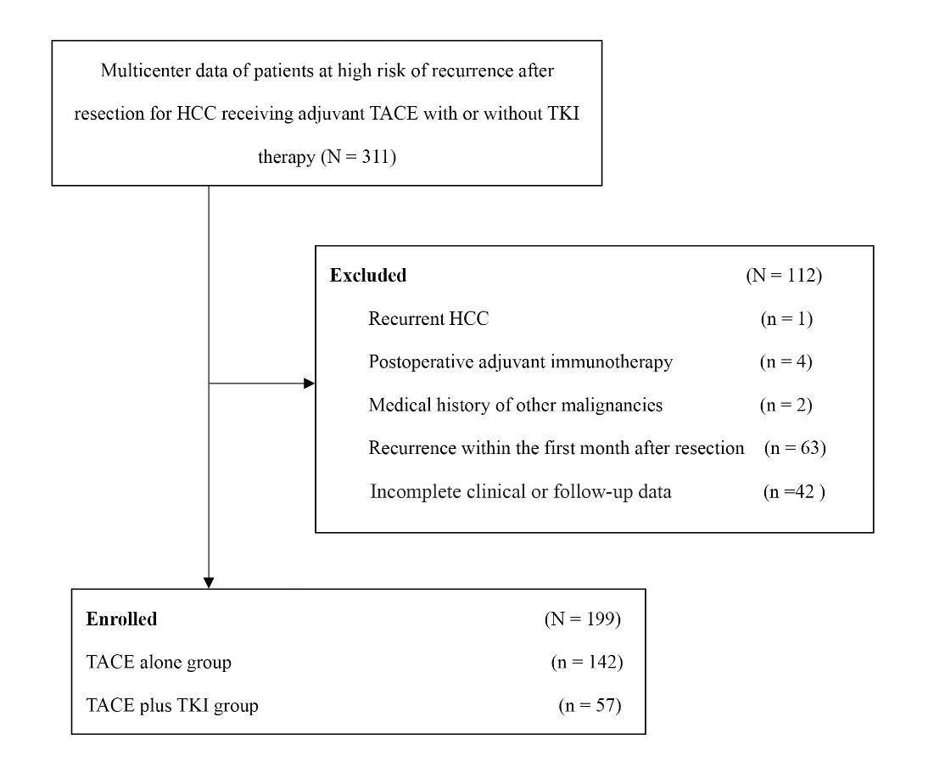
HCC, hepatocellular carcinoma.

Figure S2. Disease-free survival according to various TKI agents.
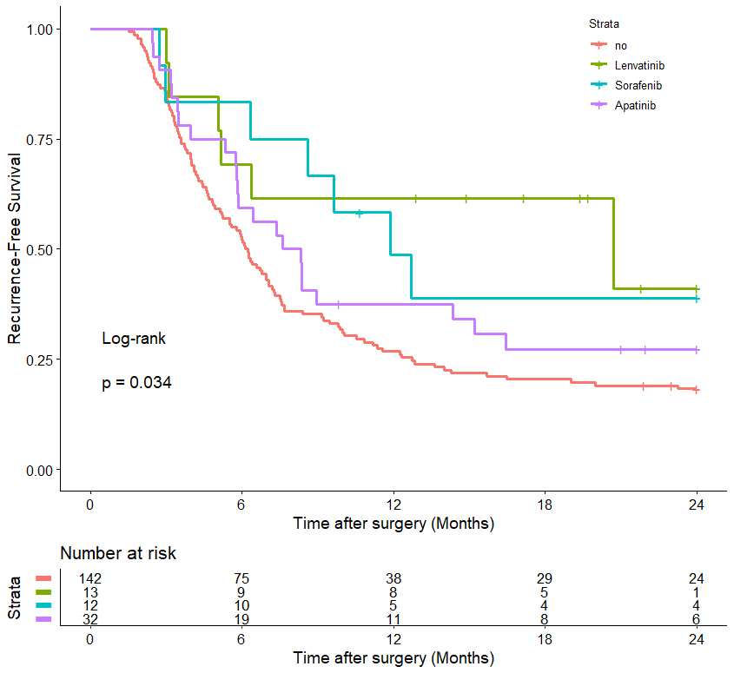
TKI, Tyrosine Kinase Inhibitor.

FigureS3. Disease-free survival according to tumor characteristics (A) Tumor diameter smaller than 5cm; (B) Tumor diameter larger than or equal to 5cm; (C) Tumor number less than 3; (D) Tumor number more than or equal to 3; (E) MVI: M1; (F) MVI: M2; (G) PVTT negative; (H) PVTT positive; (I) HVTT negative; (J) HVTT positive; (K) BDTT negative; (L) BDTT positive; (M) Rupture negative; (N) Rupture positive; (O) TNM II; (P) TNM IIIA; (Q) TNM IIIB.
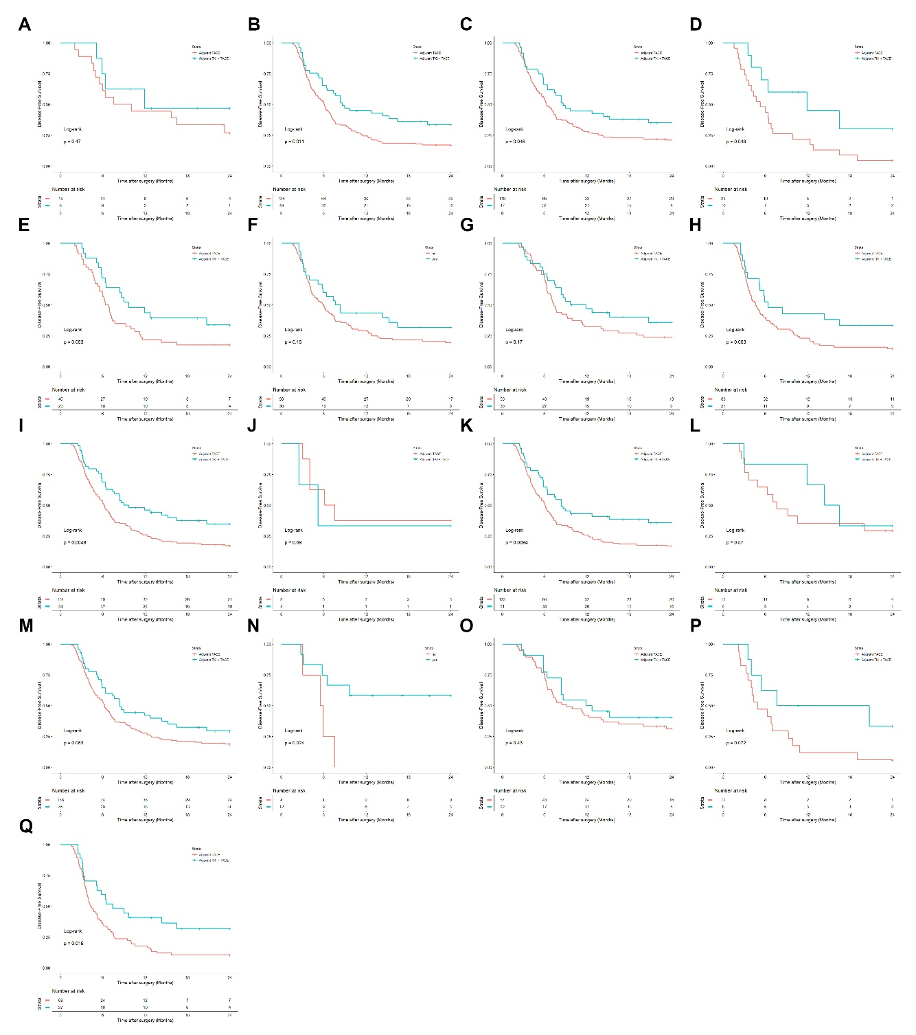
MVI, microvascular invasion; PVTT, portal vein tumor thrombus; HVTT, hepatic vein tumor thrombus; BDTT, bile duct tumor thrombus; AJCC, American Joint Committee on Cancer; TACE, transcatheter arterial chemoembolization; TKI, Tyrosine Kinase Inhibitor.

