Table S1. Univariate/multivariate analysis of overall survival in SARC patients
Characteristics | Total(N) | Univariate analysis |  |  | Multivariate analysis
Characteristics | Total(N) | Hazard ratio (95% CI) | P value |  | Hazard ratio (95% CI) | P value
Age | 263
<=60 | 130 | Reference
>60 | 133 | 1.285 (0.864-1.911) | 0.216
Gender | 263
Female | 144 | Reference
Male | 119 | 0.905 (0.607-1.349) | 0.623
Tumor depth | 209
Superficial | 21 | Reference
Deep | 188 | 2.888 (0.910-9.168) | 0.072 |  | 3.147 (0.415-23.873) | 0.268
Tumor multifocal | 239
No | 199 | Reference
Yes | 40 | 2.402 (1.502-3.840) | <0.001 |  | 1.420 (0.562-3.587) | 0.458
Radiation therapy | 257
No | 179 | Reference
Yes | 78 | 0.864 (0.557-1.339) | 0.513
Tumor necrosis | 183
No necrosis | 71 | Reference
Focal necrosis&Moderate necrosis&Extensive necrosis | 112 | 1.511 (0.899-2.541) | 0.119
Metastasis | 179
No | 120 | Reference
Yes | 59 | 2.888 (1.762-4.732) | <0.001 |  | 2.622 (1.452-4.737) | 0.001
Margin status | 213
Negative | 139 | Reference
Positive | 74 | 1.957 (1.215-3.151) | 0.006 |  | 1.191 (0.472-3.007) | 0.711
Race | 254
Asian | 6 | Reference
Black or African American&White | 248 | 0.796 (0.109-5.802) | 0.822
Residual tumor | 235
R0 | 157 | Reference
R1&R2 | 78 | 2.637 (1.721-4.038) | <0.001 |  | 2.268 (0.853-6.034) | 0.101

Table S2. The results of GO/KEGG enrichment analysis
ONTOLOGY | ID | Description | GeneRatio | BgRatio | pvalue | p.adjust | qvalue
BP | GO:0001101 | response to acid chemical | 10/41 | 343/18670 | 2.60e-09 | 4.15e-06 | 2.85e-06
BP | GO:0007584 | response to nutrient | 7/41 | 219/18670 | 4.45e-07 | 2.82e-04 | 1.94e-04
BP | GO:0071560 | cellular response to transforming growth factor beta stimulus | 7/41 | 249/18670 | 1.05e-06 | 2.82e-04 | 1.94e-04
BP | GO:0031667 | response to nutrient levels | 9/41 | 499/18670 | 1.06e-06 | 2.82e-04 | 1.94e-04
BP | GO:0060346 | bone trabecula formation | 3/41 | 10/18670 | 1.17e-06 | 2.82e-04 | 1.94e-04
CC | GO:0062023 | collagen-containing extracellular matrix | 10/41 | 406/19717 | 7.78e-09 | 1.07e-06 | 7.62e-07
CC | GO:0005583 | fibrillar collagen trimer | 3/41 | 11/19717 | 1.36e-06 | 6.26e-05 | 4.44e-05
CC | GO:0098643 | banded collagen fibril | 3/41 | 11/19717 | 1.36e-06 | 6.26e-05 | 4.44e-05
CC | GO:0044420 | extracellular matrix component | 4/41 | 51/19717 | 3.75e-06 | 1.29e-04 | 9.17e-05
CC | GO:0098644 | complex of collagen trimers | 3/41 | 19/19717 | 7.90e-06 | 2.18e-04 | 1.55e-04
MF | GO:0002020 | protease binding | 6/41 | 128/17697 | 4.65e-07 | 7.81e-05 | 5.92e-05
MF | GO:0048407 | platelet-derived growth factor binding | 3/41 | 11/17697 | 1.88e-06 | 1.07e-04 | 8.14e-05
MF | GO:0005201 | extracellular matrix structural constituent | 6/41 | 163/17697 | 1.92e-06 | 1.07e-04 | 8.14e-05
MF | GO:0019838 | growth factor binding | 5/41 | 137/17697 | 1.55e-05 | 6.50e-04 | 4.93e-04
MF | GO:0030020 | extracellular matrix structural constituent conferring tensile strength | 3/41 | 41/17697 | 1.16e-04 | 0.004 | 0.003
KEGG | hsa00590 | Arachidonic acid metabolism | 3/22 | 63/8076 | 6.27e-04 | 0.031 | 0.025
KEGG | hsa04512 | ECM-receptor interaction | 3/22 | 88/8076 | 0.002 | 0.031 | 0.025
KEGG | hsa04933 | AGE-RAGE signaling pathway in diabetic complications | 3/22 | 100/8076 | 0.002 | 0.031 | 0.025
KEGG | hsa05146 | Amoebiasis | 3/22 | 102/8076 | 0.003 | 0.031 | 0.025
KEGG | hsa04974 | Protein digestion and absorption | 3/22 | 103/8076 | 0.003 | 0.031 | 0.025

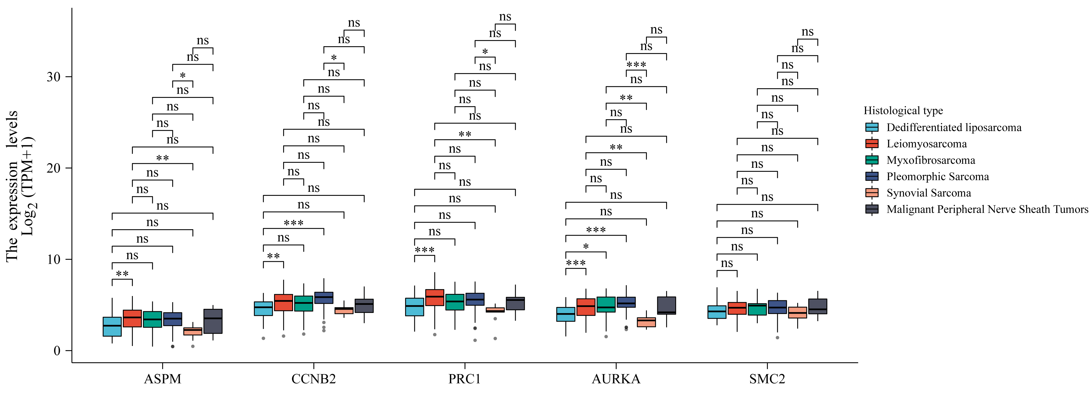

Figure S1: Differential expression of target genes in six different subtypes of sarcoma
*p<0.05, **p<0.01, ***p<0.001

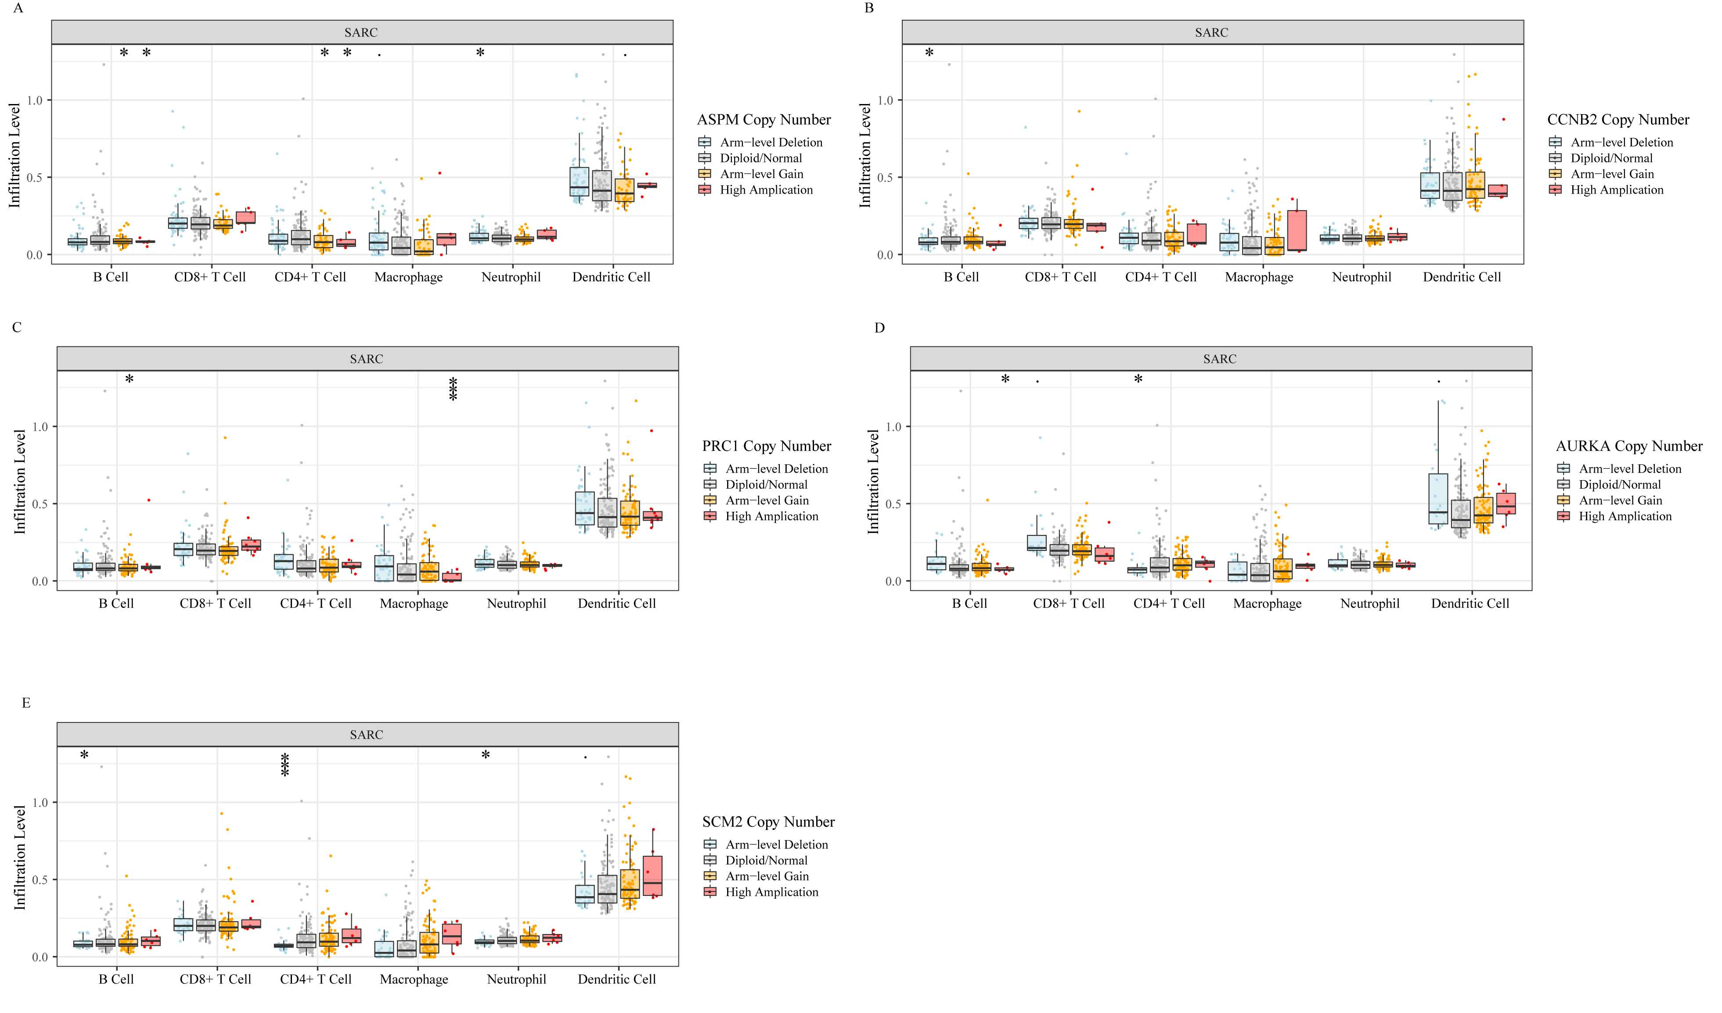

Figure S2: The comparison of tumor infiltration levels among SARC with different somatic copy number alterations for ASPM (A), CCNB2 (B), PRC1(C), AURKA (D), and SMC2(E).
*p<0.05, **p<0.01, ***p<0.001

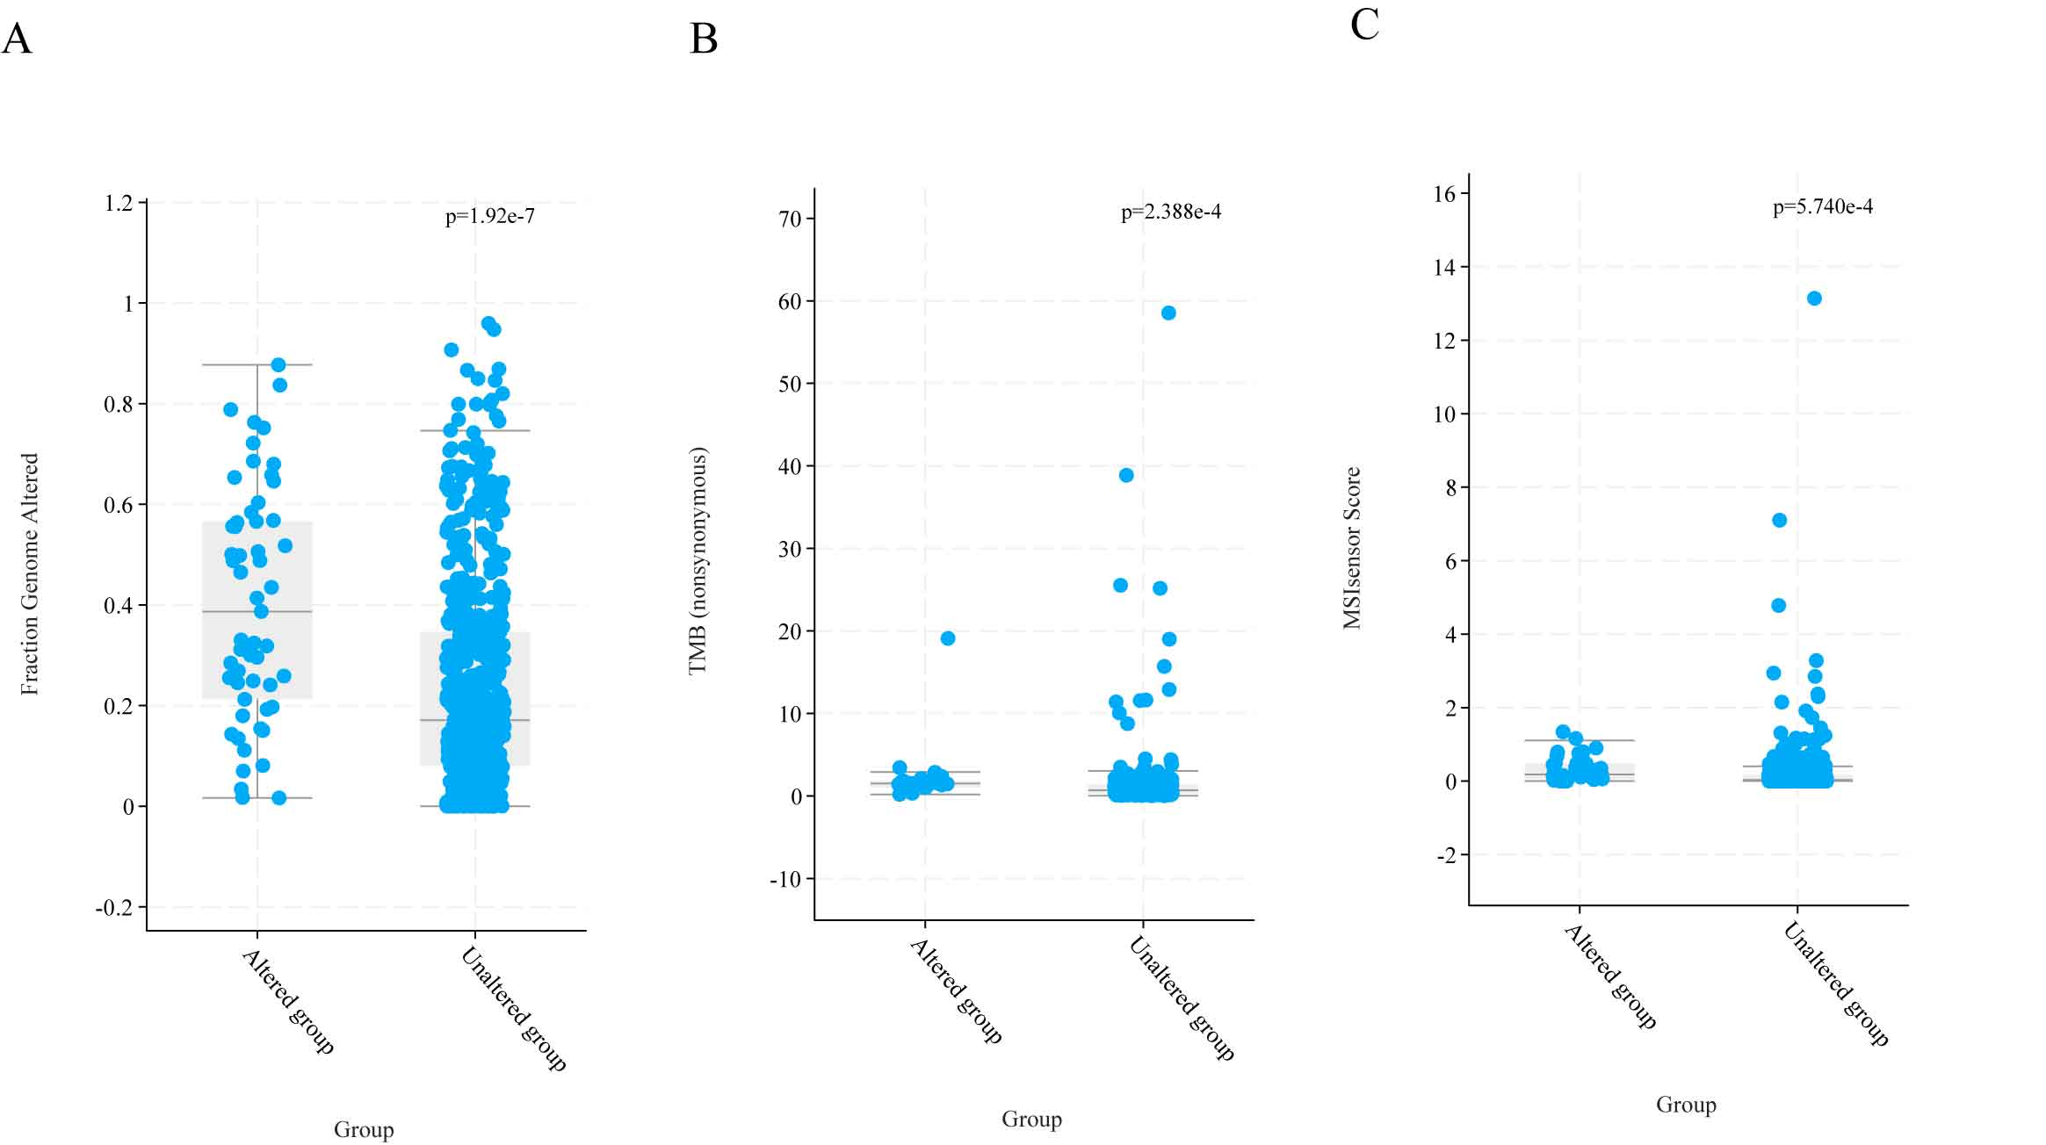

Figure S3: The correlation between gene mutation of TFG-CDEGs and tumor mutational burden (TMB) (A), Fraction Genome Altered (B), and MSIsensor Score (C).

