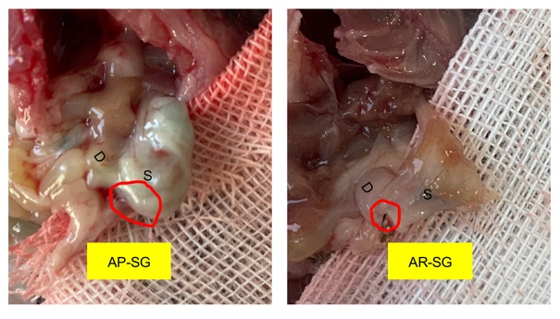
Figure S1. The size and confirmation of antrum (red circle) in AP-SG and AR-SG at the end of the study. D = duodenum; S = stomach.

