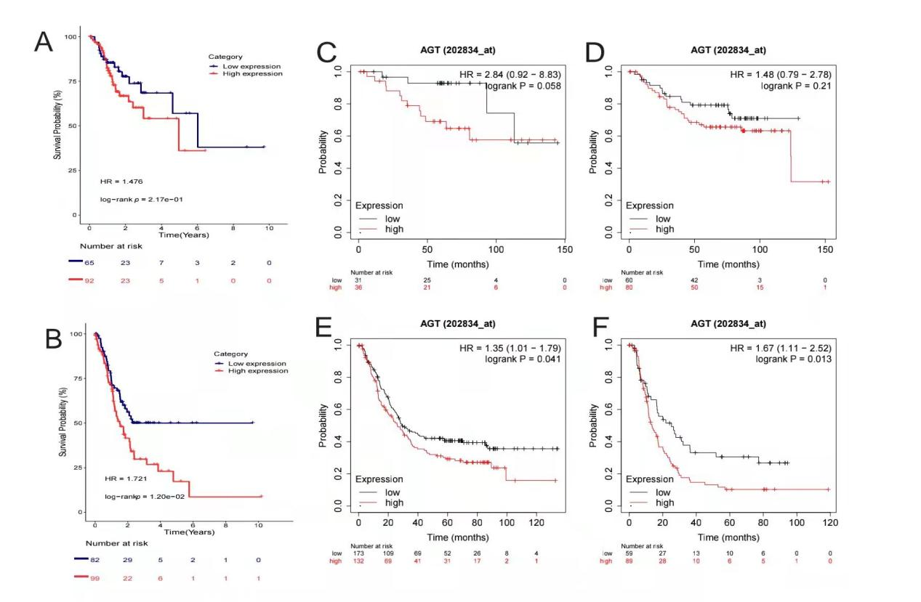
Figure S1. Correlation between AGT expression level and OS in GC patients with different TNM stages based on TCGA. (A)TNM I/II; (B)TNM stage III/IV. The prognostic value of AGT expression in GC patients with different TNM stages in the Kaplan-Meier Plotter. (C)TNM I; (D)TNM stage II; (E)TNM stage III; (F)TNM stage IV.
Abbreviations: HR, hazard ratio.

