Supplementary Figure 1 Examples of screens available in Reuma.pt/SAID – General patient data
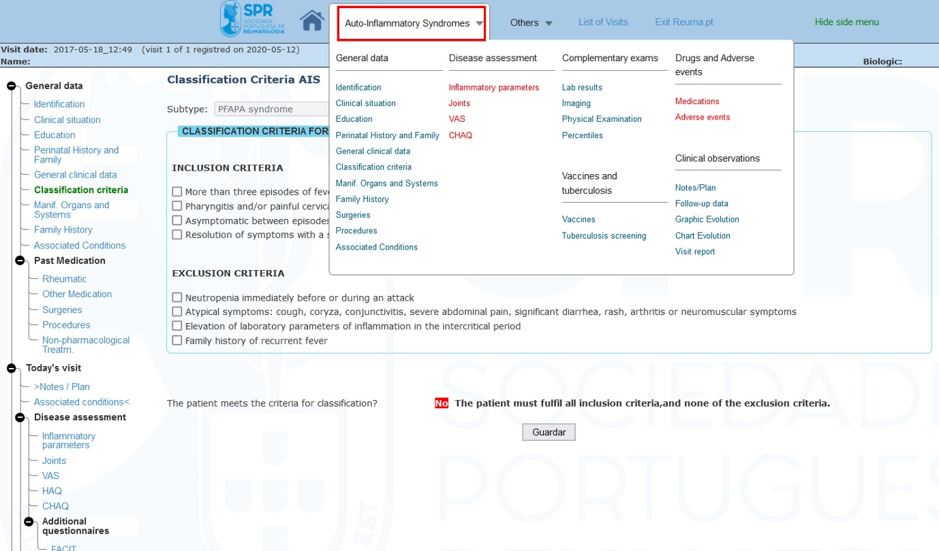

Supplementary Figure 2 Examples of screens available in Reuma.pt/SAID – General clinical data
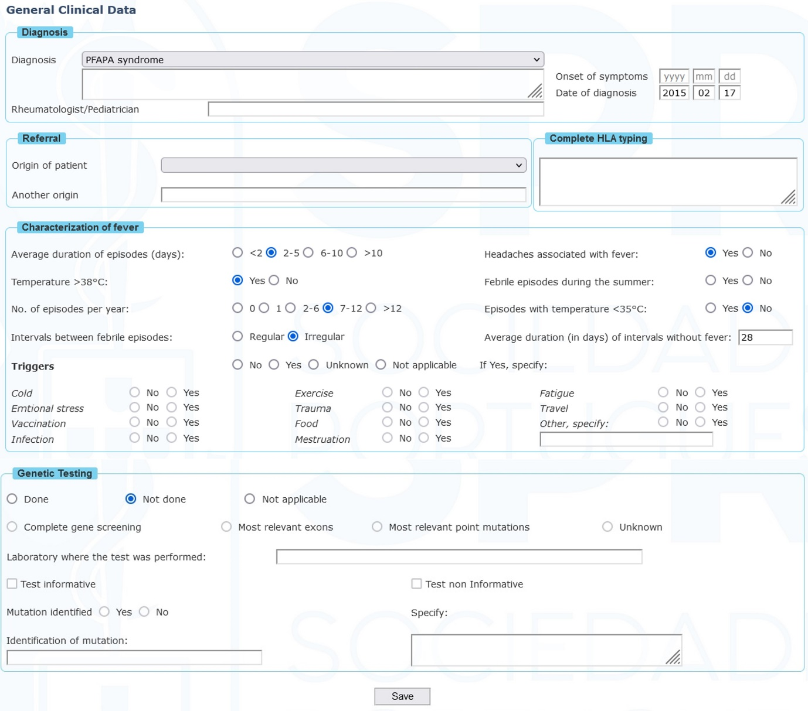

Supplementary Figure 3 Examples of screens available in Reuma.pt/SAID – Classification criteria
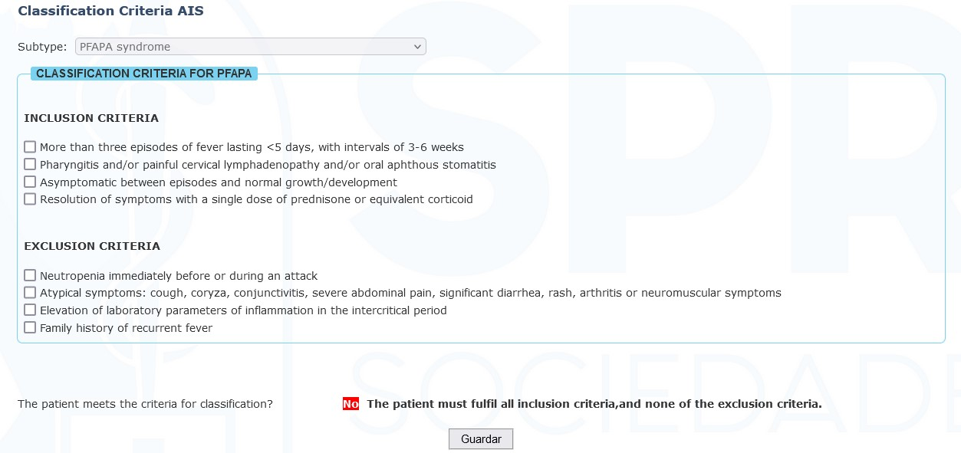

Supplementary Figure 4 Examples of screens available in Reuma.pt/SAID – Manifestations of organs and systems
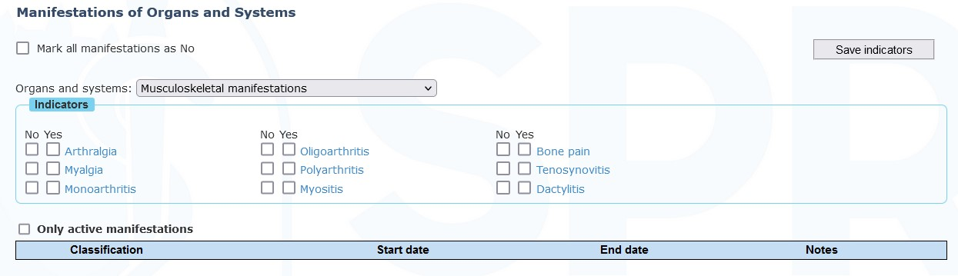

Supplementary Figure 5 Examples of screens available in Reuma.pt/SAID – Disease activity: Joints affected
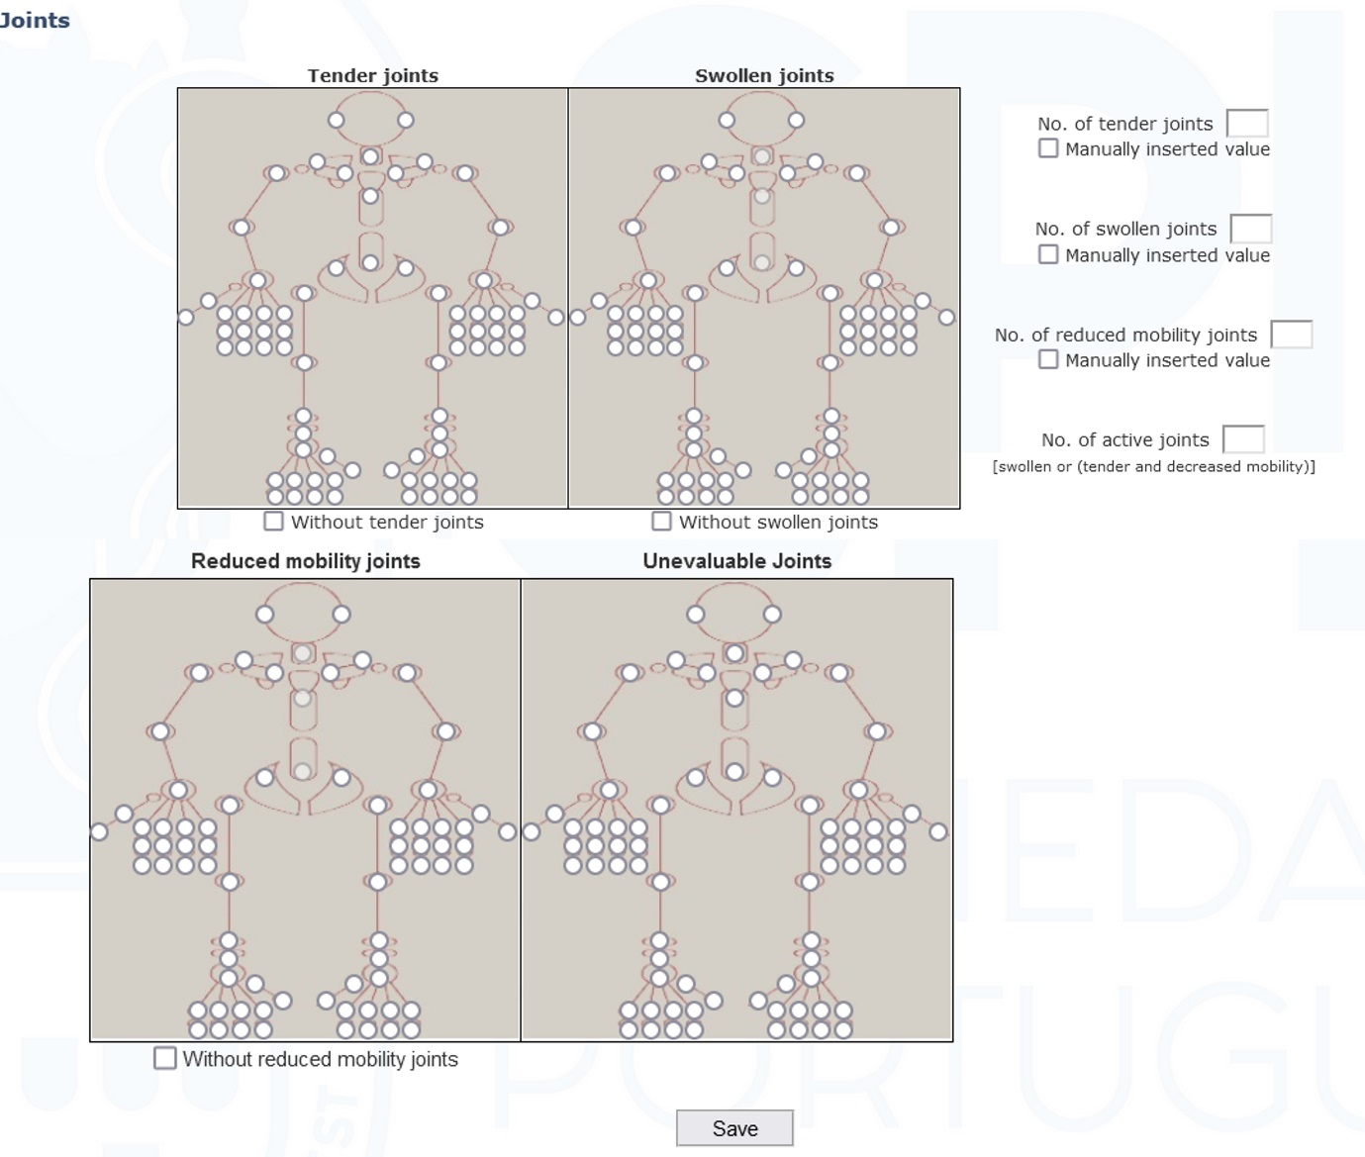

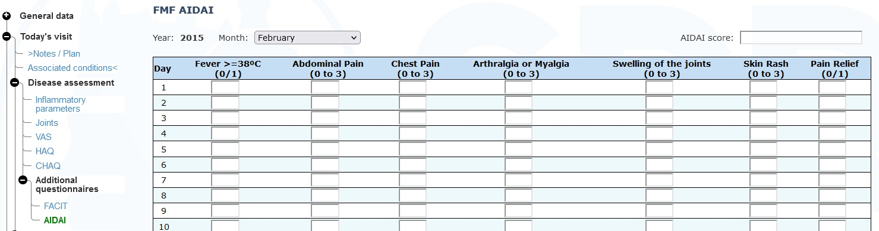
Supplementary Figure 6 Examples of screens available in Reuma.pt/SAID – Disease activity: AIDAI score

Supplementary Figure 7 Examples of screens available in Reuma.pt/SAID – Disease activity: Inflammatory parameters

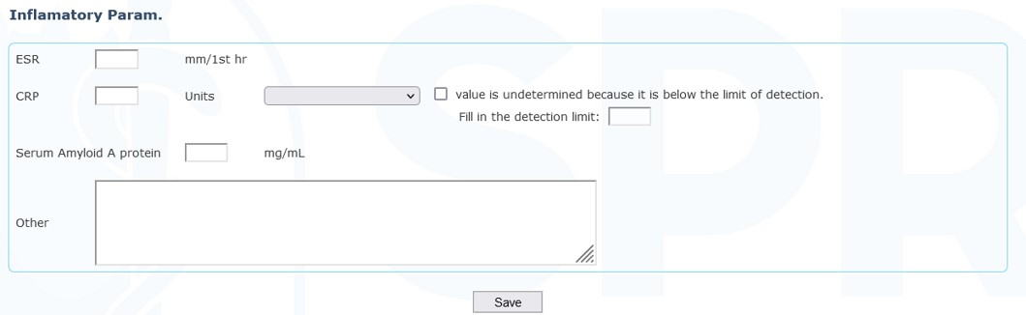

Supplementary Figure 8 Examples of screens available in Reuma.pt/SAID – Therapy
