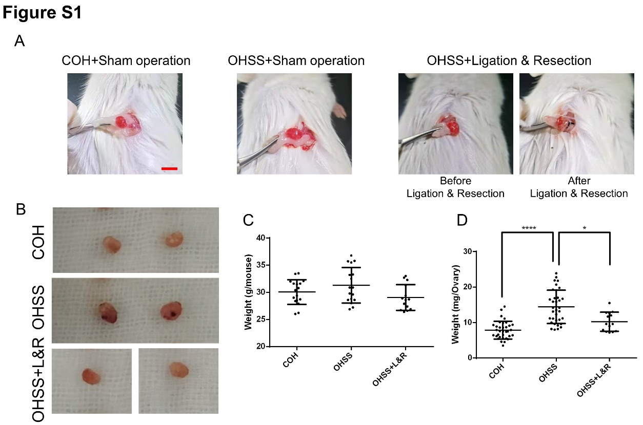
Figure S1 Symptoms of OHSS mice with unilateral ovariectomy.
- Representative images of model mice underwent unilateral ovariectomy in the OHSS+Ligation & Resection group. In the COH+Sham operation and OHSS+Sham operation group, only abdomen opening and closing surgery was performed. Scale bars, 5 mm.
- Representative images of the mice ovaries in the COH+Sham operation, OHSS+Sham operation and OHSS+Ligation & Resection group. Scale bars, 2 mm.
- Quantification of the mice body weight (g/mouse, Y-axis) in the COH+Sham operation (N=17), OHSS+Sham operation (N=17) and OHSS+Ligation & Resection (N=14) group (X-axis). Each dot represents the body weight of one mouse in the group.
- Quantification of the mice ovary weight (mg/ovary, Y-axis) in the COH+Sham operation (N=34), OHSS+Sham operation (N=34) and OHSS+Ligation & Resection (N=14) groups (X-axis). Each dot represents the weight of one ovary in the group.
Note: The bar and whiskers represent the mean and SD, One-way ANOVA demonstrated (no) significant differences among three groups, Dunnets and Bonferroni test were performed to compare significance between groups, *P < 0.05, ****P < 0.0001.

Table S1 Typical OHSS physiological symptoms and biochemical parameters of COH, OHSS and OHSS+Nin groups.
Parameters | COH group | OHSS group | OHSS+Nin Group | Remarks
Weight change (g) | 0.74 ± 0.59, n=32 ª | 1.45 ± 0.83, n=45 ^{a, b} | 0.90 ± 0.62, n=44 ^{b} | Fig. 2A
Ovarian weight (mg) | 7.26 ± 2.14, n=64 ª | 13.57 ± 4.67, n=90 ^{a, b} | 10.35 ± 4.21, n=88 ^{b} | Fig. 2C
Penetration level (%) | 100.00 ± 46.30, n=26 ª | 295.90 ± 189.20, n=28 ^{a, b} | 186.90 ± 106.70, n=31 ^{b} | Fig. 2D
Corpora lutea number | 8.13 ± 3.42, n=15 ª | 13.80 ± 4.87, n=15 ª | 10.60 ± 2.61, n=15 | Fig. 3B
Corpora lutea diameter (%) | 100.00 ± 14.42, n=45 ^{a, b} | 94.64 ± 16.48, n=64 ª | 74.58 ± 12.49, n=44 ^{b} | Fig. 3C
CD31+Vessels/mm² | 88.58 ± 20.80, n=20 ^{a, c} | 116.50 ± 31.86, n=23 ^{a, b} | 27.88 ± 19.43, n=24 ^{b, c} | Fig. 4B
E2 in Serum on Day1 (pg/mL) | 24.50 ± 7.87, n=6 | 39.00 ± 8.02, n=12 | N. A | Fig. 5A
E2 in Serum on Day2 (pg/mL) | 40.17 ± 9.87, n=6 | 55.75 ± 10.20, n=12 | N. A | Fig. 5A
E2 in Serum on Day3 (pg/mL) | 13.33 ± 5.16, n=6 ^{d} | 25.67 ± 3.88, n=6 ^{d} | 23.00 ± 4.86, n=6 ^{d} | Fig. 5A
E2 in Serum on Day4 (pg/mL) | 16.33 ± 4.23, n=6 ^{d} | 25.00 ± 4.29, n=6 ^{d} | 22.83 ± 3.87, n=6 ^{d} | Fig. 5A
P4 in Serum on Day1 (ng/mL) | 12.17 ± 4.26, n=6 | 16.67 ± 6.93, n=12 | N. A | Fig. 5B
P4 in Serum on Day2 (ng/mL) | 13.50 ± 4.32, n=6 | 19.50 ± 5.44, n=12 | N. A | Fig. 5B
P4 in Serum on Day3 (ng/mL) | 35.67 ± 4.97, n=6 ^{d} | 63.33 ± 13.76, n=6 ^{d} | 45.00 ± 9.59, n=6 ^{d} | Fig. 5B
P4 in Serum on Day4 (ng/mL) | 34.33 ± 5.50, n=6 ^{d} | 67.83 ± 13.70, n=6 ^{d} | 38.67 ± 5.47, n=6 ^{d} | Fig. 5B
VEGF in Serum on Day1 (pg/mL) | 29.50 ± 7.37, n=6 | 37.17 ± 6.32, n=12 | N. A | Fig. 5C
VEGF in Serum on Day2 (pg/mL) | 33.17 ± 4.07, n=6 | 37.50 ± 5.60, n=12 | N. A | Fig. 5C
VEGF in Serum on Day3 (pg/mL) | 37.83 ± 3.76, n=6 ^{d} | 43.00 ± 4.94, n=6 ^{d} | 48.17 ± 5.04, n=6 ^{d} | Fig. 5C
VEGF in Serum on Day4 (pg/mL) | 43.17 ± 5.91, n=6 ^{d} | 47.50 ± 6.57, n=6 ^{d} | 62.83 ± 12.66, n=6 ^{d} | Fig. 5C
Relative VEFG level (%) | 100.00 ± 27.20, n=19 ^{a, c} | 173.70 ± 40.55, n=23 ^{a, b} | 27.84 ± 24.73, n=24 ^{b, c} | Fig. 6B
Vessel bleeding point/mm² | 2.35 ± 2.25, n=20 ª | 12.44 ± 2.36, n=18 ^{a, b} | 1.524 ± 2.06, n=21 ^{b} | Fig. 7B
Vessel bleeding point/mm² | 1.85 ± 2.16, n=20 ª | 6.80 ± 2.24, n=20 ^{a, b} | 1.24 ± 1.70, n=21 ^{b} | Fig. 7D
PT (s) | 7.39 ± 0.42, n=14 | 7.56 ± 0.74, n=16 | 7.31 ± 0.44, n=16 | Fig. 8A
APTT (s) | 22.68 ± 2.26, n=14 | 22.87 ± 1.70, n=16 | 24.33 ± 3.07, n=16 | Fig. 8B
TT (s) | 16.52 ± 1.97, n=14 | 17.84 ± 3.04, n=16 | 17.93 ± 3.17, n=16 | Fig. 8C
FIB (g/L) | 1.79 ± 0.60, n=14 ª | 3.70 ± 1.72, n=16 ^{a, b} | 2.11 ± 0.80, n=16 ^{b} | Fig. 8D
D-D (μg/L) | 33.57 ± 14.99, n=14 ª | 50.00 ± 27.81, n=16 ^{a, b} | 40.63 ± 9.29, n=16 ^{b} | Fig. 8E
Weight (g) | 30.06 ± 2.28, n=17 | 31.30 ± 3.26, n=17 | 29.06 ± 2.36, n=14 | Fig. S1C
Ovarian weight (mg) | 7.88 ± 2.51, n=34 ª | 14.45 ± 4.69, n=34 ^{a, b} | 10.23 ± 2.68, n=14 ^{b} | Fig. S1D
a–c: Differences between two groups.
d: Differences among three groups.

Table S2 Differentially expressed genes list of cell adhesion among COH, OHSS and OHSS+Nin groups.
Official gene symbol
Aak1 | C4b | Efs | Itgax | Pcdhb19 | Runx3 | Tns3
Aatk | Cadm3 | Eif2ak2 | Kalrn | Pcdhga2 | Sfn | Tnxb
Abi1 | Capg | Epn2 | Kitl | Pcdhga8 | Sgk1 | Tpx2
Adam9 | Cd320 | Esyt2 | Ltbp1 | Pcdhgb4 | Siglec1 | Trib1
Afdn | Cd36 | F10 | Megf10 | Pcdhgb8 | Snap25 | Trib2
Agrn | Chmp3 | H2-Aa | Mlkl | Prkg2 | Snx9 | Trim25
Amigo1 | Cldn18 | H2-Ab1 | Nlgn3 | Prrt1 | Spon1 | Vcam1
Basp1 | Comp | H2-Q6 | Nrcam | Rab11fip4 | Stat1 | Wisp2
Bmp6 | Cxcl12 | H2-Q7 | Nrn1 | Robo1 | Thbs4
Brsk1 | Ddx58 | Homer2 | Pacsin2 | Rsrc1 | Timp1

