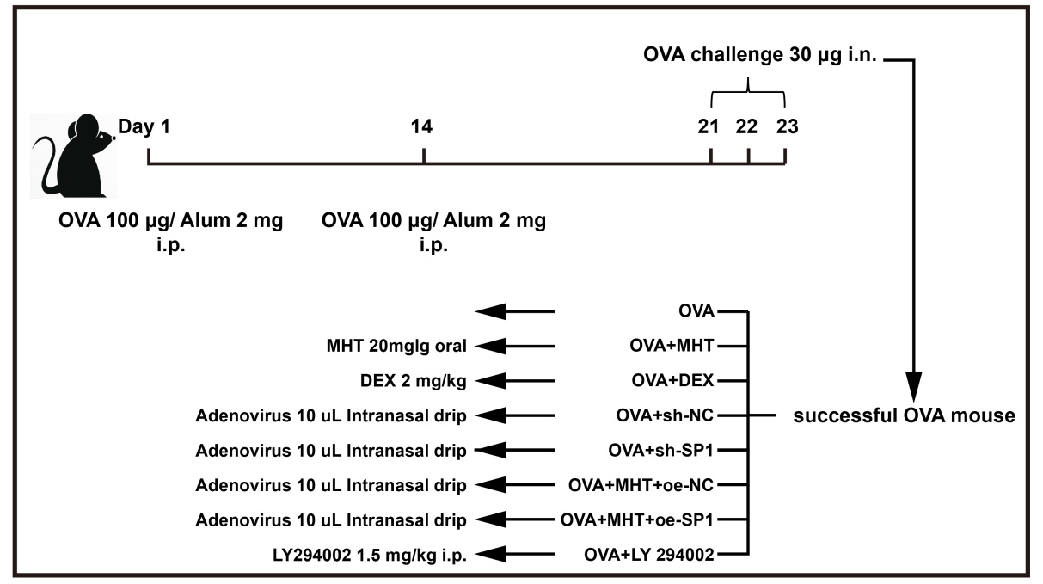
Figure S1. A schematic for experimental animal treatment.

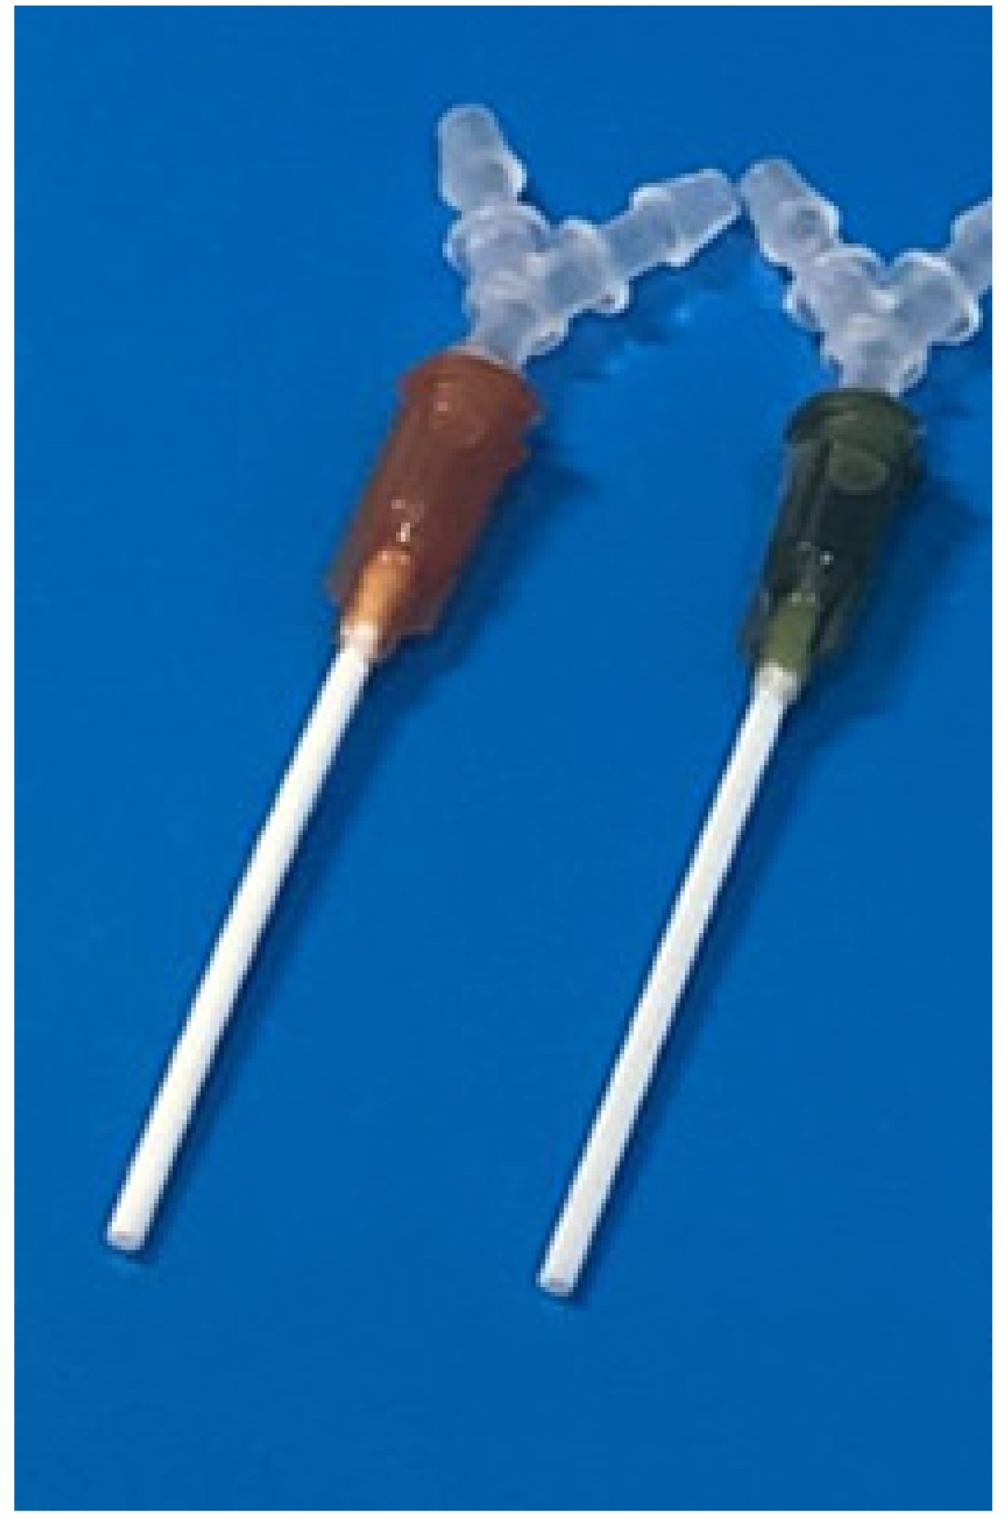
Figure S2. Homemade trachea for mouse tracheal intubation.

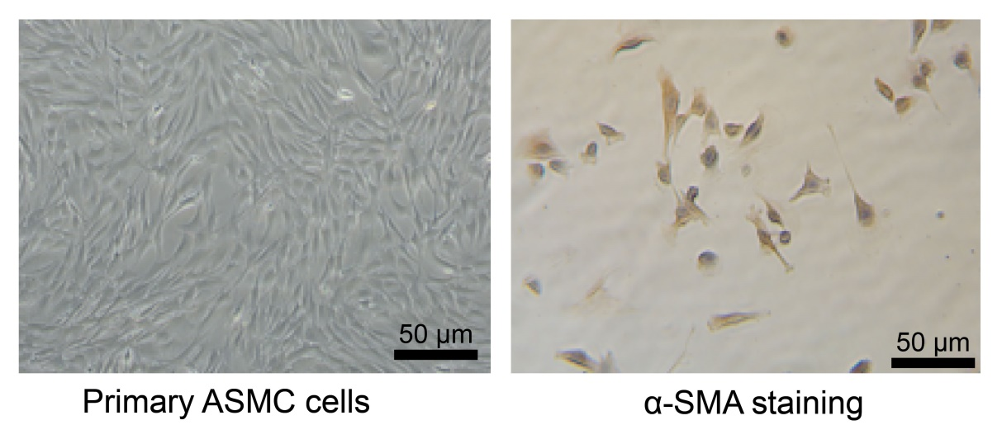
Figure S3. Isolation and identification of primary mouse ASMCs. Under a phase contrast microscope, ASMCs showed a characteristic “hill and valley” appearance (400 ×, A), and Immunocytochemistry staining suggested positive expression of α-SMA in ASMCs (400 ×, B). Cell experiments were repeated three times.

Table S1 Primer sequences for reverse transcription quantitative polymerase chain reaction
Target | Primer sequence
SP1 | Forward 5’-AGGGTCCGAGTCAGTCAGG-3’
 | Reverse 5’-CTCGCTGCCATTGGTACTGTT-3’
FGFR3 | Forward 5’-GGCCTGCGTGCTAGTGTTCT-3’
 | Reverse 5’-CCTGTACCATCCTTAGCCCAG-3’
COL1A2 | Forward 5’-TCGTGCCTAGCAACATGCC-3’
 | Reverse 5’-TTTGTCAGAATACTGAGCAGCAA-3’
COL3A1 | Forward 5’-CTGTAACATGGAAACTGGGGAAA-3’
 | Reverse 5’-CCATAGCTGAACTGAAAACCACC-3’
GAPDH | Forward 5’-AGGTCGGTGTGAACGGATTTG-3’
 | Reverse 5’-GGGGTCGTTGATGGCAACA-3’
SEMA3F | Forward 5’-ACATCAACCGAGAGCCCCTTA-3’
 | Reverse 5’-CCGGACGAAGTTACCACAC-3’
ASB4 | Forward 5’-ACCATCAACTGTCGTCCCAAC-3’
 | Reverse 5’-ATGTTTACGTTTGCACCTCTCA-3’
TOMM34 | Forward 5’-CCCAAACTCTCAGACTCTGTGG-3’
 | Reverse 5’-GGAAGTGCAATCTTTGATGCAAT-3’
PTPRN | Forward 5’-GCTTGTCCTGGCATGATGAC-3’
 | Reverse 5’-CTGAGTTAGCAATTCCCCTGC-3’
SEZ6 | Forward 5’-GAGGCGTCCACTTCGTCAC-3’
 | Reverse 5’-GCTGGAGTCGGACTGGTAAAG-3’
ERBB3 | Forward 5’-AGTGCGATTGGGACTCTGC-3’
 | Reverse 5’-CTCCAGGTTACCCATGACCAC-3’

