Supplemental Material

Supplemental Table index
Tab. 1 First response countries/regions to COVID-19 vs. SARS
Tab. 2 First response countries/regions for COVID-19
Tab. 3 Monthly COVID-19 publications in various countries
Tab. 4 Publication-journal ratio of COVID-19 and SARS in the year after the first disclosed case
Tab. 5 Journals and publications in the top five relative categories of SARS and COVID-19 research (2003-2020)
Tab. 6 First co-occurrence terms and months for different research themes for COVID-19 and SARS

Supplemental Figure index
Fig. S1 COVID-19 publications in various countries at different intervals from December. 8, 2019-Dec. 7, 2020
Fig. S2 SARS publication trends over five years after the first global case
Fig. S3 COVID-19 publication trends over 12 months after the first disclosed case

Supplemental Search Syntax index
Syntax 1: SARS
Syntax 2: COVID-19

Tab. 1 First response countries/regions to COVID-19 vs. SARS
Months after the world’s first open case | Interval 1 | Interval 2 | Interval 3 | Interval 4 | Interval 5 | Interval 6
COVID-19 | 0 | 28 | 36 | 73 | 101 | 114
SARS | 0 | 0 | 0 | 1 | 5 | 6
Source: PubMed

Tab. 2 First response countries/regions for COVID-19
Country/  Region | Date of the first confirmed case (A) | Date of the first publication (B) | Days between  A and B | Reference for the first confirmed case
Australia | 2020/1/25 | 2020/1/30 | 5 | https://en.wikipedia.org/wiki/COVID-19_pandemic_in_Australia
Belgium | 2020/2/4 | 2020/2/6 | 2 | https://en.wikipedia.org/wiki/COVID-19_pandemic_in_Belgium
Canada | 2020/1/25 | 2020/1/31 | 6 | https://www.canadianhealthcarenetwork.ca/covid-19-a-canadian-timeline
China | 2019/12/8 | 2020/1/21 | 44
France | 2020/1/24 | 2020/2/6 | 13 | https://www.ncbi.nlm.nih.gov/pmc/articles/PMC7029452/
Germany | 2020/1/27 | 2020/1/30 | 3 | https://en.wikipedia.org/wiki/COVID-19_pandemic_in_Germany
Greece | 2020/2/26 | 2020/1/29 | -28 | https://www.reuters.com/article/us-china-health-greece-idUSKCN20K1IA
Iran | 2020/2/19 | 2020/2/5 | -14 | https://www.garda.com/crisis24/news-alerts/315441/iran-first-cases-of-coronavirus-covid-19-confirmed-february-19-update-1
Italy | 2020/1/31 | 2020/2/5 | 6 | https://en.wikipedia.org/wiki/COVID-19_pandemic_in_Italy
Netherlands | 2020/2/27 | 2020/1/24 | -33 | https://en.wikipedia.org/wiki/COVID-19_pandemic_in_the_Netherlands#January_2020
Pakistan | 2020/2/26 | 2020/2/4 | -22 | https://en.wikipedia.org/wiki/COVID-19_pandemic_in_Pakistan
Portugal | 2020/3/2 | 2020/2/7 | -24 | https://www.aa.com.tr/en/europe/portugal-reports-1st-coronavirus-death/1768310
Saudi Arabia | 2020/3/2 | 2020/2/10 | -21 | https://en.wikipedia.org/wiki/COVID-19_pandemic_in_Saudi_Arabia
South Korea | 2020/1/20 | 2020/2/3 | 14 | https://en.wikipedia.org/wiki/COVID-19_pandemic_in_South_Korea
Sweden | 2020/1/31 | 2020/1/31 | 0 | https://en.wikipedia.org/wiki/COVID-19_pandemic_in_Sweden
Switzerland | 2020/2/25 | 2020/2/5 | -20 | https://www.swissinfo.ch/eng/covid-19_first-coronavirus-death-recorded-in-switzerland/45597610
United Kingdom | 2020/1/31 | 2020/1/28 | -3 | https://en.wikipedia.org/wiki/COVID-19_pandemic_in_the_United_Kingdom
United States | 2020/1/20 | 2020/1/22 | 2 | https://www.cdc.gov/media/releases/2020/s0229-COVID-19-first-death.html
Norway | 2020/2/26 | 2020/1/25 | -32 | https://en.wikipedia.org/wiki/COVID-19_pandemic_in_Norway
Vietnam | 2020/1/23 | 2020/1/28 | 5 | https://www.ncbi.nlm.nih.gov/pmc/articles/PMC7146658/
Spain | 2020/1/31 | 2020/1/27 | -4 | https://en.wikipedia.org/wiki/COVID-19_pandemic_in_Spain
Turkey | 2020/3/11 | 2020/2/4 | 36 | https://en.wikipedia.org/wiki/COVID-19_pandemic_in_Turkey
Singapore | 2020/1/23 | 2020/1/28 | 5 | https://en.wikipedia.org/wiki/COVID-19_pandemic_in_Singapore
Poland | 2020/3/4 | 2020/2/7 | -26 | https://en.wikipedia.org/wiki/COVID-19_pandemic_in_Poland
Finland | 2020/1/29 | 2020/2/7 | 9 | https://en.wikipedia.org/wiki/COVID-19_pandemic_in_Finland
Colombia | 2020/3/6 | 2020/2/6 | -29 | https://en.wikipedia.org/wiki/COVID-19_pandemic_in_Colombia
Denmark | 2020/2/27 | 2020/2/4 | -23 | https://en.wikipedia.org/wiki/COVID-19_pandemic_in_Denmark
Taiwan | 2020/1/21 | 2020/2/4 | 14 | https://en.wikipedia.org/wiki/COVID-19_pandemic_in_Taiwan
Average |  |  | -4.1
Source: PubMed and WIKI

Tab. 3 Monthly COVID-19 publications in various countries
 | Interval 1 | Interval 2 | Interval 3 | Interval 4 | Interval 5 | Interval 6 | Interval 7 | Interval 8 | Interval 9 | Interval 10 | Interval 11 | Interval 12
USA | 0 | 23 | 94 | 259 | 865 | 1674 | 2213 | 2316 | 2514 | 2464 | 2482 | 2297
China | 0 | 45 | 199 | 442 | 715 | 925 | 956 | 992 | 947 | 933 | 943 | 987
UK | 0 | 6 | 41 | 127 | 404 | 681 | 912 | 950 | 1019 | 907 | 1035 | 1050
Italy | 0 | 3 | 27 | 93 | 362 | 591 | 721 | 658 | 739 | 652 | 677 | 692
India | 0 | 21 | 16 | 75 | 205 | 299 | 441 | 386 | 494 | 442 | 528 | 422
Canada | 0 | 6 | 19 | 40 | 135 | 280 | 354 | 294 | 368 | 343 | 352 | 369
Germany | 0 | 2 | 18 | 52 | 137 | 247 | 326 | 324 | 330 | 316 | 362 | 350
Spain | 0 | 2 | 7 | 30 | 107 | 204 | 248 | 316 | 341 | 334 | 367 | 362
Australia | 0 | 4 | 20 | 40 | 94 | 208 | 245 | 276 | 343 | 329 | 293 | 357
France | 0 | 3 | 15 | 33 | 138 | 272 | 234 | 284 | 292 | 245 | 310 | 287
Brazil | 0 | 1 | 9 | 28 | 69 | 118 | 206 | 155 | 260 | 212 | 209 | 250
Switzerland | 0 | 2 | 6 | 34 | 92 | 130 | 145 | 152 | 151 | 135 | 137 | 179
Iran | 0 | 2 | 19 | 56 | 63 | 88 | 139 | 125 | 162 | 158 | 164 | 159
Netherlands | 0 | 2 | 7 | 18 | 57 | 102 | 155 | 155 | 154 | 152 | 140 | 142
Turkey | 0 | 0 | 5 | 12 | 34 | 115 | 107 | 109 | 169 | 124 | 164 | 158
Japan | 0 | 5 | 6 | 19 | 52 | 67 | 96 | 130 | 129 | 144 | 151 | 142
South Korea | 0 | 4 | 12 | 27 | 58 | 85 | 98 | 100 | 140 | 112 | 115 | 134
Singapore | 0 | 2 | 10 | 35 | 60 | 100 | 123 | 97 | 118 | 99 | 93 | 95
Belgium | 0 | 1 | 6 | 22 | 48 | 83 | 95 | 104 | 113 | 108 | 101 | 103
Saudi Arabia | 0 | 3 | 10 | 21 | 23 | 40 | 89 | 71 | 136 | 111 | 135 | 138
Source:Web of Science
Search theme: COVID-19: “covid-19”
Note: Modification of original data derived from Web of Science includes: The data of China includes “Peoples R China” ;The data of UK includes “England”, “Wales”, “North Ireland”, “Scotland”; The data of USA includes “United States of America”, “United States.”

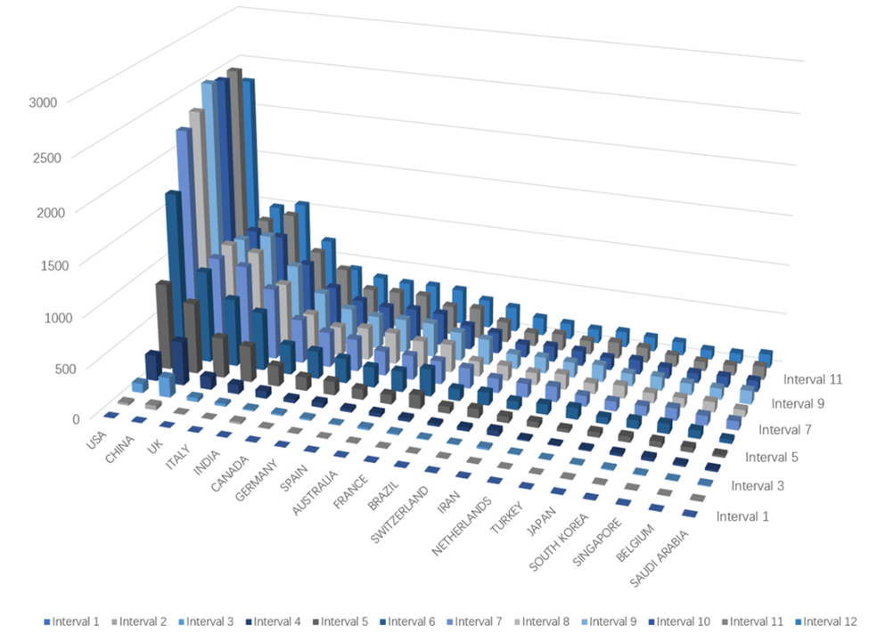
Fig. S1 COVID-19 publications in various countries at different intervals from December. 8, 2019-Dec. 7, 2020
Source: Web of Science

Tab. 4 Publication-journal ratio of COVID-19 and SARS in the year after the first disclosed case
 | Covid-19 |  |  | SARS
 | Journal | Publication | Publication/Journal | Journal | Publication | Publication/Journal
Interval 1 | 0 | 0 | 0.00 | 0 | 0 | 0.00
Interval 2 | 36 | 59 | 1.64 | 0 | 0 | 0.00
Interval 3 | 161 | 415 | 2.58 | 0 | 0 | 0.00
Interval 4 | 474 | 1588 | 3.35 | 1 | 1 | 1.00
Interval 5 | 1196 | 4690 | 3.92 | 14 | 35 | 2.50
Interval 6 | 1207 | 5236 | 4.34 | 31 | 105 | 3.39
Interval 7 | 1184 | 4377 | 3.70 | 70 | 169 | 2.41
Interval 8 | 1180 | 4290 | 3.64 | 80 | 169 | 2.11
Interval 9 | 1421 | 4269 | 3.00 | 92 | 202 | 2.20
Interval 10 | 1536 | 4787 | 3.12 | 69 | 106 | 1.54
Interval 11 | 1581 | 4795 | 3.03 | 79 | 137 | 1.73
Interval 12 | 1484 | 4223 | 2.85 | 66 | 101 | 1.53
Source：PubMed

Tab.5 Journals and publications in the top five relative categories of SARS and COVID-19 research (2003-2020)
Category | 2003 | 2020
Virology | 23 | 39
Public, Environmental & Occupational Health | 89 | 378
Medicine, General & Internal | 102 | 318
Immunology | 114 | 177
Infectious Diseases | 41 | 119
Source：JCR

Tab. 6 First co-occurrence terms and months for different research themes for COVID-19 and SARS
Cluster |  | SARS | COVID-19
Clinical Presentation & Prognostic Risk Factors | Months after the first case | 4 | 2
Clinical Presentation & Prognostic Risk Factors | Co-occurrence items | Fever; Dyspnea; Male; Middle aged; Lung; Aged; Radiography; Cough | Tomography, x-ray computed; Male; Female; Fever; Adult; Middle aged; Lung; Aged; Cough; Child; Adolescent; Child, Preschool; Infant; Age factors; Radiography, thoracic; Prognosis; Young adult
Ecology | Months after the first case | 5 | 2
Ecology | Co-occurrence items | Phylogeny; SARS Virus; Animals; RNA, Viral | Phylogeny; SARS Virus; Animals; RNA, Viral; SARS Virus; Genome, Viral; Spike glycoprotein, Coronavirus; Amino acid sequence; Sequence alignment; Antibodies, Viral; Disease reservoirs; Virus replication
Non-Pharmaceutical Interventions | Months after the first case | 5 | 2
Non-Pharmaceutical Interventions | Co-occurrence items | Contact tracing | Infection control; Communicable disease control; Travel; World health organization; Public health
Diagnostics | Months after the first case | 5 | 2
Diagnostics | Co-occurrence items | Polymerase chain reaction | Tomography, x-ray computed;  Radiography, thoracic
Modeling | Months after the first case | 6 | 2
Modeling | Co-occurrence items | Risk factors;  Severity of illness index;  Time factors | Risk assessment; Incidence
Pharmaceutical Interventions | Months after the first case | 6 | 2
Pharmaceutical Interventions | Co-occurrence items | Antiviral agents; Ribavirin; Anti-inflammatory agents; Respiration, artificial; Drug therapy, combination therapy;  Clinical laboratory techniques; Treatment outcome | Antiviral agents; Clinical laboratory techniques; Antibodies, Viral; Hospitalization; Intensive care units
Epidemiology | Months after the first case | 6 | 2
Epidemiology | Co-occurrence items | Cross infection;  Coronavirus infections | Coronavirus infections
Vaccine | Months after the first case | 7 | 2
Vaccine | Co-occurrence items | Antibodies, Viral | Antibodies, Viral
Source：PubMed

Fig. S2 SARS publication trends over five years after the first global case
Source: PubMed

Fig. S3 COVID-19 publication trends over 12 months after the first disclosed case
Source: PubMed

Search String
SARS:
((("Severe acute respiratory syndrome") OR ("SARS") OR ("SARS-CoV-1") OR ("SARSr-CoV") OR ("NOVEL CORONAVIRUS"))) AND (("2003/07/10"[Date - Publication] : "2003/08/09"[Date - Publication]))
(NOTE: Search dates are examples)
COVID-19:
((("2019-nCoV") OR ("COVID-19") OR ("SARS-CoV-2") OR ("hcov") OR ("NCOVID-19") OR ("severe acute respiratory syndrome coronavirus 2") OR ("NOVEL CORONAVIRUS"))) AND (("2019/12/30"[Date - Publication] : "2020/01/29"[Date - Publication]))
(NOTE: Search dates are examples)

The time and country of the first case of COVID-19 is still remains under controversial. China is the first country to disclose COVID-19; therefore, so the research adopted the first case of China as the first case in global case. The time of the first case in China refersed to the academic paper from of Wu and McGoogan (2020), which is a more authoritative publication. In the article from Wu and McGoogan (2020), December 8, 2019 was marked as the date of the first and disclosed case of COVID-19, November 16,2002 was marked as the date of the first and disclosed case of SARS.

