Supplemental Tables and Figures
Supplemental Table 1. Whitney-Mann-Wilcoxon test on outcome variables
Outcome Variables | p-value | Obs.
# of Asthma Attacks | <0.001 | 349
# of Hospital Visits | 0.436 | 348
# of ER Visits | 0.673 | 348
Physical Health of Children | <0.001 | 345
Activities of Children | <0.001 | 348
Activities of Family | <0.001 | 348
Emotional Health of Children | <0.001 | 347
Emotional Health of Family | <0.001 | 348

Supplemental Table 2. Cost-effectiveness ratios by child’s gender
Category | Outcome | Cost-Effectiveness Ratio
Female
Asthma Attacks (#) | 27 | 248.30/27 = 9.2
Hospital Visits (#) | 0
ER Visits (#) | 7 | 248.30/7 = 35.5
Physical Health of Children (#) | 112 | 248.30/112 = 2.2
Activities of Children (#) | 50 | 248.30/50 = 5.0
Activities of Family (#) | 69 | 248.30/69 = 3.6
Emotional Health of Children (#) | 73 | 248.30/73 = 3.4
Emotional Health of Family (#) | 90 | 248.30/90 = 2.8
Male
Asthma Attacks (#) | 33 | 248.30/33 = 7.5
Hospital Visits (#) | 3 | 248.30/3 = 82.8
ER Visits (#) | 5 | 248.30/5 = 49.7
Physical Health of Children (#) | 148 | 248.30/148 = 1.7
Activities of Children (#) | 58 | 248.30/58 = 4.3
Activities of Family (#) | 69 | 248.30/69 = 3.6
Emotional Health of Children (#) | 86 | 248.30/86 = 2.9
Emotional Health of Family (#) | 127 | 248.30/127 = 2.0
Notes: Cost-effectiveness ratio = average cost/outcome measure; females N = 152, males N = 191; # signifies the number of participants who reported a better outcome (i.e., an increase in the physical health of children, activities of children/family, and emotional health of children/family and a decrease in asthma attacks, hospital visits, and ER visits).

Supplemental Table 3. Cost-effectiveness ratios by female guardian education
Category | Outcome | Cost-Effectiveness Ratio
Less than high school
Asthma Attacks (#) | 25 | 248.30/25 = 9.9
Hospital Visits (#) | 1 | 248.30/1 = 248.3
ER Visits (#) | 5 | 248.30/5 = 49.7
Physical Health of Children (#) | 104 | 248.30/104 = 2.4
Activities of Children (#) | 37 | 248.30/37 = 6.7
Activities of Family (#) | 53 | 248.30/53 = 4.7
Emotional Health of Children (#) | 62 | 248.30/62 = 4.0
Emotional Health of Family (#) | 85 | 248.30/85 = 2.9
High school graduate
Asthma Attacks (#) | 20 | 248.30/20 = 12.4
Hospital Visits (#) | 1 | 248.30/1 = 248.3
ER Visits (#) | 4 | 248.30/4 = 62.1
Physical Health of Children (#) | 80 | 248.30/80 = 3.1
Activities of Children (#) | 38 | 248.30/38 = 6.5
Activities of Family (#) | 43 | 248.30/43 = 5.8
Emotional Health of Children (#) | 53 | 248.30/53 = 4.7
Emotional Health of Family (#) | 66 | 248.30/66 = 3.8
More than high school
Asthma Attacks (#) | 16 | 248.30/16 = 15.5
Hospital Visits (#) | 1 | 248.30/1 = 248.3
ER Visits (#) | 3 | 248.30/3 = 82.8
Physical Health of Children (#) | 81 | 248.30/81 = 3.1
Activities of Children (#) | 36 | 248.30/36 = 6.9
Activities of Family (#) | 46 | 248.30/46 = 5.4
Emotional Health of Children (#) | 46 | 248.30/46 = 5.4
Emotional Health of Family (#) | 71 | 248.30/71 = 3.5
Notes: Cost-effectiveness ratio = average cost/outcome measure; less than high school N = 131, high school graduate N = 104; more than high school N = 113; # signifies the number of participants who reported a better outcome (i.e., an increase in the physical health of children, activities of children/family, and emotional health of children/family and a decrease in asthma attacks, hospital visits, and ER visits).

Supplemental Table 4. Cost-effectiveness ratios by male guardian education
Category | Outcome | Cost-Effectiveness Ratio
Less than high school
Asthma Attacks (#) | 31 | 248.30/31 = 8.0
Hospital Visits (#) | 1 | 248.30/1 = 248.3
ER Visits (#) | 5 | 248.30/5 = 49.7
Physical Health of Children (#) | 103 | 248.30/103 = 2.4
Activities of Children (#) | 38 | 248.30/38 = 6.5
Activities of Family (#) | 54 | 248.30/54 = 4.6
Emotional Health of Children (#) | 61 | 248.30/61 = 4.1
Emotional Health of Family (#) | 88 | 248.30/88 = 2.8
High school graduate
Asthma Attacks (#) | 15 | 248.30/15 = 16.6
Hospital Visits (#) | 1 | 248.30/1 = 248.3
ER Visits (#) | 3 | 248.30/3 = 82.8
Physical Health of Children (#) | 83 | 248.30/83 = 3.0
Activities of Children (#) | 34 | 248.30/34 = 7.3
Activities of Family (#) | 47 | 248.30/47 = 5.3
Emotional Health of Children (#) | 53 | 248.30/53 = 4.7
Emotional Health of Family (#) | 65 | 248.30/65 = 3.8
More than high school
Asthma Attacks (#) | 9 | 248.30/9 = 27.6
Hospital Visits (#) | 0
ER Visits (#) | 1 | 248.30/1 = 248.3
Physical Health of Children (#) | 52 | 248.30/52 = 4.8
Activities of Children (#) | 27 | 248.30/27 = 9.2
Activities of Family (#) | 29 | 248.30/29 = 8.6
Emotional Health of Children (#) | 31 | 248.30/31 = 8.0
Emotional Health of Family (#) | 53 | 248.30/53 = 4.7
Notes: Cost-effectiveness ratio = average cost/outcome measure; less than high school N = 126, high school graduate N = 112; more than high school N = 74; # signifies the number of participants who reported a better outcome (i.e., an increase in the physical health of children, activities of children/family, and emotional health of children/family and a decrease in asthma attacks, hospital visits, and ER visits).

Supplemental Table 5. Cost-effectiveness ratios by guardian income
Category |  | Outcome | Cost-Effectiveness Ratio
Less than $14,999
Asthma Attacks (#) |  | 19 | 248.30/19 = 13.1
Hospital Visits (#) |  | 2 | 248.30/2 = 124.2
ER Visits (#) |  | 7 | 248.30/7 = 35.5
Physical Health of Children (#) |  | 112 | 248.30/112 = 2.2
Activities of Children (#) |  | 45 | 248.30/45 = 5.5
Activities of Family (#) |  | 67 | 248.30/67 = 3.7
Emotional Health of Children (#) |  | 63 | 248.30/63 = 3.9
Emotional Health of Family (#) |  | 76 | 248.30/76 = 3.3
$15,000 - $29,999
Asthma Attacks (#) |  | 24 | 248.30/24 = 10.3
Hospital Visits (#) |  | 0
ER Visits (#) |  | 1 | 248.30/1 = 248.3
Physical Health of Children (#) |  | 64 | 248.30/64 = 3.9
Activities of Children (#) |  | 34 | 248.30/34 = 7.3
Activities of Family (#) |  | 31 | 248.30/31 = 8.0
Emotional Health of Children (#) |  | 41 | 248.30/41 = 6.1
Emotional Health of Family (#) |  | 66 | 248.30/66 = 3.8
$30,000 - $60,000
Asthma Attacks (#) |  | 1 | 248.30/1 = 248.3
Hospital Visits (#) |  | 0
ER Visits (#) |  | 1 | 248.30/1 = 248.3
Physical Health of Children (#) |  | 9 | 248.30/9 = 27.6
Activities of Children (#) |  | 2 | 248.30/2 = 124.2
Activities of Family (#) |  | 6 | 248.30/6 = 41.4
Emotional Health of Children (#) |  | 6 | 248.30/6 = 41.4
Emotional Health of Family (#) |  | 12 | 248.30/12 = 20.7
More than $60,000
Asthma Attacks (#) |  | 0
Hospital Visits (#) |  | 0
ER Visits (#) |  | 0
Physical Health of Children (#) |  | 1 | 248.30/1 = 248.3
Activities of Children (#) |  | 1 | 248.30/1 = 248.3
Activities of Family (#) |  | 0
Emotional Health of Children (#) |  | 0
Emotional Health of Family (#) |  | 2 | 248.30/2 = 124.2
Notes: Cost-effectiveness ratio = average cost/outcome measure; Less than $14,999 N = 173; $15,000 - $29,999 N = 118; $30,000 - $60,000 N = 31; more than $60,000 N = 9; # signifies the number of participants who reported a better outcome (i.e., an increase in the physical health of children, activities of children/family, and emotional health of children/family and a decrease in asthma attacks, hospital visits, and ER visits).

Supplemental Table 6. Cost-effectiveness ratios by child age
Category | Outcome | Cost-Effectiveness Ratio
0 – 6 years
Asthma Attacks (#) | 21 | 248.30/21 = 11.8
Hospital Visits (#) | 1 | 248.30/1 = 248.3
ER Visits (#) | 2 | 248.30/2 = 124.2
Physical Health of Children (#) | 98 | 248.30/98 = 2.5
Activities of Children (#) | 26 | 248.30/26 = 9.6
Activities of Family (#) | 67 | 248.30/67 = 3.7
Emotional Health of Children (#) | 43 | 248.30/43 = 5.8
Emotional Health of Family (#) | 74 | 248.30/74 = 3.4
7 – 12 years
Asthma Attacks (#) | 29 | 248.30/29 = 8.6
Hospital Visits (#) | 2 | 248.30/2 = 124.2
ER Visits (#) | 7 | 248.30/7 = 35.5
Physical Health of Children (#) | 114 | 248.30/114 = 2.2
Activities of Children (#) | 54 | 248.30/54 = 4.6
Activities of Family (#) | 59 | 248.30/59 = 4.2
Emotional Health of Children (#) | 84 | 248.30/84 = 3.0
Emotional Health of Family (#) | 103 | 248.30/103 = 2.4
13 – 19 years
Asthma Attacks (#) | 11 | 248.30/11 = 22.6
Hospital Visits (#) | 0
ER Visits (#) | 3 | 248.30/3 = 82.8
Physical Health of Children (#) | 52 | 248.30/52 = 4.8
Activities of Children (#) | 30 | 248.30/30 = 8.3
Activities of Family (#) | 16 | 248.30/16 = 15.5
Emotional Health of Children (#) | 33 | 248.30/33 = 7.5
Emotional Health of Family (#) | 44 | 248.30/44 = 5.6
Notes: Cost-effectiveness ratio = average cost/outcome measure; 0 – 6 years N = 117, 7 – 12 years N = 161; 13 – 19 N = 70; # signifies the number of participants who reported a better outcome (i.e., an increase in the physical health of children, activities of children/family, and emotional health of children/family and a decrease in asthma attacks, hospital visits, and ER visits).

Supplemental Table 7. Cost-effectiveness ratios by guardian age
Category | Outcome | Cost-Effectiveness Ratio
20 – 30 years
Asthma Attacks (#) | 7 | 248.30/7 = 35.5
Hospital Visits (#) | 0
ER Visits (#) | 0
Physical Health of Children (#) | 51 | 248.30/51 = 4.9
Activities of Children (#) | 19 | 248.30/19 = 13.1
Activities of Family (#) | 31 | 248.30/31 = 8.0
Emotional Health of Children (#) | 34 | 248.30/34 = 7.3
Emotional Health of Family (#) | 32 | 248.30/32 = 7.8
31 – 40 years
Asthma Attacks (#) | 34 | 248.30/34 = 7.3
Hospital Visits (#) | 2 | 248.30/2 = 124.2
ER Visits (#) | 8 | 248.30/8 = 31.0
Physical Health of Children (#) | 136 | 248.30/136 = 1.8
Activities of Children (#) | 48 | 248.30/48 = 5.2
Activities of Family (#) | 67 | 248.30/67 = 3.7
Emotional Health of Children (#) | 70 | 248.30/70 = 3.5
Emotional Health of Family (#) | 114 | 248.30/114 = 2.2
41 – 50 years
Asthma Attacks (#) | 18 | 248.30/18 = 13.8
Hospital Visits (#) | 1 | 248.30/1 = 248.3
ER Visits (#) | 3 | 248.30/3 = 82.8
Physical Health of Children (#) | 67 | 248.30/67 = 3.7
Activities of Children (#) | 37 | 248.30/37 = 6.7
Activities of Family (#) | 40 | 248.30/40 = 6.2
Emotional Health of Children (#) | 51 | 248.30/51 = 4.9
Emotional Health of Family (#) | 67 | 248.30/67 = 3.7
More than 50 years
Asthma Attacks (#) | 2 | 248.30/2 = 124.2
Hospital Visits (#) | 0
ER Visits (#) | 1 | 248.30/1 = 248.3
Physical Health of Children (#) | 9 | 248.30/9 = 27.6
Activities of Children (#) | 6 | 248.30/6 = 41.4
Activities of Family (#) | 4 | 248.30/4 = 62.1
Emotional Health of Children (#) | 5 | 248.30/5 = 49.7
Emotional Health of Family (#) | 7 | 248.30/7 = 35.5
Notes: Cost-effectiveness ratio = average cost/outcome measure; 20 – 30 years N = 62, 31 – 40 years N = 174; 41 – 50 N = 98; more than 50 years N = 13; # signifies the number of participants who reported a better outcome (i.e., an increase in the physical health of children, activities of children/family, and emotional health of children/family and a decrease in asthma attacks, hospital visits, and ER visits).

Supplemental Table 8. Cost-effectiveness ratio % change from baseline for 20% change in CHWs wages
Category | Outcome | Cost-Effectiveness Ratio % Change for 20% Increase | Cost-Effectiveness Ratio % Change for 20% Decrease
Overall:
Asthma Attacks (#) | 61 | 8.56% | -10.00%
Hospital Visits (#) | 3 | 9.30% | -9.38%
ER Visits (#) | 12 | 9.30% | -9.38%
Physical Health of Children (#) | 265 | 13.84% | -5.62%
Activities of Children (#) | 111 | 11.18% | -7.82%
Activities of Family (#) | 142 | 12.47% | -6.75%
Emotional Health of Children (#) | 161 | 12.42% | -6.79%
Emotional Health of Family (#) | 222 | 11.18% | -7.82%
Notes: The average cost per household is $271.50 when CHWs wages are increased by 20% and $225.10 when decreased by 20%. Cost-effectiveness ratio = average cost per household/outcome measure. The outcome measure is the number of participants who reported a better outcome (i.e., an increase in the physical health of children, activities of children/family, and emotional health of children/family and a decrease in asthma attacks, hospital visits, and ER visits). For example, if a participant reports less asthma attacks at the follow-up they are included in the 61 outcome measure.

Supplemental Table 9. Cost-effectiveness ratio % change from baseline for 20% change in CHWs mileage
Category | Outcome | Cost-Effectiveness Ratio % Change for 20% Increase | Cost-Effectiveness Ratio % Change for 20% Decrease
Overall:
Asthma Attacks (#) | 61 | -0.59% | -0.86%
Hospital Visits (#) | 3 | 0.09% | -0.18%
ER Visits (#) | 12 | 0.09% | -0.18%
Physical Health of Children (#) | 265 | 4.25% | 3.97%
Activities of Children (#) | 111 | 1.81% | 1.54%
Activities of Family (#) | 142 | 3.00% | 2.72%
Emotional Health of Children (#) | 161 | 2.95% | 2.67%
Emotional Health of Family (#) | 222 | 1.81% | 1.54%
Notes: The average cost per household is $248.63 when CHWs travel mileage is increased by 20% and $247.96 when decreased by 20%. Cost-effectiveness ratio = average cost per household/outcome measure. The outcome measure is the number of participants who reported a better outcome (i.e., an increase in the physical health of children, activities of children/family, and emotional health of children/family and a decrease in asthma attacks, hospital visits, and ER visits). For example, if a participant reports less asthma attacks at the follow-up they are included in the 61 outcome measure.

Supplemental Figure 1. Distribution of the Household Cost Difference
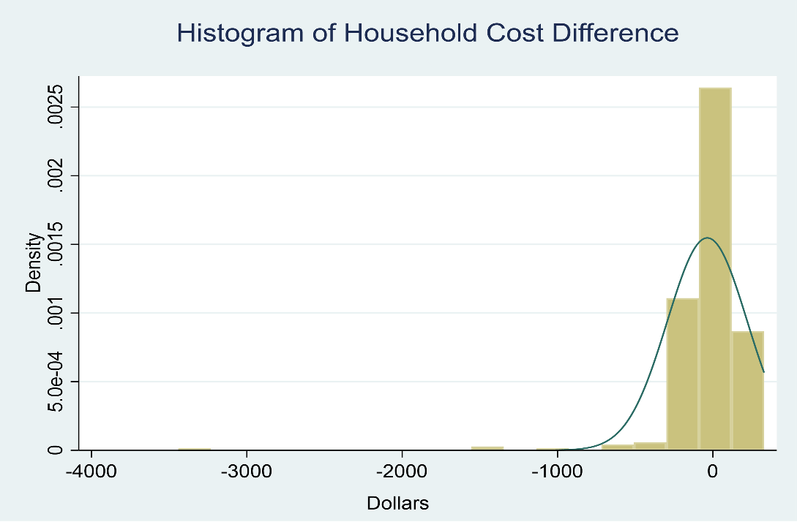

Supplemental Figure 2. Impact on household savings with a ±20% change in costs assumptions
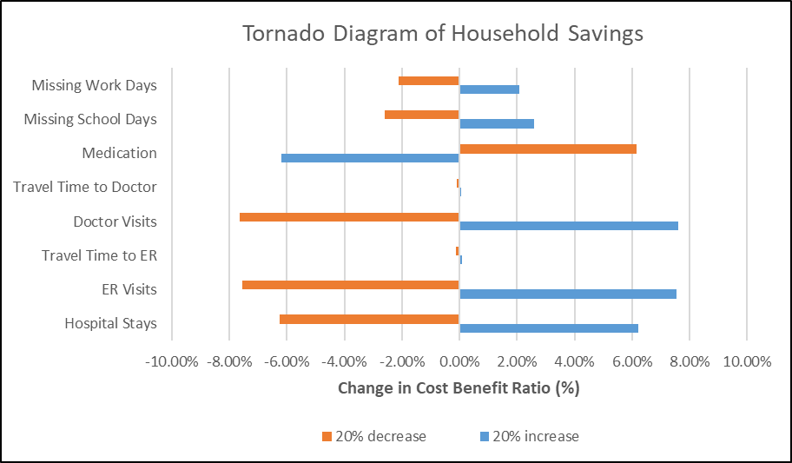
Notes: Each parameter is increased/decreased by 20% while all other parameters are held constant when calculating the new total cost benefit ratio. Baseline total cost benefit ratio = average total household cost difference/average cost of program per household (36.39/248.30=0.147).

