Table S1. Comparison of patients with REM-related OSA and NREM-related OSA
Feature | REM-related | NREM-related | P
Feature | (N=20) | (N=99) | P
Age (years) | 57.1 (52.7-62.2) | 53.1 (47.7-59.7) | 0.170
Male, n (%) | 13 (65.0) | 85 (85.9) | 0.026
BMI (kg/m²) | 27.4 (26.1-28.4) | 26.6 (24.0-28.7) | 0.145
Neck circumference (cm) | 38.5 (34.0-40.0) | 28.5 (36.0-40.0) | 0.798
Waist circumference (cm) | 95.0 (87.5-100.0) | 91.0 (86.0-97.5) | 0.192
ESS | 10.0 (8.5-15.0) | 9.0 (7.0-12.0) | 0.163
EDS, n (%) | 7 (43.8) | 34 (36.6) | 0.583
Polysomnographic parameter
REM (%) | 20.0 (14.3-24.3) | 17.1 (12.1-21.2) | 0.109
AHI (/h) | 27.6 (22.6-30.5) | 43.2 (32.5-57.4) | <0.001
≥ 30/h, n (%) | 6 (30) | 84 (84.8) | < 0.001
AHI_{REM} (/h) | 56.7 (49.2-62.7) | 46.3 (29.4-60.1) | 0.015
AHI_{NREM} (/h) | 19.4 (16.6-22.3) | 41.9 (32.5-57.2) | <0.001
CPAP pressure (cmH₂O) | 7.5 (6.0-12.0) | 9.0 (7.0-12.0) | 0.441
AHI_{MAD} (/h) | 10.9 (5.8-17.8) | 10.2 (4.6-20.7) | 0.980
AHI_{MAD} <5/h, reduction >50%, n (%) | 4 (20) | 26 (26.3) | 0.556
AHI_{MAD} <10/h reduction >50%, n (%) | 9 (45.0) | 47 (47.5) | 0.840
Data are presented as median (interquartile range) or number (percentage)
Abbreviations: BMI, body mass index; ESS, Epworth sleepiness scale; EDS, Excessive daytime sleepiness; REM (%), rapid eye movement percentage of total sleep time; AHI, apnea-hypopnea index; AHI_{REM}, apnea-hypopnea index during the rapid eye movement stage; AHI_{NREM,} apnea-hypopnea index during the non-rapid eye movement stage; CPAP, continuous positive airway pressure; AHI_{MAD}, residual apnea-hypopnea index under MAD treatment

Table S2. Univariate analysis to identify factors associated with CPAP pressure
Feature | All (N=128) |  |  | Sleep stage dependency (N=119) |  |  | Positional dependency (N=80)
Feature | β (95% CI) | B | P | β (95% CI) | B | P | β (95% CI) | B | P
Age | 0.019 (-0.048-0.085) | 0.050 | 0.578 | 0.033 (-0.036-0.103) | 0.087 | 0.347 | 0.027 (-0.061-0.114) | 0.069 | 0.543
Male | -0.212 (-1.964-1.541) | -0.021 | 0.812 | 0.044 (-1.810-1.898) | 0.047 | 0.962 | -0.022(-2.479-2.435) | -0.002 | 0.986
BMI | 0.233 (0.022-0.443) | 0.191 | 0.030 | 0.217 (-0.005-0.439) | 0.176 | 0.055 | 0.247 (-0.059-0.554) | 0.179 | 0.112
Neck circumference | 0.243 (0.042-0.444) | 0.214 | 0.018 | 0.217 (0.007-0.427) | 0.190 | 0.043 | 0.226 (-0.048-0.501) | 0.187 | 0.105
Waist circumference | 0.056 (-0.014-0.127) | 0.144 | 0.115 | 0.054 (-0.018-0.126) | 0.138 | 0.142 | 0.046 (-0.059-0.152) | 0.102 | 0.379
EDS | -0.128 (-1.571-1.314 | -0.016 | 0.860 | 0.016 (-1.511-1.542) | 0.002 | 0.984 | 0.629 (-1.376-2.634) | 0.073 | 0.534
REM (%) | -0.005 (-0.099-0.089) | -0.010 | 0.910 | -0.033 (-0.144-0.078) | -0.054 | 0.562 | -0.051 (-0.191-0.090) | -0.081 | 0.476
AHI | 0.059 (0.021-0.098) | 0.261 | 0.003 | 0.054 (0.012-0.096) | 0.230 | 0.012 | 0.085 (0.023-0.147) | 0.295 | 0.008
AHI_{REM} | 0.013 (-0.022-0.049) | 0.067 | 0.459 | 0.013 (-0.023-0.050) | 0.066 | 0.477 | −
AHI_{NREM} | 0.051 (0.016-0.086) | 0.251 | 0.004 | 0.047 (0.009-0.085) | 0.223 | 0.015 | −
AHI_{supine} | 0.036 (0.003-0.070) | 0.189 | 0.034 | − |  |  | 0.033 (-0.014-0.081) | 0.156 | 0.168
AHI_{non-supine} | 0.017 (0-0.035) | 0.187 | 0.051 | − |  |  | 0.021 (0-0.042) | 0.217 | 0.053
Sleep stage dependency | − |  |  | 0.054 (-0.871-0.979) | 0.011 | 0.908 | −
REM-predominant | − |  |  | -0.482 (-2.388-1.424) | -.0.047 | 0.617 | −
NREM-predominant | − |  |  | 1.461 (-0.752-3.673) | 0.122 | 0.194 | −
Stage-independent | − |  |  | Ref |  |  | −
Positional dependency | − |  |  | − |  |  | −
Supine-predominant | − |  |  | − |  |  | -0.925 (-2.726-0.876) | -0.115 | 0.310
Non-positional | − |  |  | − |  |  | Ref
Abbreviations: BMI, body mass index; EDS, Excessive daytime sleepiness; REM (%), rapid eye movement percentage of total sleep time; AHI, apnea-hypopnea index; AHI_{REM}, apnea-hypopnea index during the rapid eye movement stage; AHI_{NREM,} apnea-hypopnea index during the non-rapid eye movement stage; AHI_{supine}, apnea-hypopnea index during supine; AHI_{non-supine} apnea-hypopnea index during non-supine; REM, rapid eye movement; NREM, non-rapid eye movement; β, coefficient beta; B, Standardized β; Ref, reference.
Table S3. Univariate analysis to identify factors associated with the responder of MAD treatment
 | All (N=128) |  |  |  | Sleep stage dependency (N=119) |  |  |  | Positional dependency(N=80)
Feature | AHI_{MAD} <5/h, reduction >50% |  | AHI_{MAD} <10/h, reduction >50% |  | AHI_{MAD} <5/h, reduction >50% |  | AHI_{MAD} <10/h, reduction >50% |  | AHI_{MAD} <5/h, reduction >50% |  | AHI_{MAD} <10/h, reduction >50%
Feature | OR (95% CI) | P | OR (95%CI) | P | OR (95% CI) | P | OR (95% CI) | P | OR (95% CI) | P | OR (95% CI) | P
Age | 1.026 (0.985-1.069) | 0.211 | 0.990 (0.956-1.024) | 0.551 | 1.022 (0.979-1.066) | 0.319 | 0.984 (0.949-1.019) | 0.365 | 1.042 (0.985-1.102) | 0.154 | 0.979 (0.937-1.022) | 0.336
Man | 1.812 (0.568-5.782) | 0.315 | 1.275 (0.514-3.165) | 0.600 | 1.535 (0.473-4.984) | 0.476 | 1.229 (0.475-3.180) | 0.671 | 0.881 (0.213-3.636) | 0.860 | 1.149 (0.340-3.884) | 0.823
BMI | 0.743 (0.630-0.875) | <0.001 | 0.796 (0.697-0.908) | 0.001 | 0.727 (0.609-0.869) | <0.001 | 0.789 (0.685-0.907) | 0.001 | 0.766 (0.610-0.962) | 0.022 | 0.767 (0.638-0.923) | 0.005
Neck circumference | 0.891 (0.790-1.006) | 0.062 | 0.879 (0.786-0.983) | 0.024 | 0.861 (0.758-0.977) | 0.020 | 0.872 (0.776-0.979) | 0.021 | 0.820 (0.690-0.974) | 0.024 | 0.850 (0.735-0.984) | 0.030
Waist circumference | 0.935 (0.890-0.982) | 0.007 | 0.941 (0.901-0.983) | 0.006 | 0.929 (0.883-0.977) | 0.004 | 0.943 (0.903-0.985) | 0.008 | 0.905 (0.838-0.977) | 0.011 | 0.927 (0.872-0.985) | 0.015
EDS | 2.015 (0.890-4.564) | 0.093 | 0.972 (0.463-2.042) | 0.941 | 2.038 (0.866-4.797) | 0.103 | 0.952 (0.439-2.068) | 0.902 | 2.250 (0.749-6.760) | 0.149 | 0.975 (0.378-2.518) | 0.958
REM (%) | 1.017 (0.962-1.076) | 0.549 | 1.003 (0.956-1.053) | 0.888 | 1.024 (0.960-1.093) | 0.473 | 1.021 (0.965-1.081) | 0.467 | 1.109 (1.011-1.216) | 0.028 | 1.051 (0.978-1.128) | 0.174
AHI | 0.988 (0.964-1.013) | 0.337 | 0.973 (0.952-0.995) | 0.018 | 0.985 (0.959-1.012) | 0.287 | 0.972 (0.949-0.996) | 0.021 | 0.966 (0.924-1.010) | 0.124 | 0.932 (0.893-0.973) | 0.001
CPAP pressure | 0.885 (0.783-1.000) | 0.049 | 0.848 (0.763-0.943) | 0.002 | 0.874 (0.767-0.995) | 0.042 | 0.847 (0.759-0.945) | 0.003 | 0.745 (0.592-0.938) | 0.012 | 0.776 (0.657-0.915) | 0.003
Sleep stage dependency | − |  | − |  |  | 0.646 |  | 0.320 | − |  | −
REM predominant | − |  | − |  | 0.567 (0.173-1.863) | 0.350 | 0.799 (0.300-2.125) | 0.653 | − |  | −
NREM predominant | − |  | − |  | 0 | 0.998 | 0.391 (0.114-1.343) | 0.136 | − |  | −
Stage-independent | − |  | − |  | Ref |  | Ref |  | − |  | −
Positional dependency | − |  | − |  | − |  | − |  | − |  | −
Supine-predominant | − |  | − |  | − |  | − |  | 6.641 (1.732-25.465) | 0.006 | 1.680 (0.684-4.126) | 0.258
Non-positional | − |  | − |  | − |  | − |  | Ref |  | Ref
Abbreviations: BMI, body mass index; EDS, Excessive daytime sleepiness; REM (%), rapid eye movement percentage of total sleep time; AHI, apnea-hypopnea index; CPAP, continuous positive airway pressure; Ref, reference.

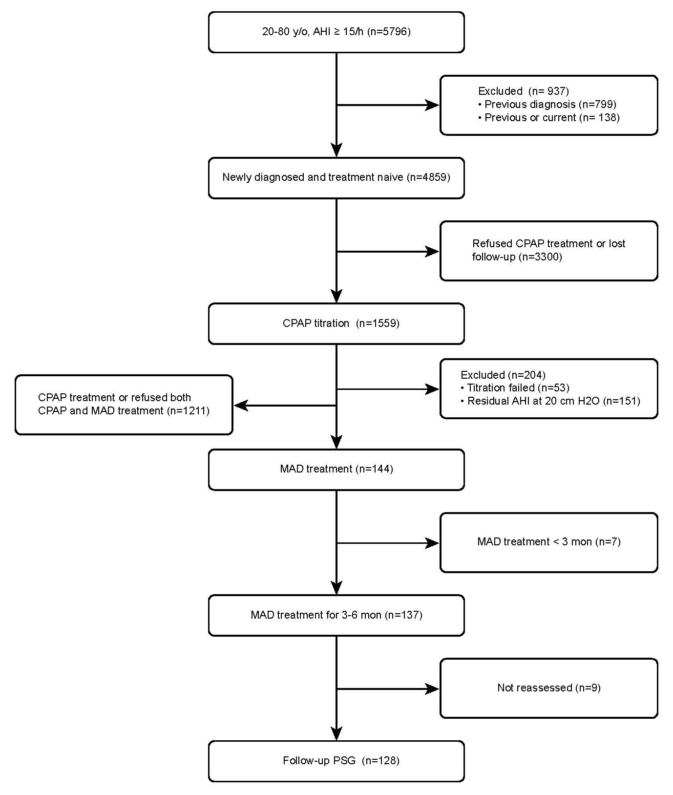
Figure S1. Trial flowchart. Abbreviations: AHI, apnea-hypopnea index; CPAP, continuous positive airway pressure; MAD, mandibular advancement device

