Supplementary materials

Screening of Chitosan Derivatives-carbon Dots Based on Antibacterial Activity and Application in Anti-Staphylococcus aureus Biofilm
Dan Zhao,*^{1,2} Rui Zhang,^{1,2} Xuemei Liu,^{1,2} Xiaoyun Li,^{1,2} Mengyu Xu,^{1,2} Xianju Huang,^{1,2} Xincai Xiao^{1,2}

¹ School of Pharmaceutical Sciences, South-Central University for Nationalities, Wuhan 430074, P. R. China; ² National Demonstration Center for Experimental Ethnopharmacology Education (South-Central University for Nationalities), Wuhan 430065, P. R. China.

Experimental section

Chemicals and materials
MH broth was obtained from Gaokeyuan Haibo Biotechnology Co., Ltd (Qingdao, China). 3-(4,5-Dimethylthiazol-2-yl)-2,5-diphenyltetrazolium bromide (MTT) came from Sigma-Aldrich. Fetal Bovine Serum (FBS) was provided by Sijiqing Company (Hangzhou, China). 3-(4,5-Dimethylthiazol-2-yl)-2,5-diphen-yltetra-zolium bromide (MTT) was acquired from Sigma-Aldrich (Shanghai, China). Dulbecco's modified Eagle's medium (DMEM) was purchased from Gibco (Carlsbad, CA, USA). Trypsin, Dulbecco phosphate-buffered saline (D-PBS) was acquired from HyClone Company (Logan, Utah, USA). Normal human hepatocyte line (LO2 cells) was provided by the Cell Bank of Chinese Academy of Sciences (Shanghai, China). Anticoagulant rabbit whole blood was obtained from Jushi Biotechnology Co., Ltd (Henan, China). Phosphate buffered saline (PBS; containing 10 mM Na ₂ HPO₄, 2.0 mM KH₂PO₄, 137 mM NaCl, and 5.0 mM KCl) served to prepare different pH solutions.

Synthesis method of different CDs
The synthesis procedure of CS-CDs is as follows: 200 mg of CS was dissolved in 20 mL 1% acetic acid. The synthesis procedure of CMCS-CDs is as follows: 200 mg of CMCS was dissolved in 20 mL DI water.
QCS-CDs are synthesized in one step by solvothermal method. The synthesis procedure of QCS-CDs is as follows: 200 mg of QCS was dissolved in 20 mL DI water and the mixture was then transferred into 25 mL Teflon-lined stainless-steel autoclave and kept at 200 °C for 4h. The synthesis methods of other CDs are in the supplementary material.
The synthesis procedure of QCS-CA-CDs is as follows: 200 mg of QCS and 50 mg citric acid (CA) were dissolved in 20 mL DI water. The mixture was then transferred into 25 mL Teflon-lined stainless-steel autoclave and kept at 200 °C for 4h.
The synthesis procedure of QCS-FO-CDs is as follows: 200 mg of QCS was dissolved in 10 mL DI water and 10 mL formamide. All the mixture was then transferred into 25 mL Teflon-lined stainless-steel autoclave and kept at 200 °C for 4 h.

QYs measurement
The QYs of QCS-EDA-CDs were calculated by comparing the integrated PL intensities and absorbance values of the samples (λ_{ex} = 370 nm), with quinine sulfate (dissolved in 0.1 mol/L H₂SO₄ aqueous solution (refractive index (η) of 1.33)) as the standard (QYs = 54%). All samples dissolved in water have absorbance less than 0.1 at 370 nm. The relative QYs can be calculated by the following equation¹:
Q_{S}=Q_{R}(I_{S}/I_{R})(A_{R}/A_{S})( η_{S}²/η_{R}²) (1)
where subscripts Q is QYs, I_{S} and I_{R} are the integrated emission intensity of the sample and the reference, A is the absorbance at the excitation wavelength and η is the solvent refraction index.

Antibacterial activity of CDs
Antibacterial kinetic data for CDs against S. aureus were calculated. The S. aureus bacteria were cultured to mid-logarithmic phase via Mueller-Hinton (MH) broth media to acquire 10⁷ CFU/mL. Bacterial suspension was incubated at varying concentrations of CDs for different time. Growth curves that described variation of OD₆₀₀ over time were gathered upon 24-hour incubation at 37 °C. The growth curves were recorded by 96-well plates with the microplate reader.
The antibacterial properties of the prepared CDs were verified using the MTT method. In brief, S. aureus, E. coli and MRSA were incubated with sterilized MH broth medium, respectively. Subsequently, the bacterial cells were inoculated on one 96-well plate. Every solution well on the 96-well microplate contained 50 μL bacterial cell suspension (10⁷ CFU/mL) and CDs at varying concentrations in 50 μL medium in an ultimate volume of 100 μL/well. The control was the bacterial suspension in 100 μL medium with no CDs, and the blank was merely 100 μL medium. After 30 minutes of exposure under daylight lamp, the 96-well microplates were cultured at 37 °C (bacteria) in 12 h. Next, 5 μL of 5 mg/mL MTT solution was introduced into every well to be continually incubated (20 min). Eventually, 150 μL DMSO was moved to each well, and the experiment was repetitively conducted thrice.

Genomic DNA and protein processing method
Two equal parts of 200 µL genomic DNA for S. aureus were diluted in 100 µL 0.01 M PBS and 20 µg /mL QCS-EDA-CDs solution to the same concentration, and afterwards received heating treatment using 95 °C water bath in 10 min, and stirred at 37 °C in 4 h. Genomic DNA was preserved at 4 °C prior to circular dichroism spectrum analysis.
S. aureus protein was performed following specifications for bacterial total protein extraction kit. Two equal parts of 200 µL protein were diluted in 100 µL 0.01 M PBS and 100 µg/mL QCS-EDA-CDs solution to the same concentration, and stirred at 37 °C in 4 h. Protein was preserved at 4 °C prior to circular dichroism spectrum analysis.

MTT assay
The bio-cytotoxicity in QCS-EDA-CDs was measured using standard MTT assay. LO2 cells were inoculated at 10⁵ cells/well density on 96-well plates and then pre-cultured in 24 h via the DMEM medium having 10% FBS (37 °C, 5% CO₂). Afterwards, QCS-EDA-CDs were dissolved in DMEM medium to the required concentration (0, 1, 10, 50, 100 and 200 µg/mL) and cultured in 24 h. Then, 20 µL of 5 mg/mL MTT solution was introduced into every well for incubation in 4 h, and the culture medium with MTT was discarded. Next, 150 µL DMSO was moved to each cell well and the plates were stirred in 10 min. The optical density (OD) in the solution was measured at 490 nm. Cell viability was assessed using the equation below²:
Cell viability (%) = OD/OD₀ × 100% (2)
where OD refers to the absorbance in the experimental group (OD was acquired with QCS-EDA-CDs) and OD₀ indicates the absorbance in the control group (OD₀ was acquired with QCS-EDA-CDs).

Hemolysis assay
Solutions at varying QCS-EDA-CDs concentrations (10, 50, 100, 250 and 500 µg mL⁻¹) were produced using Dulbecco's phosphate buffer (D-PBS) and preserved at 37 °C in 30 min. Fresh rabbit whole blood underwent centrifugation at 9000 rpm in 3 min. Upon removal of the supernatant, the lower-level RBCs were rinsed by D-PBS. CD solutions at varying concentrations were poured to dilute RBCs (0.2 mL) to 1 mL. The mixed sample was cultured at 37 °C in 3 h. Next, the sample was centrifuged; the supernatant was moved to the 96-well plate, with absorbance read at 570 nm to measure the average in three measurements. Blood samples received treatment using deionized water and D-PBS with the same method like positive and negative controls, respectively. The hemolysis rate was measured by eq. (3) ³:
Hemolysis rate (%) = [(OD_{t} - OD_{n}) / (OD_{p} - OD_{n})] ×100% (3)
where OD_{t}, OD_{n} and OD_{p} refer to absorbance values in the test sample, negative control group and positive control group.

SEM images for biofilm
The morphological assessment for bacterial biofilm was made using SEM. In brief, mature biofilm of S. aureus was rinsed thrice in PBS buffer solution (pH=7.4) to remove planktonic bacteria and excess medium, and then repeat the above steps. Then the biofilm were cultured by PBS or QCS-EDA-CDs (800 mg/mL) in 4 h and gathered through centrifugation at 8,000 rpm in 5 min. The gathered bacteria were immersed within glutaraldehyde (2.5%) at 4 °C in 12 h. Bacteria samples were rinsed again in PBS thrice. Then, biofilm underwent sequential dehydration in alcohol solutions (30, 50, 70, 80, 90 and 100%) in 15 min step by step. The ultimate suspension was dropped on the glass slide for air drying. Prior to the experiment, glass slides were sprayed by gold and screened using SEM.

Results and discussion
Figure S1 (a) The UV-Vis absorption and fluorescence spectrum of CS-CDs. (b) The UV-Vis absorption and fluorescence spectrum of CMCS-CDs. (c) The UV-Vis absorption and fluorescence spectrum of QCS-CDs. Insets: CS-CDs, CMCS-CDs and QCS-CDs solutions under daylight (left) and 365 nm UV lamp (right).
Figure S2 Zeta potential curves obtained for water suspensions of (a) CS, (b) CMCS, (c) QCS, (d) CS-CDs, (e) CMCS-CDs and (f) QCS-CDs.
Figure S3 (a) The UV-Vis absorption and fluorescence spectrum of QCS-FO-CDs. Insets: QCS-FO-CDs solutions under daylight (left) and 365 nm UV lamp (right). (b) Zeta potential curves obtained for water suspensions of QCS-FO-CDs. (c) FTIR spectra of QCS-EDA-CDs and QCS-FO-CDs.
Figure S4 Inhibition effect of different concentrations of QCS-EDA-CDs on the growth of S. aureus as a function of incubation time.
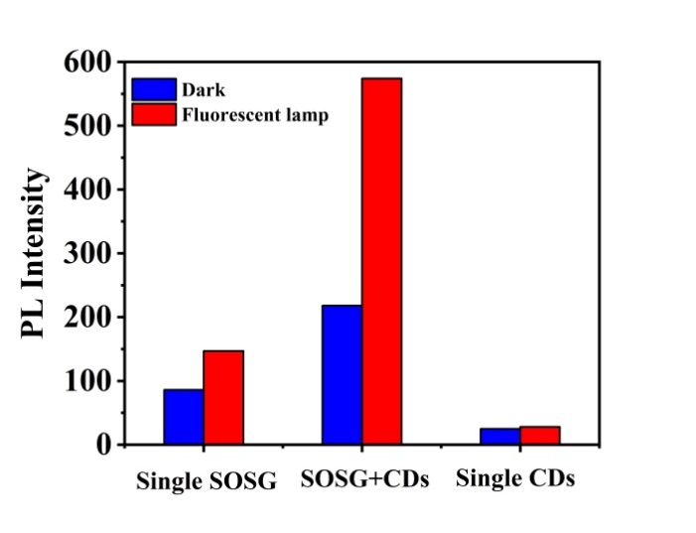
Figure S5 Different PBS solutions (containing 2.5 μM SOSG; 2.5 μM SOSG and 1 mg/mL QCS-EDA-CDs; 1 mg/mL QCS-EDA-CDs) changes in fluorescence intensity before and after the daylight lamp is irradiated for 30 min.

- Li H, Xu Y, Zhao L, Ding J, Chen M, Chen G, Li Y, Ding L. Synthesis of tiny carbon dots with high quantum yield using multi-walled carbon nanotubes as support for selective “turn-off-on” detection of rutin and Al³⁺. Carbon. 2019;143:391-401. doi: 10.1016/j.carbon.2018.11.049
- Yang X, Wang Y, Shen X, Su C, Yang J, Piao M, Jia F, Gao G, Zhang L, Lin Q. One-step synthesis of photoluminescent carbon dots with excitation-independent emission for selective bioimaging and gene delivery. J. Colloid Interface Sci. 2017;492:1-7. doi: 10.1016/j.jcis.2016.12.057
- Li S, Guo Z, Zhang Y, Xue W, Liu Z. Blood compatibility evaluations of fluorescent carbon dots. ACS Appl. Mater. Interf. 2015;7:19153-19162. doi: 10.1021/acsami.5b04866

