Table S1 Primer sequences
Gene | Primers
GAPDH | Forward: 5’-CTCCTCCTGTTCGACAGTCAGC-3’
GAPDH | Reverse: 5’-CCCAATACGACCAAATCCGTT-3’
ALCAM | Forward: 5’-TGAGGCAGACGAGATAAGTGATGA-3’
ALCAM | Reverse: 5’- ACCGAGGTCCTTGTTTACATGTTT-3’
ALCAM, activated leukocyte cell adhesion molecule； GAPDH, glyceraldehyde-3-phosphate dehydrogenase
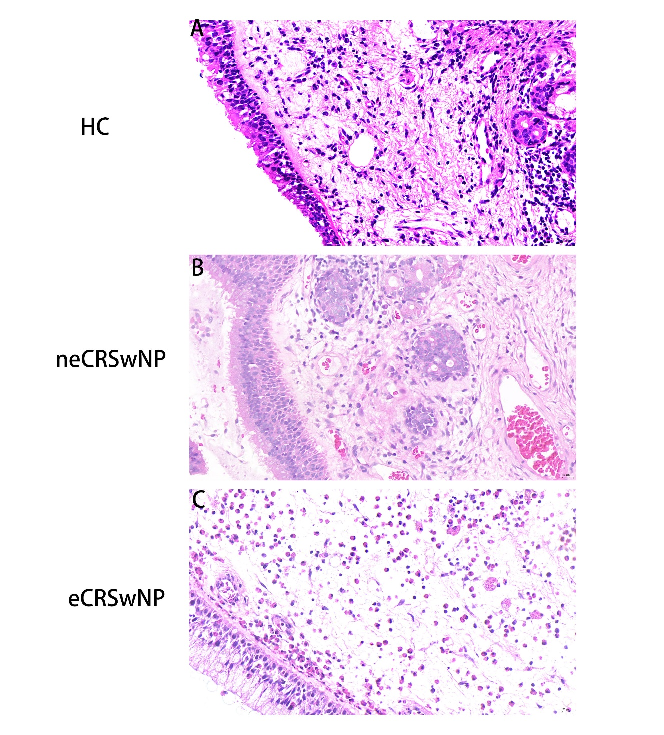
Figure S1. Representative H&E staining of eCRSwNP, neCRSwNP, and HC. (A) eCRSwNP, (B) neCRSwNP, (C) HC. eCRSwNP, eosinophilic chronic rhinosinusitis with nasal polyps; neCRSwNP, non-eosinophilic chronic rhinosinusitis with nasal polyps; HC, healthy control; H&E, hematoxylin and eosin; HPF, high-power field

