Section 1

Title: Conjugation of Anti-CD11b with TCO-NHS ester to produce Anti-CD11b-TCO at DAR 6-9.
Purpose:
To produce Anti-CD11b-TCO at DAR 6-9.
Reagents and Materials:
NO. | Reagent | Manufacturer
1 | Purified Rat Anti-Mouse CD11b | BD PharmingenTM , Cat #: 553308, Lot: 7139902
2 | TCO-NHS ester | Click Chemistry Tools, Prod# 1016
3 | DMF | J&Kseal, Cat #: 983353, Lot: LGA0S92
4 | NaHCO₃ | Sigma, S5761 lot#: SLBR9495V
5 | PNGase F | BioLabs. Inc., NEB-P0705L
Conjugation buffer: PBS, pH 7.2, 0.5M NaHCO3, pH8.9
Storage buffer: PBS, pH 7.4.
Instruments and equipment
No. | Equipment | Manufacturer/Model
1 | LC-MS | Agilent Technologies, HPLC 1260 / 6224 TOF
2 | Column for LCMS | Agilent Technologies, PLRP-S, 1000A 8 µm 50*2.1 mm, PL1912-1802
3 | SEC-HPLC | Agilent Technologies, 1260
4 | SEC column | TOSOH , TSKgel G3000SWXL, 7.8×300 mm, 5 μm, 08541
5 | NanoDrop One | ThermoScientific, 1294881
6 | Amicon Ultra Centrifugal Filter Units | Millipore, 4 mL, 30 KD , UFC803024
7 | ZebaTM Spin Desalting column | Thermo Scientific, 2 mL, 40 K, 275772
Procedure:
- The 0.5 mg/mL Anti-CD11b mAb (8 mL, 4 mg) was concentrated using 4 mL 30KD ultrafilter spin device at 4000 g to about 0.8 mL. After concentration, obvious precipitation was observed and the precipitate could not be re-dissolved by the flow-through buffer. So the mAb containing suspension was centrifuged and the supernatant (0.83 mL) was used for conjugation.
- The original 0.5 mg/mL mAb was tested by UV-VIS to calculate the extinction coefficient of the mAb.
Date | Sample Name | Baseline Correction (nm) | 280 nm
12/9/2019 13:52 | Blank_FT 1 | 0.00 abs @ 750.00nm | 0.01
12/9/2019 13:53 | 871-0.5mg/mL 1 | 0.00 abs @ 750.00nm | 0.96
12/9/2019 13:53 | 871-0.5mg/mL 2 | 0.00 abs @ 750.00nm | 1.25
12/9/2019 13:56 | 871-0.5mg/mL 3 | 0.00 abs @ 750.00nm | 1.19
The calculated extinction coefficient was 2.267 (mg/mL)⁻¹cm⁻¹.
- mAb concentration was tested with NanoDrop One at EC280 2.267:
Date | Sample Name | Baseline Correction (nm) | 280 nm
12/12/2019 14:19 | Blk 1 | 0.00 abs @ 750.00nm | 0.03
12/12/2019 14:21 | Anti-CD11b_combine 1 | 0.00 abs @ 750.00nm | 6.19
12/12/2019 14:24 | Anti-CD11b_combine 2 | 0.00 abs @ 750.00nm | 6.24
Thus concentration of Anti-CD11b mAb after concentration was 2.74 mg/ml. Total amount was 2.27 mg.
- 1.8 mg of NHS-TCO ester was dissolved in 180 μL DMF to make 10 mg/ml stock, Mw: 267.28 g/mol. 50 μL of 10 mg/ml stock solution was 2.5-fold diluted with 75 μL of DMF to 4 mg/mL.
- Conjugation of NHS-TCO with Anti-CD11b mAb was performed according to the following feeding table:
Lot# | Scale  (mg) | mAb  Conc. (mg/mL) | DMF  % | TCO/Ab  Ratio | V_{mAb}  (μL) | V_{NaHCO3} (μL) | V_{DMF}  (μL) | V_{TCO}  (μL) | Total Vol (μL)
WBP871-20191216 | 2 | 2.24 | 0.1 | 50 | 730 | 81.1 | 36.6 | 44.4 | 810.6
81.1 μL of 0.5M NaHCO₃ pH 8.9 buffer was added to 730 μL (2 mg, 1equv.) of Anti-CD11b mAb to make pH at 8.9 in the reaction. Then 36.6 μL of DMF (10%) and 44.4 μL (50 equiv.) of TCO-NHS solution (4 mg/mL) was added successively to the reaction. The reaction was incubated at 22℃ avoiding light for 2 hours.
- After 2 hrs, the conjugation was purified with Zeba Spin desalting column (2 mL, 40K) using PBS, pH 7.4 as purification buffer. 0.76 mL of product was collected.
Results:
- UV-vis for concentration determination
Concentration was determined by measuring the absorption at 280 nm and calculated using EC280 2.267 (mg/mL)⁻¹cm⁻¹.
Date | Sample Name | Baseline Correction (nm) | 280 nm
12/16/2019 13:36 | Blank 1 | 0.00 abs @ 750.00nm | 0
12/16/2019 13:44 | Anti-CD11b_TCO 1 | 0.00 abs @ 750.00nm | 4.07
12/16/2019 13:44 | Anti-CD11b_TCO 2 | 0.00 abs @ 750.00nm | 4.06
12/16/2019 13:45 | Anti-CD11b_TCO 3 | 0.00 abs @ 750.00nm | 4.02
The concentration of the product was 1.79mg/mL. Total amount was 1.644 mg.
- Aggregation determination by SEC-HPLC
Size-exclusion chromatography was performed using an Agilent 1260 series HPLC system with the TSK gel G3000SWXL Size-exclusion chromatography column (7.8×300 mm, 5 μm) at 25°C. The mobile phase was consisted of 78 mM KH₂PO₄, 122 mM K₂HPO₄, 250 mM KCl, 15% IPA at pH 7.0±0.1. The flow rate was set at 0.75 mL/min. Sample loading was 50 μg per injection. Sample was detected at 280 nm with a UV detector. The retention time of the aggregation peak was recorded based on its relative molecular weight. SEC result was shown below:
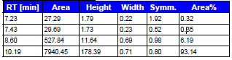
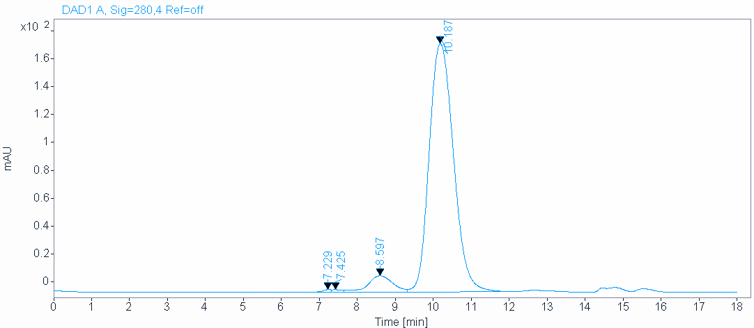
Thus aggregation level of this product was 6.86% and purity was 93.14%.
- DAR determination by LC-MS
40 ug of the conjugation sample was diluted to 100 μL using PBS, pH 7.2. Then 1 μL of PNGase F was added. The mixture was incubated at 37ºC overnight. 3 ug of deglycosylated sample was applied to LC-MS and DAR was calculated based on the peak abundance of the deconvoluted Mass. LC-MS result was shown below:
Species | Expected | Observed | Abundance
TCO | 152 | NA | NA
mAb | 147054.77 | NA | NA
mAb+1*LD | 147206.77 | NA | NA
mAb+2*LD | 147358.77 | 147340.9 | 11.74
mAb+3*LD | 147510.77 | 147496.28 | 68.06
mAb+4*LD | 147662.77 | 147649.22 | 270.72
mAb+5*LD | 147814.77 | 147798.41 | 476.35
mAb+6*LD | 147966.77 | 147950.75 | 723.25
mAb+7*LD | 148118.77 | 148110.09 | 725.89
mAb+8*LD | 148270.77 | 148261.17 | 708.63
mAb+9*LD | 148422.77 | 148406.19 | 500.73
mAb+10*LD | 148574.77 | 148558.88 | 383.74
mAb+11*LD | 148726.77 | 148717.83 | 178.23
mAb+12*LD | 148878.77 | 148865.87 | 117.53
mAb+13*LD | 149030.77 | 149020.26 | 51.47
mAb+14*LD | 149182.77 | 149173.11 | 21.52
DAR |  |  | 7.43
4. The conjugation was diluted with 0.8 mL of PBS, pH7.4 buffer and filtered with 0.22 μm filter. Concentration was determined by UV-VIS.
Date | Sample Name | Automated Pathlength | Baseline Correction (nm) | 280 nm
12/18/2019 13:46 | blank 1 | OFF | 0.00 abs @ 750.00nm | 0
12/18/2019 13:47 | Anti-CD11b-TCO 1 | OFF | 0.00 abs @ 750.00nm | 1.97
12/18/2019 13:48 | Anti-CD11b-TCO 2 | OFF | 0.00 abs @ 750.00nm | 1.95
The concentration of the final product was 0.86 mg/mL. Total amount was 1.32mg.
Summary
Lot# | Sample Name | Conc. (mg/mL) | Amount (mg) | Aggr. % | Purity % | DAR
WBP871-20191216 | Anti-CD11b-TCO | 0.86 | 1.32 | 6.86 | 93.14 | 7.43

Section 2

Title: Synthesis of HYNIC-PEG11-Tz.
Purpose:
To produce HYNIC-PEG11-Tz.

Synthesis of HYNIC-PEG₁₁-Tz
Synthetic Summary:

General procedure for preparation of compound 3
To a solution of compound 1 and compound 2 in DCM (2.50 mL) was added TEA (339 mg, 3.35 mmol). The mixture was stirred at 20 °C for 1 h. The reaction was monitored by TLC, it was showed the starting material consumed. Then the mixture was removed in vacuum. The crude product was purified by column chromatography on silica gel (100-200 mesh size) using DCM/MeOH (50:1) as eluent to give compound 3 (250 mg, 70.5% yield) as a red solid.

General procedure for preparation of compound 4
To a solution of compound 3 in DCM (5.00 mL) was added HATU (176 mg, 465 umol) and DIEA (150 mg, 1.16 mmol) , stirred at 20 °C for 15 min, then NH2-PEG11-NHBoc (250 mg, 387 umol) was added to the mixture, stirred at 20 °C for another 1 h. The reaction was monitored by TLC, it was showed the starting material consumed. Then the mixture was removed in vacuum. The residue was purified by prep-TLC (SiO₂, DCM: MeOH = 10:1) to give compound 4 (320 mg, 81.7% yield) as a red oil.

LCMS of compound 4:
Charomatograms
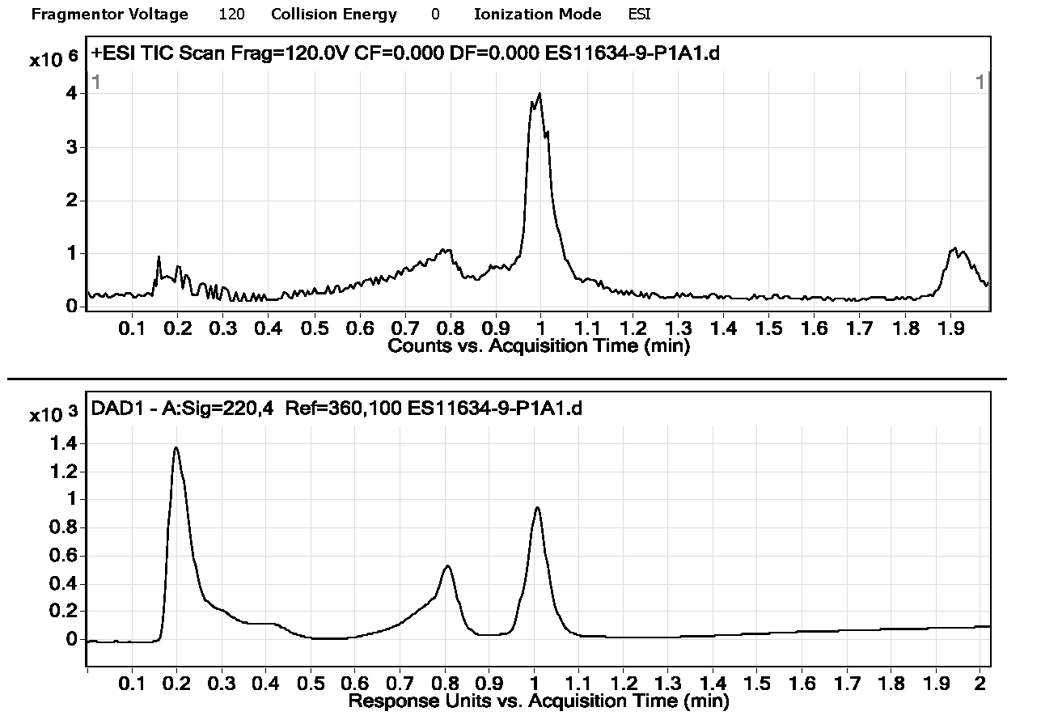

Spectra
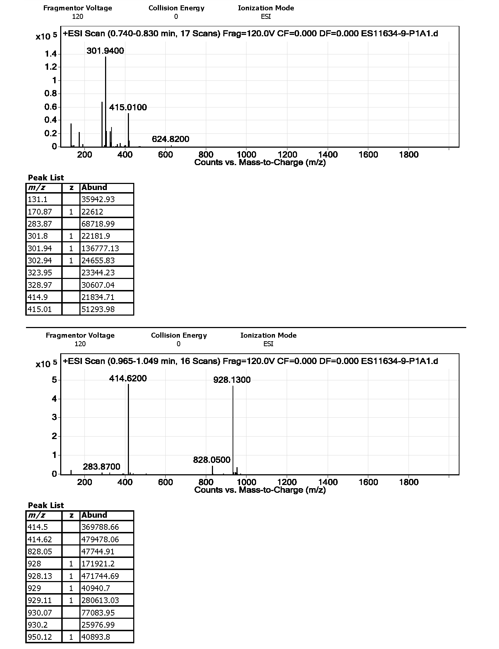

General procedure for preparation of compound 5
To a solution of compound 4 (320 mg, 344 umol) in EtOAc (3.00 mL) was added HCl/EtOAc (4.00 M, 86.2 uL) .The mixture was stirred at 20 °C for 30 min. The reaction was monitored by TLC, it was showed the starting material consumed. The mixture was removed in vacuum and the crude product was not purified and used for next step directly to give compound 5 (260 mg, 81.9% yield) as a red oil.
LCMS of compound 5:
Charomatograms
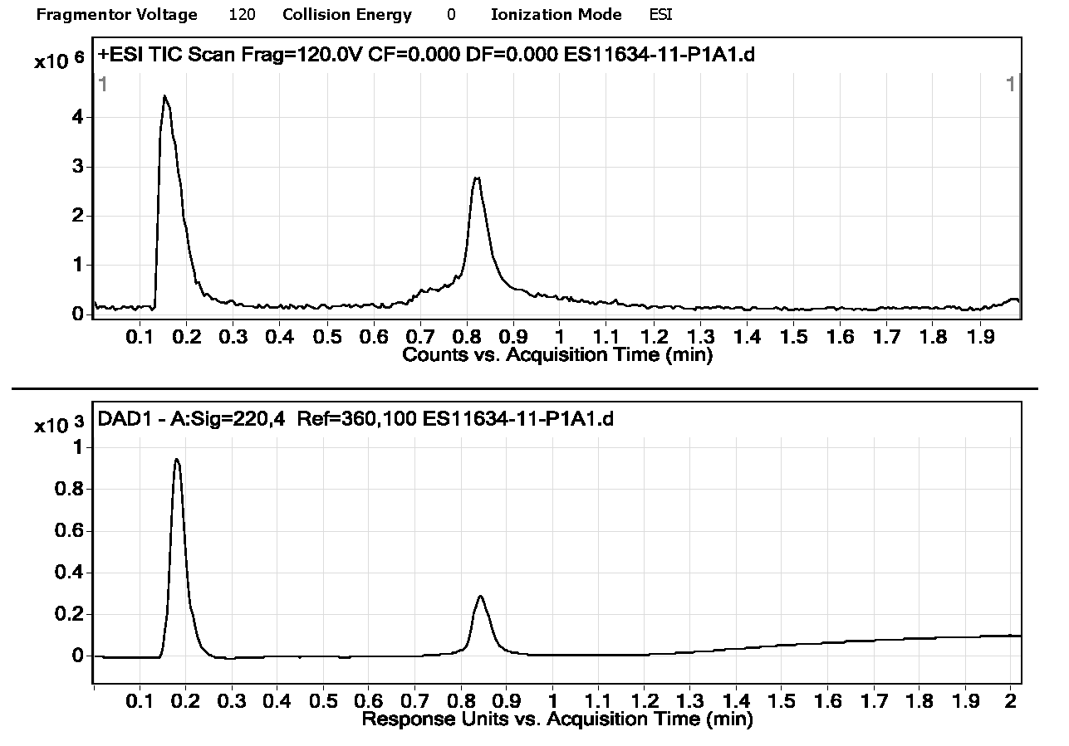
Spectra
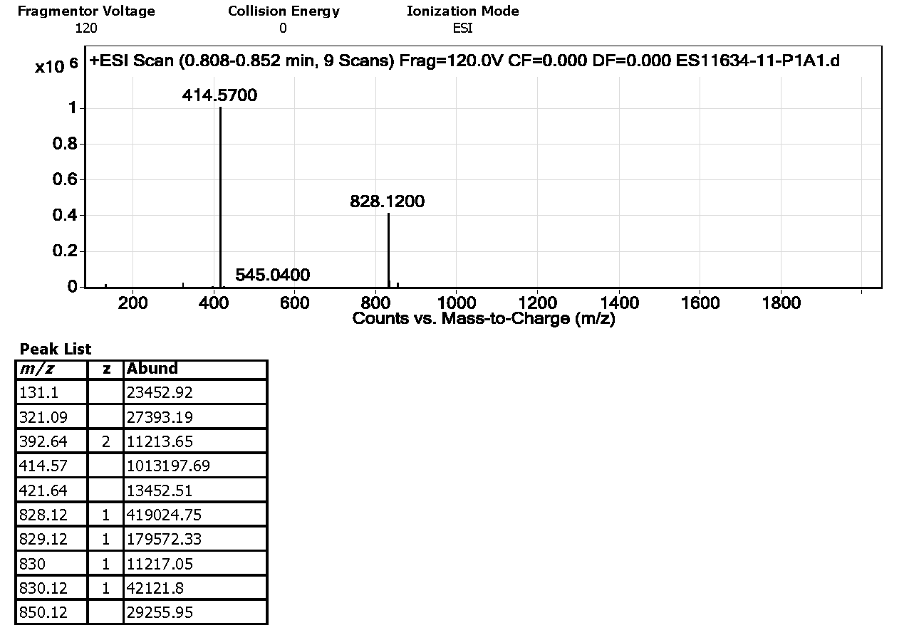
General procedure for preparation of compound 6

To a solution of compound 6 (159 mg, 628 umol) in DMF (2 mL) was added HATU (143 mg, 376 umol) and DIEA (162 mg, 1.26 mmol), stirred at 20 °C for 15 min, then compound 5 (260 mg, 314umol) was added to the mixture, stirred at 20 °C for another 1 h. The reaction was monitored by TLC, it was showed the starting material consumed. The mixture was removed in vacuum. The residue was purified by prep-TLC (SiO2, DCM: MeOH = 10:1) to give compound 7 (300 mg, 86.53% yield) as a red oil.

LCMS of compound 7
Charomatograms
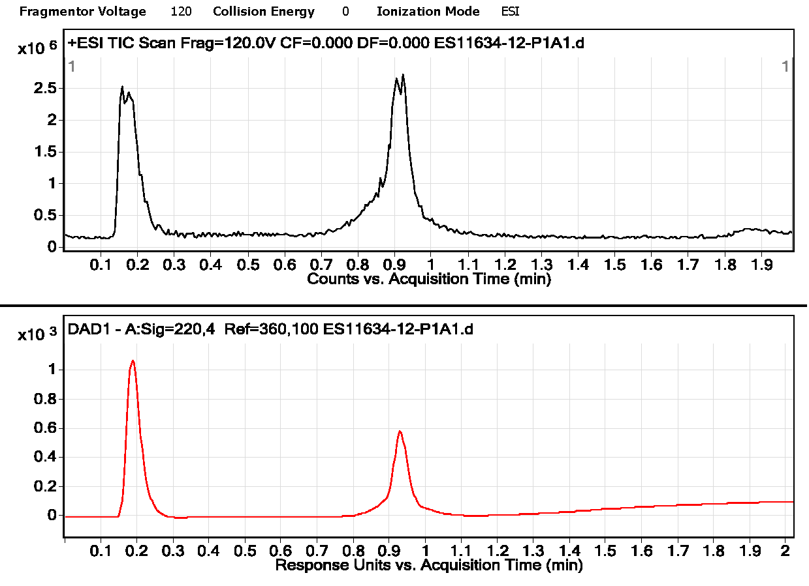

Spectra
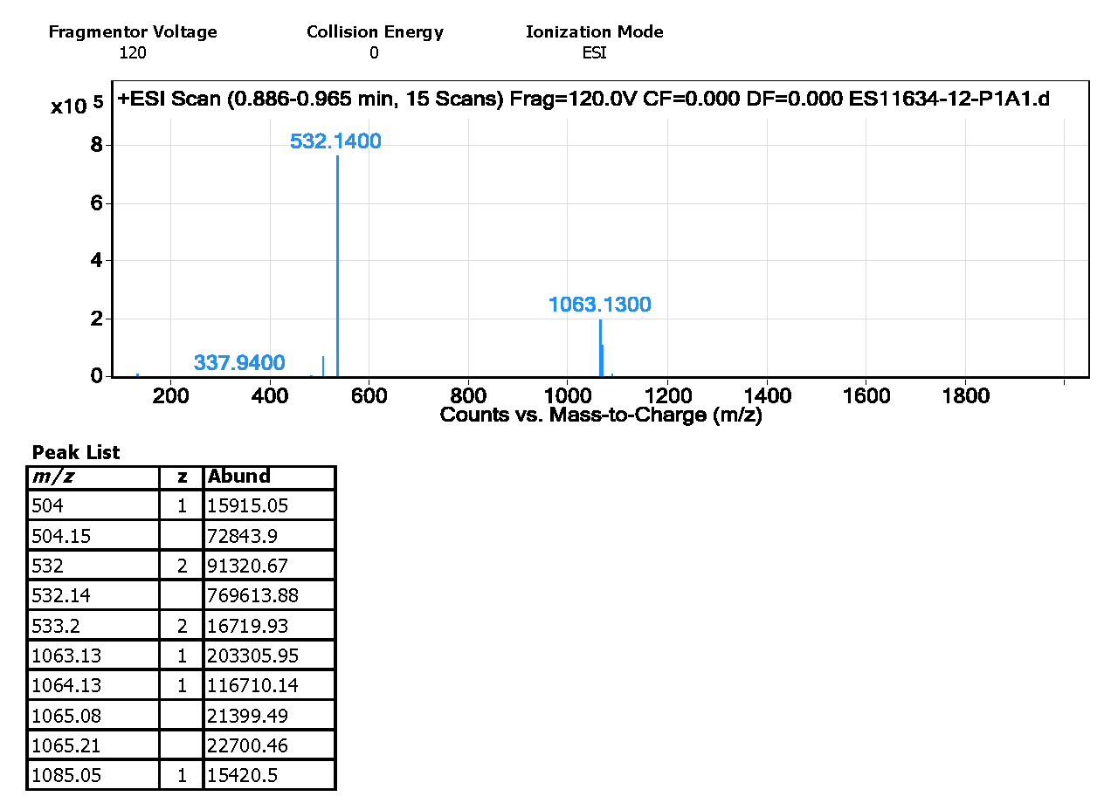
General procedure for preparation of C18122916
To a solution of compound 7 (300 mg, 282 umol) in EtOAc (3.00 mL) was added HCl/EtOAc (4 M, 3.00 mL) .The mixture was stirred at 20 °C for 30 min. LCMS showed starting material was consumed, LCMS showed the desired mass. The mixture was removed in vacuum. The residue was purified by prep-HPLC (TFA condition) to give C18122916 (133 mg, 44.0% yield, 90.0% purity) as s red solid.

