Supplementary figure S1. Outline of HIFU treatment lines, exposure parameters, and the expected consequential lifting effects (arrows).
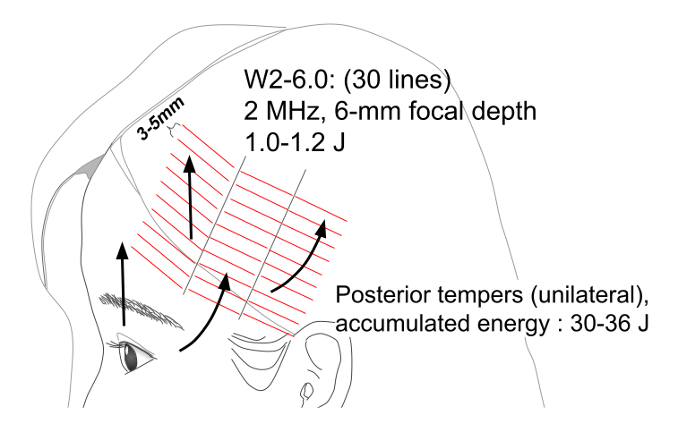
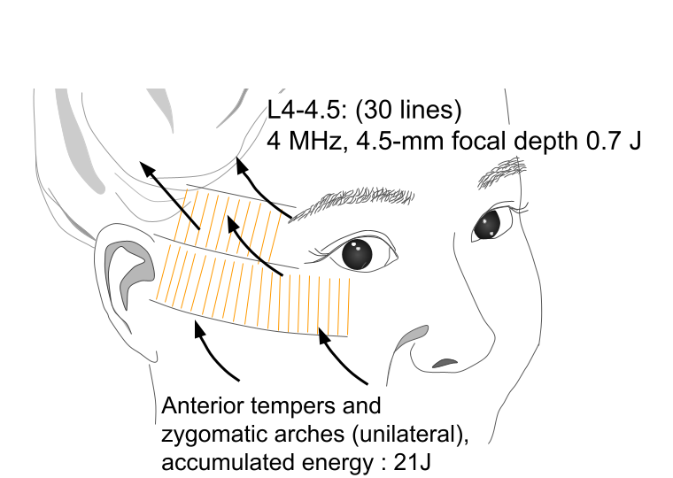
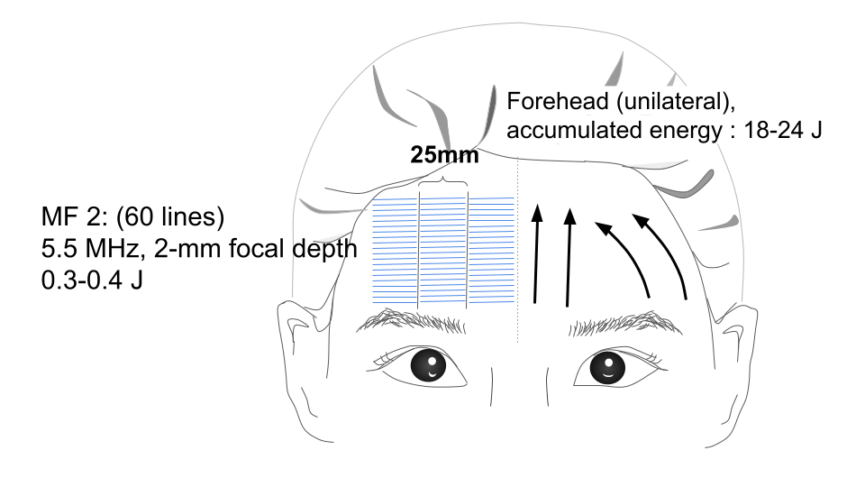

The procedure was repeated on the collateral side. The total treatment included 240 exposure lines, and each session lasted 15–20 min. The total accumulated facial energy was 138–162 J. MHz: megahertz, J: joule, mm: millimeter.

Supplementary figure S2. Results of the angular assessment presented in a boxplot.
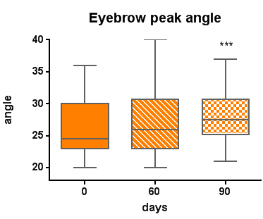 | 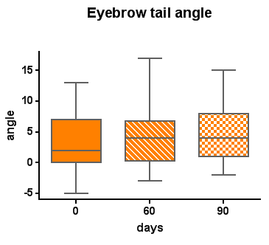
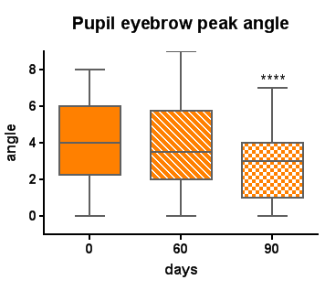 | 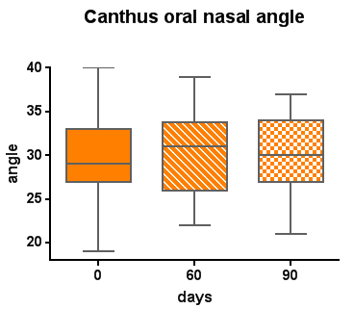
X-axis: days of treatment; Y-axis: angle. *** means p< 0.001 and **** means p <0.0001.

Supplementary figure S3. Results of the linear assessment presented in a boxplot.
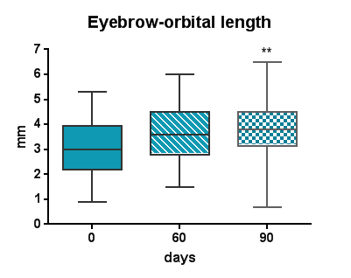  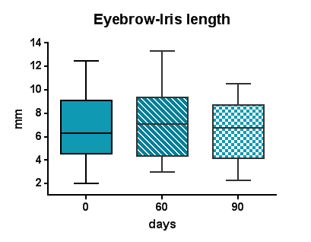 | 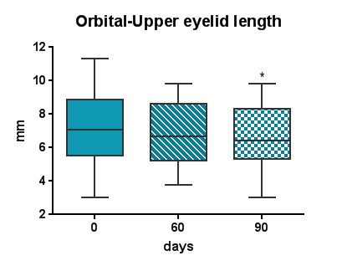  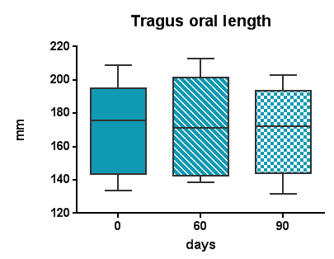 | 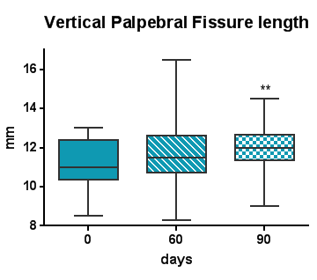
X-axis: days of treatment; Y-axis: mm, millimeter. * means p <0.05 and ** means p <0.01.

Supplementary table S1.Thirteen designed facial landmarks.
Landmarks | Definitions
Ei | inferior border of eyebrow
Os | superior orbital rim
Ps | superior palpebral fissure
Pi | inferior palpebral fissure
Il | lateral limbus of iris
Eh | eyebrow head
Ep | eyebrow peak
Et | eyebrow tail
Pu | center of pupil
Na | lateral end of nasal ala
Cl | lateral canthus
Oc | Oral commissure
Tr | Tragus

