Appendix

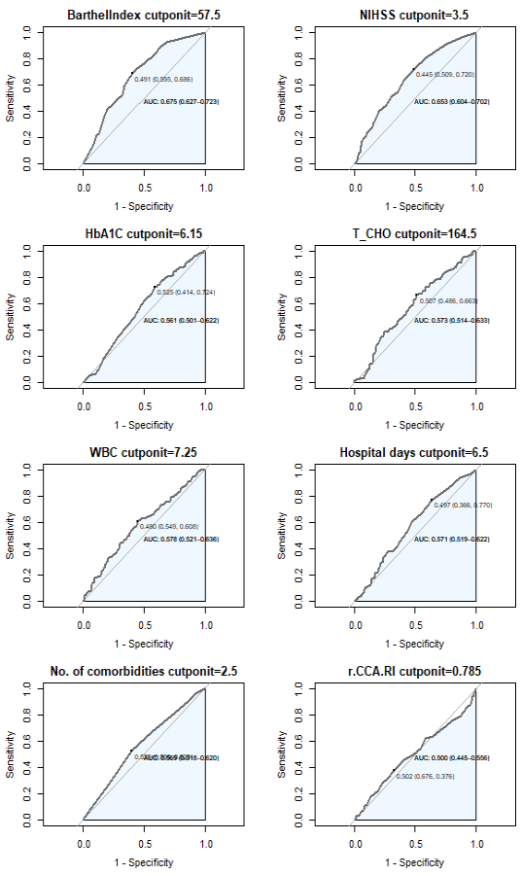

Appendix 1.
The ROC (AUC: area under curve, measurement) and cut-off point searching (with referenced to Table 6)

