A pooled analysis of mortality in patients with COPD receiving dual bronchodilation with and without additional inhaled corticosteroid: Supplemental material
Marc Miravitlles,¹ Katia Verhamme,² Peter M.A. Calverley,³ Michael Dreher,⁴ Valentina Bayer,⁵ Asparuh Gardev,⁶ Alberto de la Hoz,⁶ Jadwiga Wedzicha,⁷ David Price^{8,9}
¹Pneumology Department, Hospital Universitari Vall d’Hebron, Vall d’Hebron Research Institute (VHIR), Vall d’Hebron Barcelona Hospital Campus. CIBER de Enfermedades Respiratorias (CIBERES) Barcelona, Spain; ²Department of Medical Informatics, Erasmus MC, Rotterdam, The Netherlands; ³Clinical Science Centre, Institute of Ageing and Chronic Disease, University of Liverpool, Liverpool, UK; ⁴Department of Pneumology and Intensive Care Medicine, University Hospital Aachen, Aachen, Germany; ⁵Boehringer Ingelheim Pharmaceuticals, Inc., Ridgefield, CT, USA; ⁶Boehringer Ingelheim International GmbH, Ingelheim am Rhein, Germany; ⁷Head Respiratory Division, National Heart and Lung Institute, Imperial College London, London, UK; ⁸Observational and Pragmatic Research Institute, Singapore; ⁹Centre of Academic Primary Care, Division of Applied Health Sciences, University of Aberdeen, Aberdeen, United Kingdom
e-Table 1. Proportion of patients that discontinued trial medication within the 52 weeks
 | LAMA/LABA  n=3,133 | LAMA/LABA/ICS  n=3,133
Prematurely discontinued trial medication, n (%) | 380 (12.1) | 409 (13.1)
Adverse event  Worsening of COPD  Worsening of other pre-existing diseases  Other adverse event | 195 (6.2)  63 (2.0)  23 (0.7)  109 (3.5) | 183 (5.8)  70 (2.2)  12 (0.4)  101 (3.2)
Lack of efficacy | 18 (0.6) | 13 (0.4)
Non-compliance with protocol | 22 (0.7) | 33 (1.1)
Lost to follow-up | 13 (0.4) | 7 (0.2)
Refused continuation of medicine | 55 (1.8) | 101 (3.2)
Consent withdrawn not due to adverse event | 55 (1.8) | 36 (1.1)
Other | 22 (0.7) | 36 (1.1)
COPD, chronic obstructive pulmonary disease; ICS, inhaled corticosteroid; LABA, long-acting β₂-agonist; LAMA, long-acting muscarinic antagonist.

e-Table 2. Adjudicated cause of death for patients who died in the mortality analysis (on-treatment and on- and off-treatment)
Adjudicated cause of deathª, n (%) | LAMA/LABA  N=3,133 | LAMA/LABA/ICS  N=3,133
Total deaths on-treatment | 41 (1.3) | 45 (1.4)
Cardiac | 2 (0.1) | 2 (0.1)
Respiratory | 9 (0.3) | 11 (0.4)
Cancer | 6 (0.2) | 8 (0.3)
Other | 24 (0.8) | 25 (0.8)
Total deaths on- and off-treatment | 74 (2.4) | 66 (2.1)
Cardiac | 5 (0.2) | 4 (0.1)
Respiratory | 18 (0.6) | 19 (0.6)
Cancer | 16 (0.5) | 14 (0.4)
Other | 35 (1.1) | 30 (1.0)
ªAdjudicated cause of death was based on the primary SOC. The WISDOM study used investigator-reported deaths. One patient in the triple therapy arm had two causes of death (respiratory and other) and both are counted.
ICS, inhaled corticosteroid; LABA, long-acting β₂-agonist; LAMA, long-acting muscarinic antagonist; SOC, System Organ Class.

e-Figure 1. Distribution of propensity score among patients treated with LAMA/LABA versus LAMA/LABA/ICS
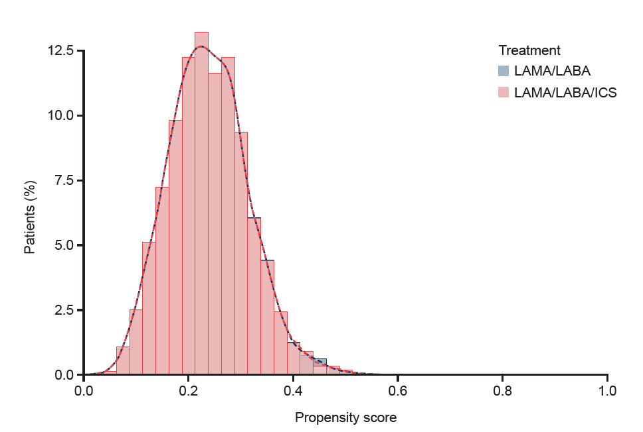

ICS, inhaled corticosteroid; LABA, long-acting β₂-agonist; LAMA, long-acting muscarinic antagonist.
e-Figure 2. Estimated probability of all-cause mortality over 52 weeks (ITT analysis)
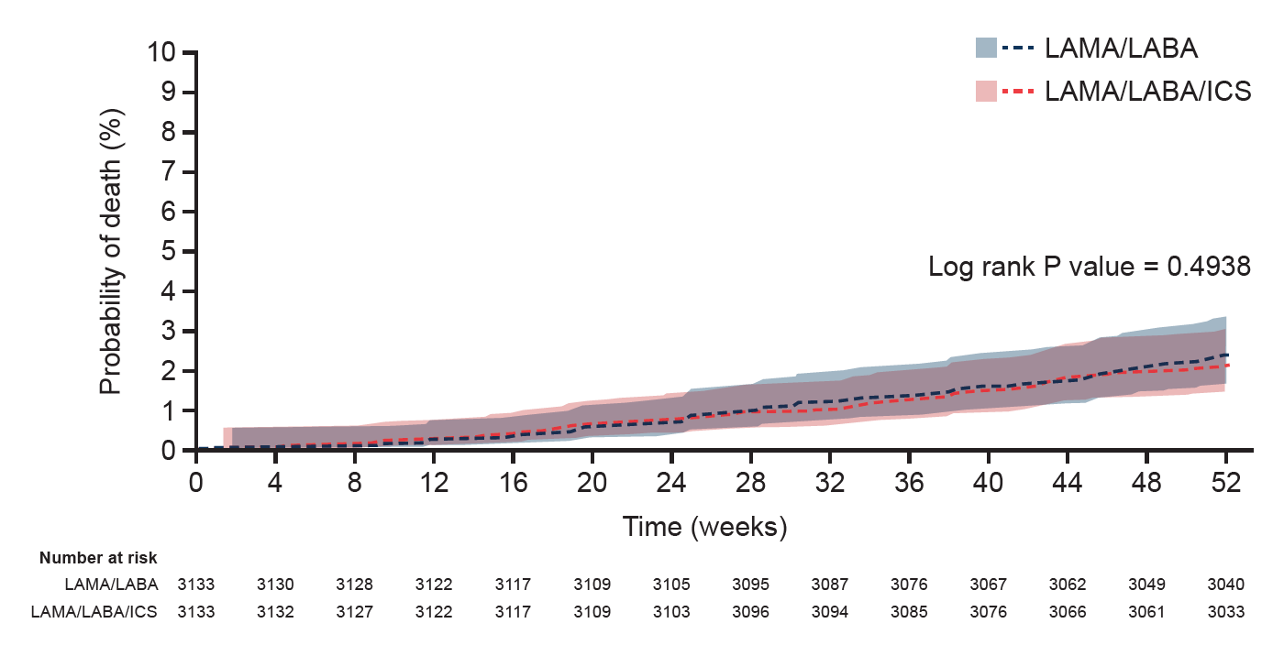
ICS, inhaled corticosteroid; ITT, intention-to-treat; LABA, long-acting β₂-agonist; LAMA, long-acting muscarinic antagonist.

