Supplementary Material

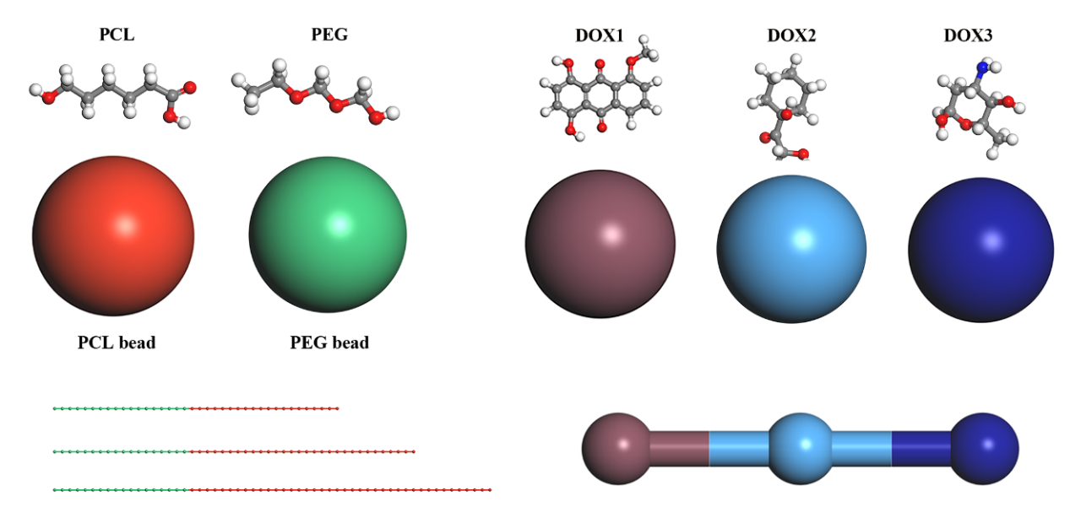
Figure S 1 The schematic diagram of blocks and drug (DOX) of micelles in the DPD simulation. The red bead represents PCL, the green bead represents PEG, and DOX is divided into three beads.

Table S 1 Interaction parameters a_{ij} between different beads used in DPD simulations
a_{ij} | PEG | PCL | DOX1 | DOX2 | DOX3 | WATER
PEG | 25
PCL | 34.41 | 25
DOX1 | 31.14 | 25.42 | 25
DOX2 | 34.22 | 25.03 | 25.26 | 25
DOX3 | 33.61 | 25.14 | 25.75 | 25.13 | 25
WATER | 26.10 | 117.12 | 40.37 | 31.36 | 130.78 | 25

