Supplementary materials

Figure S1. The MIR155HG promoter sequence and putative SP1-binding sites are indicated in red.
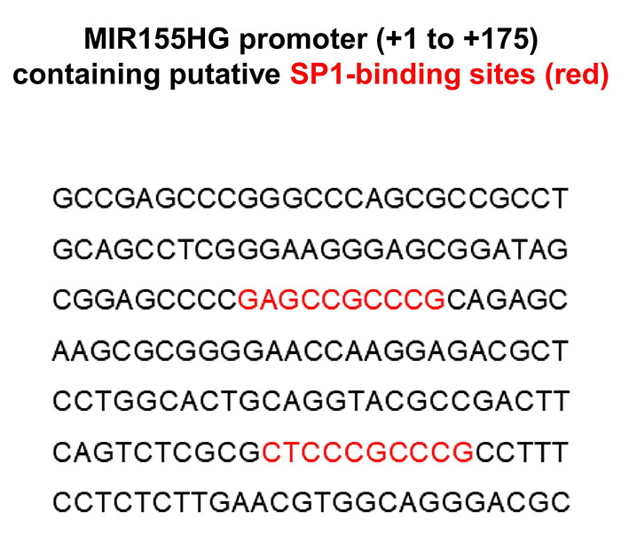

Figure S2. MIR155HG was related to specific gene ontology (GO) terms in glioma. The detail of MIR155HG-related BP (biological process) (A, B), CC (cell component) (C, D), and MF (molecular function) (E, F) terms in TCGA and CGGA datasets.

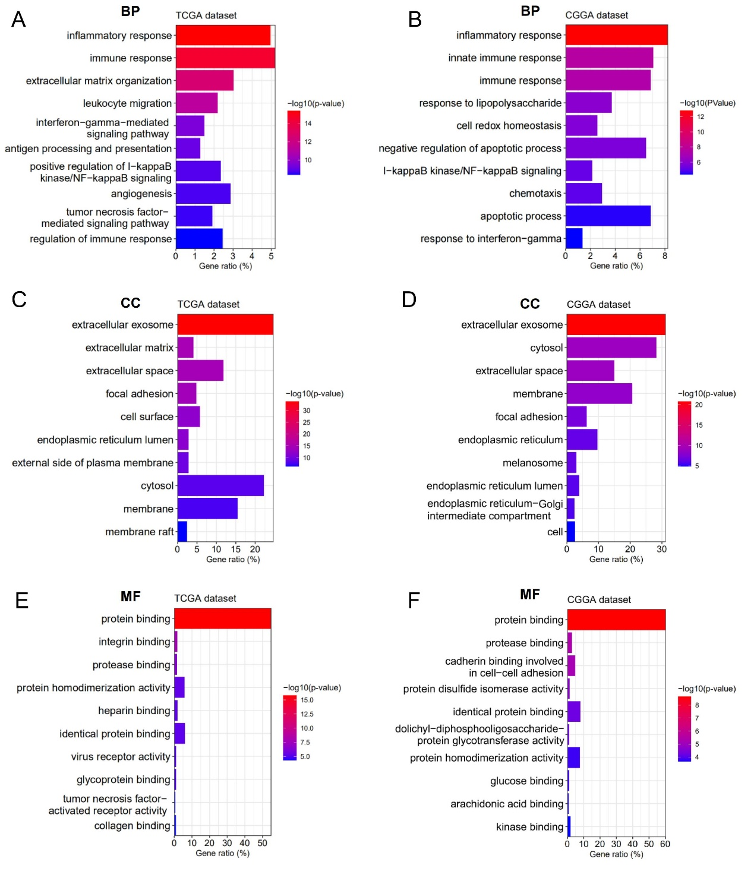

Figure S3. Summary of the 22 immune cells’ abundance estimated by CIBERSORT for different MIR155HG expression groups. *, p < 0.05; **, p < 0.01; ***, p < 0.001; ****, p < 0.0001.

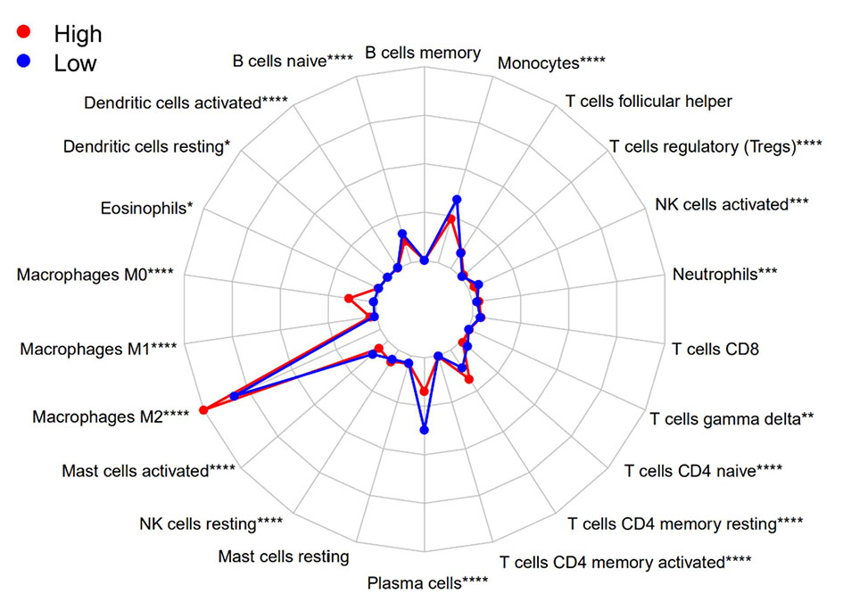

Figure S4. MIR155HG expression was correlated with immune checkpoints and immunosuppressive properties. (A, B) Correlation between MIR155HG and immune checkpoints in GBM in TCGA and CGGA datasets. (C) Correlation between MIR155HG and the surface markers of macrophages in CGGA dataset. (D) Correlation between MIR155HG and several key factors that drive M2 phenotype macrophages differentiation in CGGA dataset.

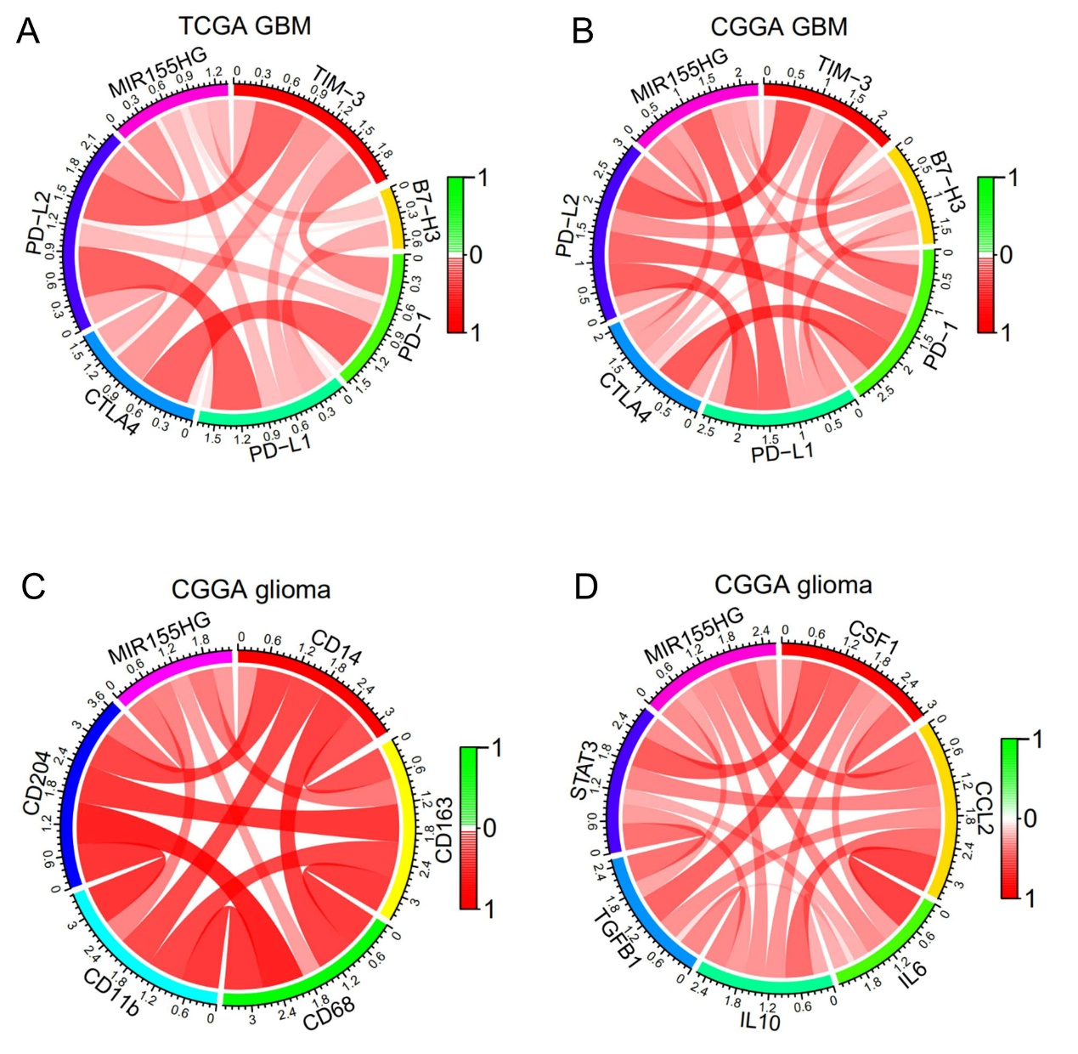

Figure S5. Correlation between MIR155HG and common biomarkers of epithelial-mesenchymal transition (EMT) in TCGA dataset (A) and CGGA dataset (B).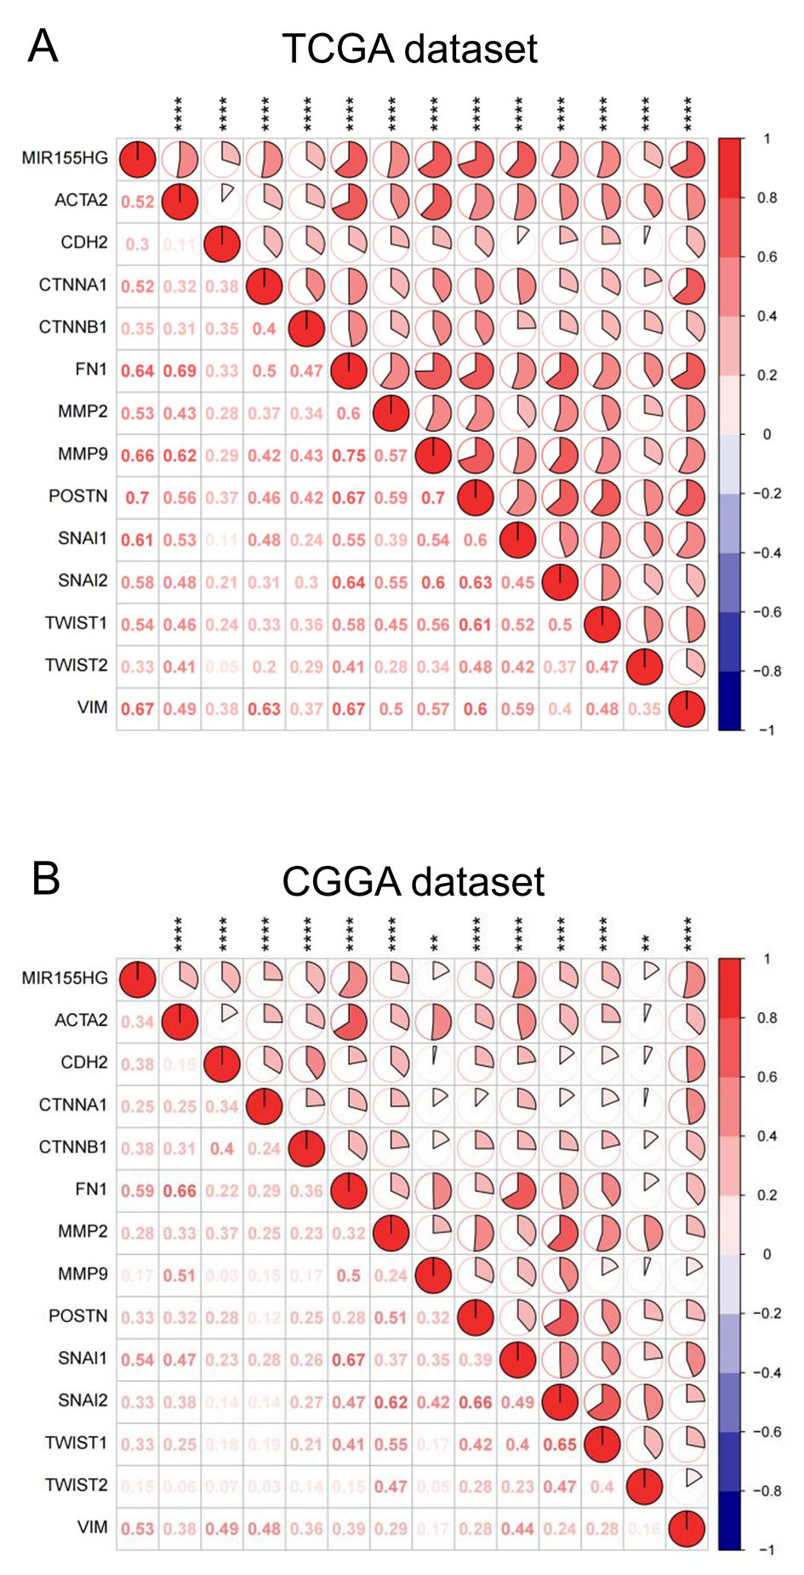
Figure S6. Univariate (A) and multivariate (B) Cox regression analyses revealed that MIR155HG was an independent prognostic biomarker for glioma patients in CGGA dataset.

