Supplementary Table S1. Pathological characteristic of patients.

Characteristics | Total | Mutation(%) | Wild Type(%)
Patients Number | 47 | 8 | 39
Median Age | 47 | 44 | 48
Gender
Male | 42（89%） | 6（75%） | 36（92%）
Female | 5（11%） | 2（25%） | 3（8%）
Lymph Node
Metastasis | 10（21%） | 2（25%） | 8（21%）
No metastasis | 37（79%） | 6（75%） | 31（79%）
Portal invasion
Yes | 16（34%） | 2（25%） | 14（36%）
No | 31（66%） | 6(75%) | 25(64%)
Extrahepatic metastasis
Yes | 18(38%) | 3(38%) | 15(38%)
No | 29(62%) | 5(62%) | 24(62%)
Histologic grade
Well Differentiated | 6(13%) | 0（0%） | 6(15%)
Moderately Differentiated | 21(45%) | 5(63%) | 16(41%)
Poorly Differentiated | 6(13%) | 1（13%） | 5(13%)
Unknown | 14(30%) | 2(25%) | 12(31%)

Supplementary Figure S1
The mutation of LRP1B gene in pan-tumor analysis.

Supplementary Figure S2
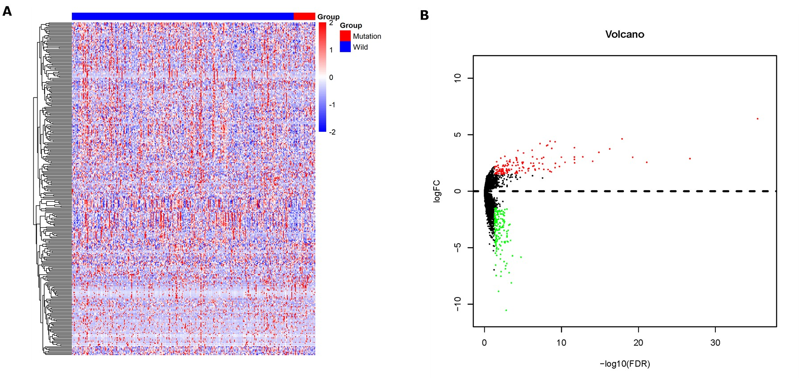
Heat map (A) and volcano map (B) of the differential expressed genes of the mutation group and wild groups.

Supplementary Figure S3

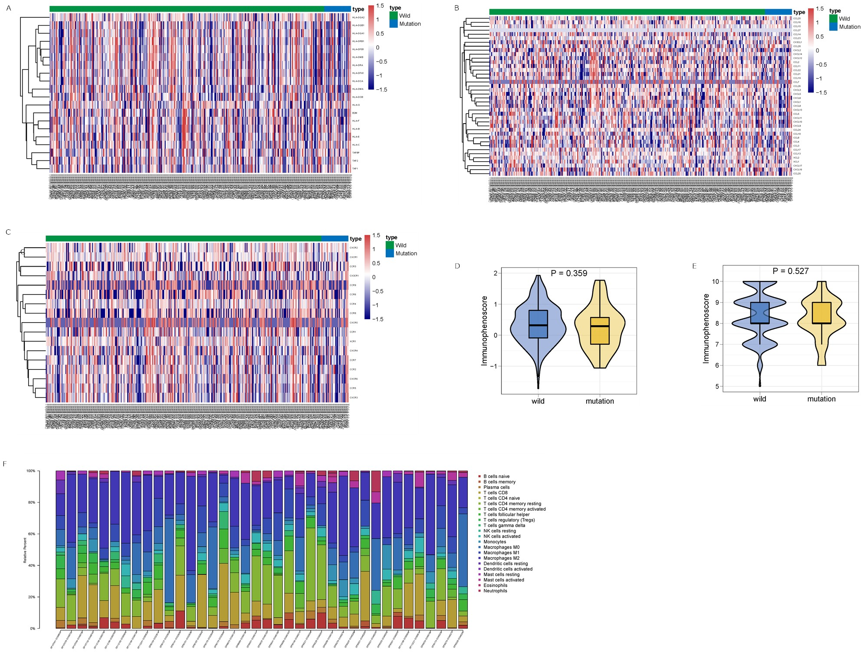Heat map for LRP1B mutation and the expression of MHC molecules (A), chemokines (B) and chemokine receptors (C). D. TIDE score for LRPB mutation group and wild group. E. IPS score for LRPB mutation group and wild group. F. Stacked bar chart shows distribution of 22 immune cells in each sample.

Supplementary Figure S4
LRP1B mutation and the sensitivity of small molecule drugs in the GDSC database.

Supplementary Figure S5.
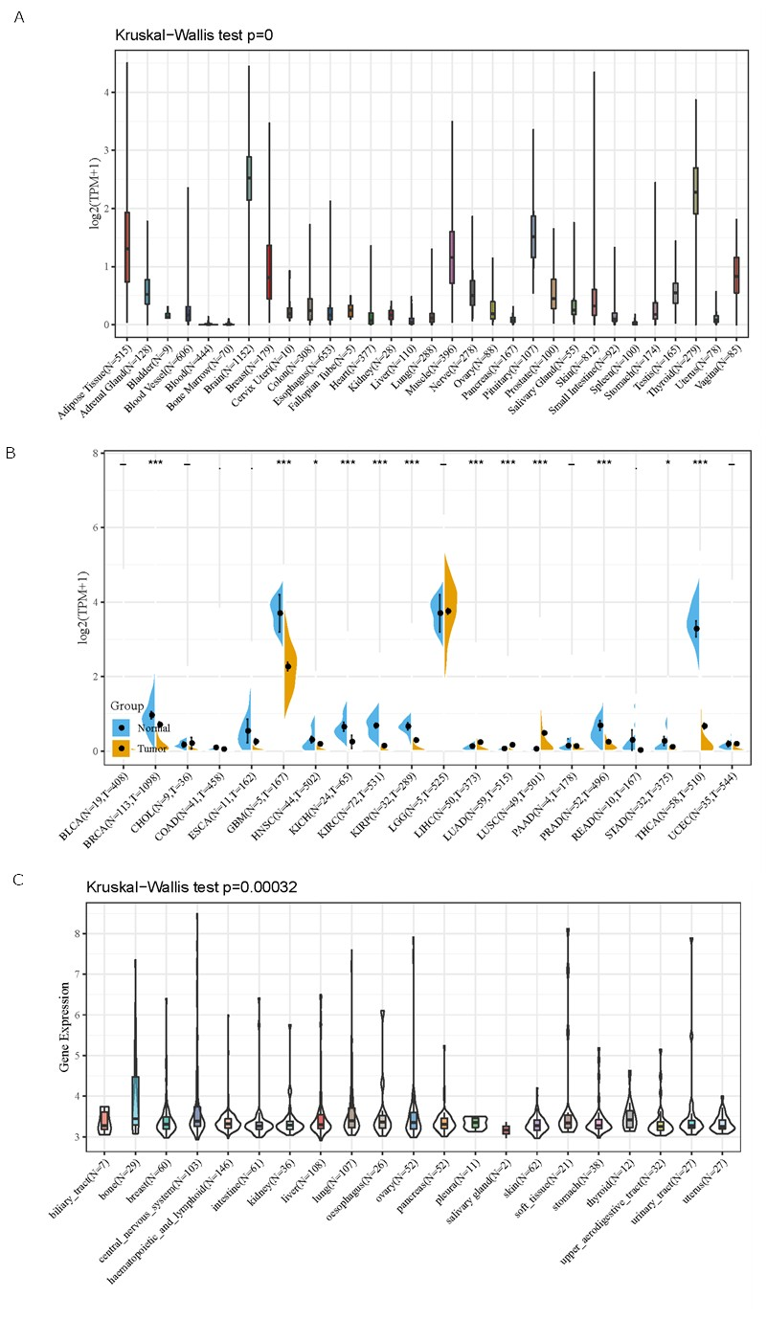
Pan-tumor analysis of LRP1B expression.
A. The expression level of LRP1B in various tissues using the GTEx dataset. B. Comparison of LRP1B expression in tumor and normal tissues in different cancer types using TCGA data. *P<0.05, ***P<0.001. C. The expression level of LRP1B in various cancer cell lines using the CCLE dataset.

Supplementary Figure S6.
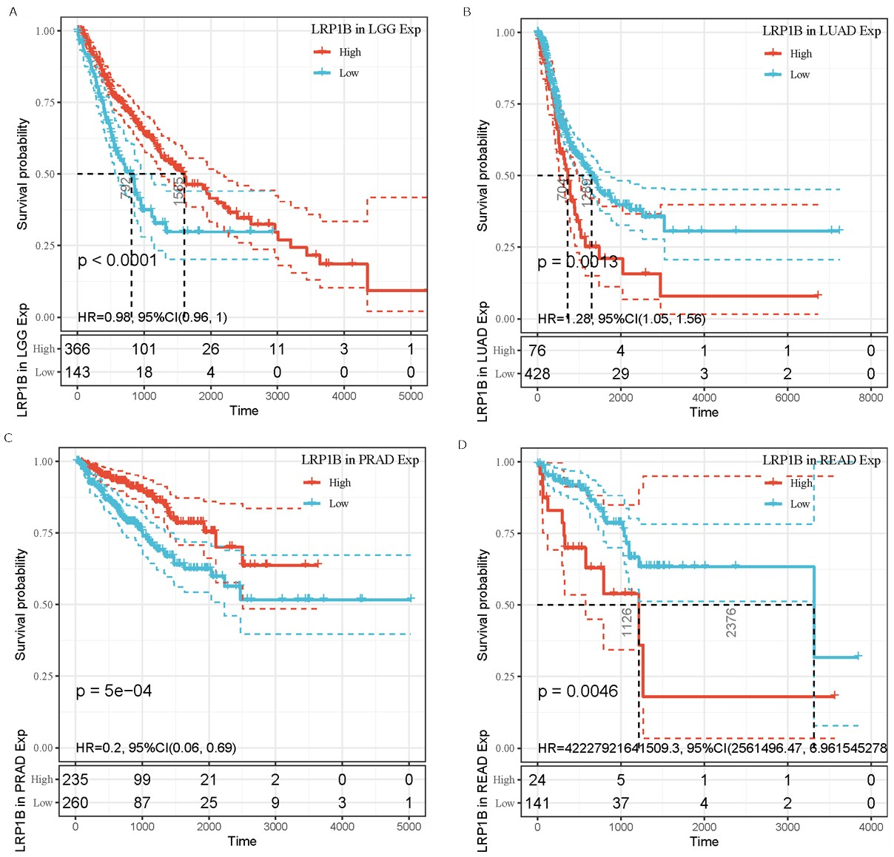
Kaplan–Meier survival curves for OS of patients with different cancer types between high and low LRP1B expression using TCGA data. Those with significant difference between high and low LRP1B expression was shown. A. Survival curves for patients with low-grade glioma, (B) lung adenocarcinoma expression, (C) prostate adenocarcinoma and (D) rectum adenocarcinoma.

Supplementary Figure S7.
Pan-tumor analysis of LRP1B expression and infiltration score of immune cells.

Supplementary Figure S8.
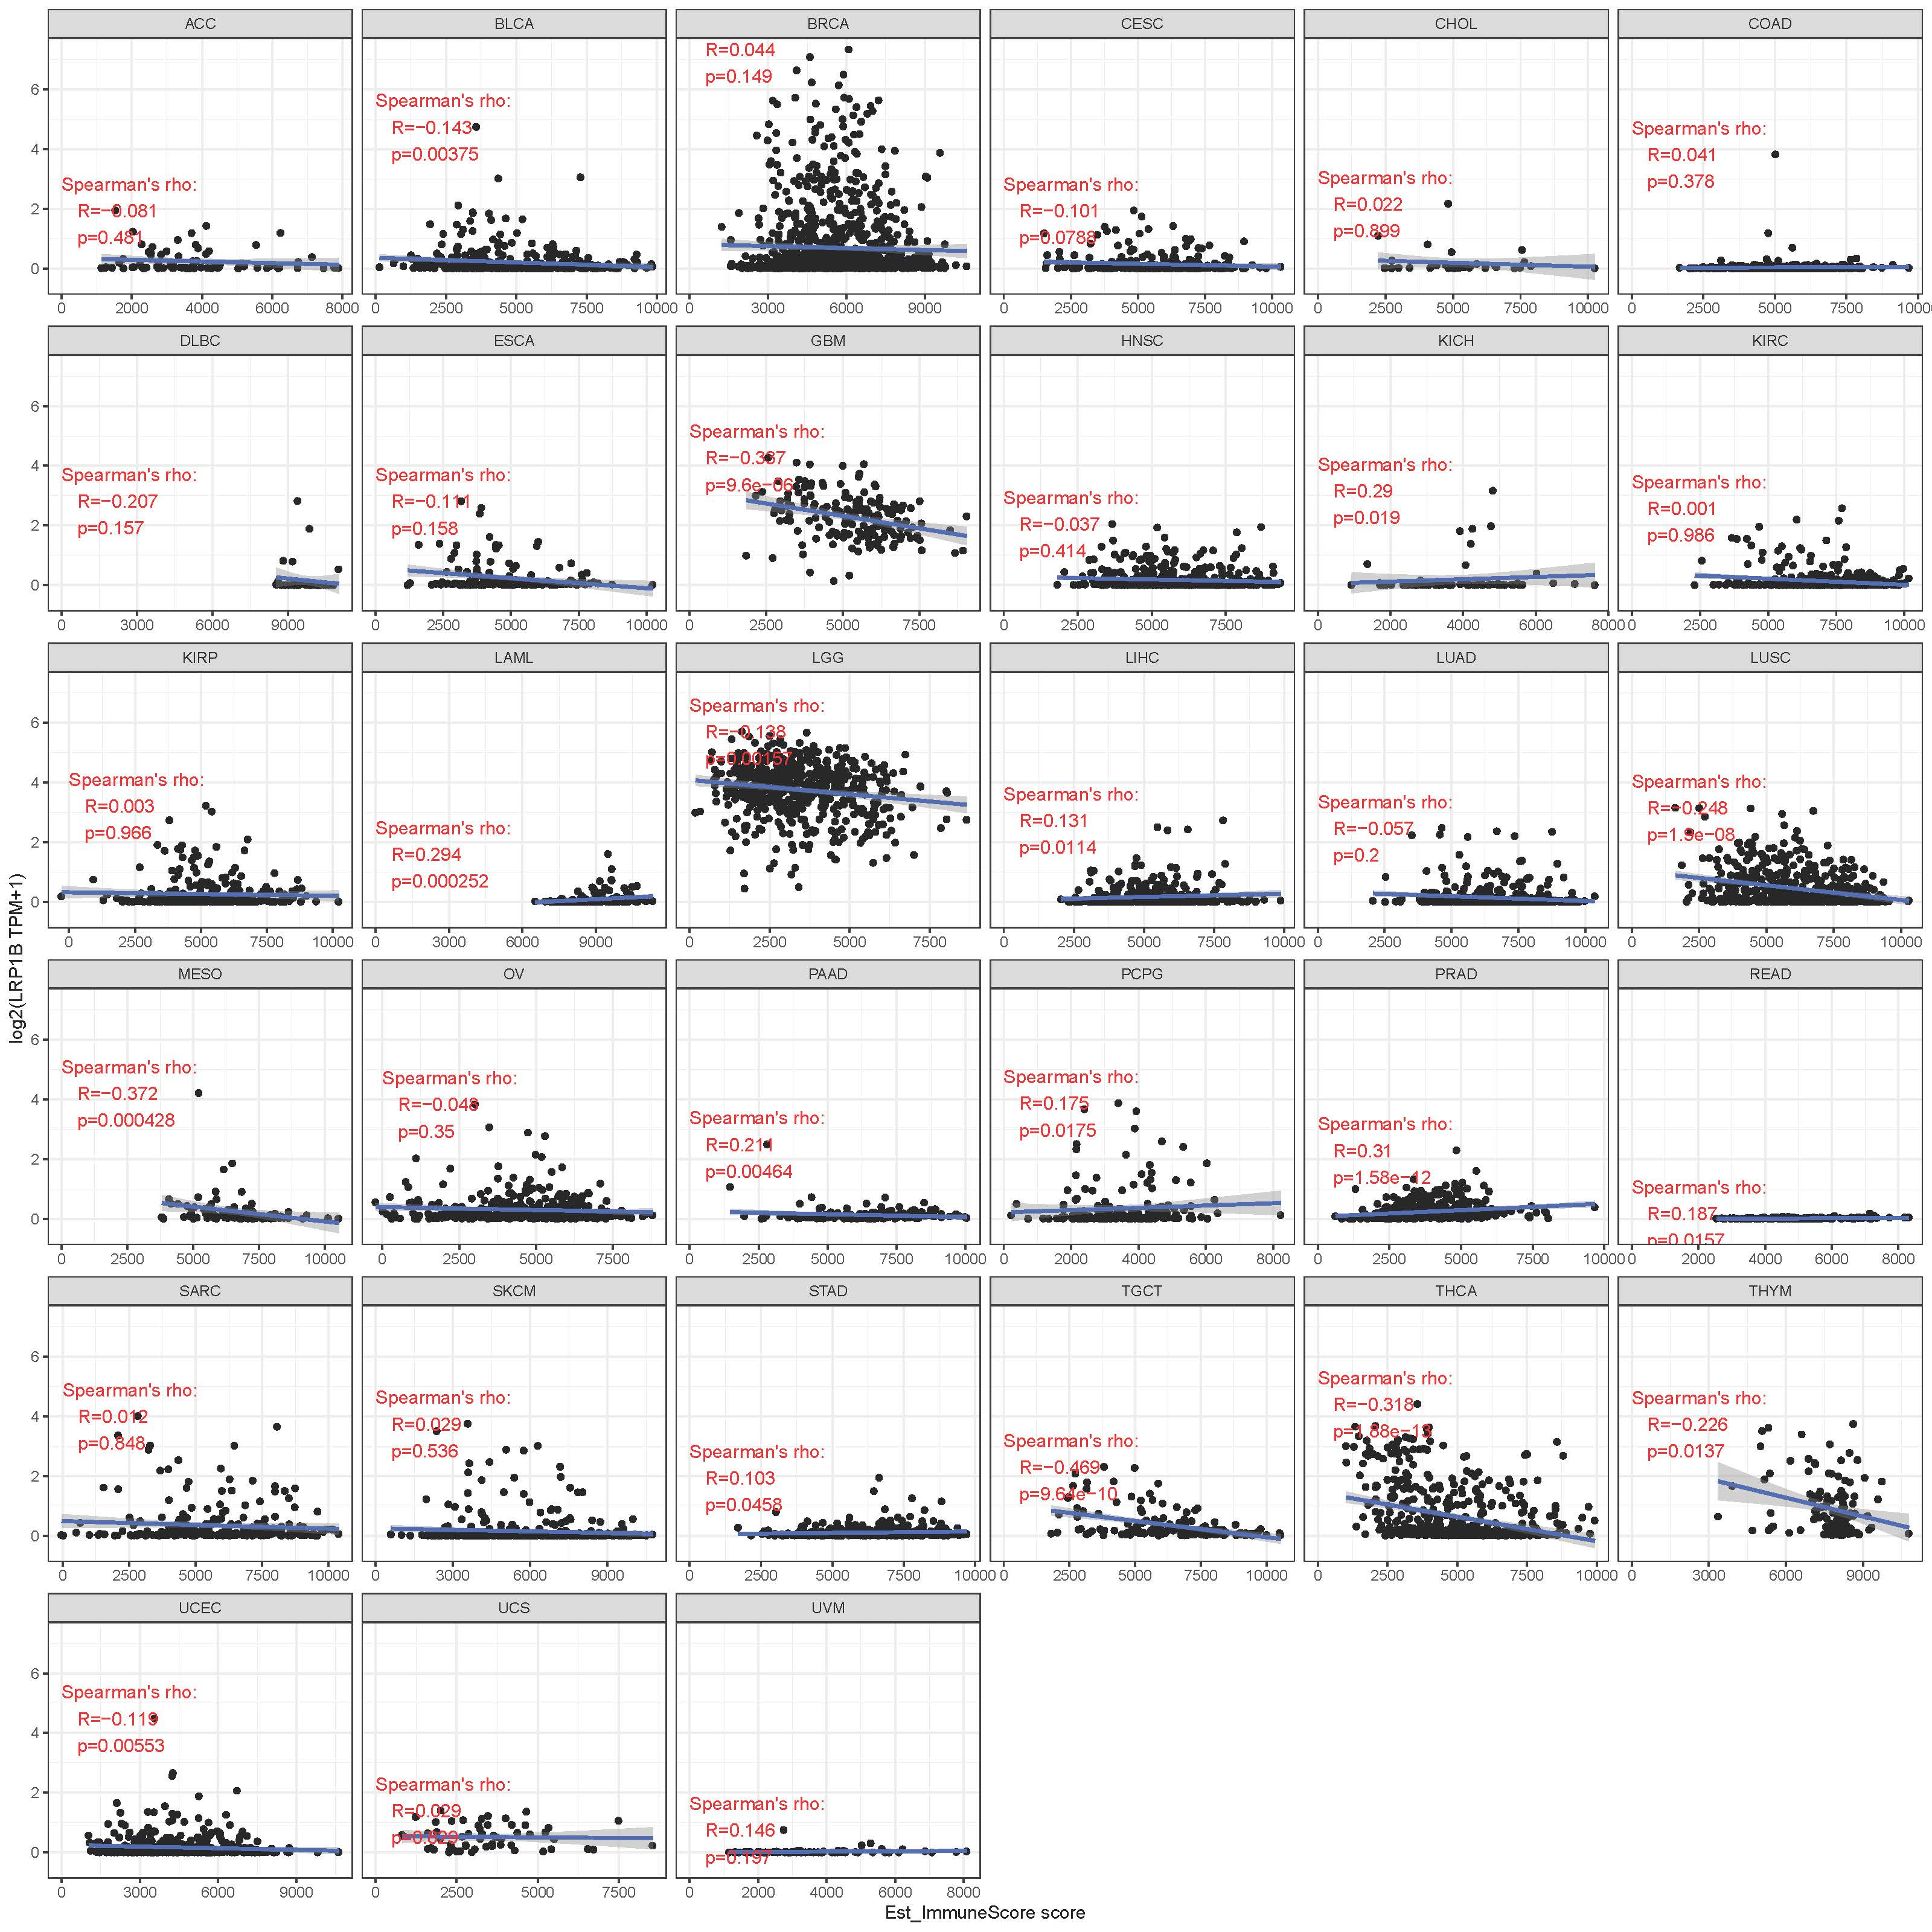
Pan-tumor analysis of LRP1B expression and Immune score.

Supplementary Figure S9.
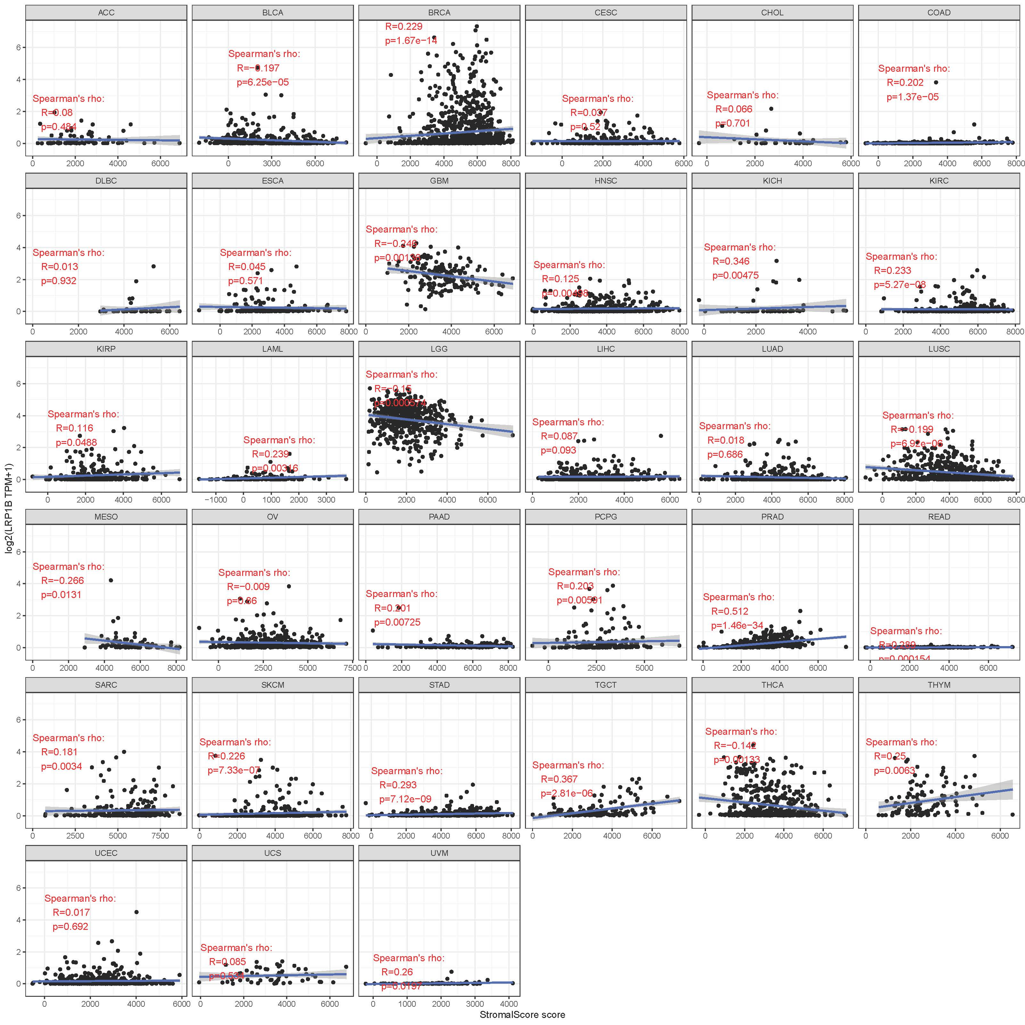
Pan-tumor analysis of LRP1B expression and Stromal score.

Supplementary Figure S10.
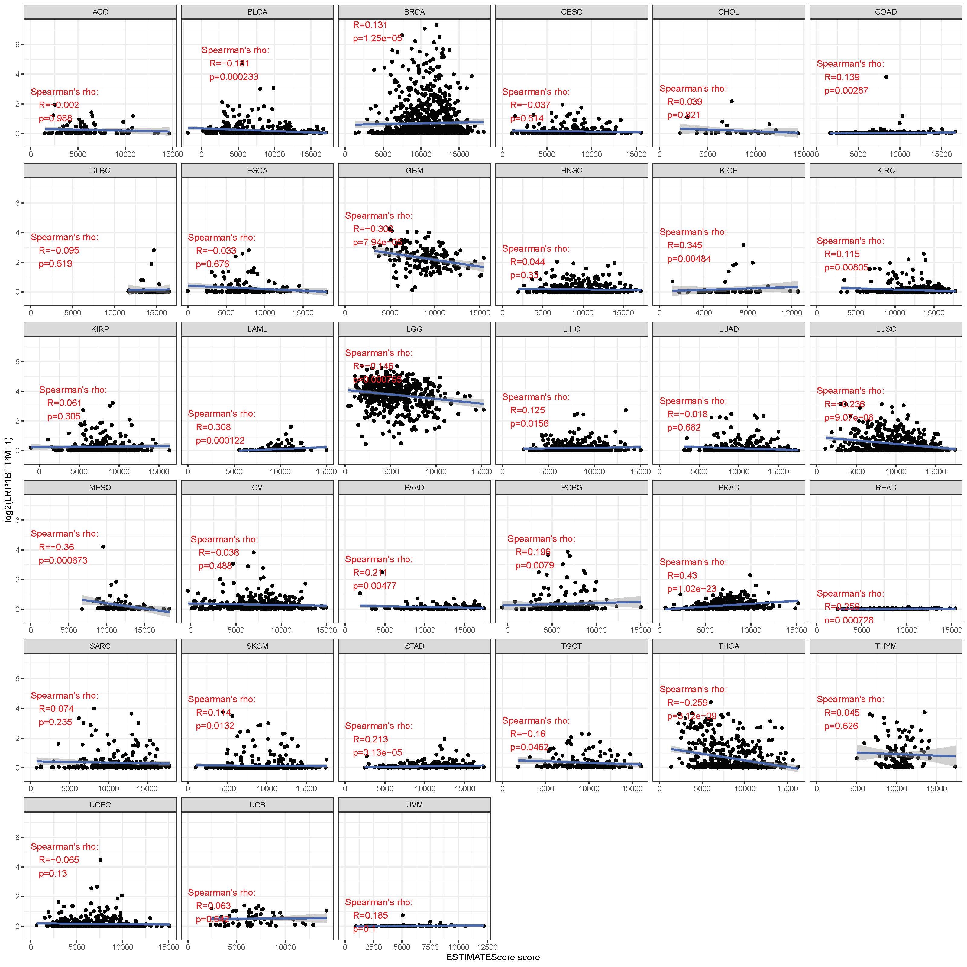
Pan-tumor analysis of LRP1B expression and Estimate score.

Supplementary Figure S11.
Scatter plot of the correlation between LRP1B expression in tumor tissues and key immunosuppressive molecules in TCGA dataset, GTEx database and the CCLE database.

Supplementary Figure S12.
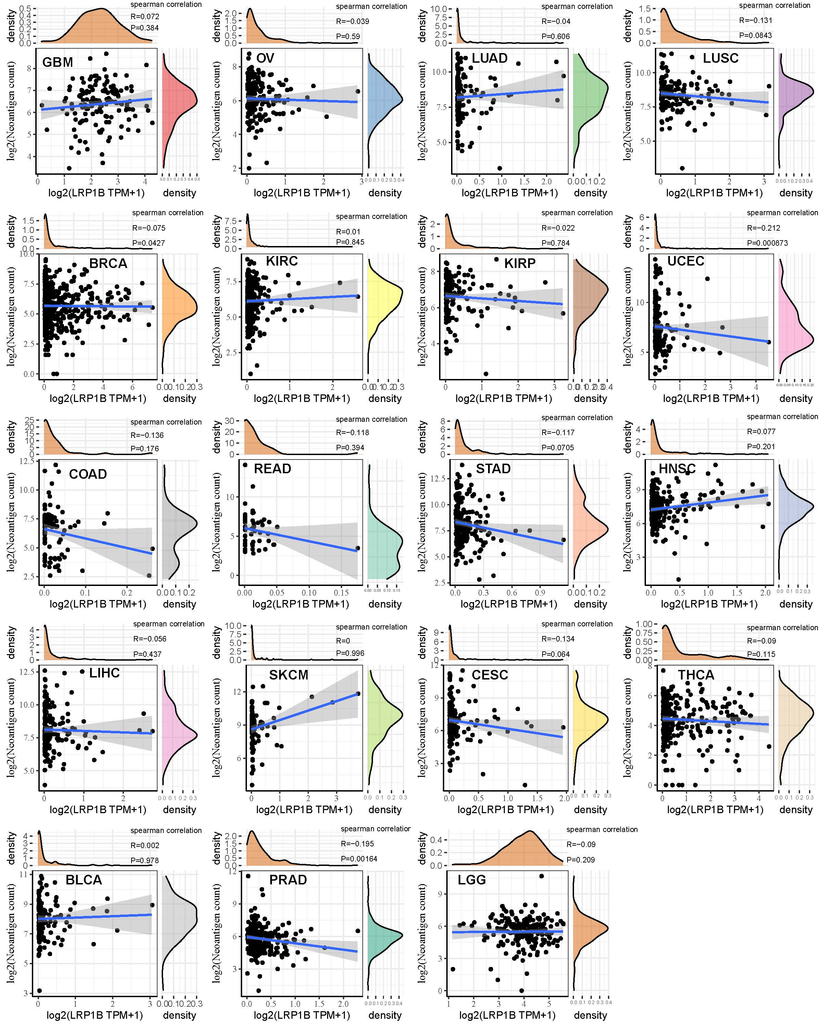Pan-tumor analysis for the correlation between expression of LRP1B and the immune neoantigen.

Supplementary Figure S13.
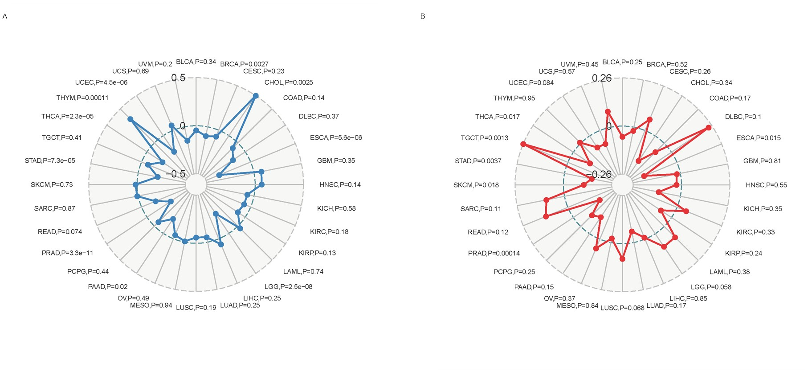
Pan-tumor analysis for the correlation between expression of LRP1B and TMB (A) and MSI (B).

Supplementary Figure S14.
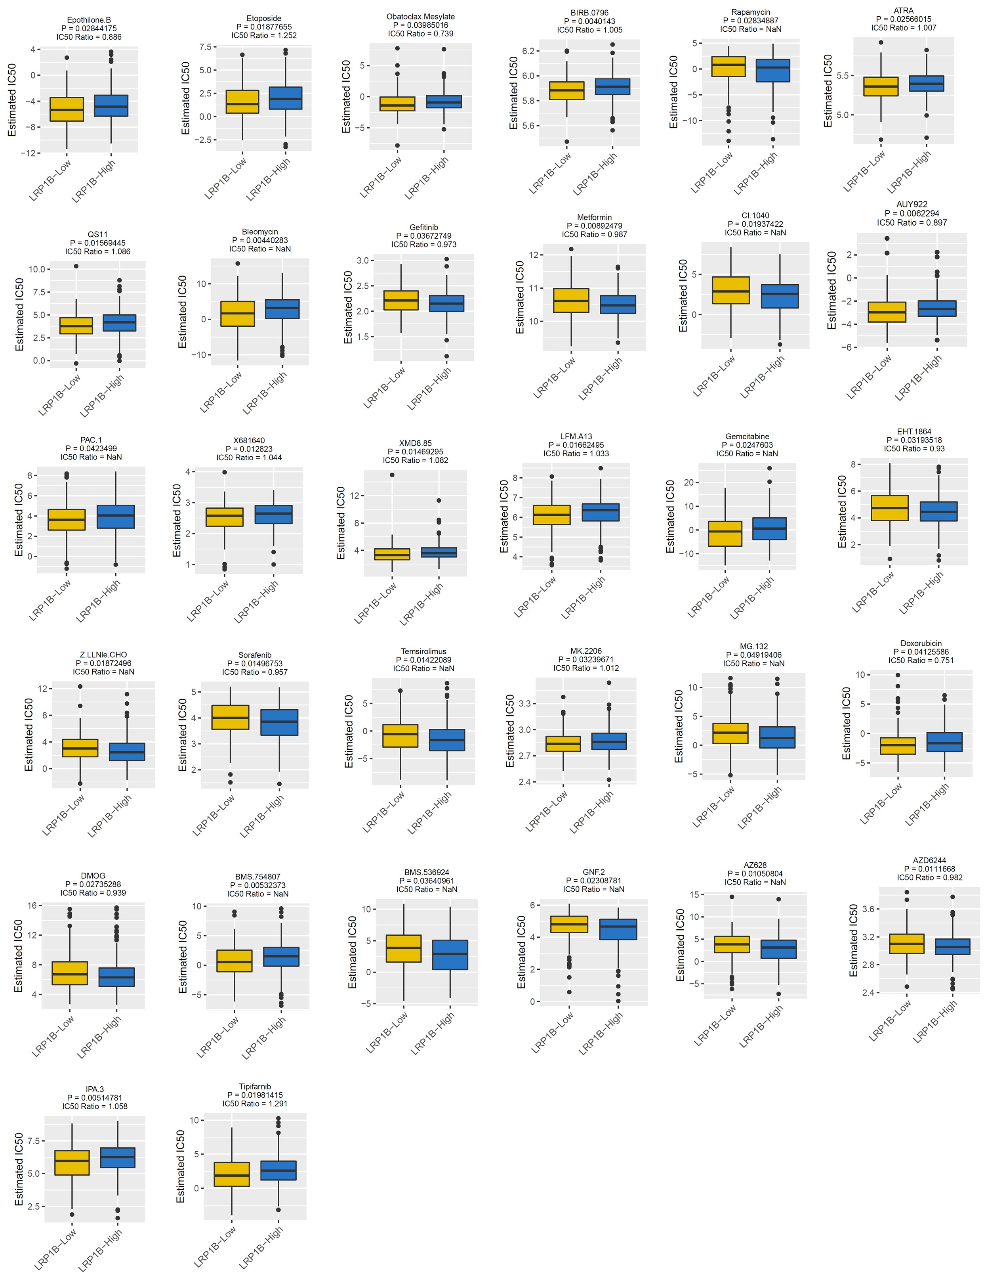
The expression of LRP1B and the sensitivity prediction of some small molecule drugs.

Supplementary Figure S15. 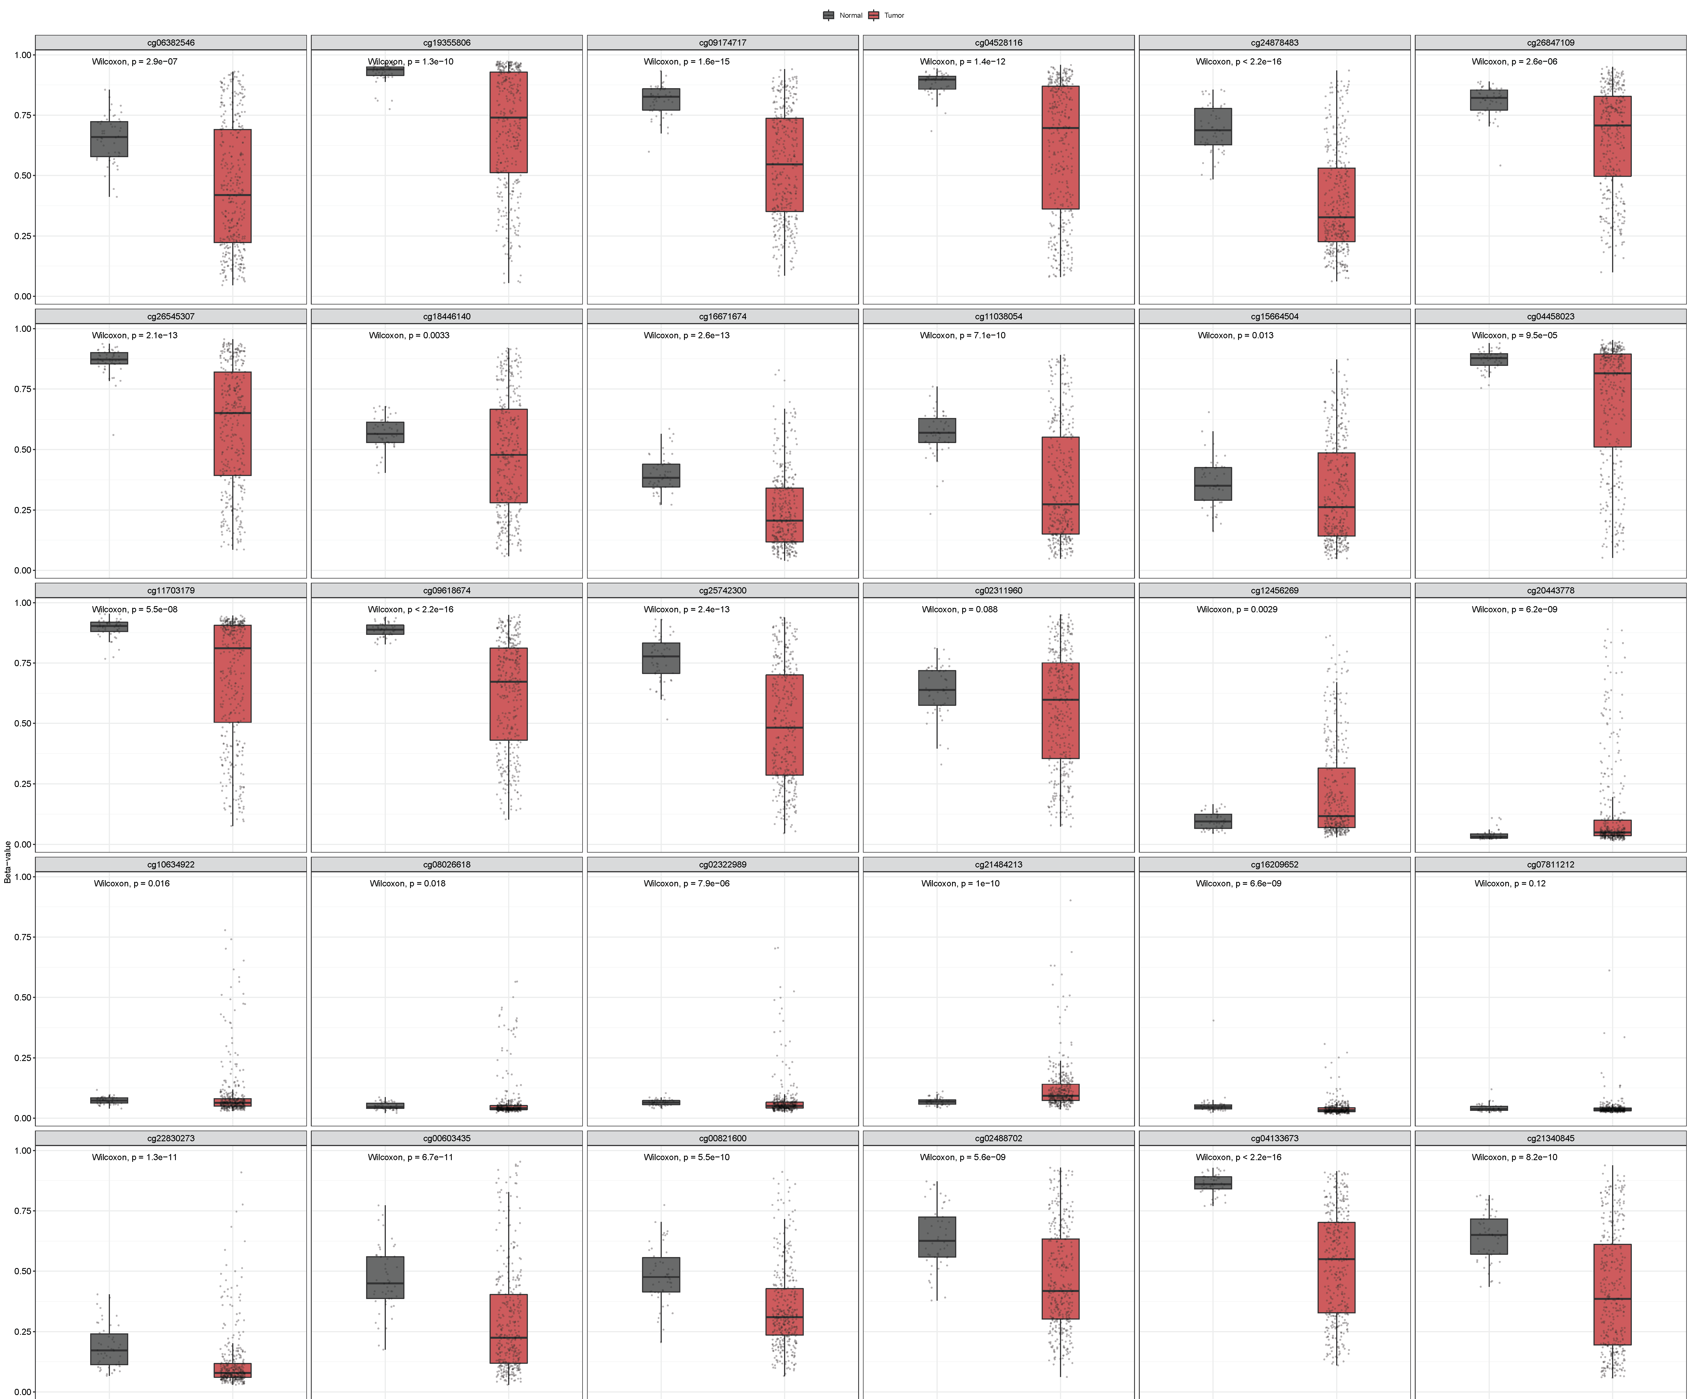

Differences in methylation between tumor and adjacent tissues of liver cancer.

Supplementary Figure S16.
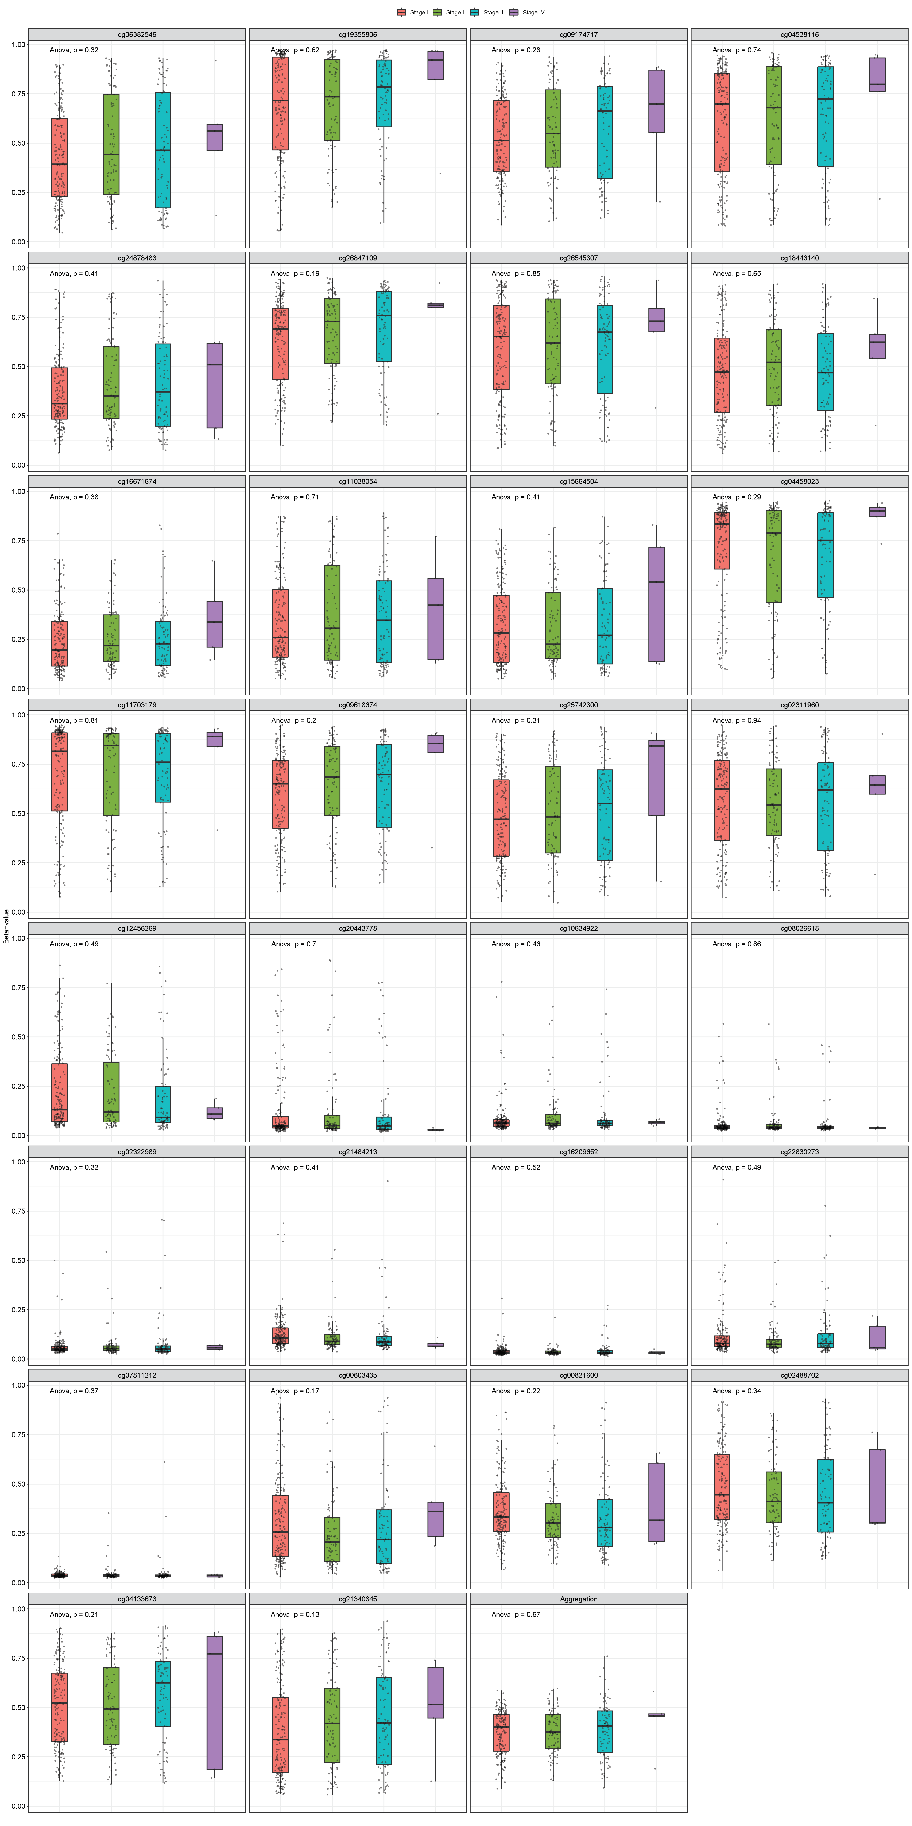
Methylation in samples with different stages of liver cancer.

Supplementary Figure S17.
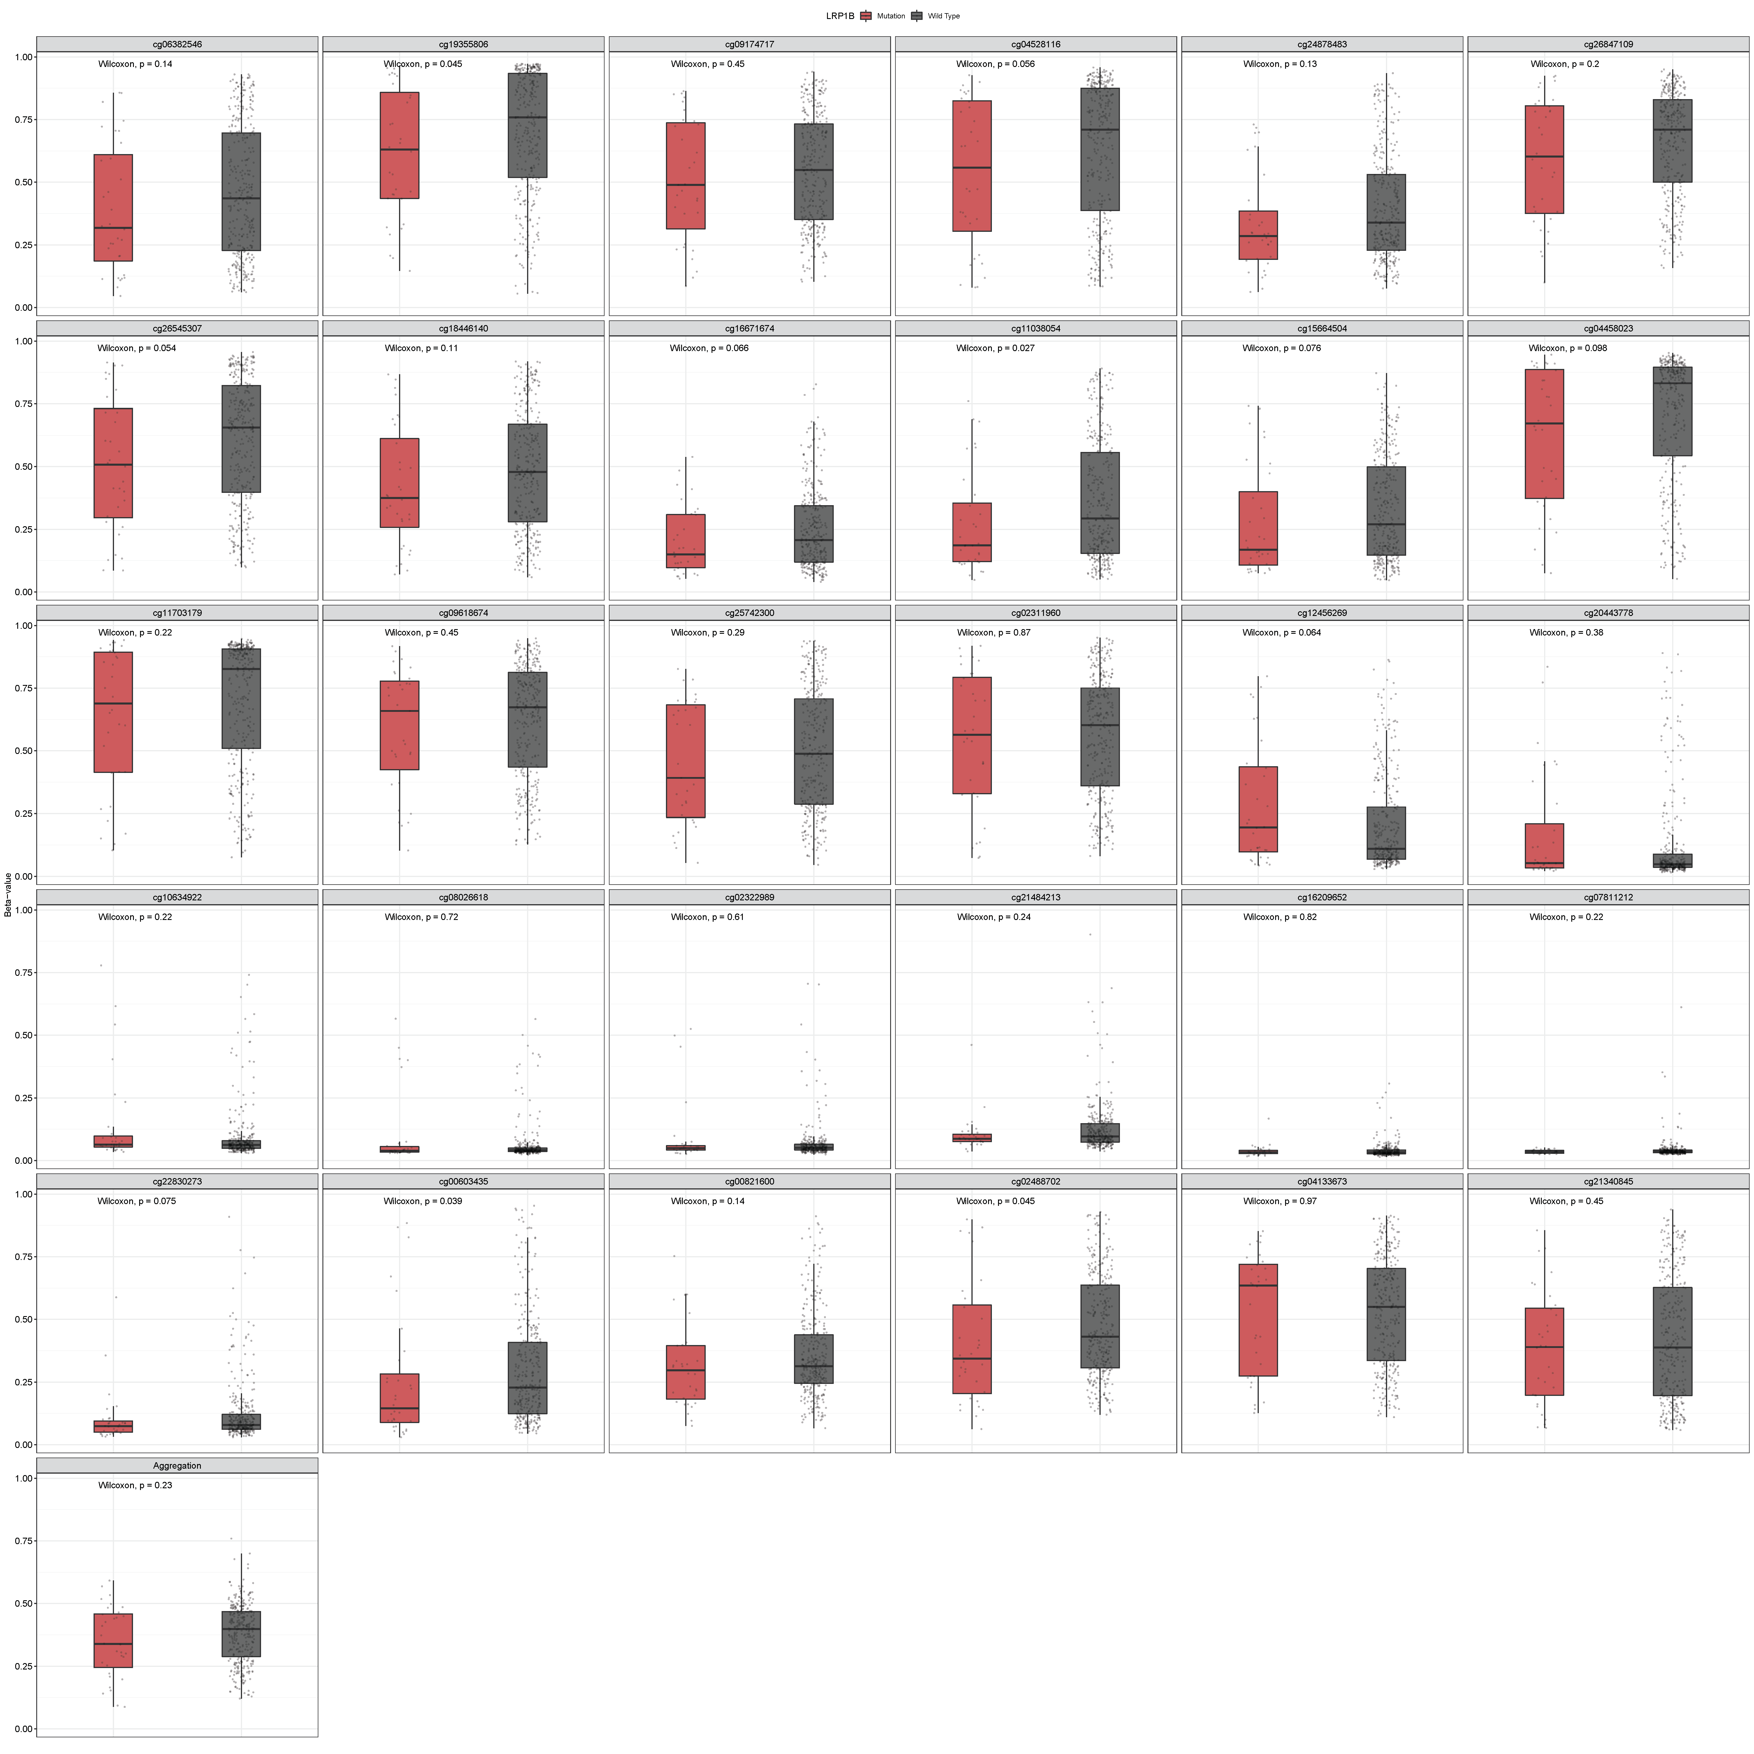
The methylation levels in LRP1B wild and mutant samples.

Supplementary Figure S18.
Pan-tumor analysis of the association between LRP1B expression and the expression of four methyltransferases (red: DNMT1, blue: DNMT2, green: DNMT3A, purple: DNMT3B).

Supplementary Figure S19.
Pan-tumor analysis for correlation between LRP1B expression and expression of MMRs. *P<0.05, **P<0.01, ***P<0.001.

