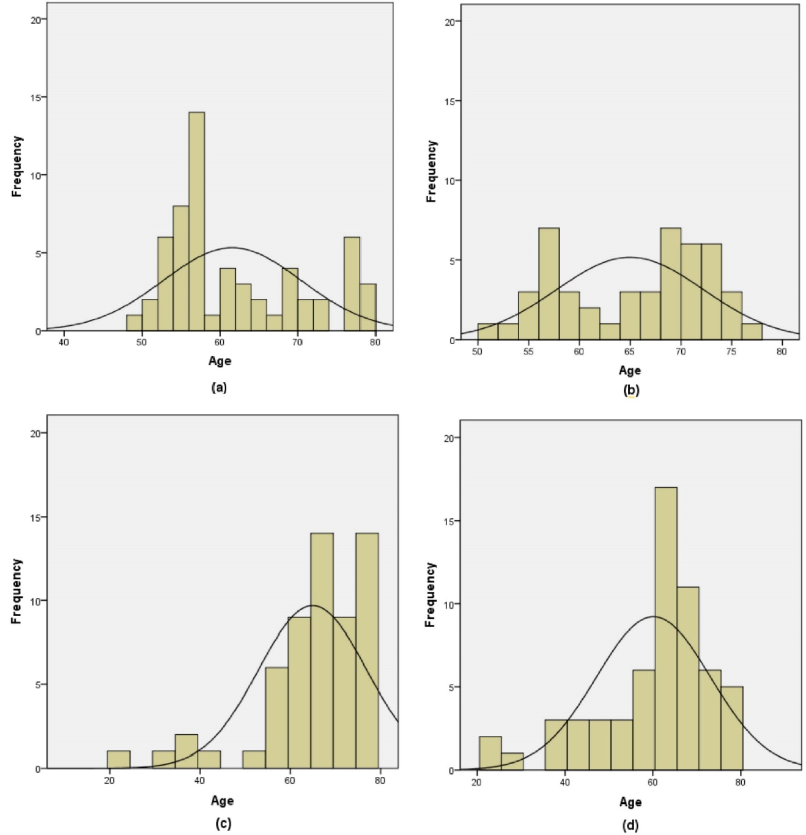Supplementary Figure 1 Age distribution of AMD group and control group.
- age distribution of men in the control group; (b) age distribution of women in the control group; (c) age distribution of men in the AMD group; (d) age distribution of women in the AMD group.

