Contents
SUPPLEMENTARY METHODS 2
SUPPLEMENTARY TABLES 5
SUPPELMENTARY FIGURES 10

SUPPLEMENTARY METHODS
Patient pathway optimization
The patient pathway optimization (PPO) program at Cantonal Hospital Münsterlingen was custom designed for the comprehensive management of patient care for orthopedic surgery, and it guided the coordination of care and standardization of key practices. The PPO program consisted of the following elements:
- Services that improved the current care pathway and reduced inefficiencies and variation in clinical practice
A standardized process was implemented to identify the optimal patient pathway in alignment with all the professional groups who were involved (see section ii for details of the professional groups). This process included single interviews with representatives from all involved professional groups, analysis of current patient pathway in local visitations, presentation of results from the analysis in a comprehensive workshop where recommended areas of improvement were discussed, definition of working groups and leads for different parts of the patient pathway as well as selection criteria for the final pathway definition.
- Increase the commitment and involvement of the multidisciplinary team
There was a strong focus on including all involved professional groups, independent of hospital hierarchy, to ensure comprehensive inclusion of all relevant perspectives. Single interviews were conducted with all parties to include unbiased feedback and suggestions for improvement, and there was participation of all stakeholders with working groups and joint selection of criteria for final pathway definition. The interviewed stakeholders included the Chief Executive Officer, Chief Finance Officer, management team, Head of Surgery department, Senior Surgeon, Head of Anesthesiology department, Senior Anesthesiologist, Head Nurse, Operating Room Manager, Head of recovery room, Head of Physiotherapy, Head of Social Service, admission and discharge management, pre- and post-clinical outpatient services, inpatient services, quality management, medical controlling, with further groups included in the working groups.
- Enhanced recovery principles
As part of the PPO program, five additional enhanced recovery principles were introduced.
Preoperative patient education: An information workshop event was conducted to educate patients on pre-operative preparations, anesthesia methods, the surgery, as well as post-operative mobilization and recovery. Patient materials were developed specifically for Cantonal Hospital Münsterlingen; these included all essential information, checklists for preparation and a physiotherapy manual to prepare for and guide through helpful exercises pre- and post-operation.
Pre-operative physiotherapy: Prior to the surgery, patients were introduced to the exercises that they would be required to do post-operatively and also encouraged to practice them before as well as to master the use of forearm crutches. The necessary information and support were given in a dedicated educational event for the patients as well as supplementary hand-outs.
Local infiltration analgesia: Peri-operative local analgesia with long lasting local anesthesia was used to improve control of post-operative pain and to prevent pain low-point when patients awoke from anesthesia. Administration of opioids was avoided as much as possible to prevent related side effects, especially nausea and hypotonia, thereby enhancing early mobilization from surgery day.
Early mobilization: Under the surveillance of physiotherapy team, patients were encouraged to sit on the edge of the bed or get up from bed on the same day as the surgery was performed. The goal of early mobilization was to reduce the time needed for patients to reach a state where they could switch from using a walking frame to using forearm crutches instead, as well as to master walking up and down stairs. Avoiding the use of parenteral pain medication and switching to oral medication allowed for early removal of intravenous access and thereby reduced the perception of patients of being ill, vulnerable and dependent on assistance; this was further stressed by inviting patients to wear their own clothes.
Oral analgesia: Avoiding the use of parenteral pain medication and switching to oral medication allowed for early removal of intravenous access and thereby reduced the perception of patients of being ill, vulnerable and dependent on assistance; this was further stressed by inviting patients to wear their own clothes.

SUPPLEMENTARY TABLES
Supplemental Table S1: ICD-10 codes defining complications following Total Knee Arthroplasty and Total Hip Arthroplasty procedures
ICD-10 code† | Definition
I97.84 | Lymphedema after medical measures in the inguinal lymphatic drainage area, stage I
I97.85 | Lymphedema after medical measures in the inguinal lymphatic drainage area, stage II
I97.86 | Lymphedema after medical measures in the inguinal lymphatic drainage area, stage III
I97.88 | Lymphedema after medical measures, other locations, all stages
I97.89 | Other circulatory complications following medical procedures, not elsewhere classified
I97.9 | Postprocedural disorder of circulatory system, unspecified
J95.5 | Postprocedural subglottic stenosis
J95.8 | Other postprocedural respiratory disorders
J95.81 | Stenosis of the trachea after medical measures
J95.88 | Other respiratory diseases after medical intervention
J95.9 | Postprocedural respiratory disorder, unspecified
M96.8 | Other postprocedural musculoskeletal disorders
M96.88 | Other diseases of the musculoskeletal system following medical measures
M96.9 | Postprocedural musculoskeletal disorder, unspecified
N99.0 | Postprocedural renal failure
N99.8 | Other postprocedural disorders of genitourinary system
N99.9 | Postprocedural disorder of genitourinary system, unspecified
T80.0 | Air embolism following infusion, transfusion and therapeutic injection
T80.1 | Vascular complications following infusion, transfusion and therapeutic injection
T80.2 | Infections following infusion, transfusion and therapeutic injection
T80.3 | ABO incompatibility reaction
T80.4 | Rh incompatibility reaction
T80.5 | Anaphylactic shock due to serum
T80.6 | Other serum reactions
T80.8 | Other complications following infusion, transfusion and therapeutic injection
T80.9 | Unspecified complication following infusion, transfusion and therapeutic injection
T81.0 | Hemorrhage and hematoma complicating a procedure, not elsewhere classified
T81.1 | Shock during or resulting from a procedure, not elsewhere classified
T81.2 | Accidental puncture and laceration during a procedure, not elsewhere classified
T81.3 | Disruption of operation wound, not elsewhere classified
T81.4 | Infection following a procedure, not elsewhere classified
T81.5 | Foreign body accidentally left in body cavity or operation wound following a procedure
T81.6 | Acute reaction to foreign substance accidentally left during a procedure
T81.7 | Vascular complications following a procedure, not elsewhere classified
T81.8 | Other complications of procedures, not elsewhere classified
T81.9 | Unspecified complication of procedure
T84.04 | Mechanical complication of a joint endoprosthesis: hip joint
T84.05 | Mechanical complication of a joint endoprosthesis: knee joint
T84.5 | Infection and inflammatory reaction due to internal joint prosthesis
T84.7 | Infection and inflammatory reaction due to other internal orthopedic prosthetic devices, implants and grafts
T84.8 | Other complications of internal orthopedic prosthetic devices, implants and grafts
T84.9 | Unspecified complication of internal orthopedic prosthetic device, implant and graft
T85.78 | Infection and inflammatory reaction from other internal prostheses, implants or grafts
T88.2 | Shock due to anesthesia
T88.3 | Malignant hyperthermia due to anesthesia
T88.4 | Failed or difficult intubation
T88.5 | Other complications of anesthesia
T88.6 | Anaphylactic shock due to adverse effect of correct drug or medicament properly administered
T88.7 | Unspecified adverse effect of drug or medicament
T88.8 | Other specified complications of surgical and medical care, not elsewhere classified
T88.9 | Complication of surgical and medical care, unspecified
† The German version of the ICD-10 codes were applied as follows: 2014, ICD-10 GM Version 2012; 2015-2016, ICD-10 GM Version 2014; 2017-2018, ICD-10 GM Version 2016; 2019, ICD-10 GM Version 2018

Supplemental Table S2: Summary of study outcomes for total knee and hip arthroplasty cohorts pre- and post-Patient Pathway Optimization implementation – bivariate analyses
Outcomes |  | Total knee arthroplasty |  |  | Total hip arthroplasty
 |  | Pre-PPO (N=122) | Post-PPO (N=45) |  | Pre-PPO (N=180) | Post-PPO (N=93)
Length of stay, days
 | Mean (SD) | 8.41 (2.11) | 6.04 (1.33) |  | 7.88 (2.32) | 5.16 (1.67)
Inpatient costs during the index hospitalization, USD
 | Mean (SD) | 20,304 (4,826) | 18,864 (3,140) |  | 17,822 (4,937) | 17,250 (3,222)
Hospital (inpatient) costs up to 90 days post-admission, USD
 | Mean (SD) | 20,655 (5,626) | 19,222 (3,688) |  | 17,822 (4,937) | 17,250 (3,222)
Complications during the index hospitalization, n (%)
 |  | 2 (1.6%) | 1 (2.2%) |  | 2 (1.1%) | 0 (0%)
Complications leading to readmission, n (%)
 | ≤18 days | 0 | 0 |  | 1 (0.6%) | 1 (1.1%)
 | 19–90 days | 2 (1.6%) | 1 (2.2%) |  | 0 | 0
Discharge destination, n (%)
 | Home | 76 (62.2%) | 37 (82.2%) |  | 114 (63.3%) | 73 (78.5%)
 | Not home | 46 (37.7%) | 8 (17.8%) |  | 66 (36.7%) | 20 (21.5%)
 | Rehabilitation | 45 (36.9%) | 8 (17.8%) |  | 63 (35.0%) | 20 (21.5%)*
 | Other hospital | 1 (0.8%) | 0 |  | 0 | 0
 | Nursing home | 0 | 0 |  | 3 (1.7%) | 0
Abbreviations: PPO, Patient Pathway Optimization; SD, standard deviation
* One patient from this cohort was discharged to a spa hotel instead of a rehabilitation center

SUPPELMENTARY FIGURES
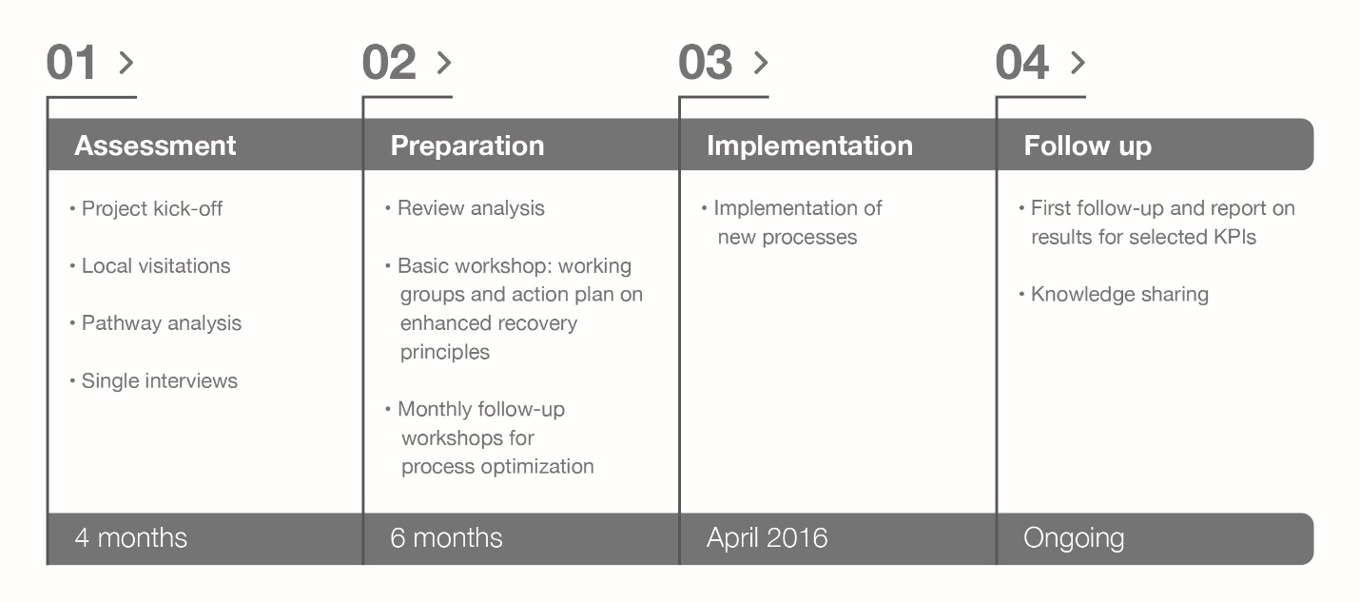
Supplemental Figure S1: Patient pathway optimization study flow at Cantonal Hospital Münsterlingen (Switzerland).
Abbreviations: KPI, key performance indicator.
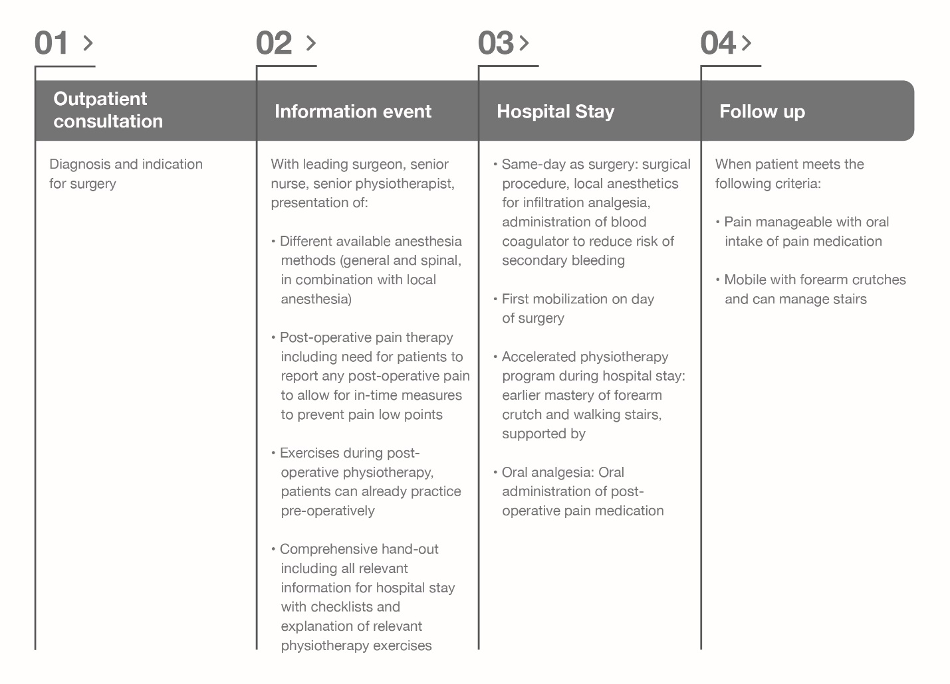
Supplemental Figure S2: Implementation of enhanced recovery principles in the patient pathway optimization.
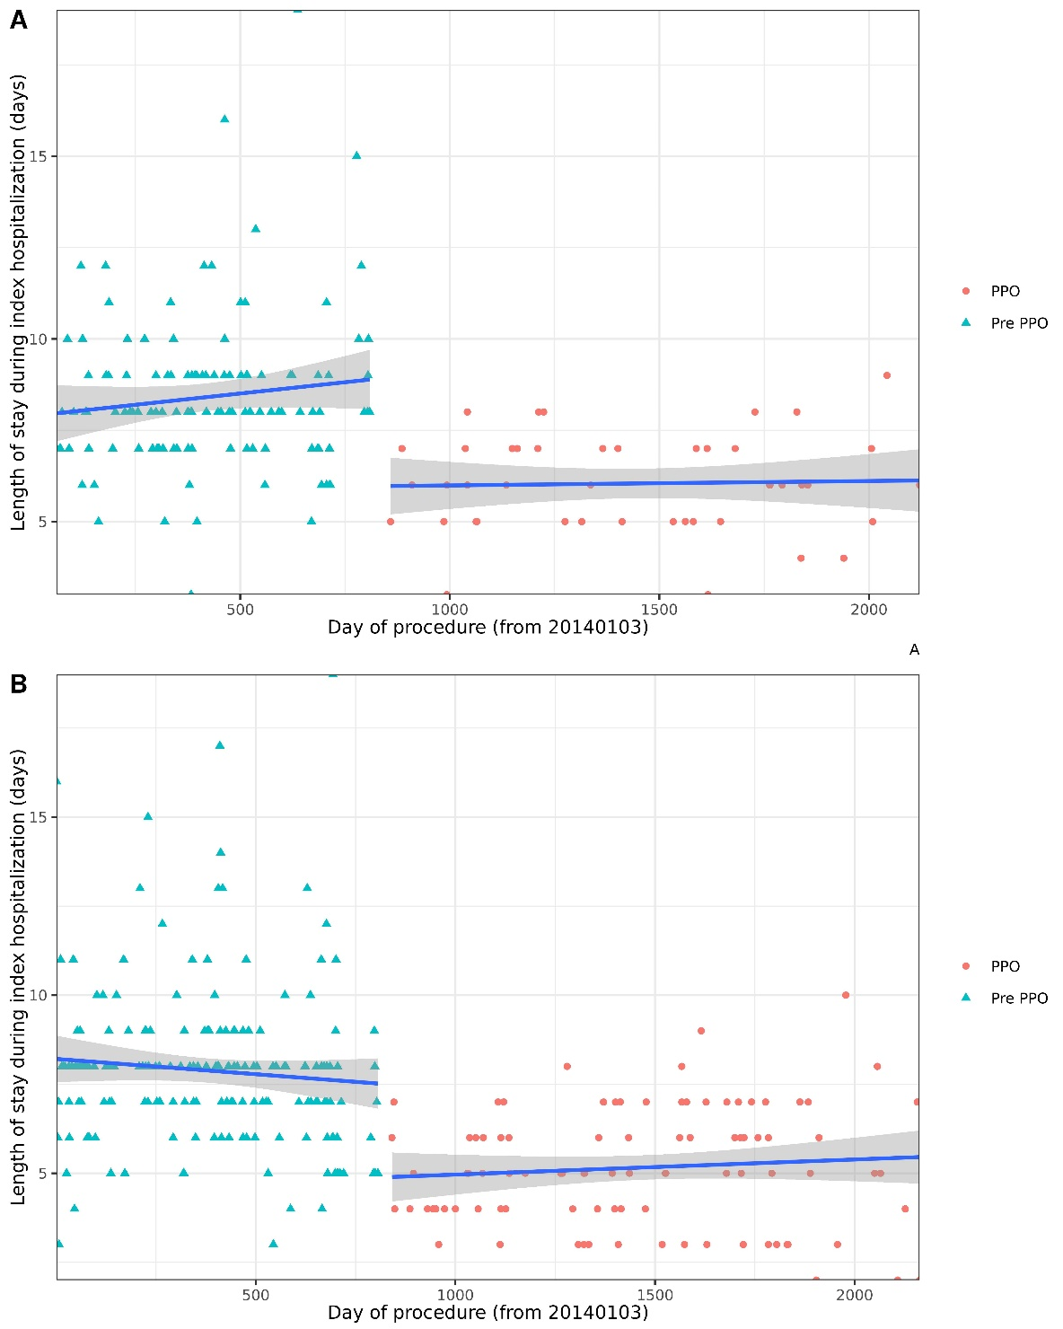
Supplemental Figure S3: Plot of median length of study during the index hospitalization for patients who had (A) total knee arthroplasty and (B) total hip arthroplasty by Year.
Abbreviations: PPO, patient pathway optimization.
Note: Blue lines show linear trendlines with gray areas showing the standard errors for pre-PPO (2014 to 2016) and PPO (2016 to 2019) data points, respectively.

