Folate Decorated Multifunctional Biodegradable Nanoparticles for Gastric Carcinoma Active Targeting Theranostics

Xin Zhang, *^{, 1} Ronglin Yan, *^{, 1} Ziran Wei, *^{, 1} Dejun Yang, ¹ Zunqi Hu, ¹ Yu Zhang, ¹ Xin Huang, ¹ Hejing Huang, †^{, 2} Weijun Wang †^{, 1}

¹Department of Gastrointestinal Surgery, Second Affiliated Hospital of Naval Medical University, Shanghai, 200003, China
²Department of ultrasound, Second Affiliated Hospital of Naval Medical University, Shanghai, 200003, China

†Corresponding author：
E-mail: wangweijun@smmu.edu.cn, Tel: +86-021-81885601
E-mail: huanghejinga@163.com, Tel: +86- 021-81886051

Experiment
Statistical analysis
All data were presented as the mean ± standard deviation (SD). One-way analysis of variance (ANOVA) was used to assess significance between groups, after which post-hoc tests with the Bonferroni correction were used for comparison among individual groups. *p < 0.05 was considered significant, and **p < 0.01 and ***p < 0.001 were considered highly significant.

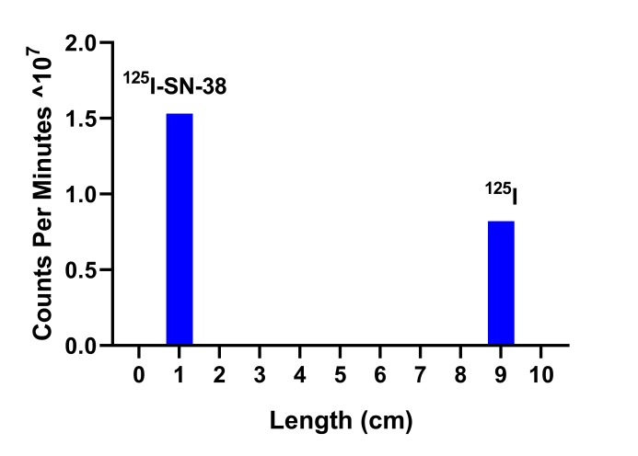
Figure S1. Thin layer chromatography analysis of ¹²⁵I-SN-38. The R_{f} of ¹²⁵I-SN-38 was ~0.1, and free ¹²⁵I was ~0.9.

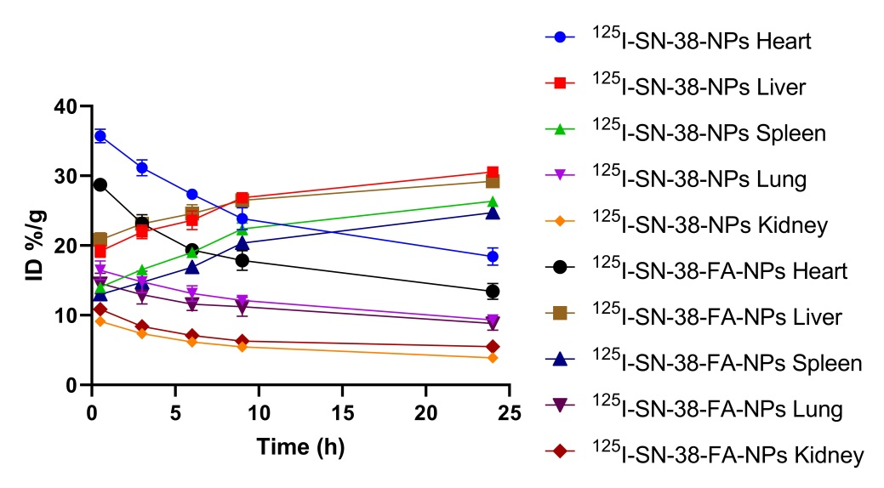
Figure S2. Quantification of distribution of major organs was obtained from SPECT images varied with postinjection time.

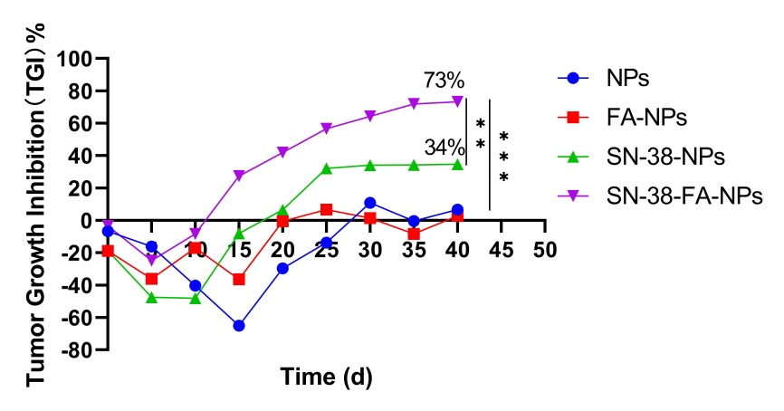
Figure S3. The tumor growth inhibition of NPs, FA-NPs, SN-38-NPs, and SN-38-FA-NPs was calculated over time. **p < 0.01 and ***p < 0.001 considered highly significant.

