SUPPLEMENTARY MATERIAL

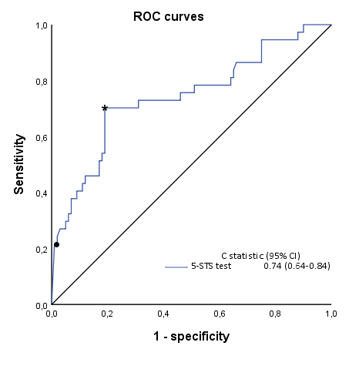

Figure S1 Receiver operating characteristics curves demonstrating the ability of 5-STS test to predict 5-year all-cause mortality.

Notes: *identifies the Youden’s index point and •identifies the more specific point. To define the four categories for the 5-STS, we first selected three cut-offs on this curve, of which the two extreme values were the maximum Youden index (16 s) and the highest specific value (22 s). The intermediate point was established at the middle (19 s) in order to have the same number of seconds in each of two intermediate categories.
Abbreviations: 5-STS, five-repetition sit-to-stand test; ROC, receiver-operating characteristics; CI, confidence interval; C statistics, concordance index.

Table S1 Regression coefficients and development of the point assignment system for the 5-STS test.

 | Coefficients βs per unit increase | Category (j)† | Reference values Wij (midpoint) | βs×(Wij–Wi reference) | Risk score (βs×[Wij–Wi reference]/B‡)
5-STS test, s | 0.065  (P=0.000) | <16  16–18.9  19–22  ≥22 | 12.5  17.5  20.5  27.0 | ..  0.325  0.520  0.943 | 0  1  2  3

Notes: †Identified categories; ‡Coefficient B=0.325 is the constant for the point system. Points rounded to the next integer. A Cox regression analysis, with 5-year mortality as the outcome variable and the 5-STS categories as predictor, was used to generate the point assignment system to the four 5-STS. The strength of association determined the scores to these categories.
Abbreviations: 5-STS, five-repetition sit-to-stand test; s, seconds.
.

