Appendix 1. List of IRBs
SONATA study
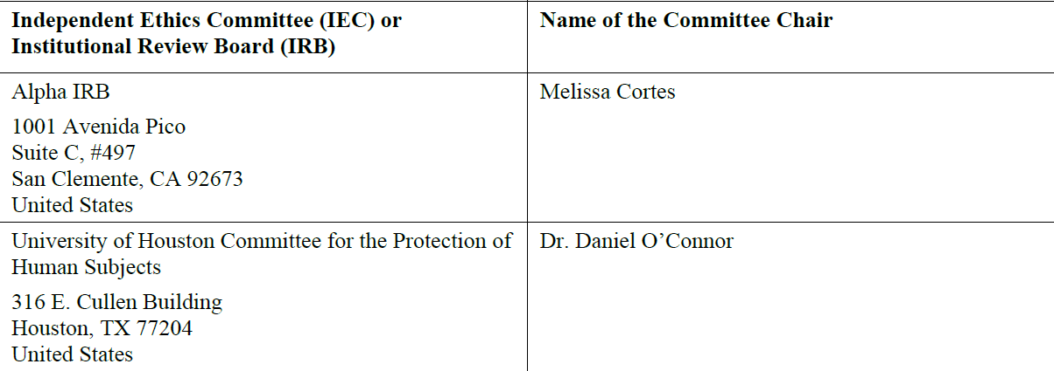

RWE Chart review study:
All study materials were approved by the New England Independent Review Board (NEIRB) under the exempt category as data were de-identified and patient informed consent was not required.

