Supplementary Information
Supplementary figure and table legends
Supplementary Table 1. Weighted adjacency matrix
Supplementary Table 2. Mean, and standard deviation of SI symptoms by sex.
Supplementary Figure 1. Accuracy of the edge-weights for the SI network model.
Supplementary Figure 2. Estimation of edge weight difference by bootstrapped difference test.
Supplementary Figure 3. Comparison of network centrality indices between male and female participants.
Supplementary Figure 4. Comparison of network properties between male and female participants.

Supplementary Table 1. Weighted adjacency matrix
 | SIQ_1 | SIQ_2 | SIQ_3 | SIQ_4 | SIQ_5 | SIQ_6 | SIQ_7 | SIQ_8 | SIQ_9 | SIQ_10 | SIQ_11 | SIQ_13 | SIQ_14 | SIQ_15 | SIQ_16 | SIQ_18 | SIQ_19 | SIQ_20 | SIQ_21
SIQ_1 | 0.00 | 0.20 | 0.22 | 0.10 | 0.02 | 0.12 | 0.07 | 0.00 | 0.01 | 0.00 | 0.00 | 0.02 | 0.00 | 0.14 | 0.00 | 0.00 | 0.00 | 0.07 | 0.00
SIQ_2 | 0.20 | 0.00 | 0.39 | 0.00 | 0.02 | 0.02 | 0.04 | 0.00 | 0.00 | 0.00 | -0.07 | 0.00 | -0.01 | 0.13 | 0.00 | 0.00 | 0.00 | 0.02 | 0.00
SIQ_3 | 0.22 | 0.39 | 0.00 | 0.23 | 0.00 | 0.00 | 0.00 | 0.00 | 0.00 | 0.03 | -0.01 | 0.00 | 0.00 | 0.04 | 0.00 | 0.00 | 0.00 | 0.01 | 0.00
SIQ_4 | 0.10 | 0.00 | 0.23 | 0.00 | 0.12 | 0.00 | 0.02 | 0.00 | 0.00 | 0.08 | 0.11 | 0.07 | 0.04 | -0.20 | 0.00 | -0.05 | 0.07 | 0.00 | 0.02
SIQ_5 | 0.02 | 0.02 | 0.00 | 0.12 | 0.00 | 0.33 | 0.00 | 0.16 | 0.02 | 0.00 | 0.03 | 0.02 | 0.00 | 0.00 | 0.00 | 0.13 | 0.03 | 0.00 | -0.03
SIQ_6 | 0.12 | 0.02 | 0.00 | 0.00 | 0.33 | 0.00 | 0.15 | 0.08 | 0.21 | -0.06 | 0.00 | 0.00 | 0.00 | 0.27 | 0.01 | 0.00 | 0.00 | 0.00 | 0.00
SIQ_7 | 0.07 | 0.04 | 0.00 | 0.02 | 0.00 | 0.15 | 0.00 | 0.38 | 0.16 | 0.03 | 0.00 | 0.00 | 0.00 | 0.03 | 0.00 | 0.00 | 0.00 | 0.02 | 0.04
SIQ_8 | 0.00 | 0.00 | 0.00 | 0.00 | 0.16 | 0.08 | 0.38 | 0.00 | 0.27 | 0.06 | 0.03 | 0.02 | 0.00 | 0.00 | 0.02 | 0.00 | 0.02 | 0.00 | 0.05
SIQ_9 | 0.01 | 0.00 | 0.00 | 0.00 | 0.02 | 0.21 | 0.16 | 0.27 | 0.00 | 0.11 | 0.12 | 0.02 | 0.00 | 0.01 | 0.00 | 0.08 | 0.00 | 0.05 | 0.04
SIQ_10 | 0.00 | 0.00 | 0.03 | 0.08 | 0.00 | -0.06 | 0.03 | 0.06 | 0.11 | 0.00 | 0.47 | 0.00 | 0.16 | -0.09 | 0.00 | 0.00 | 0.02 | 0.02 | 0.00
SIQ_11 | 0.00 | -0.07 | -0.01 | 0.11 | 0.03 | 0.00 | 0.00 | 0.03 | 0.12 | 0.47 | 0.00 | 0.00 | 0.10 | 0.00 | 0.02 | 0.04 | 0.01 | 0.00 | 0.12
SIQ_13 | 0.02 | 0.00 | 0.00 | 0.07 | 0.02 | 0.00 | 0.00 | 0.02 | 0.02 | 0.00 | 0.00 | 0.00 | 0.70 | 0.00 | 0.05 | 0.00 | 0.05 | 0.05 | 0.00
SIQ_14 | 0.00 | -0.01 | 0.00 | 0.04 | 0.00 | 0.00 | 0.00 | 0.00 | 0.00 | 0.16 | 0.10 | 0.70 | 0.00 | -0.07 | 0.09 | 0.00 | 0.00 | 0.09 | 0.00
SIQ_15 | 0.14 | 0.13 | 0.04 | -0.20 | 0.00 | 0.27 | 0.03 | 0.00 | 0.01 | -0.09 | 0.00 | 0.00 | -0.07 | 0.00 | 0.16 | 0.07 | -0.01 | 0.29 | -0.01
SIQ_16 | 0.00 | 0.00 | 0.00 | 0.00 | 0.00 | 0.01 | 0.00 | 0.02 | 0.00 | 0.00 | 0.02 | 0.05 | 0.09 | 0.16 | 0.00 | 0.22 | 0.14 | 0.00 | 0.23
SIQ_18 | 0.00 | 0.00 | 0.00 | -0.05 | 0.13 | 0.00 | 0.00 | 0.00 | 0.08 | 0.00 | 0.04 | 0.00 | 0.00 | 0.07 | 0.22 | 0.00 | 0.43 | 0.02 | 0.11
SIQ_19 | 0.00 | 0.00 | 0.00 | 0.07 | 0.03 | 0.00 | 0.00 | 0.02 | 0.00 | 0.02 | 0.01 | 0.05 | 0.00 | -0.01 | 0.14 | 0.43 | 0.00 | 0.05 | 0.28
SIQ_20 | 0.07 | 0.02 | 0.01 | 0.00 | 0.00 | 0.00 | 0.02 | 0.00 | 0.05 | 0.02 | 0.00 | 0.05 | 0.09 | 0.29 | 0.00 | 0.02 | 0.05 | 0.00 | 0.21
SIQ_21 | 0.00 | 0.00 | 0.00 | 0.02 | -0.03 | 0.00 | 0.04 | 0.05 | 0.04 | 0.00 | 0.12 | 0.00 | 0.00 | -0.01 | 0.23 | 0.11 | 0.28 | 0.21 | 0.00

Supplementary Table 2. Mean, and standard deviation of SI symptoms by sex.
Construct/nodes | Label | Male (n=565) | Female (n=675) | p | Cohen's d
 |  | Mean(SD) | Mean(SD)
Difficulty getting up | SIQ_1 | 2.87 (1.29) | 3.15 (1.22) | <0.001 | -0.22
Need an alarm to wake up | SIQ_2 | 2.96 (1.46) | 3.59 (1.23) | <0.001 | -0.47
Hit the snooze button on the alarm | SIQ_3 | 2.63 (1.46) | 2.92 (1.39) | <0.001 | -0.20
Bump into and drop things | SIQ_4 | 1.78 (1.13) | 1.82 (0.98) | 0.579 | -0.03
Move more slowly | SIQ_5 | 2.78 (1.32) | 3.06 (1.20) | <0.001 | -0.22
Feel sleepy | SIQ_6 | 3.06 (1.32) | 3.38 (1.18) | <0.001 | -0.26
Heavy, sore, or itchy eyes | SIQ_7 | 2.73 (1.32) | 3.00 (1.28) | <0.001 | -0.21
Tired or heavy arms and/or legs | SIQ_8 | 2.72 (1.32) | 2.94 (1.22) | 0.002 | -0.18
Groggy, fuzzy or hazy mind | SIQ_9 | 2.65 (1.31) | 2.87 (1.23) | 0.002 | -0.18
Get winded more easily | SIQ_10 | 1.98 (1.12) | 1.99 (1.06) | 0.891 | -0.01
Difficulty keeping balance | SIQ_11 | 2.19 (1.25) | 2.24 (1.17) | 0.462 | -0.04
Anxious about the upcoming day | SIQ_13 | 2.18 (1.21) | 2.33 (1.15) | 0.024 | -0.13
Dread starting your day | SIQ_14 | 1.97 (1.13) | 2.02 (1.06) | 0.388 | -0.05
Wish to sleep more | SIQ_15 | 3.49 (1.37) | 3.86 (1.11) | <0.001 | -0.30
Difficulty concentrating | SIQ_16 | 2.56 (1.33) | 2.77 (1.19) | 0.003 | -0.17
React more slowly | SIQ_18 | 2.66 (1.33) | 2.93 (1.23) | <0.001 | -0.21
Make more mistakes/errors | SIQ_19 | 2.47 (1.27) | 2.72 (1.17) | <0.001 | -0.21
Can’t imagine being able to wake up | SIQ_20 | 2.56 (1.40) | 2.95 (1.32) | <0.001 | -0.29
Difficulty getting thoughts together | SIQ_21 | 2.43 (1.29) | 2.63 (1.19) | 0.005 | -0.16
Note: Adapted from Kanady JC, Harvey AG. Development and validation of the Sleep Inertia Questionnaire (SIQ) and assessment of sleep inertia in analogue and clinical depression. Cognitive Ther Res. 2015;39(5):601–612. Supplementary Table 2 is copyright protected and excluded from the open access licence.²⁸
Supplementary Figure 1. Accuracy of the edge-weights for the SI network model.
The gray area represents the 95% Confidence Intervals of edge weights, estimated with the non-parametric bootstrap procedure. Wide intervals indicate lower stability and narrow intervals indicate higher stability. The red dots indicate the sample values, while the black dots indicate the values of each edge weight, ordered from the highest to the lowest value.

Supplementary Figure 2. Estimation of edge weight difference by bootstrapped difference test. Bootstrapped difference tests between edge weights in the network. Gray boxes indicate edges that do not significantly differ from one-another. Black boxes represent edges with significant difference from one another (α = 0.05). Blue boxes in the edge-weight plot indicate positive correlations, and orange boxes in the edge-weight plot indicate negative correlations.

Supplementary Figure 3. Comparison of network centrality indices between male and female participants. Orange dots represent female sample, and blue dots represent male sample.

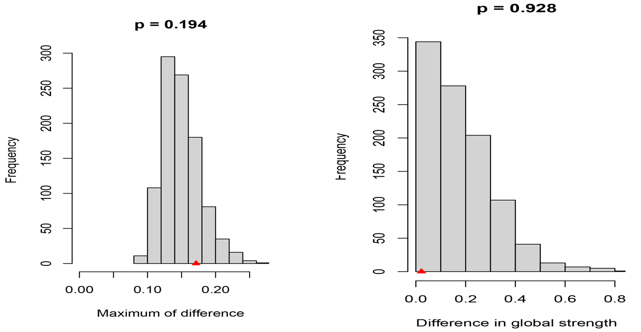
Supplementary Figure 4. Comparison of network properties between male and female participants. Left panel: the maximum difference in edge strength; Right panel: the difference in global strength. The red triangle indicates the test statistic based on the observed (real) data.

