Supplementary Material

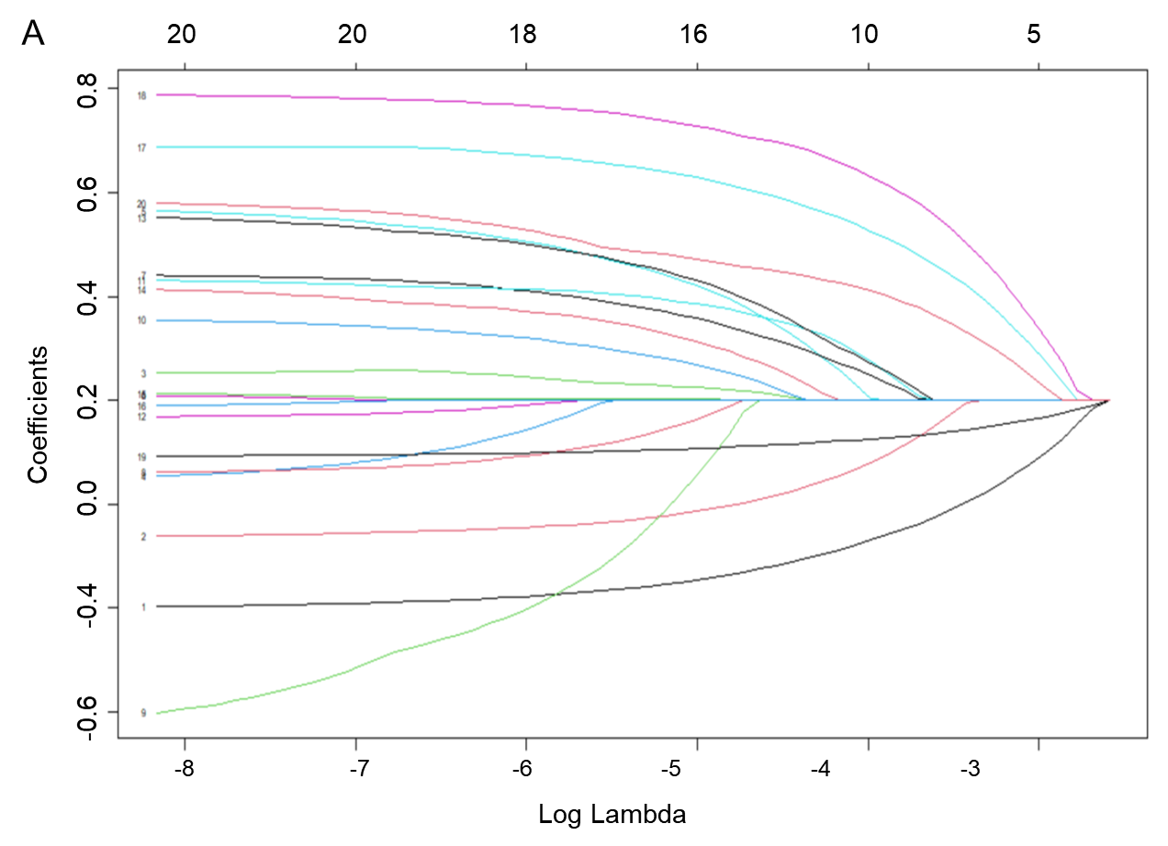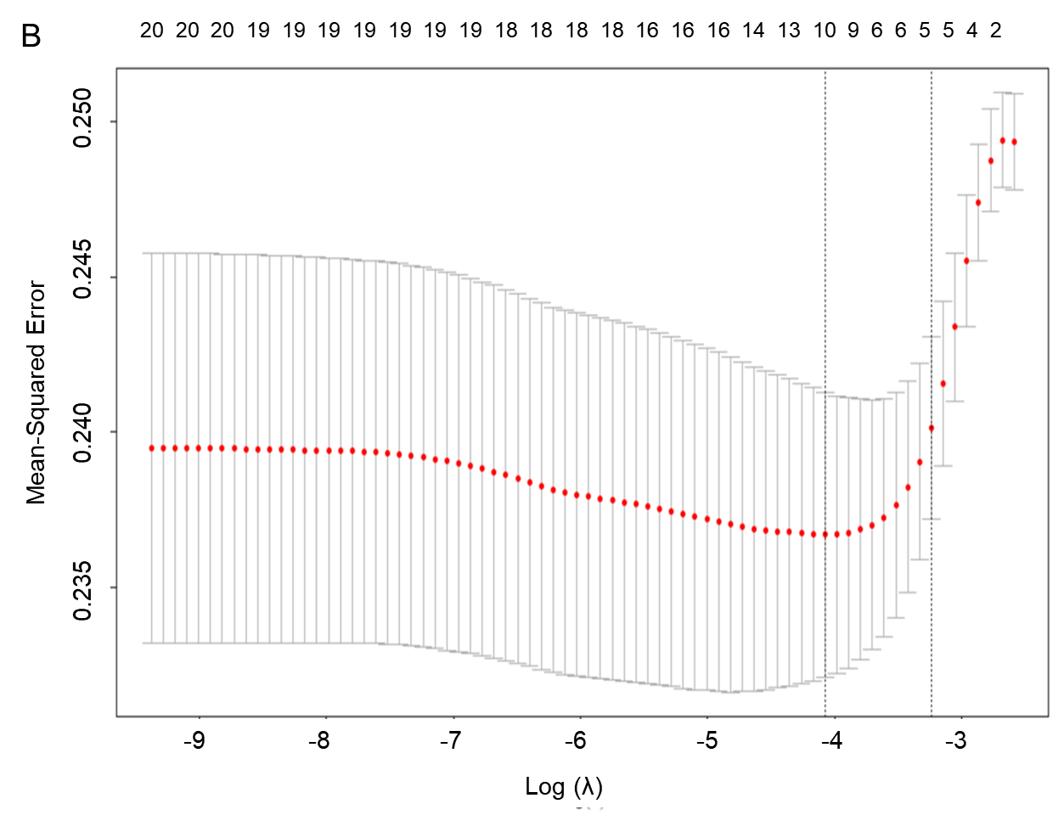

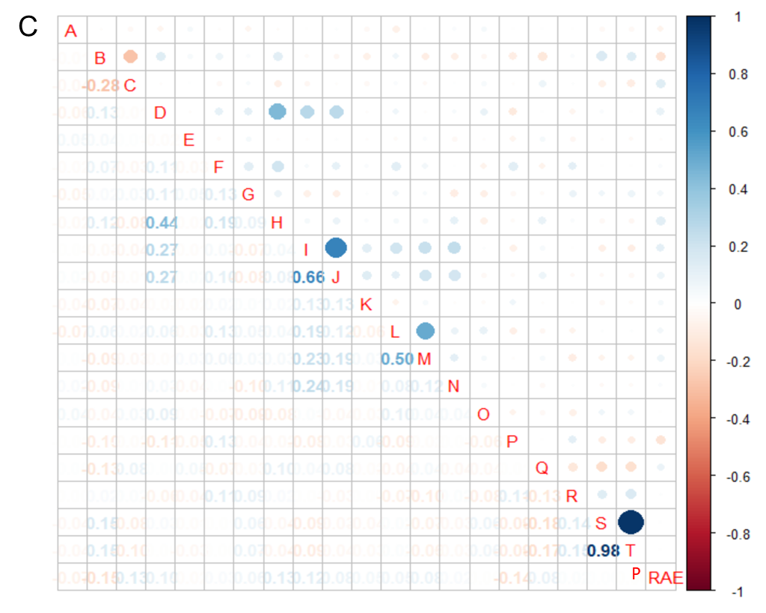

Supplementary Figure 1: Demographic and clinical feature selection using the LASSO. (A) The minimum criterion of 10-fold cross-validation selects the optimal parameter (λ) in the LASSO model; (B) LASSO coefficient profiles of the 20 features. The coefficient profiles are drawn as a function of log(λ);(C) Visualization of PRAE data correlation coefficients. A:gender; B:age; C:obesity; D:ASA; E:asthma; F:eczema; G:allergy; H:smoking; I:CSAS; J:time of upper respiratory tract infection; K:fever; L:stuffy nose; M:runny nose; N:coughing; O: anesthetist experience; P: premedication; Q: anesthesia method; R: anesthesia maintenance; S: anesthesia time; T: operation time; PRAE: perioperative respiratory adverse events
Figure 3 Forest plot of odds ratio (OR) with confidence intervals.

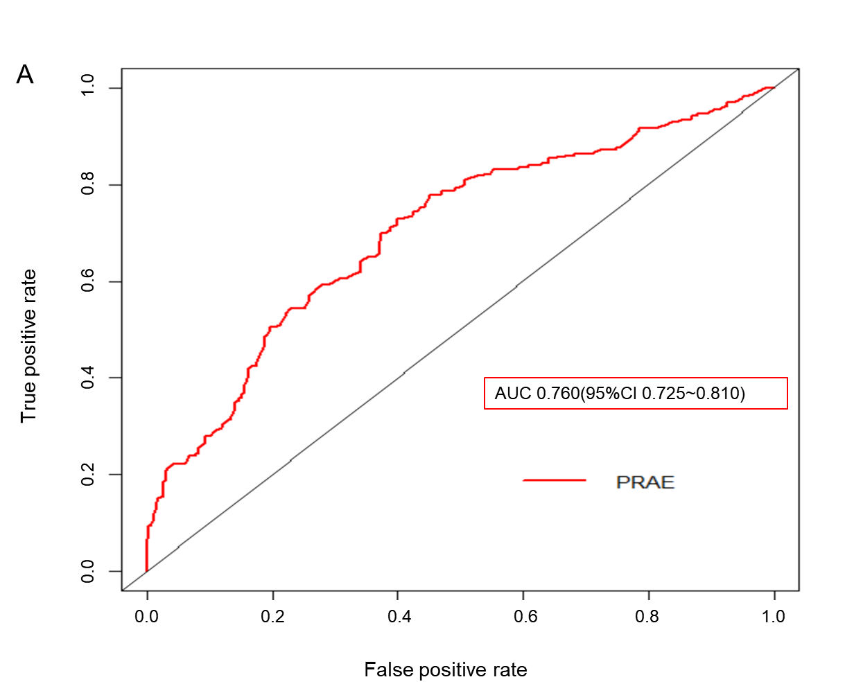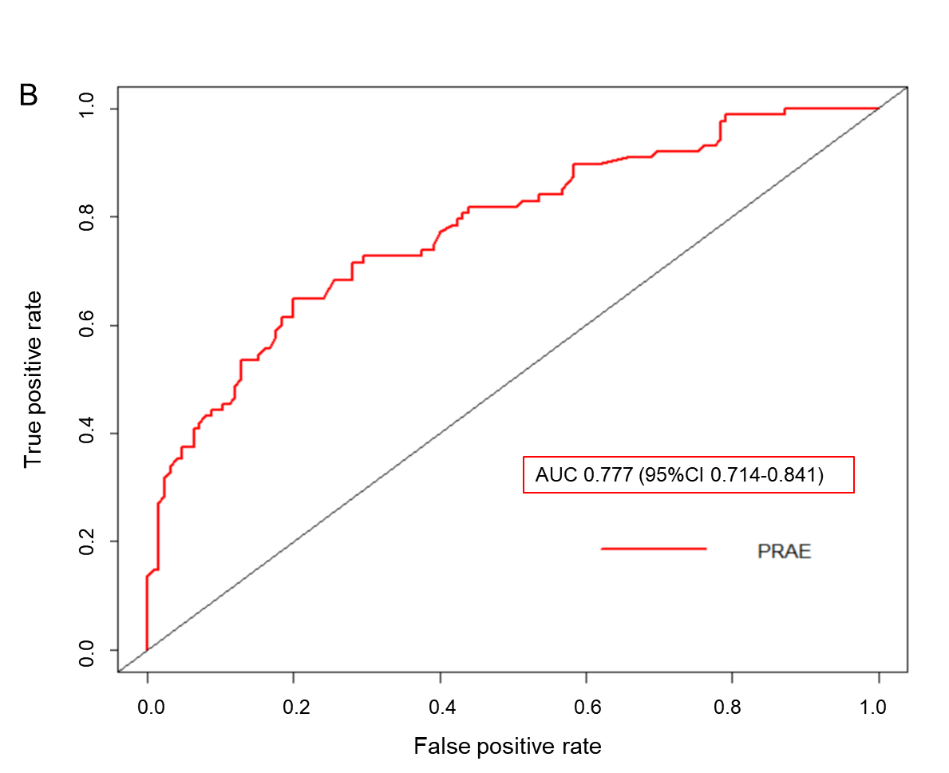

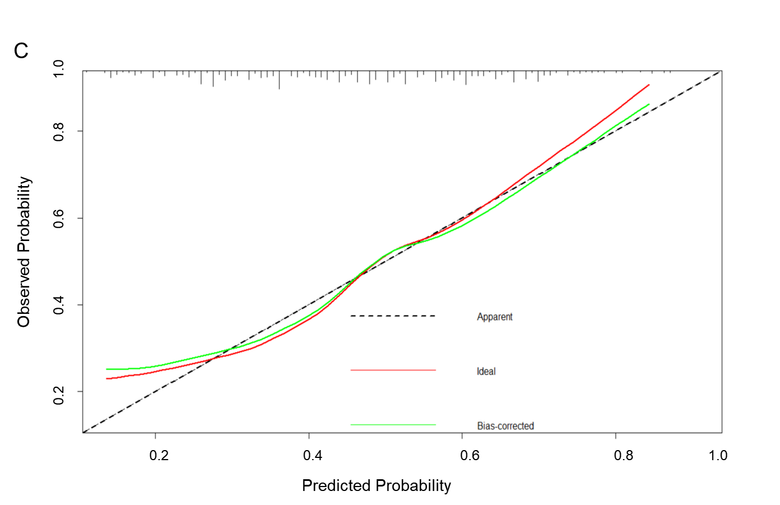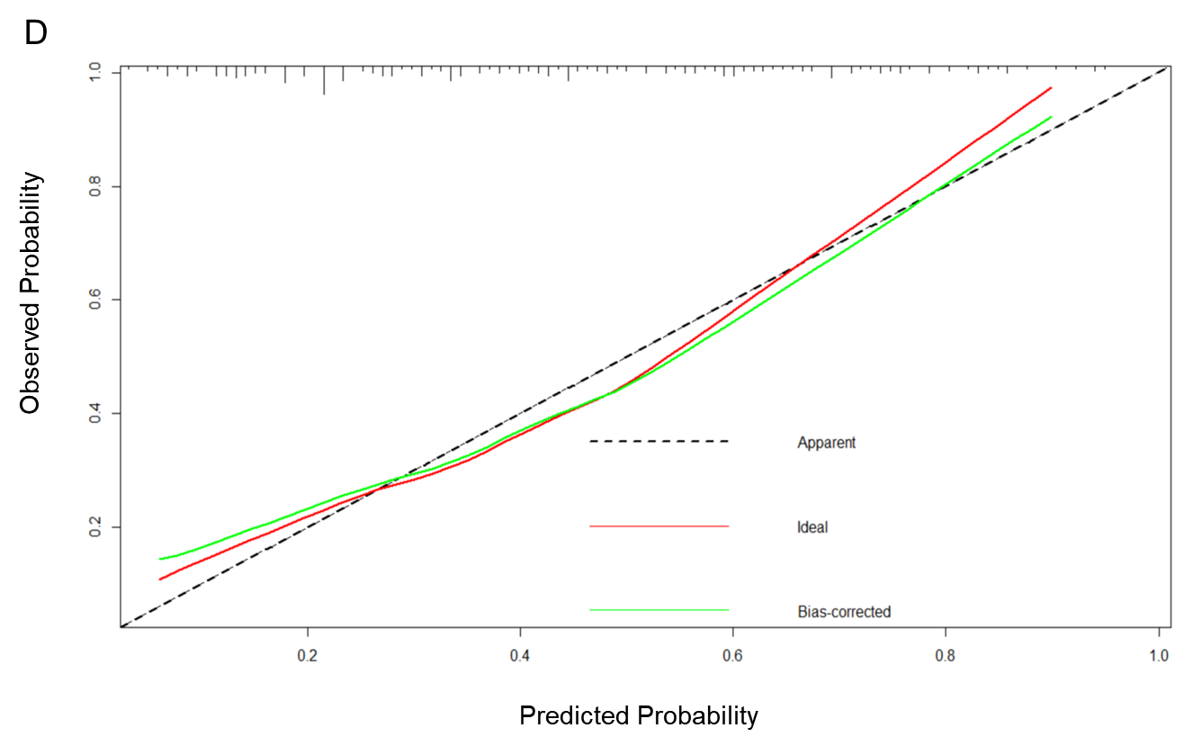

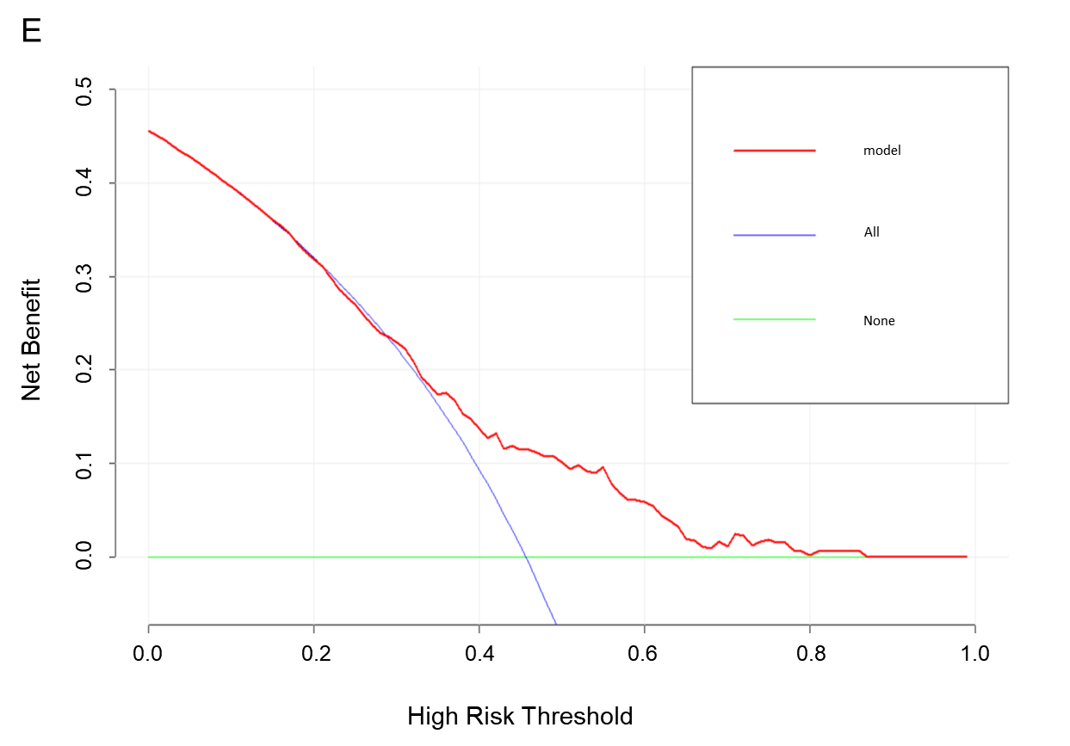

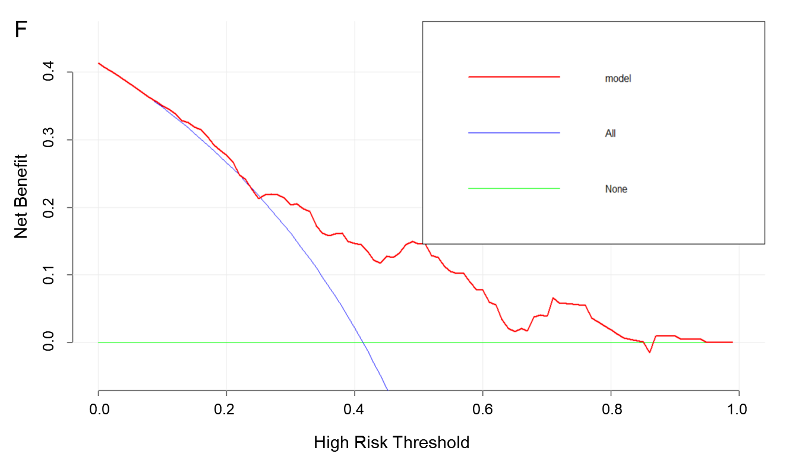

Supplementary Figure 2: ROC curve of the nomogram for predicting PRAE in Children undergoing Airway Surgery. (A) ROC curve in the training cohort; (B) ROC curve in the validation cohort; Calibration curve of the nomogram for the training cohort (C) and the validation cohort (D),the X-axis represents the overall predicted probability of PRAE and the Y-axis represents the actual probability. Model calibration is indicated by the degree of fitting of the curve and the diagonal; Decision curve analysis for the training cohort (E) and the validation cohort (F). A horizontal line indicates that all samples are negative and no PRAE, with a net benefit of zero. An oblique line indicates that all samples are positive. The net benefit has a negative slope.

