Supplementary table 1. Sensitivity analysis for the associations between various outcomes and age-adjusted elevation of D-dimer with multiple adjustments for established risk factors.
Level of  D-dimer | All-cause death  HR (95% CI) | P-value | Cardiac death  HR (95% CI) | P-value | MACE  HR (95% CI) | P-value
Patients with liver disease excluded
Low D-dimer | 1 (reference) | - | 1 (reference) | - | 1 (reference) | -
High D-dimer | 1.69 (1.27-2.28) | <0.001 | 1.71 (1.19-2.46) | 0.003 | 1.45 (1.16-1.82) | 0.001
Patients with tumor disease excluded
Low D-dimer | 1 (reference) | - | 1 (reference) | - | 1 (reference) | -
High D-dimer | 1.65 (1.23-2.20) | 0.001 | 1.79 (1.26-2.55) | 0.001 | 1.43 (1.15-1.78) | 0.001
Patients with cardiac arrest excluded
Low D-dimer | 1 (reference) | - | 1 (reference) | - | 1 (reference) | -
High D-dimer | 1.77 (1.32-2.38) | <0.001 | 1.94 (1.34-2.80) | <0.001 | 1.45 (1.16-1.82) | 0.001
Patients with cerebrovascular diseases excluded
Low D-dimer | 1 (reference) | - | 1 (reference) | - | 1 (reference) | -
High D-dimer | 1.70 (1.23-2.38) | 0.002 | 1.90 (1.27-2.84) | 0.002 | 1.42 (1.11-1.82) | 0.006
Patients with acute MACE events during the acute phase (≤ 14 days)
Low D-dimer | 1 (reference) | - | 1 (reference) | - | 1 (reference) | -
High D-dimer | 1.43 (1.04-1.96) | 0.030 | 1.39 (0.92-2.11) | 0.121 | 1.27 (1.00-1.61) | 0.045
Established risk factors included age, sex, diabetes, hypertension, peripheral artery diseases, diagnosis of ST-segment elevation myocardial infarction, atrial fibrillation, old myocardial infarction, history of stroke, incidence of cardiac arrest, ejection fraction, creatinine, peak value of cardiac troponin I, low-density lipoprotein cholesterol, high-sensitivity C-reactive protein, culprit lesion, multivessel disease, pre- and post-procedure TIMI flow, door-to-balloon time. HR = hazard ratio, MACE = major adverse cardiovascular events, TIMI grade flow = Thrombolysis In Myocardial Infarction grade flow.
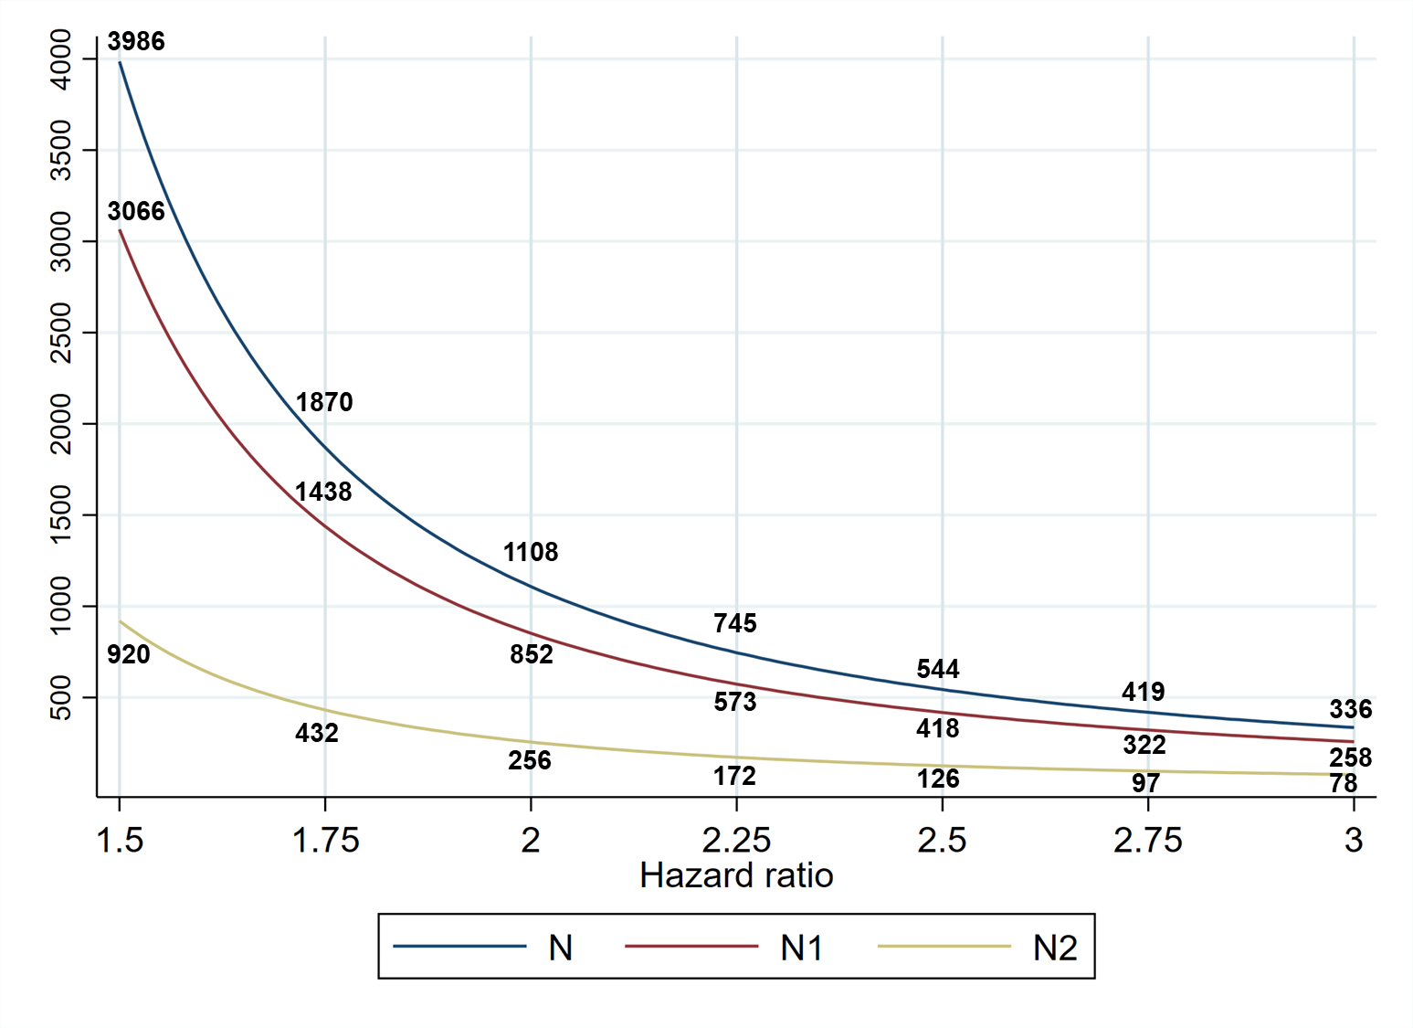
Supplementary figure 1. Required sample size to detect a hazard increase at a power of 80% of a two-sided log-rank test with α = 0.05. N = sample size for the whole cohort, N1 = sample size for low D-dimer group, N2 = sample size for high D-dimer group. Based on the current cohort, the ratio of patients in high and low D-dimer group (N2/N1) was set as 0.3. The observed survival probability in the low D-dimer group (equivalent as the control group) was 0.987, 0.980 ,0.974, 0.959, 0.951, 0.928, 0.919, and 0.893 by the end of first to eighth years. To detect a 61 % increase in the hazard (hazard ratio: 1.61) of the high D-dimer group, as shown in the Cox regression with multiple adjustments, a total of 2743 patients needs to be recruited, namely 2110 patients in low D-dimer group and 633 patients in high D-dimer group.

