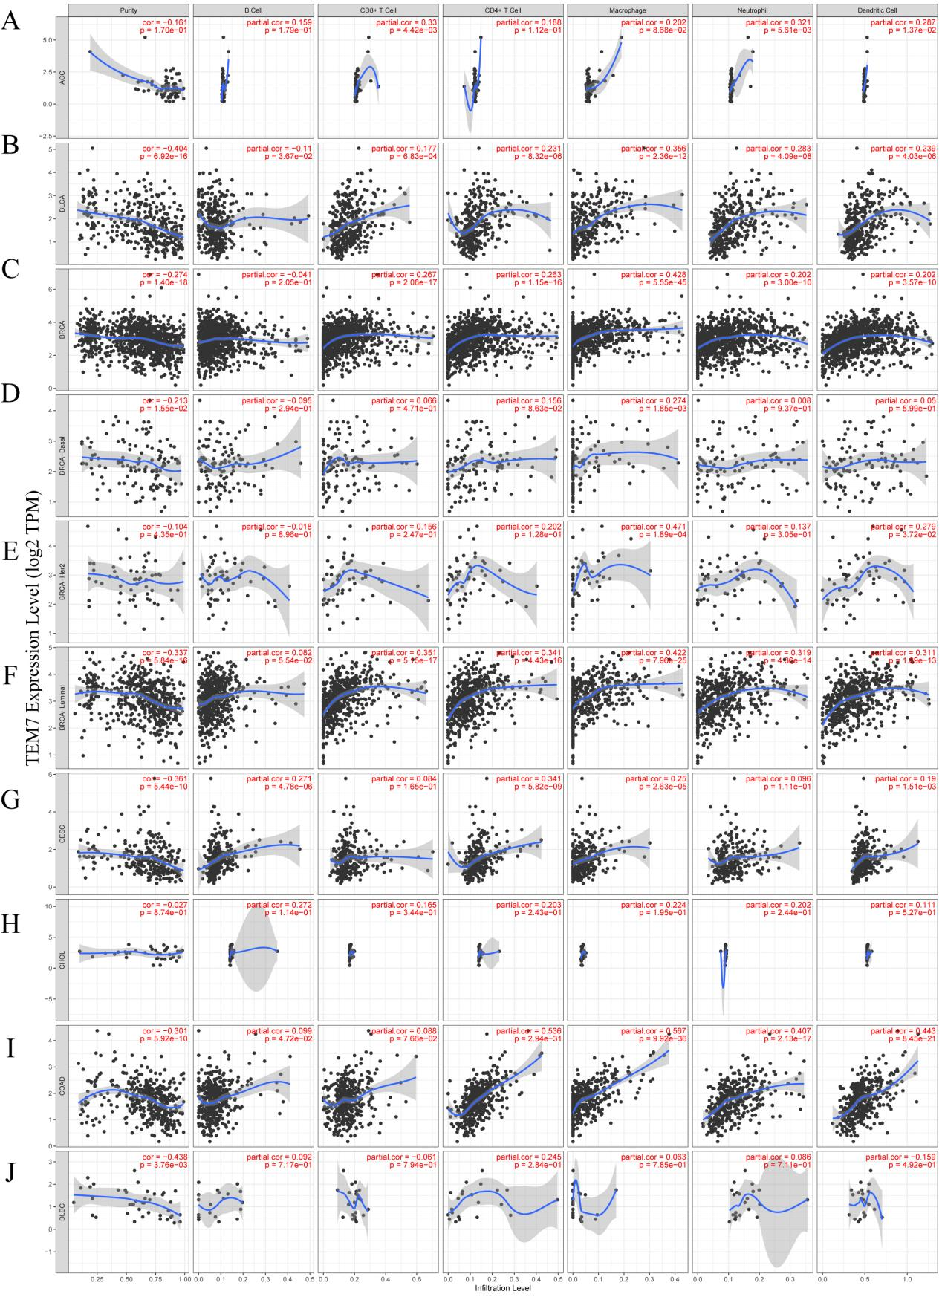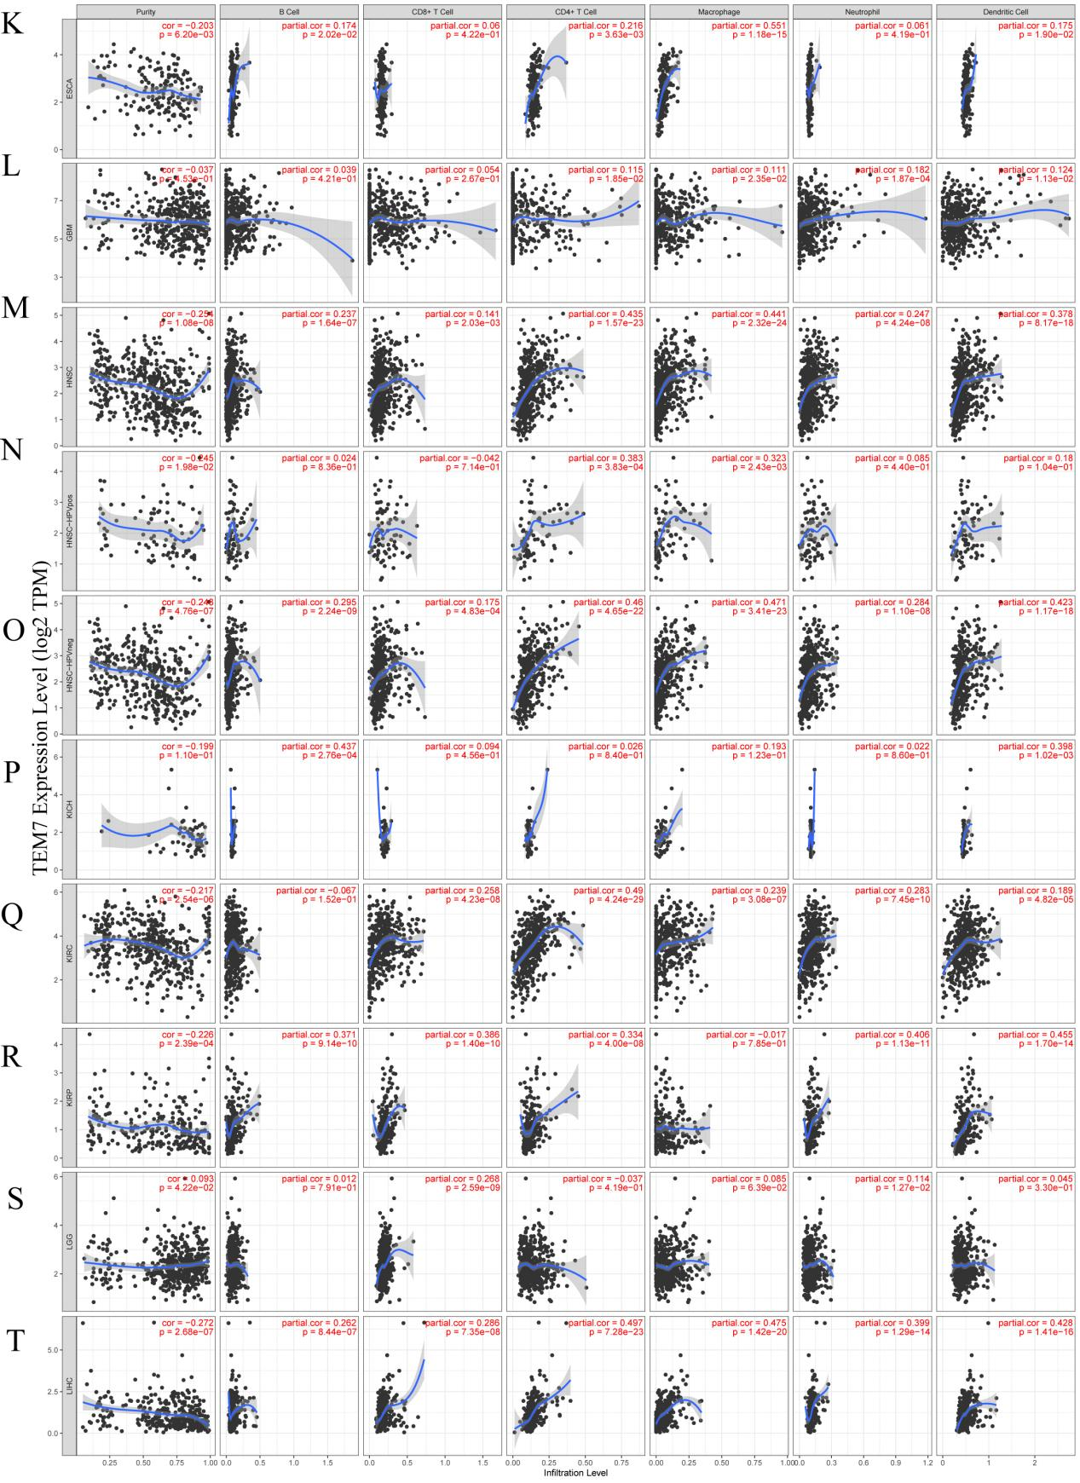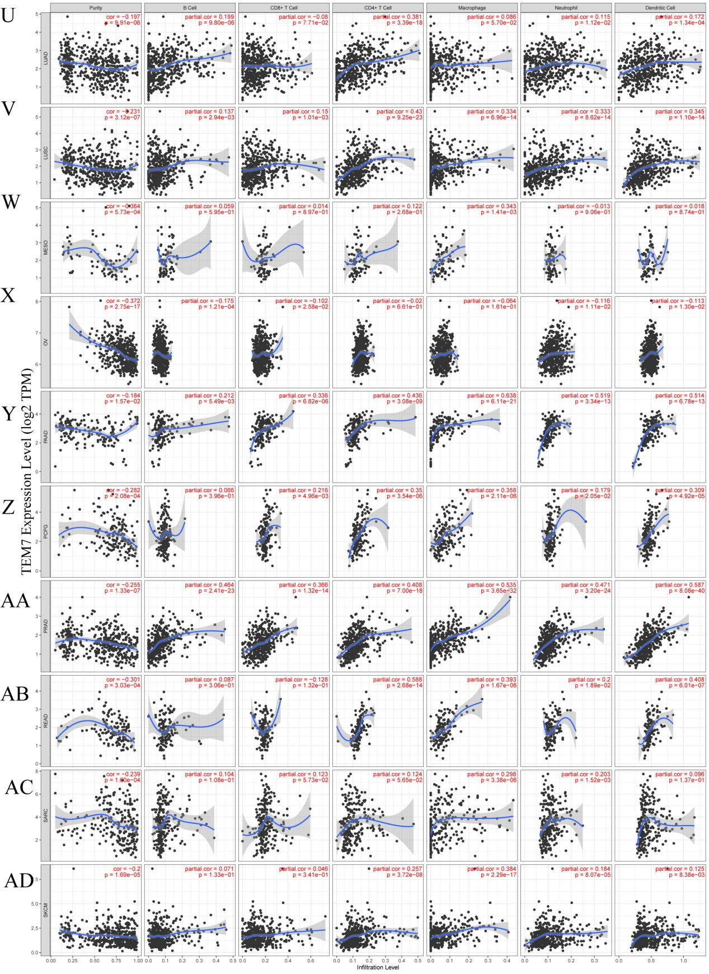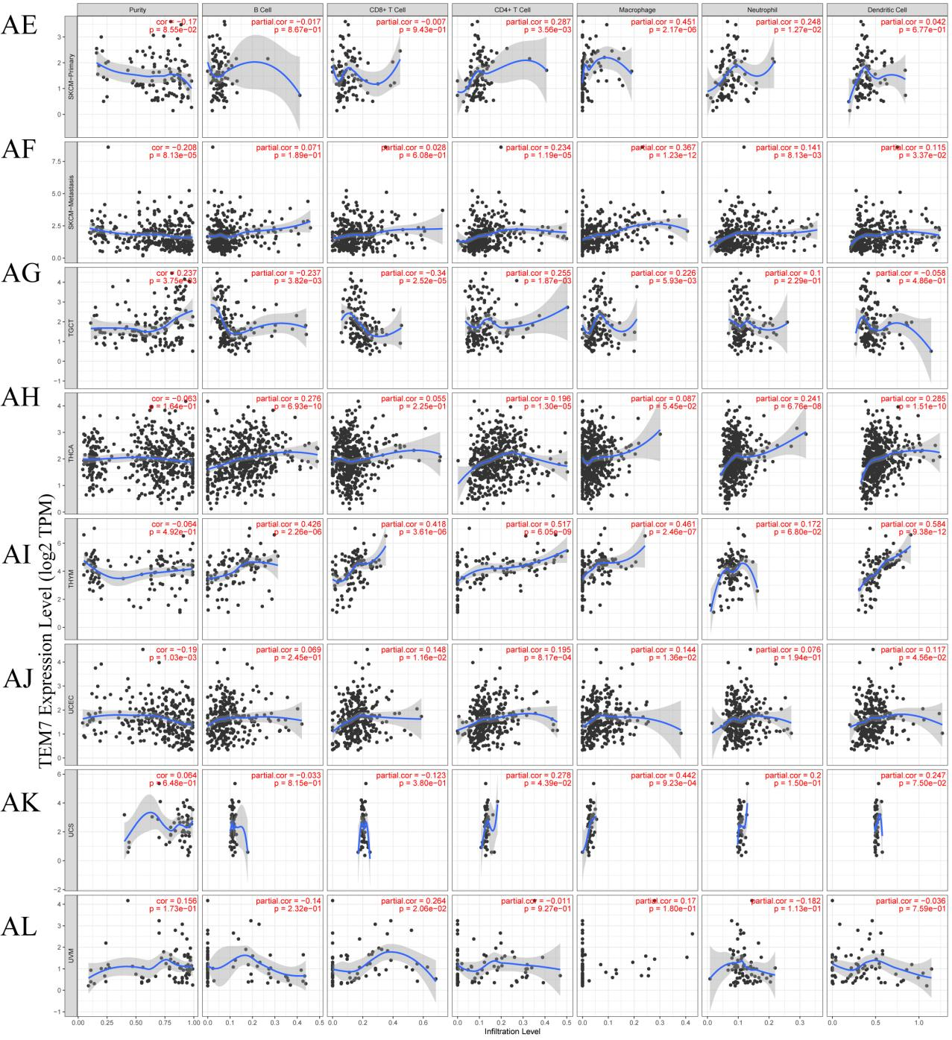
Supplementary Figure S1: Correlation of TEM7 expression with immune infiltration levels in diverse types of cancer in the TIMER database. Adrenocortical carcinoma (ACC) (A), Bladder Urothelial Carcinoma (BLCA) (B), Breast invasive carcinoma (BRCA) (C), Breast invasive carcinoma-Basal (BRCA-Basal) (D), Breast invasive carcinoma-Her2 (BRCA-Her2) (E), Breast invasive carcinoma-Luminal (BRCA- Luminal) (F), Cervical squamous cell carcinoma and endocervical adenocarcinoma (CESC) (G), Cholangiocarcinoma (CHOL) (H), Colon adenocarcinoma (COAD) (I), Lymphoid Neoplasm Diffuse Large B-cell Lymphoma (DLBC) (J), Esophageal carcinoma (ESCA) (K), Glioblastoma multiforme (GBM) (L) ,Head and Neck squamous cell carcinoma (HNSC) (M), Head and Neck squamous cell carcinoma- HPVpos (HNSCHPVpos) (N) , Head and Neck squamous cell carcinoma-HPVneg (HNSC-HPVneg) (O), Kidney Chromophobe (KICH) (P), Kidney renal clear cell carcinoma (KIRC) (Q), Kidney renal papillary cell carcinoma (KIRP) (R), Brain Lower Grade Glioma (LGG) (S), Liver hepatocellular carcinoma (LIHC) (T), Lung adenocarcinoma (LUAD) (U), Lung squamous cell carcinoma (LUSC) (V), Mesothelioma (MESO) (W), Ovarian serous cystadenocarcinoma (OV) (X), Pancreatic adenocarcinoma (PAAD) (Y), Pheochromocytoma and Paraganglioma (PCPG) (Z), Prostate adenocarcinoma (PRAD) (AA), Rectum adenocarcinoma (READ) (AB), Sarcoma (SARC) (AC), Skin Cutaneous Melanoma (SKCM) (AD), Skin Cutaneous Melanoma-Primary (SKCMPrimary) (AE), Skin Cutaneous Melanoma-Metastasis (SKCM- Metastasis) (AF), Testicular Germ Cell Tumors (TGCT) (AG), Thyroid carcinoma (THCA) (AH), Thymoma (THYM) (AI), Uterine Corpus Endometrial Carcinoma (UCEC) (AJ), Uterine Carcinosarcoma. (UCS) (AK), Uveal Melanoma (UVM) (AL).

Supplementary Table 1.
TEM7 expression in cancers verus normal tissue in oncomine database.

Cancer | Cancer type | P-value | Fold change | Rank  (%) | Sample | Reference  PMID
Bladder | Infiltrating Bladder Urothelial Carcinoma | 1.57E-05 | 1.533 | 12% | 129 | 16432078
Brain and CNS Cancer | Glioblastoma | 5.04E-04 | 2.935 | 6% | 25 | 16697959
Breast Cancer | Invasive Ductal Breast Carcinoma | 0.019 | 1.578 | 6% | 25 | 17389037
 | Breast Phyllodes Tumor | 0.007 | 2.07 | 6% | 149 | 22522925
 | Invasive Breast Carcinoma Stroma | 6.44E-12 | 19.938 | 10% | 59 | 18438415
 | Male Breast Carcinoma | 0.013 | 1.703 | 15% | 822 | TCGA
 | Ductal Breast Carcinoma in Situ Epithelia | 1.42E-04 | -1.729 | 3% | 23 | 19187537
 | Invasive Ductal Breast Carcinoma Stroma | 0.006 | -1.804 | 8% | 23 | 17914389
 | Ductal Breast Carcinoma | 7.73E-04 | -3.102 | 13% | 47 | 16473279
Colorectal Cancer | Colorectal Carcinoma | 7.98E-07 | 1.642 | 8% | 60 | 20957034
 | Rectal Adenocarcinoma | 9.97E-14 | 1.730 | 12% | 130 | 20725992
 | Colon Mucinous Adenocarcinoma | 2.09E-04 | 1.632 | 14% | 18 | 17615082
 | Rectosigmoid Adenocarcinoma | 0.003 | 1.509 | 21% | 15 | 17615082
 | Colon Carcinoma Epithelia | 2.13E-04 | 1.679 | 16% | 15 | 20957034
 | Colon Carcinoma | 4.40E-05 | 2.478 | 16% | 15 | 20957034
 | Colon Mucinous Adenocarcinoma | 8.71E-04 | 1.674 | 25% | 44 | TCGA
 | Colon Adenocarcinoma | 2.35E-05 | 1.534 | 26% | 123 | TCGA
 | Rectosigmoid Adenocarcinoma | 0.048 | -1.534 | 34% | 25 | TCGA
Esophageal Cancer | Barrett's Esophagus | 5.60E-04 | 2.365 | 6% | 35 | 16952561
 | Esophageal Adenocarcinoma | 0.005 | 16.653 | 18% | 27 | 16952561
 | Esophageal Adenocarcinoma | 1.96E-10 | 1.588 | 6% | 103 | 21152079
 | Esophageal Adenocarcinoma | 0.008 | 1.515 | 10% | 16 | 15833844
Gastric Cancer | Gastric Cancer | 7.16E-07 | 2.048 | 1% | 27 | 21132402
 | Diffuse Gastric Adenocarcinoma | 0.023 | 1.621 | 22% | 37 | 19081245
 | Gastric Mixed Adenocarcinoma | 0.025 | 2.040 | 28% | 35 | 19081245
Head and Neck Cancer | Thyroid Gland Papillary Carcinoma | 9.58E-07 | 1.821 | 1% | 18 | 16365291
 | Head and Neck Squamous Cell Carcinoma | 0.011 | -1.817 | 11% | 38 | 14676830
Kidney Cancer | Clear Cell Renal Cell Carcinoma | 9.57E-09 | 3.681 | 1% | 31 | 19445733
 | Renal Wilms Tumor | 0.019 | 1.844 | 17% | 9 | 19445733
 | Chromophobe Renal Cell Carcinoma | 0.036 | 2.381 | 24% | 9 | 19445733
 | Non-Hereditary Clear Cell Renal Cell Carcinoma | 1.20E-09 | 3.975 | 2% | 38 | 19470766
 | Hereditary Clear Cell Renal Cell Carcinoma | 4.34E-10 | 3.425 | 3% | 43 | 19470766
 | Clear Cell Sarcoma of the Kidney | 5.63E-05 | 2.553 | 3% | 17 | 16299227
 | Renal Wilms Tumor | 0.002 | 1.683 | 5% | 21 | 16299227
 | Clear Cell Renal Cell Carcinoma | 2.44E-05 | 3.067 | 6% | 20 | 17699851
 | Clear Cell Renal Cell Carcinoma | 2.08E-09 | 2.427 | 9% | 46 | 16115910
 | Chromophobe Renal Cell Carcinoma | 6.73E-04 | -1.647 | 12% | 29 | 16115910
Leukemia | Acute Adult T-Cell Leukemia/Lymphoma | 8.96E-04 | -2.791 | 4% | 28 | 16909099
 | Chronic Adult T-Cell Leukemia/Lymphoma | 0.001 | -2.696 | 6% | 25 | 16909099
 | Chronic Lymphocytic Leukemia | 0.003 | -2.372 | 16% | 111 | 15459216
Liver Cancer | Hepatocellular Carcinoma | 2.54E-14 | 2.286 | 3% | 178 | 12058060
 | Hepatocellular Carcinoma | 3.11E-07 | 1.868 | 2% | 45 | 17393520
Lymphoma | Marginal Zone B-Cell Lymphoma | 0.016 | 1.665 | 6% | 11 | 12713594
 | Follicular Lymphoma | 4.85E-09 | 1.760 | 9% | 58 | 19412164
 | Germinal Center B-Cell-Like Diffuse Large B-Cell Lymphoma | 0.002 | 1.766 | 14% | 29 | 19412164
 | Diffuse Large B-Cell Lymphoma | 1.39E-06 | 1.554 | 19% | 64 | 19412164
 | Acute Adult T-Cell Leukemia/Lymphoma | 8.96E-04 | -2.791 | 4% | 28 | 16909099
 | Chronic Adult T-Cell Leukemia/Lymphoma | 0.001 | -2.696 | 6% | 25 | 16909099
 | Classical Hodgkin's Lymphoma | 2.17E-04 | -2.044 | 4% | 45 | 19657361
 | Anaplastic Large Cell Lymphoma, ALK-Negative | 0.006 | -1.773 | 8% | 45 | 19657361
 | Primary Cutaneous Anaplastic Large Cell Lymphoma | 0.002 | -1.603 | 11% | 48 | 19657361
Melanoma | Cutaneous Melanoma | 5.88E-05 | -1.827 | 10% | 52 | 16243793
 | Benign Melanocytic Skin Nevus | 0.003 | -1.620 | 12% | 25 | 16243793
Other Cancer | Parathyroid Gland Adenoma | 0.002 | 1.533 | 11% | 40 | 15277230
 | Malignant Fibrous Histiocytoma | 0.008 | 2.712 | 19% | 24 | 15994966
 | Vulvar Intraepithelial Neoplasia | 7.14E-04 | -1.689 | 5% | 19 | 17471573
 | Skin Squamous Cell Carcinoma | 0.006 | -1.817 | 5% | 15 | 18442402
 | Seminoma, NOS | 1.33E-06 | -1.982 | 9% | 18 | 16424014
 | Embryonal Carcinoma, NOS | 1.62E-05 | -1.679 | 16% | 21 | 16424014
 | Testicular Seminoma | 0.012 | -7.252 | 17% | 6 | 15994931
 | Testicular Embryonal Carcinoma | 0.041 | -3.387 | 23% | 8 | 15994931
 | Testicular Yolk Sac Tumor | 0.043 | -3.534 | 24% | 7 | 15994931
Ovarian Cancer | Ovarian Serous Adenocarcinoma | 3.41E-11 | -10.804 | 4% | 53 | 19486012
 | Ovarian Serous Cystadenocarcinoma | 0.021 | -1.516 | 23% | 594 | TCGA
Pancreatic Cancer | Pancreatic Ductal Adenocarcinoma | 2.02E-14 | 3.923 | 1% | 78 | 19260470
 | Pancreatic Carcinoma | 4.08E-05 | 2.828 | 2% | 17 | 15867264
 | Pancreatic Ductal Adenocarcinoma | 0.031 | -1.617 | 9% | 49 | 16053509
Prostate Cancer | Benign Prostatic Hyperplasia Stroma | 0.005 | 1.728 | 3% | 11 | 17173048
 | Benign Prostatic Hyperplasia Epithelia | 0.035 | -2.064 | 7% | 21 | 17173048
 | Prostatic Intraepithelial Neoplasia Epithelia | 0.005 | -1.666 | 10% | 29 | 17173048
Sarcoma | Dedifferentiated Liposarcoma | 6.41E-13 | 3.444 | 2% | 55 | 20601955
 | Myxofibrosarcoma | 7.63E-12 | 4.034 | 2% | 40 | 20601955
 | Pleomorphic Liposarcoma | 1.94E-06 | 2.589 | 6% | 32 | 20601955
 | Clear Cell Sarcoma of the Kidney | 5.63E-05 | 2.553 | 3% | 17 | 16299227
 | Dedifferentiated Liposarcoma | 0.031 | 2.462 | 13% | 19 | 15994966
 | Malignant Fibrous Histiocytoma | 0.008 | 2.712 | 19% | 24 | 15994966
 | Synovial Sarcoma | 0.002 | -1.798 | 6% | 19 | 15994966

