Supplementary Figure 1 The funnel plot for postoperative opioid consumption showed symmetry.
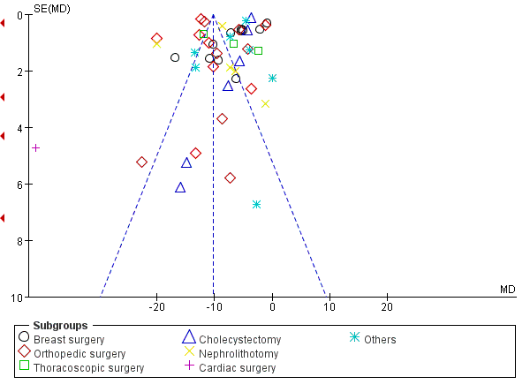

Supplementary Figure 2 Time to first rescue analgesia
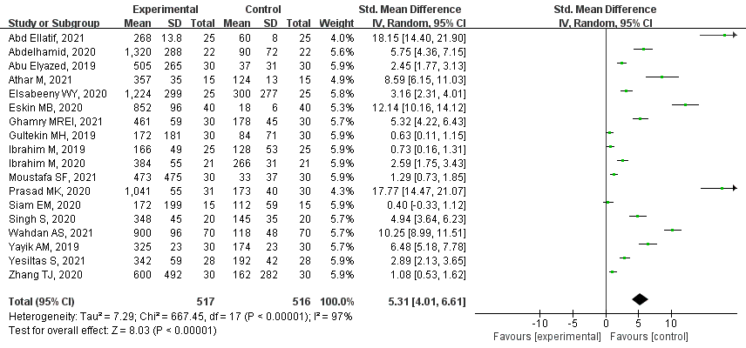

Supplementary Figure 3 Rescue analgesia requirement
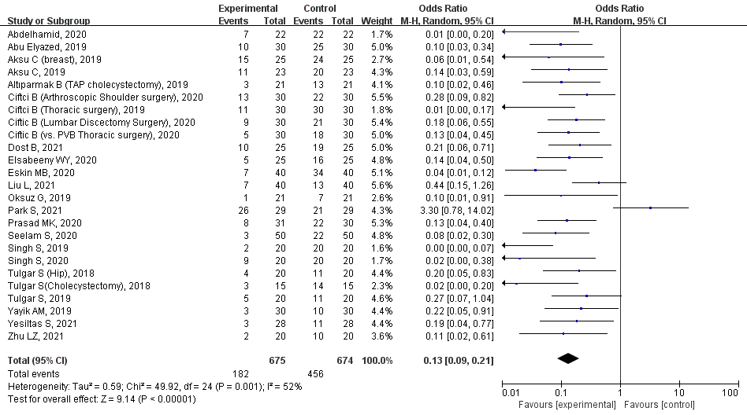

Supplementary Figure 4 The incidence of PONV
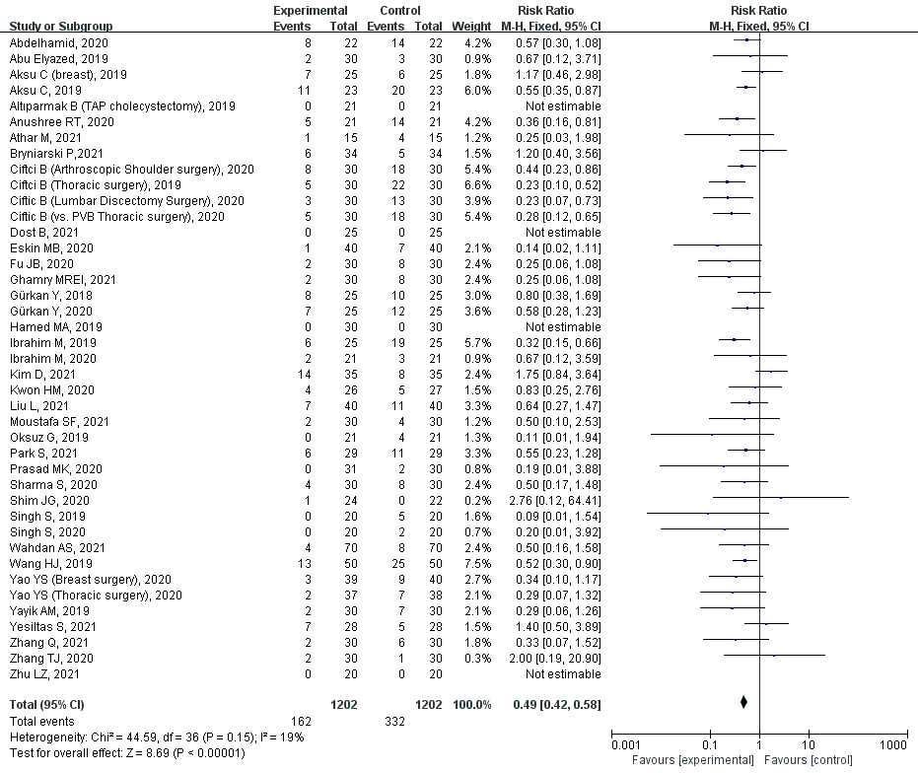

Supplementary Table 1 Search terms
“Erector spinal plane block” | AND | “Randomized controlled trial”
OR “erector spinae plane block” | AND | OR “Controlled clinical trial”
OR “erector” | AND | OR “Randomized”
OR “ESPB” | AND | OR “Randomly”
 | AND | OR “Trial”

