Supporting Information

Hybrid cell membrane-functionalized biomimetic nanoparticles for targeted therapy of osteosarcoma
Jia-Xin Cai^{1,2,3,#}, Ji-Hua Liu^{1,2,3,#}, Jun-Yong Wu^{1,2,3}, Yong-Jiang Li^{1,2,3}, Xiao-Han Qiu^{1,2,3}, Wen-Jie Xu^{1,2,3}, Ping Xu^{1,2,*}, Da-Xiong Xiang^{1,2,3,*}

1 Department of Pharmacy, The Second Xiangya Hospital, Central South University, Changsha 410011, Hunan, People’s Republic of China；
2 Institute of Clinical Pharmacy, Central South University, Changsha 410011, Hunan, People’s Republic of China；
3 Hunan Provincial Engineering Research Center of Translational Medicine and Innovative Drug, Changsha, Hunan, People’s Republic of China
#These authors contributed equally to this work

*Correspondence:
Ping Xu, Ph.D.
Department of Pharmacy, The Second Xiangya Hospital, Central South University, Changsha 410011, Hunan, People’s Republic of China
Email: xuping1109@csu.edu.cn
Da-Xiong Xiang, Ph.D.
Department of Pharmacy, The Second Xiangya Hospital, Central South University, Changsha 410011, Hunan, People’s Republic of China
Email: xiangdaxiong@csu.edu.cn

Table S1. Particle characterizations and drug loading properties of PLGA-PTX.
Sample | Particle size (nm) | Polydispersity Index | Zeta potential (mV) | Encapsulation Efficiency (%) | Drug Loading (%)
PLGA | 132.73±0.61 | 0.093±0.03 | -24.60±1.32 | - | -
PLGA-PTX | 138.96±0.40 | 0.097±0.02 | -24.53±0.90 | 64.86±0.17 | 4.24±0.02
Data were presented as Mean ± SD.

Table S2. The particle size and zeta potential of the membrane-coated nanoparticles.
Method | Sample | Particle size(nm) | Polydispersity Index | Zeta potential(mv)
 | PLGA NPs | 132.73±0.61 | 0.093±0.03 | -24.60±1.32
Co-extusion | PLGA@143B NPs | 222.37±0.58 | 0.156±0.01 | -26.03±1.78
Co-extusion | PLGA@RAW NPs | 226.40±3.18 | 0.167±0.02 | -30.13±2.15
Co-extusion | PLGA@[143B-RAW] NPs | 249.17±6.16 | 0.179±0.01 | -30.67±1.56
Ultrasonication | PLGA@143B NPs | 215.93±1.97 | 0.208±0.01 | -31.63±1.35
Ultrasonication | PLGA@RAW NPs | 211.20±0.66 | 0.130±0.02 | -24.33±0.95
Ultrasonication | PLGA@[143B-RAW] NPs | 221.33±3.33 | 0.170±0.02 | -34.13±2.24
Data were presented as Mean ± SD.

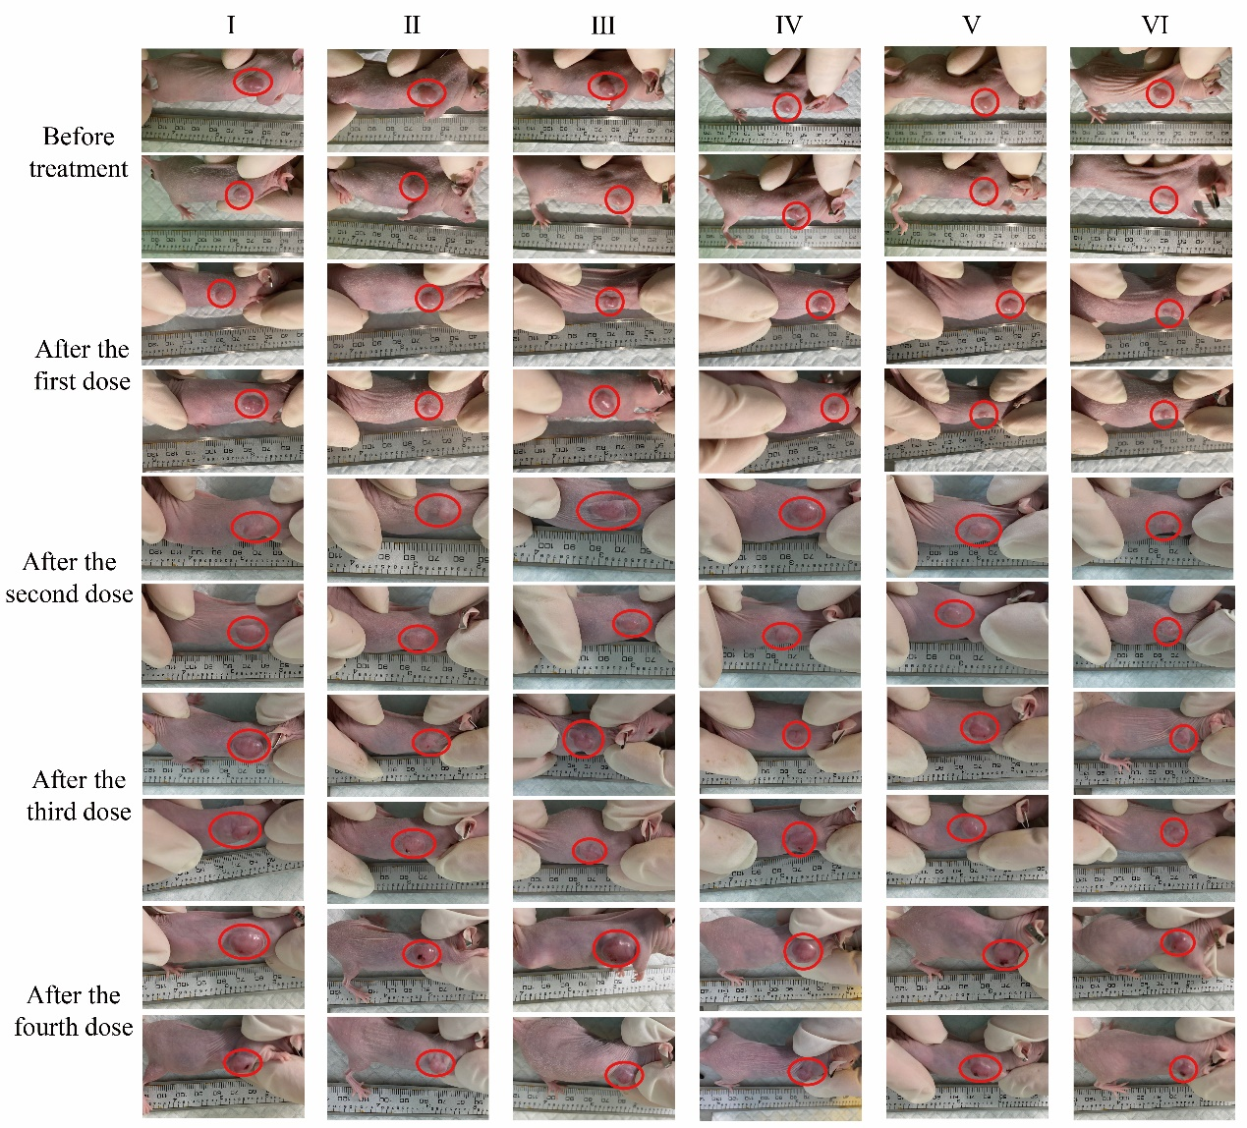
Figure S1. Representative photos of tumor-bearing mice before and after treatment. (Ⅰ) PBS; (Ⅱ) Free PTX; (Ⅲ) PLGA-PTX NPs; (Ⅳ) PTX-PLGA@RAW NPs; (Ⅴ) PTX-PLGA@143B NPs; (Ⅵ) PTX-PLGA@[143B-RAW] NPs.

