Supplementary S1
Reagents/kits | Company | Cat No. | Lot No.
CII | Chondex | 20021 | 180390
IFA | Chondex | 7002 | 200079
GM-CSF ELISA kit | Multi-Science | 70-EK363 | A36391152
IL-1β ELISA kit | Multi-Science | 70-EK301B/3 | A301B10214
IL-17α ELISA kit | Multi-Science | 70-EK317/3 | A31701113
TNF-α ELISA kit | Multi-Science | 70-EK382/3 | A38200623
IL-6 ELISA kit | Multi-Science | 70-EK306/3 | A30610643
PMA | Multi-Science | CS1001 | A10123
BFA | Multi-Science | CS1002 | A01125
BCG | Rebio Scientiﬁc | R19021 | 202010
Universal qPCR Master Mix | New England Biolabs | M3003L | 10090983
Anti-rat primary p65 antibody | ABclonal | A19653 | 4000000132
Anti-rat primary p-p65 antibody | Affinity | AF3387 | 74z3198
Anti-rat primary JNK antibody | ABclonal | A11119 | WH118576
Anti-rat primary p-JNK antibody | ABclonal | AP0473 | WH110874
Anti-rat primary CD43 antibody | Santa Cruz | Sc-53044 | G2417
Anti-rat primary SIRT1 antibody | CST | D107 | 9475S
Anti-rat primary STAT3 antibody | Proteintech | 10253-2-AP | 00079764
Anti-rat primary P-STAT3 antibody | Affinity | AF3294 | 77i8762
Anti-rat primary CD3-FITC antibody | Thermo Fisher | 11-0030-82 | 2007720
Anti-rat primary CD4-PE antibody | Thermo Fisher | 12-0040-82 | 2203513
Anti-rat primary IL-17α-APC antibody | Thermo Fisher | 17-7177-81 | 2142931
Anti-rat primary CD172a-FITC antibody | Thermo Fisher | MA1-90103 | VJ3111389F
Anti-rat primary CD43-PE antibody | Thermo Fisher | MA5-17386 | WA3174012
Anti-rat primary CD86-PE antibody | Thermo Fisher | 12-0860-83 | 2172548
Anti-rat primary CD11b-FITC antibody | Thermo Fisher | MA5-17509 | VF3007101
ReverAid First Strand cDNA Synthesis kit | Thermo Fisher | K1622 | 00820611
Hyclone RPMI-1640 | Thermo Fisher | SH30809.1 | AF32246309
fetal bovine serum | Lonsa | S711-001S | QT08773
phosphate buffered saline | Biosharp | BL302A | 21105885
Anti-rabbit HRP-linked Antibody | Biosharp | BL003A | 21183464
Anti-mouse HRP-linked Antibody | Affinity | S0002 | 78z0879
BCA kit | Beyotime | P0012S | 122120210520
penicillin-streptomycin | Beyotime | C0222
Sample Loading Buffer | Beyotime | P0015L | 012521210318
RIPA lysis buffer | Beyotime | P0013B | 030221210521
Rat Whole blood Mononuclear Cell Isolation Fluid Kit | Solarbio | P9160 | 20210603
Rat peripheral blood lymphocyte Isolation Kit | Solarbio | P8630 | 20210413
Rat peripheral blood monocyte Isolation kit | Solarbio | P6700 | 20210112
Antifade Mounting Medium | Beyotime | P0126 | 041420201014
QuickBlockTM Bloking buffer | Beyotime | P0260 | 081820201015
eBioscience™ Fixation/Permeabilization Concentrate | Thermo Fisher | 00-5123-43 | 2010090
Red Blood Cell Lysis Buffer | Biosharp | BL503B | 21175764
TRIzol reagent | Tiangen | DP424 | W9330
Red donkey anti-rabbit IgG | Abbkine | A24421 | ATTSE2401
Orange donkey anti-mouse IgG | Abbkine | A24311 | ATTAP0901
Chemiluminescent HRP substrate kit | Millipore | WBKLS0100 | 2006401
Sinomenine, SIN | Yuanye | B20997 | R19O10F100717
Sophocarpine, SCA | Yuanye | B20544 | C18S10Q97803
Matrine, MT | Yuanye | B20679 | T03F9F54046
Pageruler Prestained Protein Ladder | Thermo Fisher | 26616 | 01012463
DEPC-treated Water | Biosharp | BL510A | 71027223
Freud’s adjuvant incomplete | Rebio | R19016 | A1020R19016
MicroAmp™ Optical 8-Tube Strip | Thermo Fisher | 4316567 | I26D0q724
PVDF membranes | MerckMillipore | IPVH00010 | R1AB92614
Phosphatase inhibitor cocktail A | Beyotime | P1050 | 071320200918
DAPI solution | Boster | AR1176 | 16G22C76
Anti-rat primary SCF | ABclonal | A5672 | WH110873
Anti-rat primary Flt-3L antibody | Affinity | DF7676 | 58x6376
Anti-rat primary c-kit antibody | ABclonal | A0357 | WH103614

Supplementary S2
Gene | FP(5-3) | RP(5-3)
β-actin | TGTCCACCTTCCAGCAGATGT | AGCTCAGTAACAGTCCGCCTAGA
iNOS | TGCCTTTGCTCATGACATCG | AACACGTTCTTGGCGTGGA
IL-1β | TCCTCTGTGACTCGTGGGAT | TCAGACAGCACGAGGCATTT
MCP-1 | TTAATGCCCCACTCACCTGC | AGCTTCTTTGGGACACCTGC
IL-10 | AGTGGAGCAGGTGAAGAATGA | ATTTGCTGGTTCCCACACTC
Arg-1 | ACCCTGACCTATGCGTCATT | ATTCCCAGAGCTGGTTGTCA
SIRT1 | GTGTCATAGGTTAGGTGGCGAG | GAAGAGGTGTTGGTGGCAACTC
SCF | GATGACCTCGTGGCATGTATG | CAGGACCTAATGTTGAAGAGAG

Supplementary S3
Normalization | Normal 1 | Normal 2 | CIA1 | CIA2 | QLY1 | QLY2
POS1 | 371897 | 349867 | 313904 | 318255 | 310273 | 308166
POS2 | 91679 | 97110 | 105976 | 104903 | 106871 | 107390
4-1BB | 3376 | 3084 | 3198 | 21132 | 6191 | 10654
Activin A | 2150 | 3220 | 3538 | 3460 | 1777 | 2390
Adiponectin | 593 | 749 | 721 | 692 | 799 | 673
B7-1 | 1300 | 1325 | 1735 | 1420 | 1955 | 1217
CD48 | 2597 | 2115 | 2494 | 16911 | 4007 | 8596
CTACK | 677 | 884 | 1064 | 993 | 1169 | 978
Decorin | 8698 | 7253 | 10246 | 27750 | 12888 | 16697
Eotaxin | 86611 | 89806 | 109626 | 123568 | 113018 | 122294
EphA5 | 2467 | 2892 | 4130 | 2272 | 3958 | 2694
Erythropoietin | 653 | 619 | 631 | 556 | 569 | 627
FGF-BP | 1382 | 1602 | 1806 | 1964 | 1775 | 1980
Flt-3L | 27022 | 30493 | 33185 | 55299 | 31150 | 40462
Galectin-1 | 16928 | 16827 | 24611 | 49484 | 25727 | 31352
Galectin-3 | 1354 | 749 | 2028 | 1533 | 4573 | 1426
Gas 1 | 44621 | 53960 | 56456 | 82771 | 62142 | 71853
GFR alpha-1 | 4262 | 3805 | 3533 | 26656 | 6998 | 12347
gp130 | 1862 | 2888 | 2133 | 2476 | 1858 | 2358
HGF | 30515 | 30574 | 37970 | 67281 | 38591 | 53963
IL-1 R6 | 2173 | 2929 | 2144 | 2439 | 2357 | 2067
IL-1 ra | 2319 | 2829 | 2822 | 20416 | 3081 | 8563
IL-2 Ra | 6635 | 5446 | 6090 | 35077 | 8643 | 18650
IL-3 | 4429 | 4632 | 2677 | 24846 | 6234 | 14343
IL-7 | 3590 | 3547 | 2696 | 24450 | 5347 | 12108
IL-17F | 5516 | 4557 | 3619 | 45962 | 5923 | 24123
IL-22 | 2440 | 2178 | 2851 | 15727 | 1778 | 9124
JAM-A | 7882 | 10655 | 7203 | 14830 | 8004 | 11678
MIP-1a | 237 | 388 | 265 | 259 | 292 | 382
Neuropilin-1 | 3079 | 3577 | 4920 | 3874 | 4854 | 5160
Neuropilin-2 | 6356 | 7473 | 10193 | 8702 | 9952 | 9459
Nope | 32737 | 38926 | 35199 | 49026 | 34017 | 44052
Notch-1 | 29321 | 32527 | 30791 | 44048 | 37380 | 40434
Notch-2 | 186965 | 193646 | 190972 | 184874 | 184123 | 204494
P-Cadherin | 3477 | 2681 | 2646 | 23062 | 3889 | 11445
Prolactin | 12514 | 11776 | 12005 | 30624 | 14148 | 19097
RANTES | 50925 | 54946 | 55617 | 58618 | 75873 | 69239
SCF | 2765 | 2333 | 2381 | 17716 | 2610 | 6411
TIM-1 | 1990 | 2274 | 3387 | 3320 | 2853 | 3334
TIMP-2 | 538 | 685 | 574 | 589 | 572 | 590
TREM-1 | 3199 | 3278 | 3135 | 10386 | 3479 | 5043
TWEAK R | 28871 | 29138 | 36036 | 60149 | 38127 | 49311
POS-Ave | 371897 | 371897 | 371897 | 371897 | 371897 | 371897

Supplementary S4

Supplementary S5

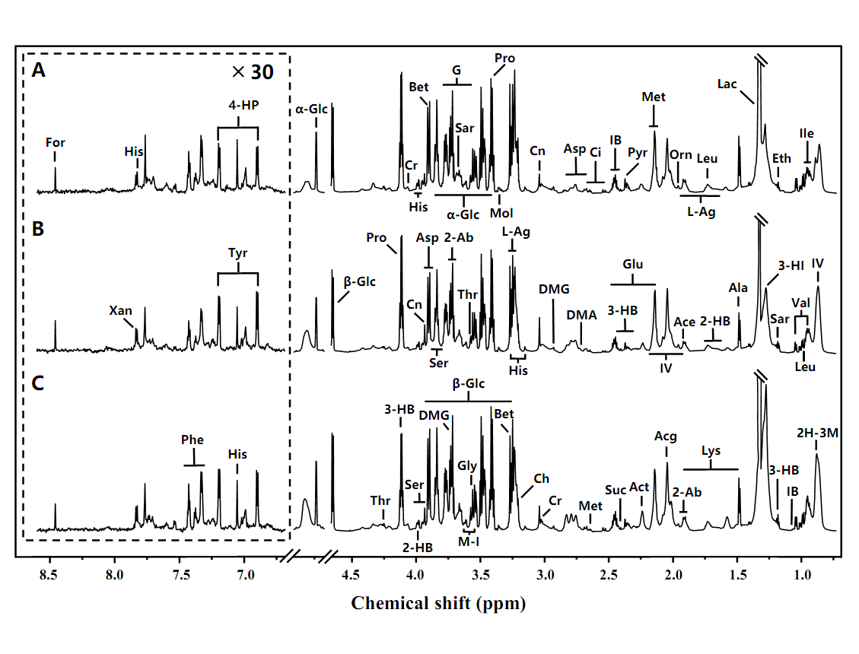

Supplementary S6

Supplementary S7
Drug | ID | MolName
Bixie | BX1 | EINECS 213-897-0
Huangbo | A1 | beta-sitosterol
Qingfengteng | A1 | beta-sitosterol
Huangbo | A2 | Magnograndiolide
Qingfengteng | A2 | Magnograndiolide
Huangbo | B | quercetin
Kusheng | B | quercetin
Bixie | BX2 | diosgenin
Huangbo | HB1 | berberine
Huangbo | HB10 | Worenine
Huangbo | HB11 | Cavidine
Huangbo | HB12 | Hericenone H
Huangbo | HB13 | palmatine
Huangbo | HB14 | Fumarine
Huangbo | HB15 | Isocorypalmine
Huangbo | HB16 | phellamurin_qt
Huangbo | HB17 | (S)-Canadine
Huangbo | HB18 | poriferast-5-en-3beta-ol
Huangbo | HB19 | berberrubine
Huangbo | HB2 | coptisine
Huangbo | HB20 | campesterol
Huangbo | HB21 | thalifendine
Huangbo | HB22 | Stigmasterol
Huangbo | HB3 | Phellavin_qt
Huangbo | HB4 | delta 7-stigmastenol
Huangbo | HB5 | Phellopterin
Huangbo | HB6 | Dehydrotanshinone II A
Huangbo | HB7 | rutaecarpine
Huangbo | HB8 | Skimmianin
Huangbo | HB9 | Chelerythrine
Kusheng | KS1 | (2R)-5,7-dihydroxy-2-(4-hydroxyphenyl)chroman-4-one
Kusheng | KS10 | (2R)-7-hydroxy-2-(4-hydroxyphenyl)chroman-4-one
Kusheng | KS11 | 5,7-dihydroxy-2-(3-hydroxy-4-methoxyphenyl)chroman-4-one
Kusheng | KS12 | matrine
Kusheng | KS13 | luteolin
Kusheng | KS14 | Glyceollin
Kusheng | KS15 | hyperforin
Kusheng | KS16 | (2S)-7-hydroxy-2-(4-hydroxyphenyl)-5-methoxy-8-(3-methylbut-2-enyl)chroman-4-one
Kusheng | KS17 | kushenin
Kusheng | KS18 | kushenol J_qt
Kusheng | KS19 | kushenol,t
Kusheng | KS2 | Inermine
Kusheng | KS20 | leachianone,g
Kusheng | KS21 | Norartocarpetin
Kusheng | KS22 | Phaseolin
Kusheng | KS3 | 8-Isopentenyl-kaempferol
Kusheng | KS4 | sophocarpine
Kusheng | KS5 | Inermin
Kusheng | KS6 | Wighteone
Kusheng | KS7 | sophoridine
Kusheng | KS8 | formononetin
Kusheng | KS9 | cis-Dihydroquercetin
Qingfengteng | QFT1 | 16-epi-Isositsirikine
Qingfengteng | QFT2 | Michelenolide
Qingfengteng | QFT3 | Sinomenine
Qingfengteng | QFT4 | Stepholidine

Supplementary S8
Standard
SIN
SCA
MT
Blank
Qualification curve
SIN

SCA

MT

Sample
SIN
SCA
MT

