Figure S1
Supplementary Material

B
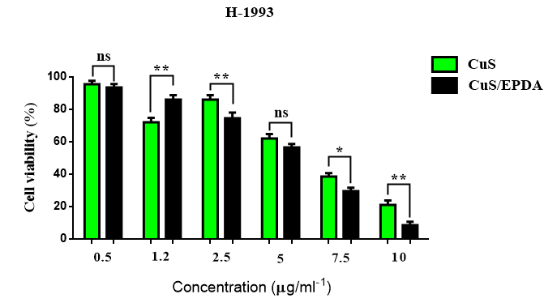
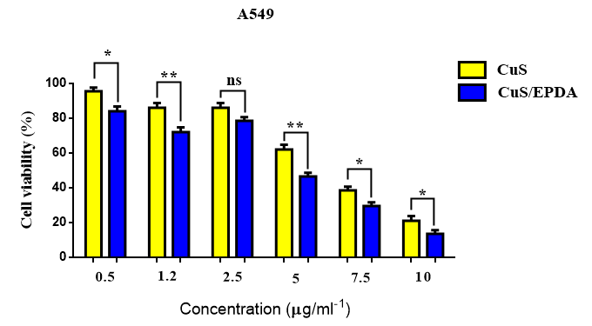
A

Figure S1. Biocompatibility and cytotoxicity of CuS nanoparticles in vitro. Cell viability CCK-8 assay of lung cancer A549 (A) and H-1993 (B) cells after treatment with CuS or CuS/EPDA at different concentrations for 24h. Data represent the mean ±SD of three independent experiments. Differences were considered statistically significant at p<0.05. Statistically significant data are indicated by asterisks (*P < 0.05, **P <0.01, ns: not significant).

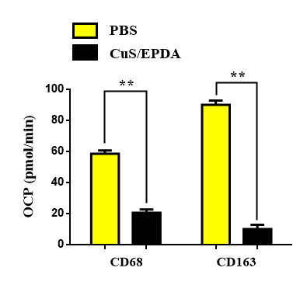
Figure S2

Figure S2. CuS/EPDA treatment inhibits polarization of CD163⁺M2 macrophages. Expression levels of M2 macrophage markers (CD68⁺/CD163⁺) using FACS analysis after treatment with CuS/EPDA NCs in BALB/c mice. Differences were considered statistically significant at p < 0.05. Statistically significant data are indicated by asterisks (**P < 0.01).

Supplementary Tables S1-S3

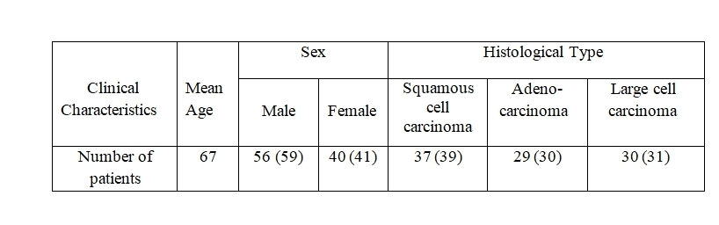

Table S1. Clinical characteristics of lung cancer patients. Numbers in parenthesis indicate percentiles (%) in the total population of patients.
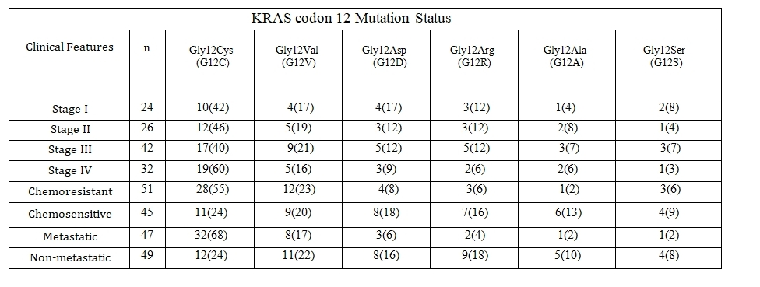

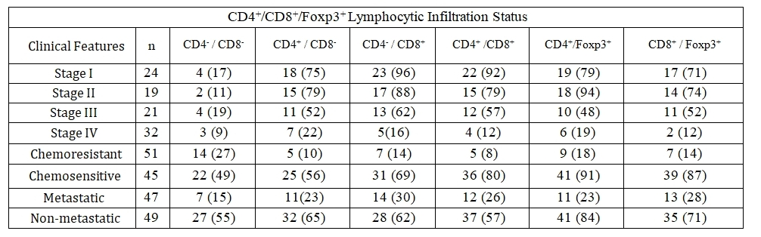
Table S2. Correlation between KRAS mutation status in lung cancer patients. Numbers in parenthesis indicate percentiles (%) in the total population of patients.

Table S3. Correlation between combined CD4⁺/CD8⁺/Foxp3⁺ lymphocytic infiltration status in lung cancer patients. Numbers in parenthesis indicate percentiles (%) in the total population of patients.

Supplementary Methods

Reagents
Carboplatin (CAS Number 41575-94-4), Epacadostat (CAS Number 024360) and Dasatinib Monohydrate (CAS Number S7782) were purchased from Selleckchem (Selleckchem, München, Germany). Dulbecco’s modified eagle medium (DMEM) and fetal bovine serum (FBS) were obtained from Invitrogen (Invitrogen, Paisley, UK). DMSO (Dimethyl sulfoxide) and Tris-EDTA (Tris-Ethylene Diamine Tetraacetic Acid) were purchased from Applichem (Applichem, Darmstadt, Germany). DMEM-Hepes, PBS (Phosphate Buffer Saline), FBS (Fetal Bovine Serum), Trypsin–EDTA, and DMSO reagents were purchased from Invitrogen (Invitrogen, Darmstadt, Germany). The stock solution was filtered through a 0.22 μΜ syringe filter, then aliquoted and stored in the dark at room temperature. Copper(II) chloride (CuCl2), sodium sulfide (Na2S39H2O), sodium citrate, and PLGA-PEG (molecular weight 3000) were purchased from Sigma-Aldrich (St. Louis, MO, USA). Isoflurane was purchased fromBaxter (Deerfield, IL, USA)

Antibodies

Mouse CD4 and CD8 mAb and isotype control were purchased from R&D Systems (Minneapolis, MN, USA). For analysis of surface markers, cells were stained in PBS containing 2% bovine serum albumin. Intracellular staining of the transcription factors Foxp3 was performed using the Foxp3 Fix/Perm Buffer Set (eBioscience, San Diego, CA, USA). For detection of intracellular cytokines, cells were first stimulated for 4 h with 50 ng/ml phorbol 12-myristate 13-acetate (PMA) and 1 μg/ml ionomycin in the presence of Brefeldin A (5 μg/ml; all obtained from Sigma-Aldrich), followed by staining for surface markers. Cells were then fixed and permeabilized using the Foxp3 Fix/Perm Buffer Set (eBioscience) and stained for intracellular cytokines. The following antibodies were used at a dilution of 1/150–1/600: Primary antibody sources and dilutions (2%BSA) obtained from Abcam included: anti-CD4 (ab183685, 1/200). Anti-CD8 (14-0808, 1/100), anti-Foxp3 (13-5773, 1/200) and anti-IL-10 (#14-
7101, 1/50) were from eBioscience. Cell sorting was performed using a FACSAria analyser.

Immunofluorescence analysis

A549 cells were treated with CuS/EPDA NCs (0.4 mg/mL⁻¹) or PBS for 4h. Next, cells were fixed in 4% formaldehyde for 15 min at room temperature prior to cell permeabilization with 0.1% Triton X-100 (4°C, 10 min). Cells were saturated with PBS containing 2% BSA for 1 h at room temperature and processed for immunofluorescence with Arg1, iNOS, Ly6C, Ly6G and Ki67 antibodies, respectively, at 4ºC overnight. Then, they were incubated with Alexa Fluor 488- conjugated anti-rabbit IgG antibody (1:100). Between all incubation steps, cells were washed three times for three minutes with PBS containing 0.2% BSA. Fluorescence signals were analyzed using a Carl Zeiss fluorescent microscope at a 100× magnification, with excitation and emission wavelengths of 488 nm and 520 nm, respectively, using image analysis software.

Cell proliferation assay

For detection of cell proliferation the Cell Counting Kit-8 (CCK-8) assay was used to monitor cell growth. The number of viable CuS or CuS/EPDA-treated cells was assessed by measuring the absorbance at 450 nm by FlUOstar OPTIMA (BMG Labtech, Offenburg, Germany).

Transmission Electron Microscopy

CuS/EPDA-treated A549 cells were collected and fixed in 2% paraformaldehyde, 0.1% glutaraldehyde in 0.1 M sodium cacodylate for 2 h, postfixed with 1% OsO4 for
1.5 h, and washed and stained for 1 h in 3% aqueous uranyl acetate. The samples were then washed again, dehydrated with graded alcohol and embedded in Epon- Araldite resin (Canemco, Quebec, Canada). Ultra-thin sections were generated using an UCT-EMFCS Leica microtome (Leica, Germany), counterstained with 0.3% lead citrate and examined on a Philips electron microscope. The magnification of image is indicated at the bottom of micrograph images; a minimum of 20 representative cells from at least three grids were evaluated.

Pharmacokinetics analysis

For the pharmacokinetic analysis, blood kinetics were assessed by drawing 10 ml of blood from the tail veins of BALB/c mice at certain time intervals post-injection of

the CuS/EPDA NCs. Each blood sample was dissolved in 1ml of lysis buffer and the blood concentration of the NCs was determined by fluorescence spectrum acquired using a Fluoromax 4 fluorometer. The plasma, tumors, and various tissues were collected at 0, 0.5, 1, 2, 4, 6, 12, 24, 48, 72, and 96 h after treatment. The plasma, tumor, and tissue samples were stored at −80 °C until further analysis.

MDSC analysis

For MDSCs analysis, single-cell suspensions were prepared from lymph nodes, lungs and tumour tissues. Bone marrow cells were obtained by flushing bones with PBS using a 28G 1/2 syringe. Tumour and lung tissues were dissociated and digested with collagenase for 50min at 37C. Erythrocytes were lysed with ACK lysis buffer (Gibco). These cells were labelled with fluorescence-conjugated Ly6C (dilution 1/300), Ly6G (dilution 1/150) and CD11b (dilution 1/250) antibodies from Biolegend and analysed on a FACS flow cytometer (BD Biosciences). Different subsets of MDSCs were sorted with a FACS Aria cell sorter (BD Biosciences). For co-culture experiments, tumour cells were cultured either alone (control) or with 0.5 mM CFSE labelled MDSCs in 10% FBS RPMI media for 24–48 h at the ratio of 1:1. After incubation, FITC negative tumour cells were isolated with a FACS Aria cell sorter for following experiments. Culture supernatant were collected for cytokine analysis

Lung cancer tissue samples

Lung cancer tissues were obtained from AHEPA Hospital, Medical School, Aristotle University of Thessaloniki (Thessaloniki, Greece). Tissue samples were collected in the operating room immediately after surgery with non-tumor tissues sent to Pathology for diagnosis by a certified pathologist. For each patient, a frozen tumor sample (stored at 80◦ C) and a paraffin-embedded tissue specimen were available. A written consent was obtained from 96 lung cancer (NSCLC) patients, 37–88 years of age, prior to surgery, from each patient voluntarily involved in the usage of tissues solely for research purposes (Supplementary Tables S1, S2). Patients had read and understood the patient information document provided, and the aims and methods of this study had been fully explained to them. Patients involved had also given written informed consent to authors of this manuscript for publication of these data. The study methodologies were approved by the local ethics committee. The clinical

investigation was conducted according to the guidelines expressed in the Declaration of Helsinki.

Dendritic cell isolation
Isolated CD11c⁺ lung cells were detached by immunomagnetic sorting using CD11c microbeads (Miltenyi Biotec) following manufacturer’s instructions. Following separation, DCs were purified by FACS sorting with FACS Aria II (BD Biosciences), Staining of CD11c⁺ cells was performed in PBS + 2% FBS with the following antibodies: CD11c-A647 (N418), CD103-PE (2E7) purchased from Biolegend and SiglecF-BB515 (E50-2440), CD11b-BV421 (M1/70) and MHCII-BV711
(M5/114.15.2) from BD Biosciences.

PTT/PA imaging

For photothermal imaging analysis, three separate groups of BALB/c mice bearing A549 tumors were treated with PBS or CuS or CuS/EPDA (1-4, 5, 10 mg/kg⁻¹) via intravenous injection respectively. PA images were obtained under a 970 nm irradiation at several post-injection times. In order to perform photothermal imaging at 30min, 1h post-injection, the mice were irradiated under a 970 nm laser for 10 min. Images of photothermal analysis were obtained by an infrared thermal imaging device.

Characterization methods

The morphology of the CuS/EPDA NCs was characterized using an MFP-3D AFM system with an ACTA-50 Probe (AppNano, Mountain View, CA, USA). The TEM images were acquired on the JEOJEM-2010 TEM at an acceleration voltage of 200 kV. The Fourier transform infrared (FTIR) spectroscopy was performed on a NEXUS 670 FT-IR & Raman spectrometer (Thermo Nicolet, US).The ultraviolet–visible-NIR absorption spectra were acquired on a TU-1810 ultraviolet–visible spectrophotometer (Purkinje General Instrument, Beijing, China) using QS-grade quartz cuvettes at room temperature.

Animals

Six weeks old male BALB/c mice were purchased from the Jackson laboratory (Bar Harbor, ME) and were housed under pathogen-free environment with a 12 h light/12 h dark schedule and fed with an autoclaved diet and water ad libitum. To establish

orthotopic xenografts in mice, A549 luciferase cells (2x10⁶) were suspended in 20 ml of HBSS media and directly implanted into the upper region of the lungs. Three days later, mice were randomly divided into four groups. Three separate groups of mice (n=8) were injected subcutaneously in lung section with CuS and/or CuS/EPDA (2 mg/kg body weight in 0.1 ml PBS, once a day and 5 days per week for 8 weeks). Control mice (n=8) were treated the same with vehicle (0.1 ml PBS). In addition, distinct groups of mice (n=8) were injected subcutaneously in lung section with Epacadostat, and/or Dasatinib (2 mg/kg body weight in 0.1 ml PBS, once a day and 5 days per week for 8 weeks). After treatment, mice were sacrificed, lungs and lymph nodes were removed for bioluminescence imaging and quantification of tumor volume. Tumor volume (V) was determined by measuring length (L) and width (W) by a vernier caliper and calculated according to the following formula: V = L × W 2/2. For imaging, mice were given ip injections of 150 mg of D-luciferin 10 min prior to imaging. All of the protocols were approved by the University’s Animal Research Committee in accordance with the NIH Guidelines for the Care and Use of Laboratory Mice.

Localization of CuS/EPDA in tumor tissues.

To visualize intracellular localization of CuS-EPDA we employed the TEM method. For TEM analysis, A549 cells were incubated with sterilized CuS or CuS/EPDA (0.5 mg/mL⁻¹) for 4h, respectively. Then, cells were trypsinised, centrifuged, and fixed in 2.5% glutaraldehyde in sodium cacodylate buffer (pH 7.4, 0.1 M) for 1 h at room temperature and rinsed. Cells were then post fixed 1 h in 2% osmium tetroxide with 3% potassium ferrocyanide and rinsed. After that, cells were put into propylene oxide, a series of propylene/ epon dilutions and embedded in 100% Epon. The 70 nm thin sections were cut on a Leica ultramicrotome, and images were taken using an Kodak digital Camera.

In vivo NIR imaging

In vivo NIR imaging was performed using an IVIS Spectrum Imaging System (Perkin-Elmer). The fluorescent light emitted from the mice was detected by a CCD camera. The acquisition and data analysis were performed using the Living Image
4.2.1 Software. The mice were injected with PBS, CuS, and CuS/EPDA at various concentrations through the tail vein.

ROS assay

The reactive oxygen species (ROS) production was evaluated using two different probes following the manufacturer’s instructions: 6-carboxy-2',7'- dichlorodihydrofluorescein diacetate (Carboxy-H2DCFDA) (Life Technologies) and the ROS Deep Red Dye from the Cellular Reactive Oxygen Species Detection Assay Kit Deep Red Fluorescence (Abcam). Briefly, H-1993 cells (1-1.5×10⁵) plated in 12- well plates at ~85% confluence were pre-incubated with increasing concentrations of CuS (2mg/ml) or CuS/EPDA (2-4mg/ml) for 4h at 37°C, and then further incubated with 2 μM Deep Red Reagent for 30 min. Tert-butyl hydroperoxide (TBHP) (Sigma), an oxidative stress inducer, was used as a positive control.Carboxy-H2DCFDA and ROS Deep Red Dye fluorescence were determined by the FACSCalibur flow cytometer (BD) at the excitation wavelength of 495 nm for Carboxy-H2DCFDA and 650 nm for the ROS Deep Red Dye.

In vivo fluorescence imaging

For the in vivo fluorescence imaging experiments, BALB/c mice bearing A549 lung tumours were intravenously injected with the Cy5.5-labelled CuS/EPDA NCs (100 ml) and examined by a fluorescence imaging system (IVIS-Spectrum) for a period of time up to 72h. NIR light with a peak wavelength of 675nm was used as the excitation source and in vivo spectral imaging with the Cy5.5 emission filter (680–720 nm) was carried out for an exposure time of 150 ms for each image frame.

