Table S1. Reagents for PSC NPs synthesis.
Category | Name | Brand | Catalog No.
Chemical  reagent | Polylactic acid-glycolic acid (PLGA)-PEG-COOH | Xi’an Ruixibio Biotechnology | R-PL1063-20.4K
Chemical  reagent | superparamagnetic iron oxide (SPIO) | Xi’an Ruixibio Biological Technology | R-PL1063
Chemical  reagent | Dichloromethane (CH₂Cl₂) | China National Pharmaceutical  Group Corporation | 80047318
Chemical  reagent | Polyvinyl Alcohol (PVA) | Shanghai Macklin | P823117
Chemical  reagent | Cypate | Home-made
Chemical  reagent | Isopropyl alcohol | Shanghai Macklin | I811925
Chemical  reagent | Hydrochloric acid (HCl) | China National Pharmaceutical  Group Corporation | 10011028

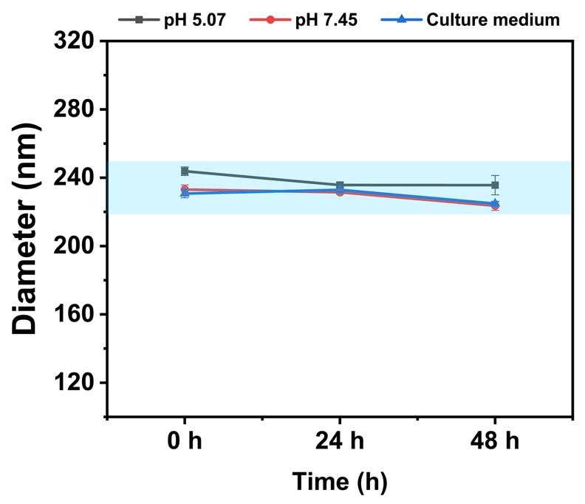
Figure S1. The stability of PSC NPs in different media. No significant change in particle size was detected after 48 hours’ incubation (n=3 technical repeats). Data shown represent means ± SD.

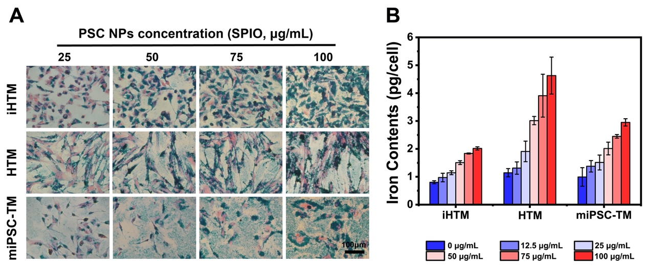
Figure S2. Prussian blue staining and iron quantification. (A). Prussian blue staining of iHTM, HTM, and miPSC-TM cells labeled with PSC NPs at a series of concentrations (25, 50, 75, and 100 μg/mL). Cell morphology after labeling is not changed. Blue granules indicating PSC NPs are evident in the cytoplasm pre-stained with Eosin (Pink). (B). Iron contents in iHTM, HTM, and miPSC-TM labeled with PSC NPs at a series of concentrations (0, 12.5, 25, 50, 75, and 100 μg/mL) are determined by thiocyanate colorimetry. The iron uptake is increased as PSC NPs increased. Data represent the mean ± SD. Typical results from n=3 technical repeats are shown.

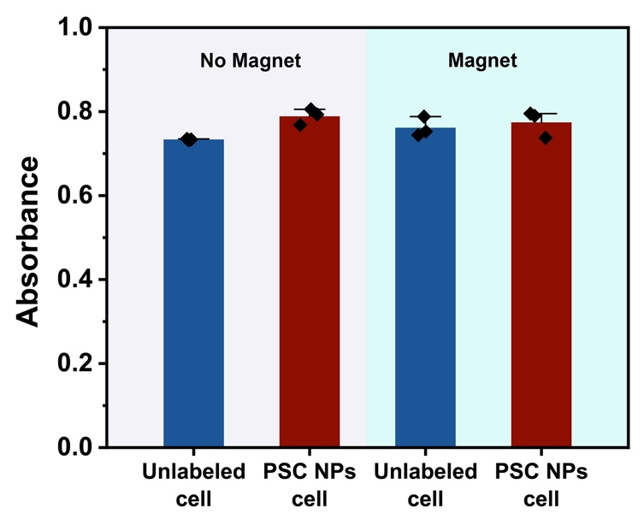
Figure S3. The influence of the magnet on cell viability of NP-labeled HTM. HTM cells were labeled with PSC NPs (35 μg/mL; 10 hours). In the presence of a magnet (189 mT magnetic strength) for 48 hours, cell viability was determined by CCK-8 assay. Compared to no magnet control, cell viability cannot be affected by this magnetic strength. Typical results from n=3 technical repeats are shown. P > 0.05 by one-way ANOVA.

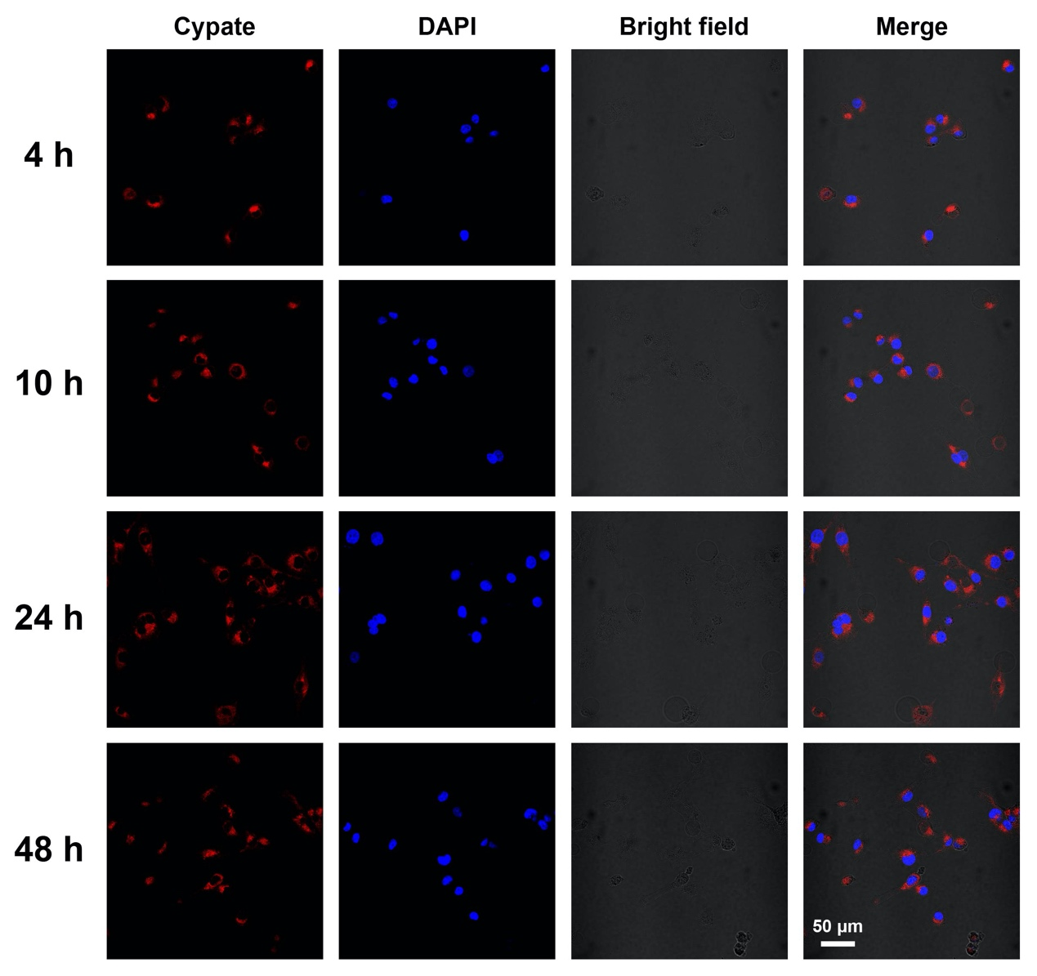
Figure S4. Confocal images of PSC NPs-labeled iHTM. After incubation for 4, 10, 24, 48 hours, PSC NPs accumulated in the cytoplasm are shown in red. Nuclei are labeled with DAPI (blue). Scale bars: 50 μm.

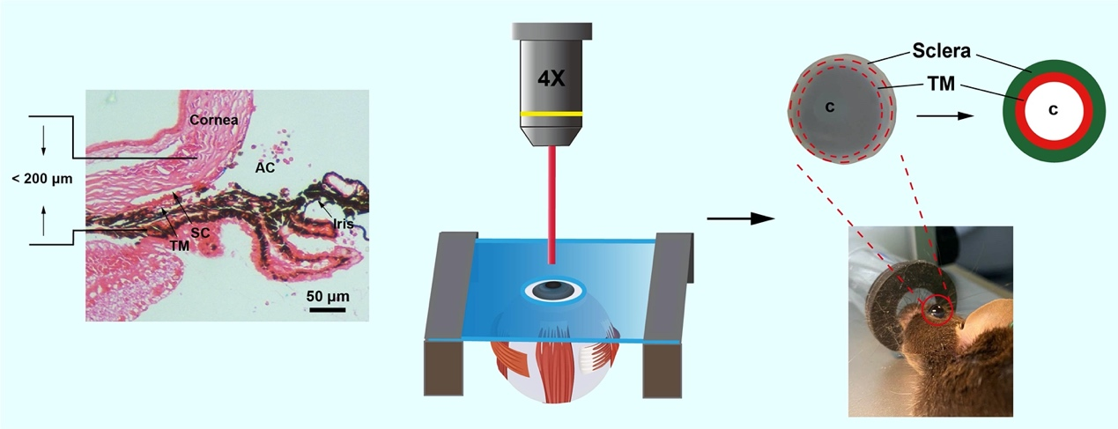
Figure S5. Schematic diagram of near-infrared imaging (Left panel) and definition of the TM region in living mice (Right panel; see details in methods).

