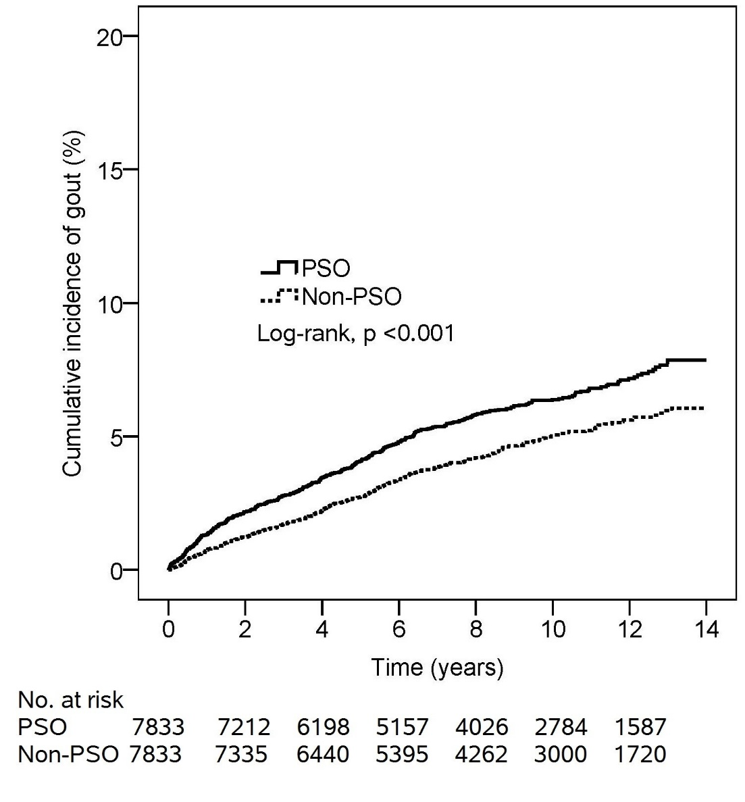

Figure S1 Cumulative incidence comparison of gout for the patient with or without psoriasis

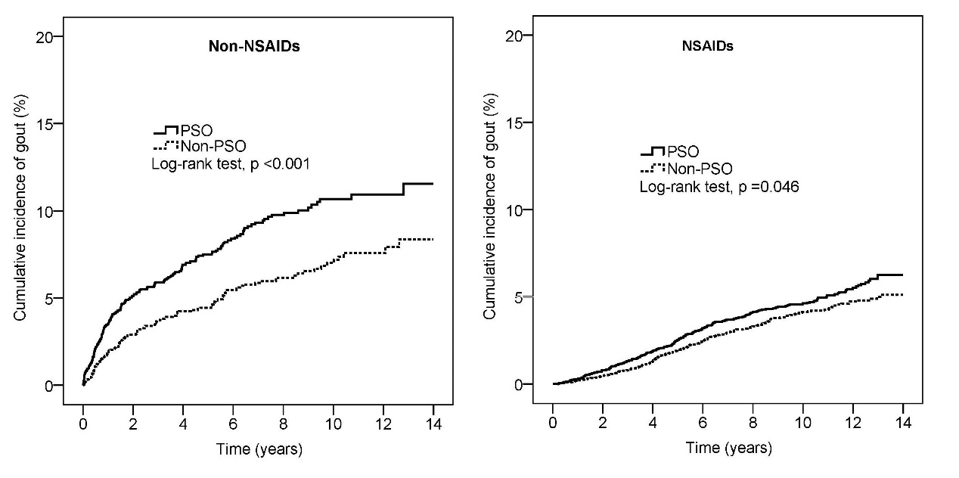

Figure S2 Kaplan-Meier curves stratified by NSAID use

