Supplementary Material
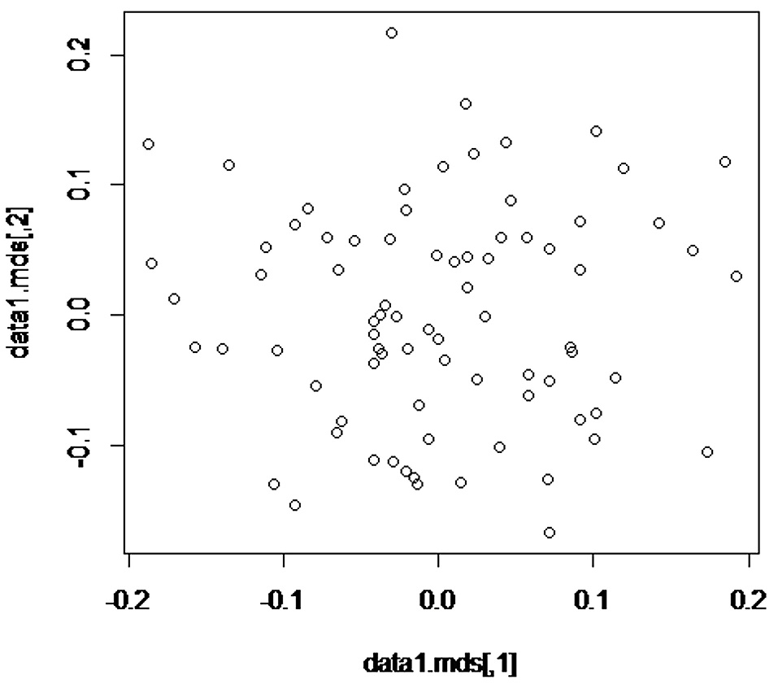

Supplementary Figure S1. Multidimensional scaling (MDS) plot of adjacent MDS components.
A multidimensional (MDS) plot showed no population stratification exists and also there were no differences in allele frequencies among the population.

