SUPPLEMENTARY MATERIAL

Supplementary Table 1. Treatment Attributes and Features Included in the Survey
A. Attributes and Levels for the Discrete-Choice Experiment Questions
Attribute | Level Description
Time until [your/the] multiple myeloma comes back or starts advancing again | 6 months
 | 12 months (1 year)
 | 24 months (2 years)
Nerve damage | None
Nerve damage | Mild to moderate: You/the patient will experience muscle weakness that comes and goes. Your/the patient’s normal reflexes will not work as well. You/the patient will feel a slight tingling or burning in the hands, legs, arms, and feet, and may lose sensitivity on the skin. Even with these problems, you/the patient will still be able to do normal daily activities like dressing and bathing.
Nerve damage | Severe: Your/the patient’s muscles will feel very weak most of the time. You/the patient may stumble or fall down more frequently because your/their reflexes do not work normally. You/the patient will feel tingling, burning, or prickling in the hands and feet, numbness, muscle weakness, sensitivity to touch, or stabbing pains. These problems may be so severe that they would interfere with your/the patient’s ability to do normal daily activities.
Stomach problems (GI problems) | None
Stomach problems (GI problems) | Nausea and vomiting
Stomach problems (GI problems) | Diarrhea
Stomach problems (GI problems) | Constipation
Risk of low blood counts | None
Risk of low blood counts | 10% (10 out of 100)
Risk of low blood counts | 25% (25 out of 100)
Risk of low blood counts | 70% (70 out of 100)
Risk of heart failure | None
Risk of heart failure | 3% (3 out of 100)
Risk of heart failure | 5% (5 out of 100)
How [you/the patient] take(s) the medicine | Pill once a day for 3 weeks each month
How [you/the patient] take(s) the medicine | Pill once a week for 3 weeks each month
How [you/the patient] take(s) the medicine | Injection at doctor's office or outpatient clinic once a week for 3 weeks each month
How [you/the patient] take(s) the medicine | 4-hour IV infusion at doctor’s office or outpatient clinic once a week for 3 weeks each month
How [you/the patient] take(s) the medicine | 1-hour IV infusion at doctor’s office or outpatient clinic twice a week for 3 weeks each month

B. Medicine Features in the Best-Worst Scaling Questions in the Survey
Medicine Feature
1-hour IV, 2 times per week for 3 weeks out of every month
4-hour IV, 1 time per week for 3 weeks out of every month
Injection at doctor’s office 1 time per week for 3 weeks out of every month
Pill daily taken at home with water
Pill once a week for 3 weeks out of every month
You need to travel 3 hours roundtrip once a week to receive your treatment
Changes in mood that may include lack of patience or nonstop talking for two or three days after each treatment
Difficulty sleeping for two or three nights after each treatment
Feeling exhausted or tired most days during treatment
Having thinking or memory problems for a few weeks after receiving treatment
Treatment weakens your immune system and you get sick more often
Treatment weakens your bones and increases the risk of a bone fracture
Experiencing hair loss for several months during treatment
Having trouble working at your job or at home during treatment
Treatment lowers platelet counts and increases the risk of bleeding problems
Treatment lowers white blood cell counts and increases the risk of serious infection
Treatment damages kidneys and increases the risk of kidney failure
Needing to go to the hospital to treat a side effect of the treatment
IV = intravenous.

Supplementary Figure 1. Preference Weights
A. Patients (N = 94)
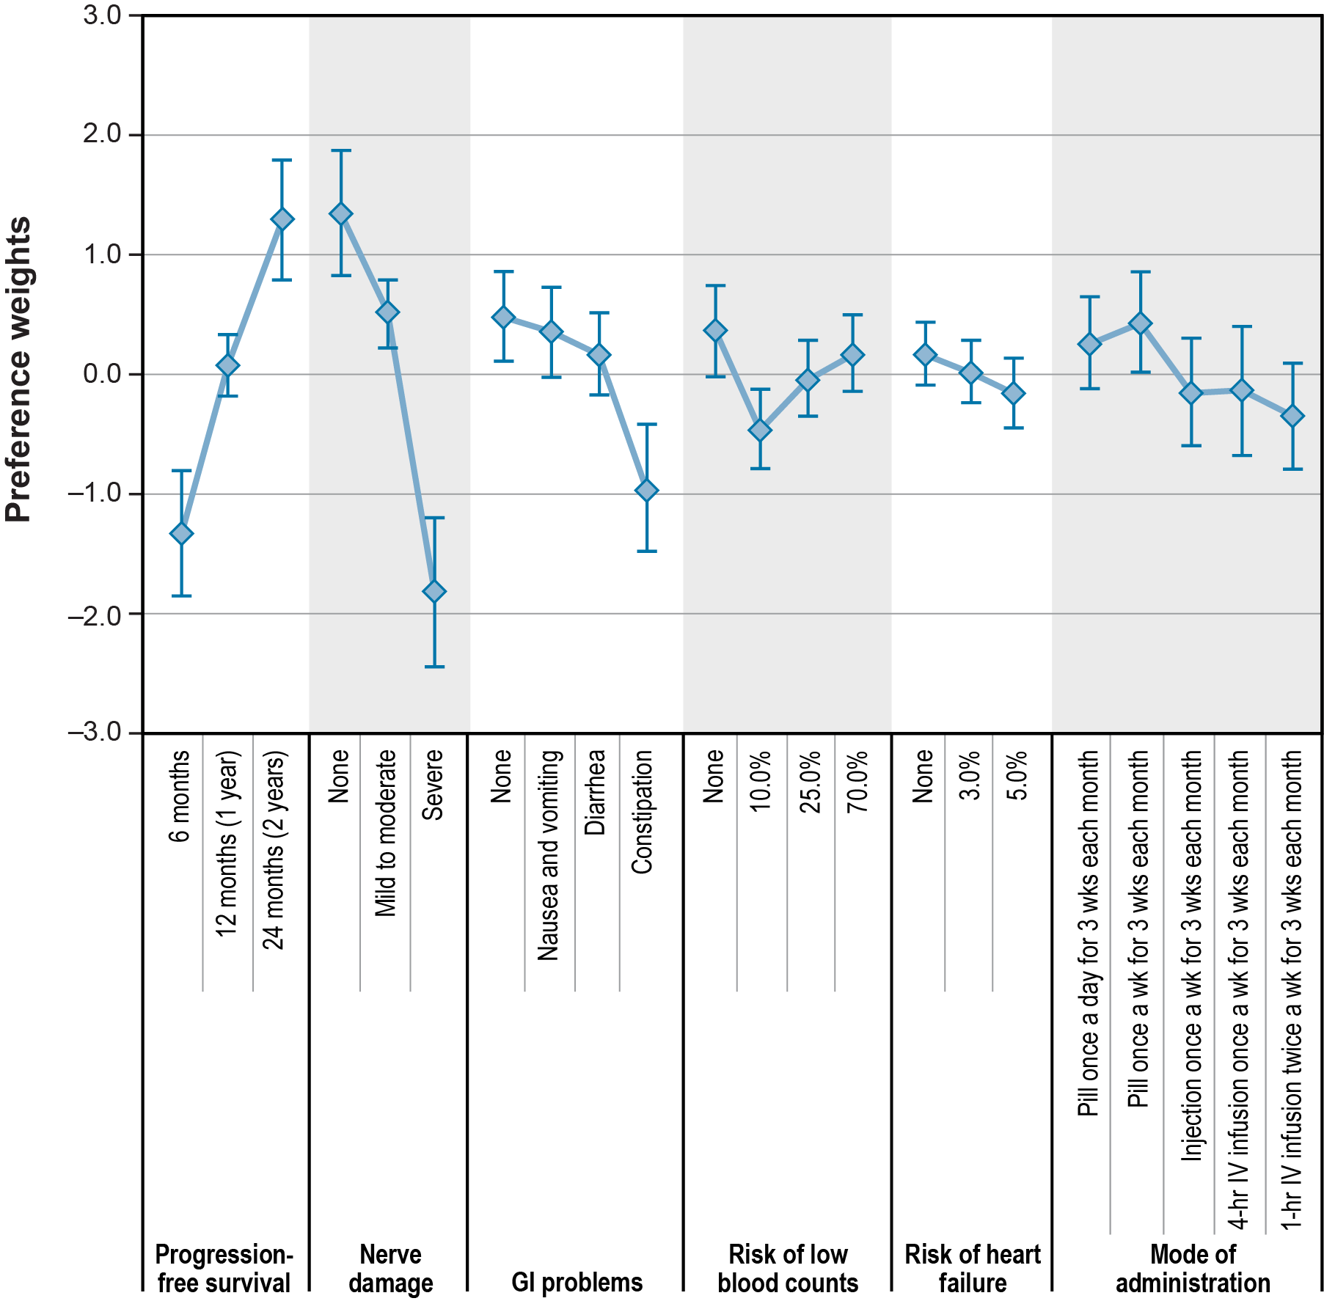
B. Caregivers (N = 32)
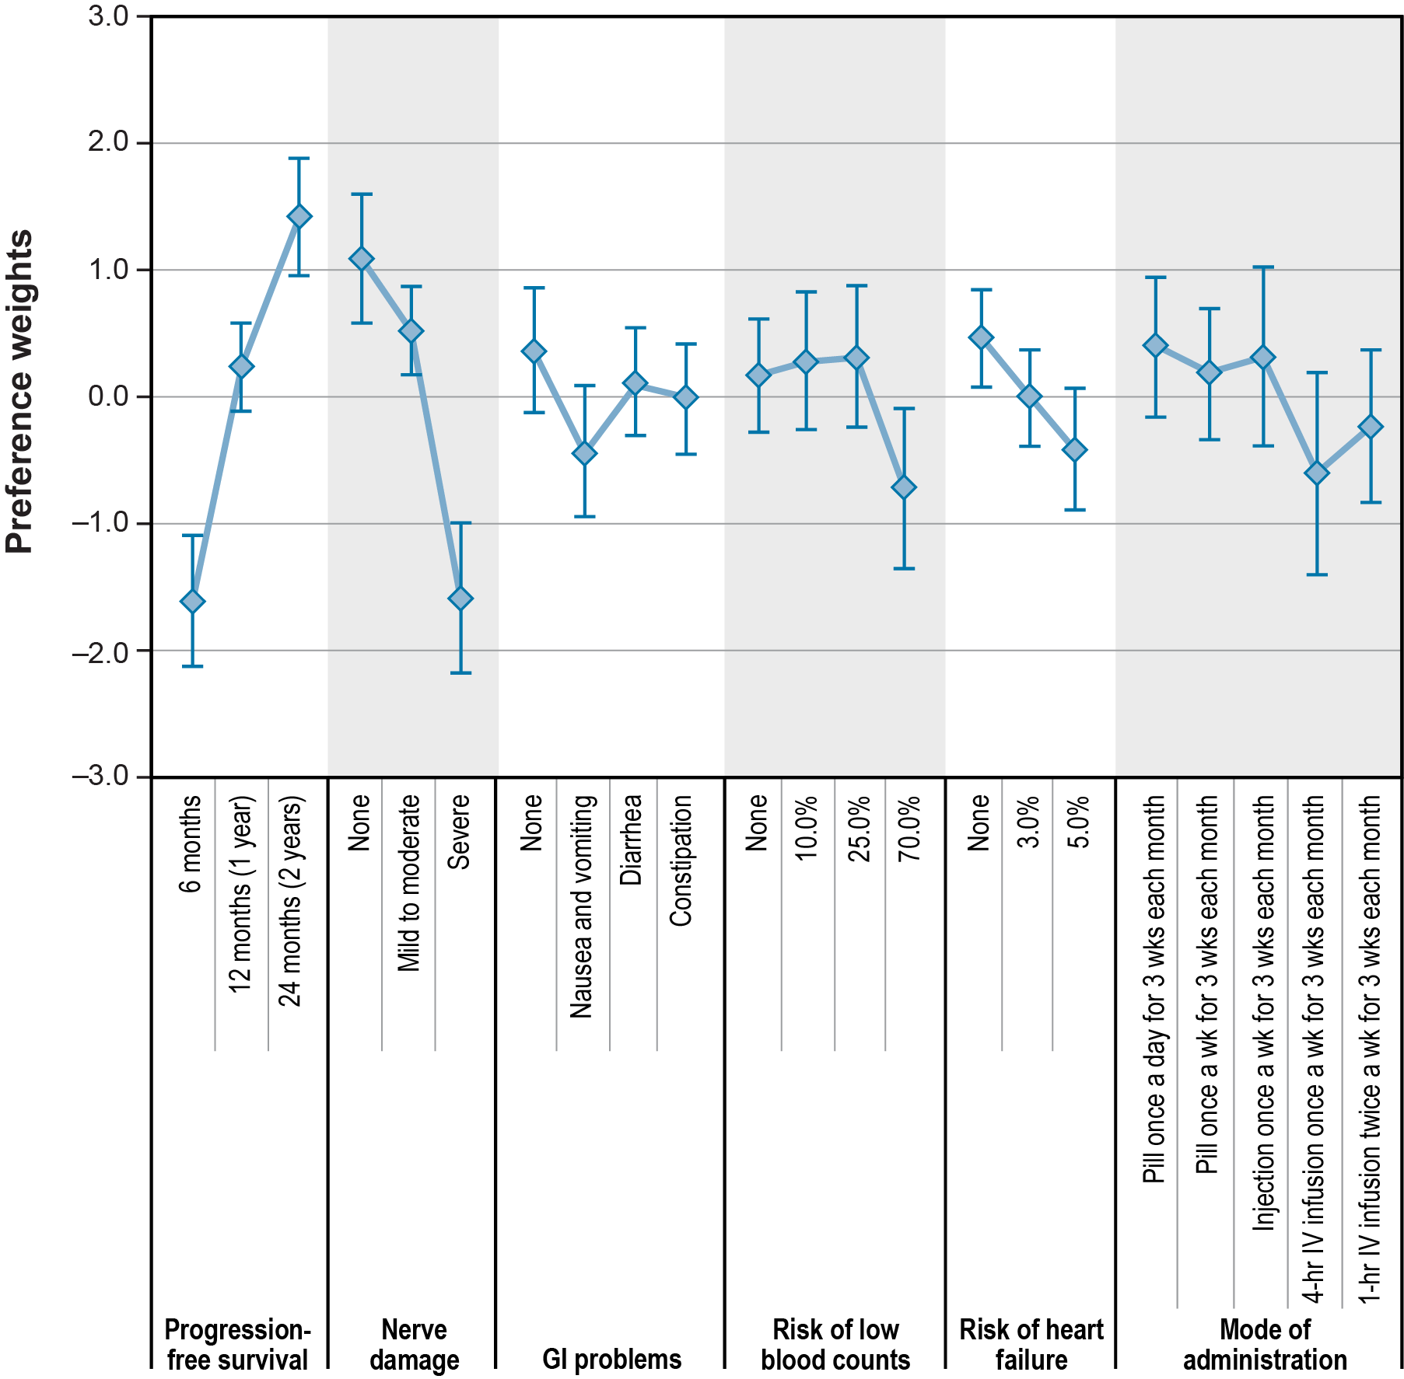
GI = gastrointestinal; IV = intravenous.
Note: The vertical distance between preference weights represents the relative importance of moving from one level of an attribute to another level of the same attribute. The vertical bars surrounding each mean preference weight denote the 95% confidence interval of the point estimate.

