Supplementary materials
Investigating the impact of the optimized trans-cinnamic acid loaded PLGA nanoparticles on epithelial to mesenchymal transition in breast cancer

F1
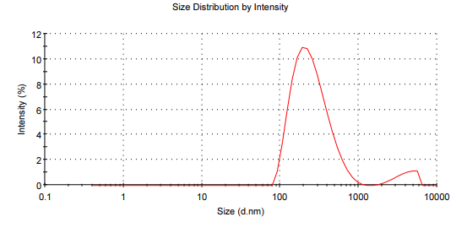 | 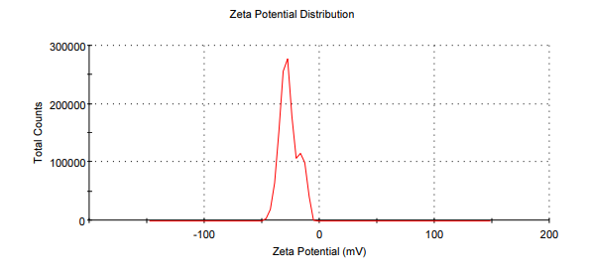

Figure S1. Particle size distribution and zeta potential for batch F1.

F2
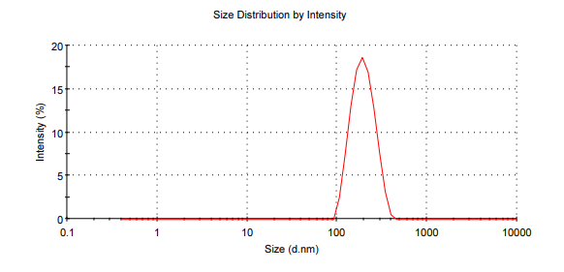 | 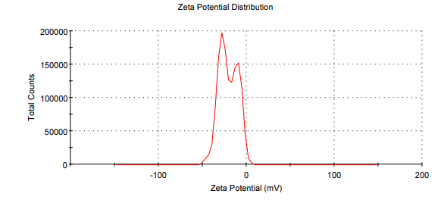

Figure S2. Particle size distribution and zeta potential for batch F2.

F3
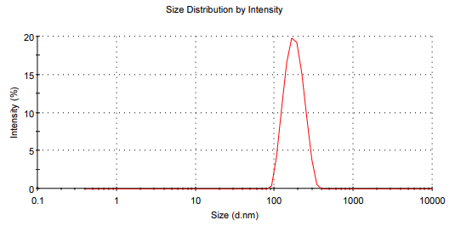 | 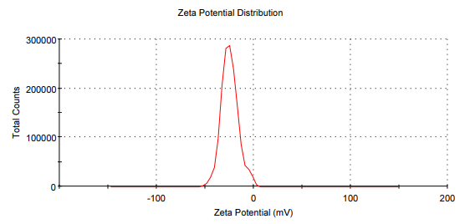

Figure S3. Particle size distribution and zeta potential for batch F3.

F4
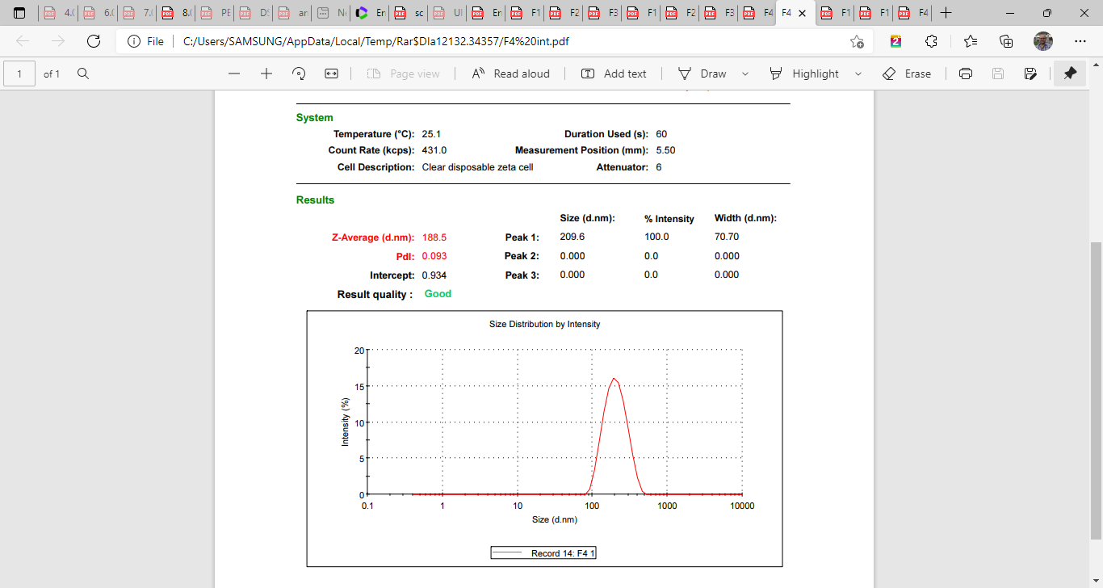 | 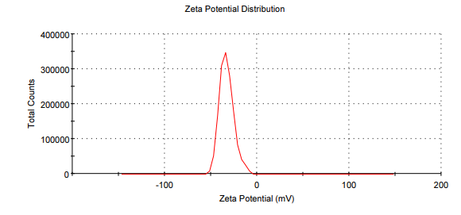

Figure S4. Particle size distribution and zeta potential for batch F4.

F5
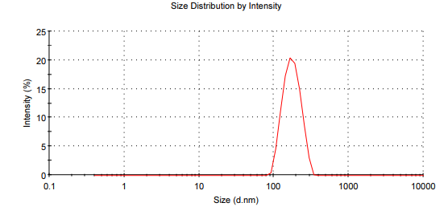 | 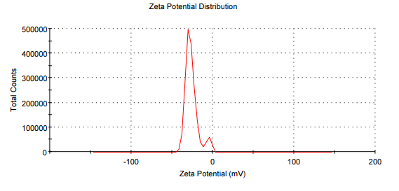

Figure S5. Particle size distribution and zeta potential for batch F5.

F6

Figure S6. Particle size distribution and zeta potential for batch F6.

F7

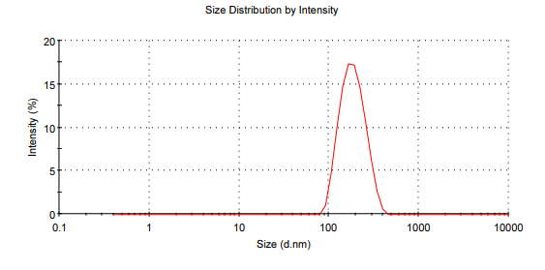

Figure S7. Particle size distribution and zeta potential for batch F7.

F8

Figure S8. Particle size distribution and zeta potential for batch F8.

F9
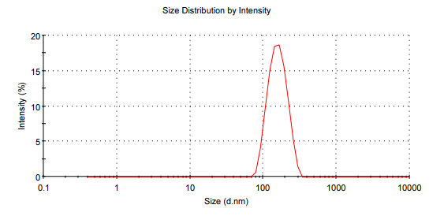 | 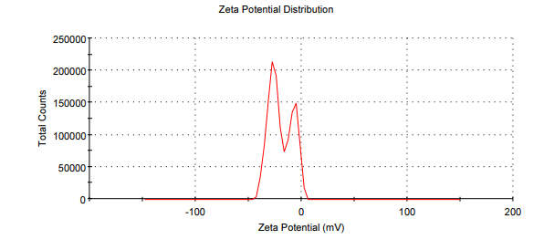

Figure S9. Particle size distribution and zeta potential for batch F9.
F10
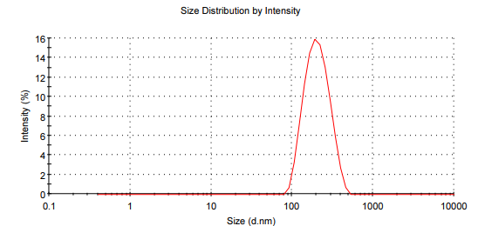 | 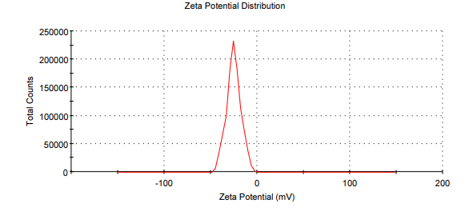

Figure S10. Particle size distribution and zeta potential for batch F10.

F11

Figure S11. Particle size distribution and zeta potential for batch F11.

F12

Figure S12. Particle size distribution and zeta potential for batch F12.
F13
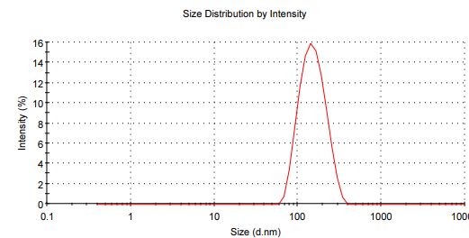 | 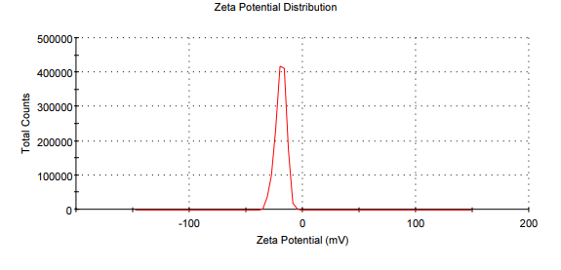

Figure S13. Particle size distribution and zeta potential for batch F13.

