Supplementary Material
Description of familiarisation tasks
A set of six familiarisation tasks were designed based on training videos provided by the developing institute of the FlexDex™ (FlexDex Surgical®) which are as follows (Supplementary Table 1):
TASK | DESCRIPTIONS | IMAGE
Movement of Articulating End | Insert instrument into the box trainer and flex the articulating wrist of the instrument up, down, left, and right. Rotate the articulating end effector. | 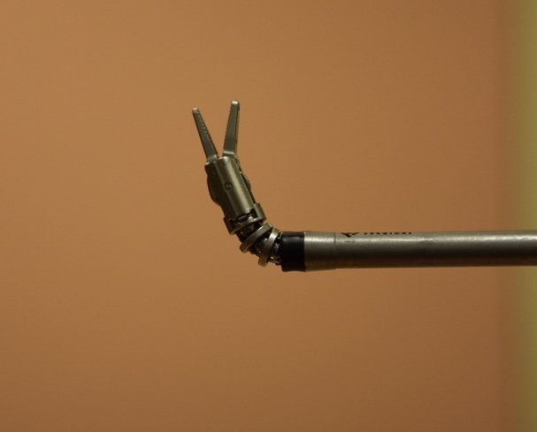
Four Corner Manoeuvring | Touch all four corners of the silicon pad model using the end effector of the FlexDex™. | 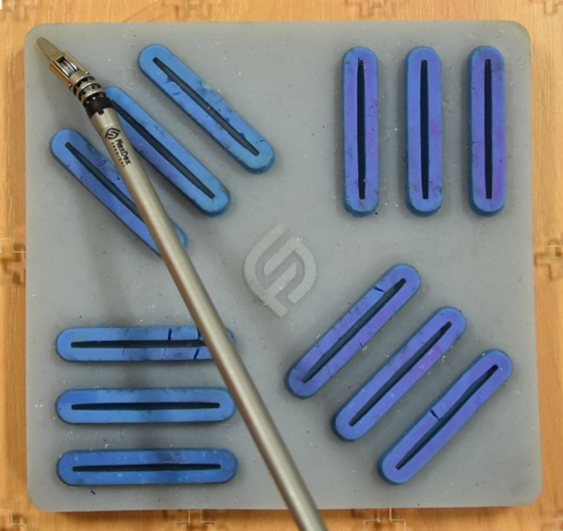
End-Slit Instrument Placement | Flex the end effector of the instrument tip downwards and touch the ends of all 12 columns on the silicon model. | 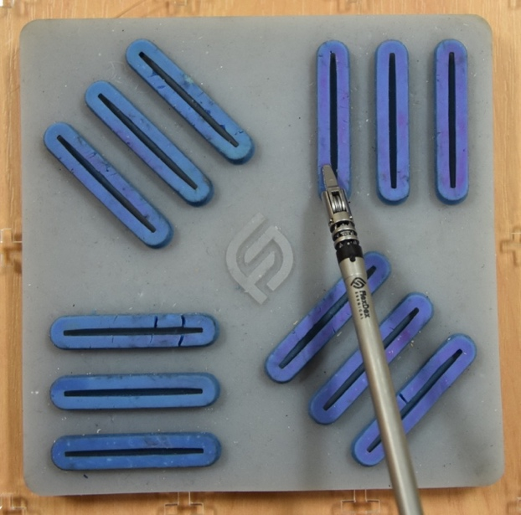
Instrument Tracking | Flex the end effector of the instrument tip downwards and drag it through the groves within the columns of the silicon model. | 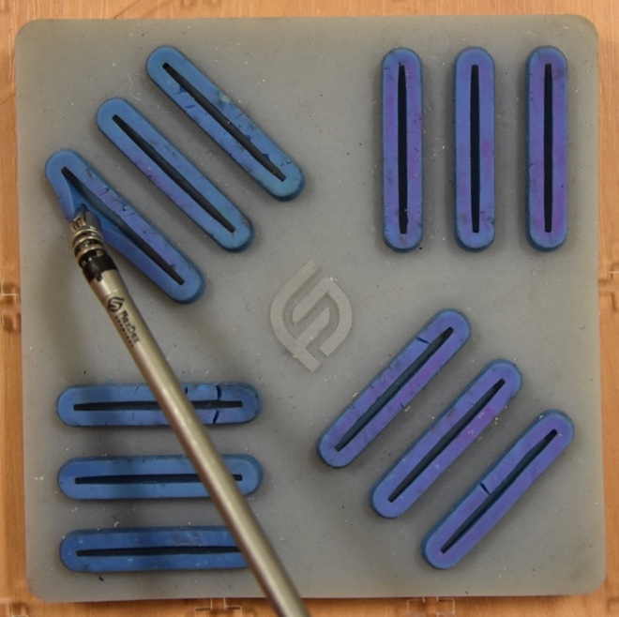
Articulating End Rotation | Place the end effector between the columns on the silicon pad and begin rotating the end effector. | 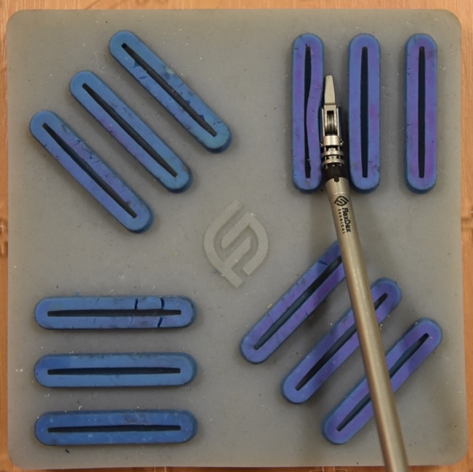
Ring Manipulation | Use the FlexDex™ to pick up the plastic ring placed on the silicon pad and begin moving it to different locations. | 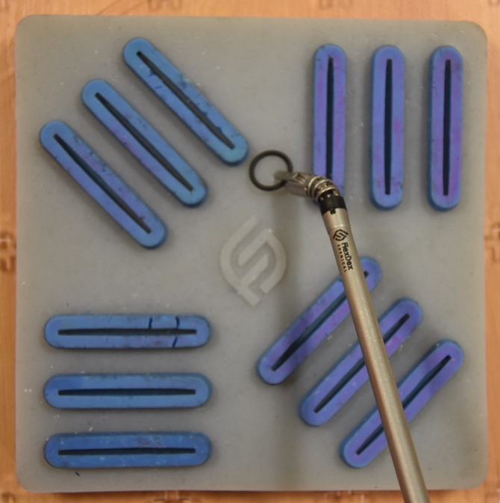

Supplementary Table 1. Description of the familiarisation tasks to be completed using the FlexDex™ prior to the assessment task.
Description of the Assessment task
Participants were required to complete task 1 (Grasping and Manipulation) of the LapPass® examination created by the Association of Laparoscopic Surgeons of Great Britain and Ireland (ALSGBI). The instruments utilised by the participants include a FlexDex™ needle holder (held in the dominant hand and a laparoscopic grasper (Maryland) held in the non-dominant hand. The exercise consists of a sequenced series of movements between three rings and three pegs and passing a 15cm string through the rings. These tasks were originally meant to be with polo mints but were adapted for rubber bands.

Supplementary Figure 1. Assessment model used comprised of a sponge surface with 3 pegs, 3 plastic rings and a 15cm piece of string.
To begin the task, three black-coloured plastic rings are placed on the model surface. The following sequence of actions is then performed.
- Using the dominant hand each ring is individually lifted and placed on the first peg.
- Again, using the dominant hand, each ring is individually lifted from the first peg and rotated 180 degrees and placed on the second peg.
- Then, using either hand the rings are individually picked up and transferred mid-air to the other hand which then places them on the third peg.
- Finally, using either hand individual rings are picked up and a 15cm piece of string is passed mid-air through each of the three plastic rings.
Participant timing is begun as soon as the first ring is picked up to be placed on the first peg. Timing is finished when the string has been passed through the last ring (Figure 9).

FlexDex TM
Supplementary figures 2 demonstrates the FlexDex™ needle holder.
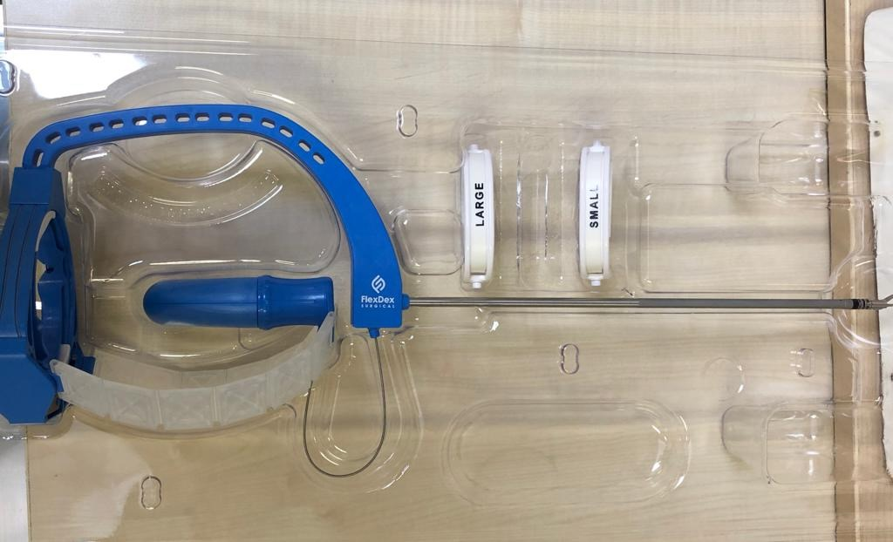
Supplementary Figure 2: Image of the FlexDexTM needle holder

