Supplementary materials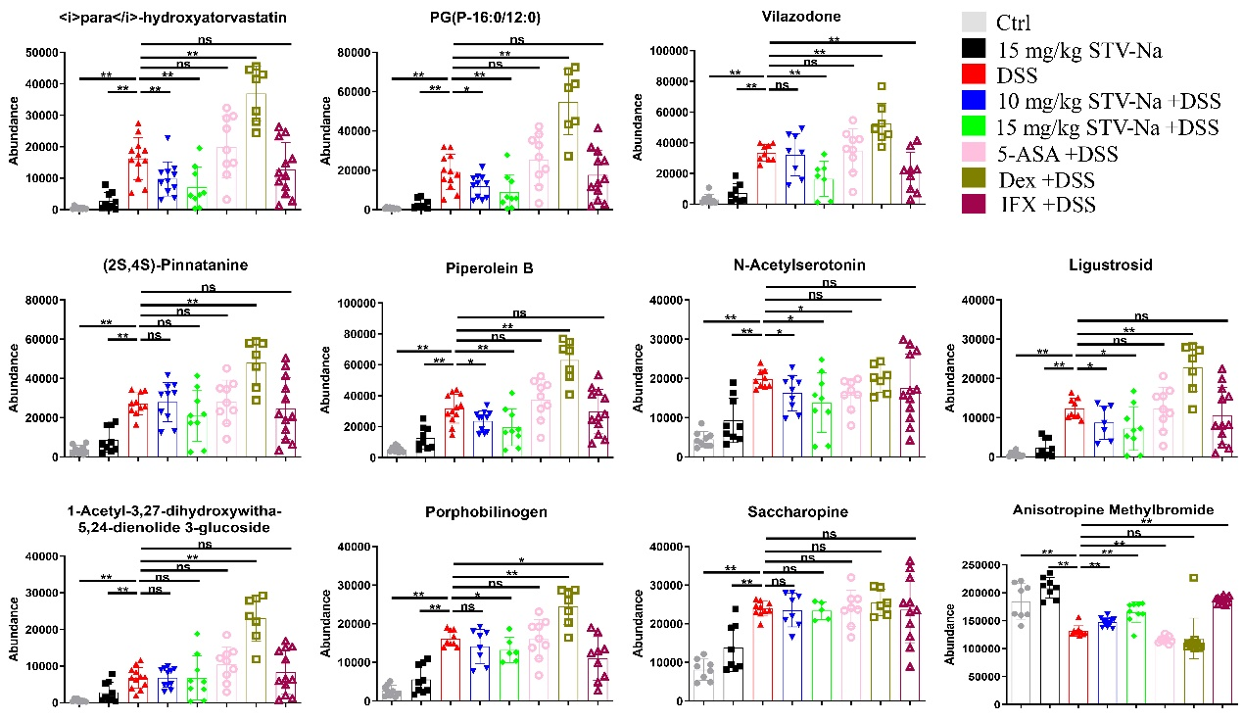
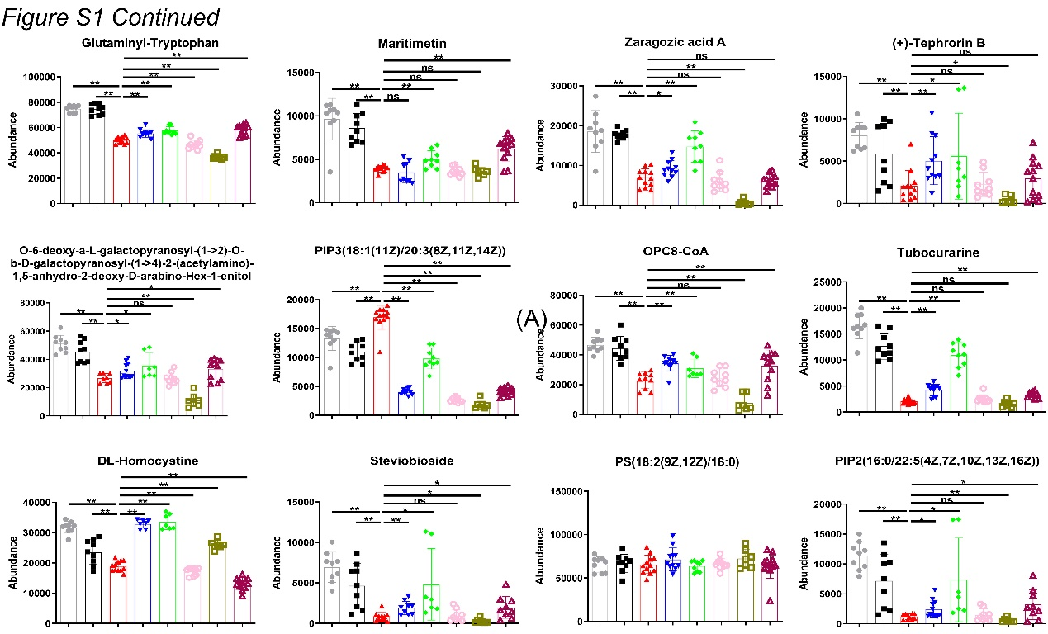
Supplementary Figure S1 STV-Na significantly affects metabolites in mice with colitis. Data is published in terms of means ± SDs. The statistical analyses were performed with Student’s t-test or one-way ANOVA followed Turkey’s post hoc test (n = 6 to 12 mice per group; each data point represents one mouse); *P < 0.05 and **P < 0.01 in contrast to the DSS group; ns, not significant.

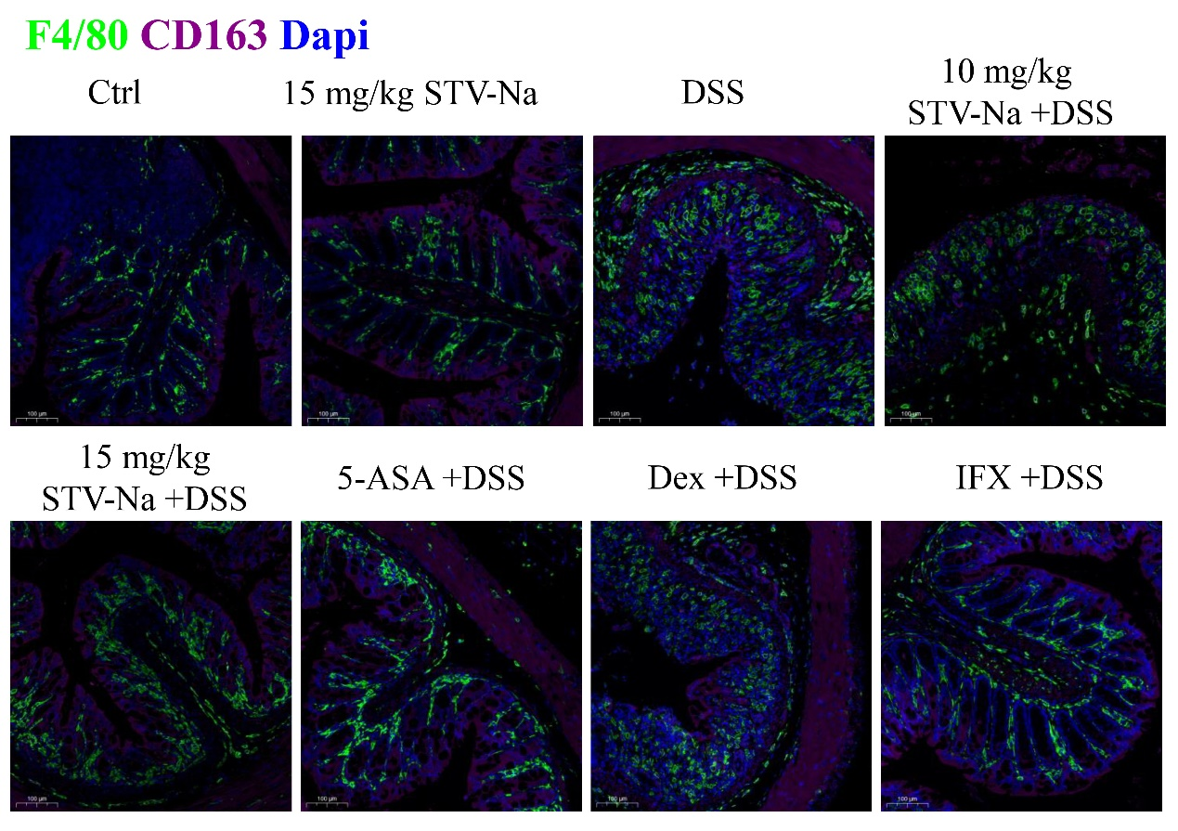
Supplementary Figure S2 Effect of STV-Na on F4/80+CD163+ M2 macrophages in the colons of mice with IBDs. Immunofluorescence staining images representing F4/80 (macrophage marker, green), CD163 (M2 macrophages marker, red), and Dapi (nuclei, blue).

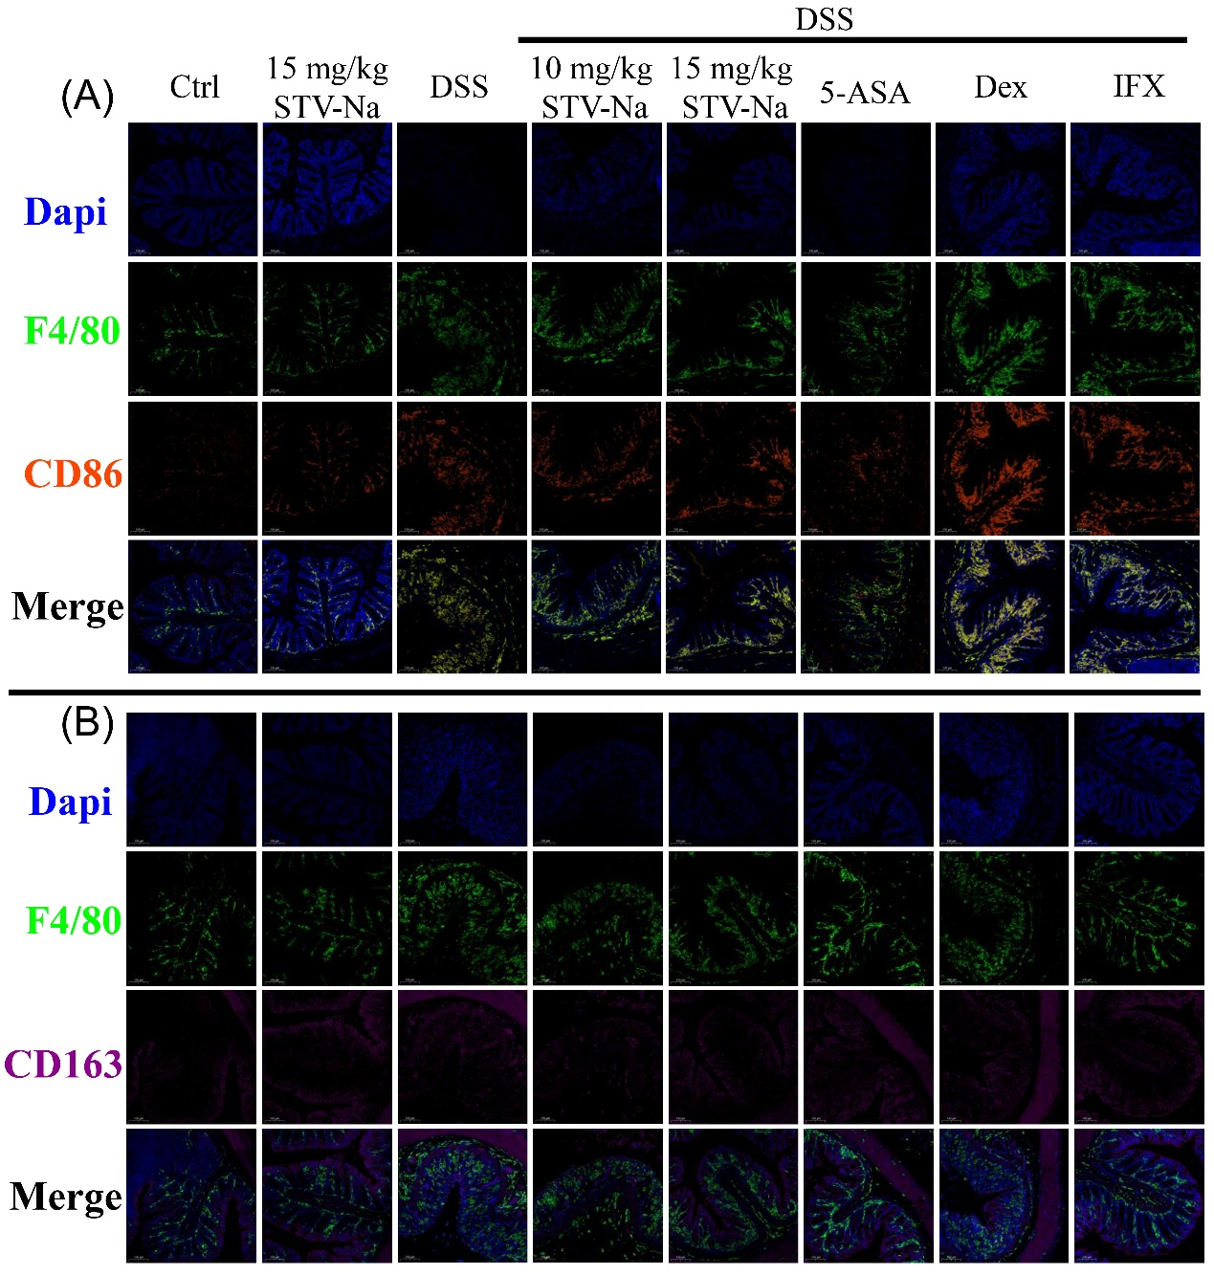
Supplementary Figure S3 Effect of STV-Na on F4/80+CD86+ M1 macrophages and F4/80+CD163+ M2 macrophages in the colons of mice with IBDs. Macrophages were visualized using immunofluorescence microscopy in the colons of mice with IBDs in different groups. (A) From top to bottom: Dapi (nuclei, blue), F4/80 (macrophage marker, green), CD86 (marker of M1 macrophage and inflamed tissue, orange-red), and merged image. (B) Dapi (nuclei, blue), F4/80 (macrophage marker, green), CD163 (M2 macrophage marker, red), and merged image. Scale bars: 100 µm.

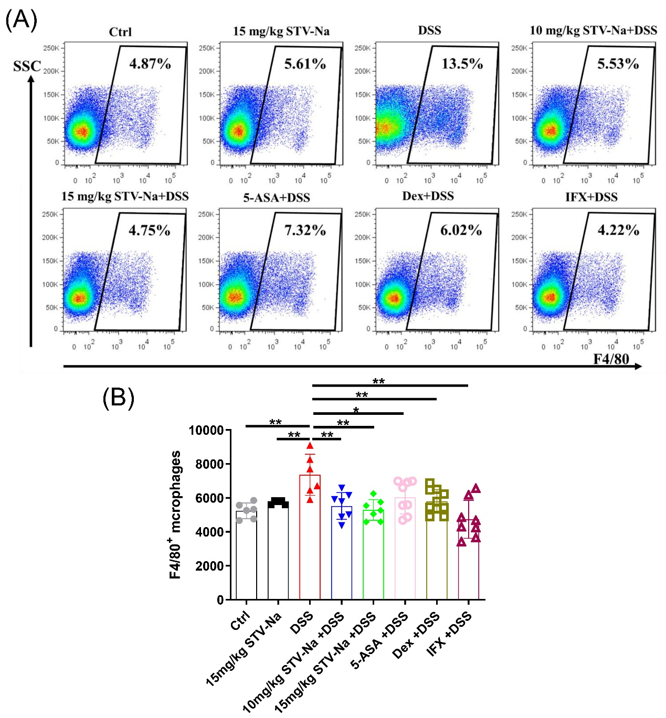
Supplementary Figure S4 STV-Na suppresses F4/80+ macrophages in the spleen. (A) Representative flow cytometric dot plots of F4/80 macrophages from each group. Scale bars, 100 µm. (B) Counts of macrophages in the spleen. Data is published in terms of means ± SDs. The statistical analyses were performed with Student’s t-test or one-way ANOVA followed Turkey’s post hoc test (n = 6 to 10 mice per group; each data point represents one mouse); *P < 0.05 and **P < 0.01 in contrast to the DSS group.

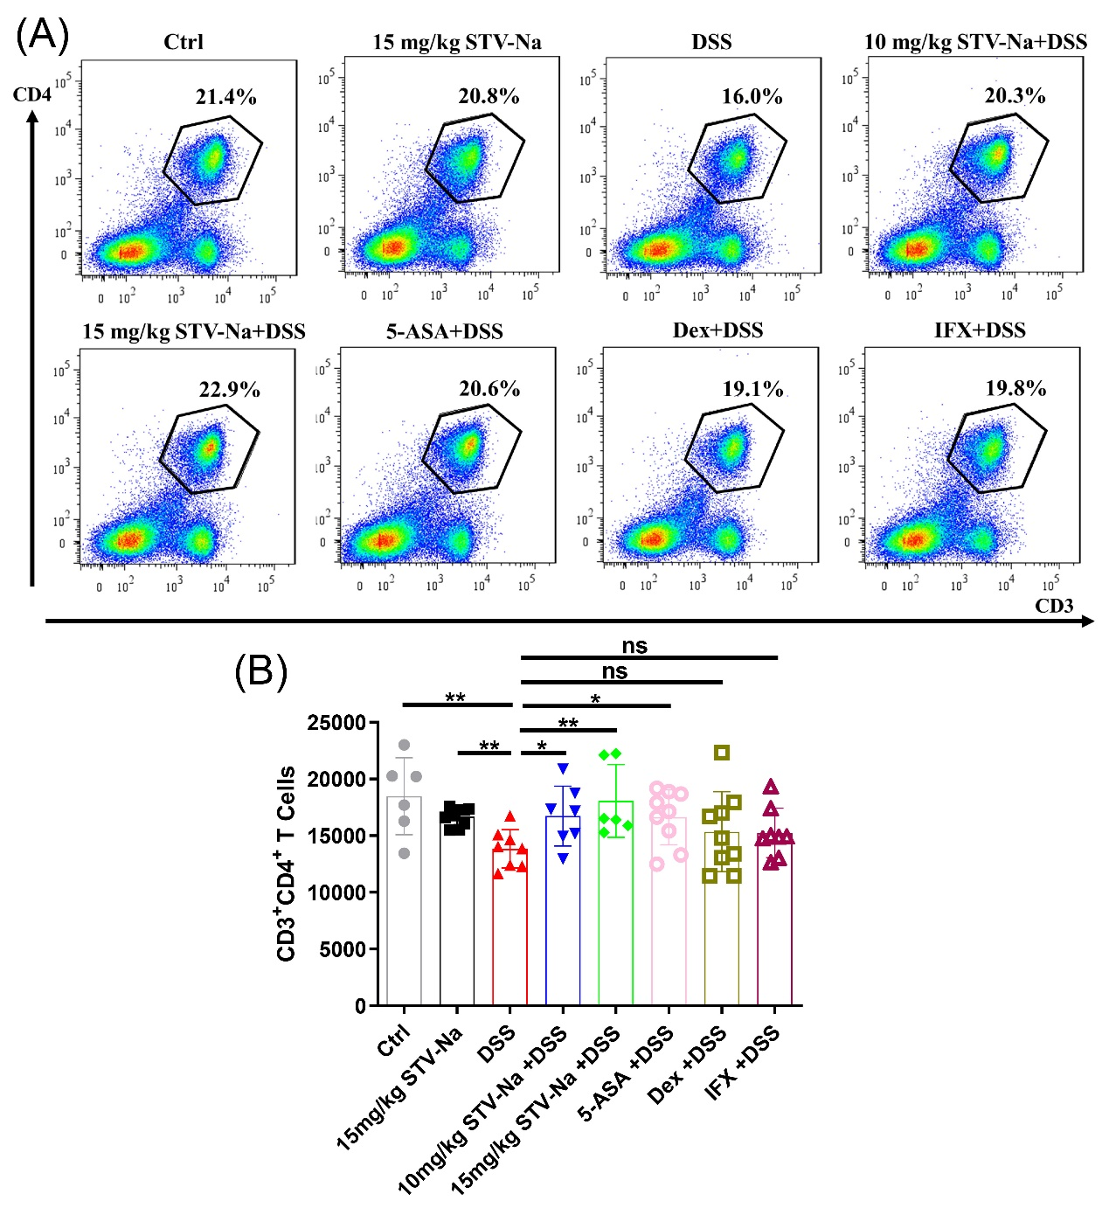
Supplementary Figure S5 STV-Na suppresses CD3+CD4+ T cells in the spleen. (A) Representative flow cytometric dot plots of CD3+CD4+ T cells from each group. (B) Counts of CD3+CD4+ T cells in the spleen. Data are published in terms of means ± SDs. The statistical analyses were performed with Student’s t-test or one-way ANOVA followed Turkey’s post hoc test (n = 6 to 9 mice per group; each data point represents one mouse); *P < 0.05 and **P < 0.01 in contrast to the DSS group; ns, not significant.

Supplementary Tables
Supplementary Table S1 Sequences of used in the RT- qPCR assay.
Gene | Species | Primer sequences (5´-3´)
TNF-α | Mouse | Forward ATGAGCACAGAAAGCATGA  Reverse AGTAGACAGAAGAGCGTGGT
IFN-γ | Mouse | Forward GAACTGGCAAAAGGATGGTGA  Reverse TGTGGGTTGTTGACCTCAAAC
IL-1β | Mouse | Forward AATGAAAGACGGCACACCCA  Reverse TGCTTGTGAGGTGCTGATGT
IL-4 | Mouse | Forward GGTCTCAACCCCCAGCTAGT  Reverse CCGATGATCTCTCTCAAGTGAT
IL-17A | Mouse | Forward TCTCCACCGCAATGAAGACC  Reverse CACACCCACCAGCATCTTCT
ZO-1 | Mouse | Forward GGGGCCTACACTGATCAAGA  Reverse TGGAGATGAGGCTTCTGCTT
Claudin-1 | Mouse | Forward ACGGTCCTCCTGGCTCAGTT  Reverse GATAAGCGAACCTTGGCGGC
Occludin | Mouse | Forward GCTTATCTTGGGAGCCTGGACA  Reverse GTCATTGCTTGGTGCATAATGATTG
MUC2 | Mouse | Forward GATAGGTGGCAGACAGGAGA  Reverse GCTGACGAGTGGTTGGTGAATG
Reg3γ | Mouse | Forward ATGCTTCCCCGTATAACCATCA  Reverse GGCCATATCTGCATCATACCAG
Rpl32 | Mouse | Forward GCTGCCATCTGTTTTACGG  Reverse TGACTGGTGCCTGATGAACT

Supplementary Table S2 Histopathological grading system for colonic sections.
Feature graded | Grade | Description
Inflammation | 0 | Normal
Inflammation | 1 | Minimal infiltration of the lamina propria, focal to multifocal
Inflammation | 2 | Mild infiltration of the lamina propria, multifocal, mild gland separation
Inflammation | 3 | Moderate to mixed infiltration, multifocal with minimal edema
Inflammation | 4 | Marked mixed infiltration into the submucosa and lamina propria with extensive areas of gland separation, enlarged Peyers patches, edema
Epithelium | 0 | Normal
Epithelium | 1 | Minimal: focal mucosal hyperplasia
Epithelium | 2 | Mild: multifocal tufting of rafts of epithelial cells with increased numbers of goblet cells
Epithelium | 3 | Moderate: extensive locally extensive to multifocal erosion or epithelial attenuation
Epithelium | 4 | Marked: locally extensive mucosal ulceration
Glands | 0 | Normal
Glands | 1 | Minimal: rare gland dilatation
Glands | 2 | Mild: multifocal gland dilatation
Glands | 3 | Moderate: multifocal gland dilatation with abscessation and occasional loss of glands
Glands | 4 | Marked: locally extensive to subtotal loss of glands
Depth of lesion | 0 | None
Depth of lesion | 1 | Mucosa
Depth of lesion | 2 | Mucosa and submucosa
Depth of lesion | 3 | Transmural
Extent of section  affected | 0 | None
Extent of section  affected | 1 | Minimal: < 10%
Extent of section  affected | 2 | Mild: 10-25%
Extent of section  affected | 3 | Moderate: 26-50%
Extent of section  affected | 4 | Marked: > 50%

Supplementary Table S3 Plasma metabolites after STV-Na pretreatment of mice with colitis.
NO | RT (min)ª | m/z | Mode | Biomarker identification | Formula | Trend ^{b} | Trend ^{c} | Related pathway
1 | 2.79 | 573.2387 | ^{d} N | <i>para</i>-hydroxyatorvastatin | C₃₀H₃₈O₁₁ | ↑** | ↓**
2 | 4.62 | 685.4258 | N | PG(P-16:0/12:0) | C₂₁H₂₉NO₃ | ↑** | ↓**
3 | 3.43 | 440.2125 | N | Vilazodone | C₂₆H₂₇N₅O₂ | ↑** | ↓*
4 | 2.73 | 279.0740 | P | (2S,4S)-Pinnatanine | C₂₅H₃₂O₁₂ | ↑** | -
5 | 4.62 | 342.2090 | P | Piperolein B | C₂₁H₂₉NO₃ | ↑** | ↓**
6 | 1.58 | 217.1001 | N | N-Acetylserotonin | C₁₂H₁₄N₂O₂ | ↑** | ↓* | Tryptophan metabolism
7 | 2.73 | 559.1557 | N | Ligustroside | C₂₅H₃₂O₁₂ | ↑** | ↓*
8 | 4.44 | 697.3310 | N | 1-Acetyl-3,27-dihydroxywitha-5,24-dienolide 3-glucoside | C₃₆H₅₄O₁₁ | ↑** | -
9 | 2.73 | 261.0650 | N | Porphobilinogen | C₁₀H₁₄N₂O₄ | ↑** | ↓* | Porphyrin and chlorophyll metabolism
10 | 2.86 | 293.0885 | N | Saccharopine | C₁₁H₁₈N₂O₅ | ↑** | - | Lysine degradation
11 | 3.89 | 377.1491 | N | Glutaminyl-Tryptophan | C₁₇H₃₂BrNO₂ | ↓** | -
12 | 7.16 | 321.0152 | N | Maritimetin | C₁₅H₁₁ClO₆ | ↓** | ↑**
13 | 5.28 | 735.2813 | N | Zaragozic acid A | C₃₅H₄₆O₁₄ | ↓** | ↑**
14 | 3.31 | 519.1625 | N | (+)-Tephrorin B | C₃₀H₂₈O₆ | ↓** | ↑*
15 | 3.47 | 556.1922 | N | O-6-deoxy-a-L-galactopyranosyl-(1->2)-O-b-D-galactopyranosyl-(1->4)-2-(acetylamino)-1,5-anhydro-2-deoxy-D-arabino-Hex-1-enitol | C₂₀H₃₃NO₁₄ | ↓** | ↑**
16 | 3.75 | 1161.4148 | N | PIP3(18:1(11Z)/20:3(8Z,11Z,14Z)) | C₄₇H₈₆O₂₂P₄ | ↑** | ↓**
17 | 4.55 | 1042.3217 | N | OPC8-CoA | C₃₉H₆₄N₇O₁₈P₃₅ | ↓** | ↑**
18 | 4.03 | 654.2949 | N | Tubocurarine | C₃₇H₄₁N₂O₆P | ↓** | ↑**
19 | 0.75 | 267.0497 | N | DL-Homocystine | C₈H₁₆N₂O₄S₂ | ↓** | ↑**
20 | 3.56 | 641.3176 | N | Steviobioside | C₃₂H₅₀O₁₃ | ↓** | ↑*
21 | 17.92 | 804.5035 | N | PS(18:2(9Z,12Z)/16:0) | C₄₀H₇₄NO₁₀P | ↓** | - | glycerophospholipid metabolism
22 | 4.97 | 1079.4332 | N | PIP2(16:0/22:5(4Z,7Z,10Z,13Z,16Z)) | C₄₇H₈₃O₁₉P₃ | ↓** | ↑* | glycerophospholipid metabolism
23 | 3.89 | 379.1967 | P | Anisotropine Methylbromide | C₁₆H₂₀N₄O₄ | ↓** | ↑**

a RT: retention time of the components; b ↑ indicates that the metabolites were upregulated in the model group in contrast to the control group; c ↓ indicates that the metabolites were downregulated in the STV group compared with the model group; d P and N represent ESI (+) and ESI (-), respectively. ** indicates a very significant change (p < 0.01), and * indicates a significant change (p < 0.05).

