Supplementary materials
Appendix 1. Details of Search Strategy
- Search strategy for CNKI (China National Knowledge Infrastructure), WANFANG DATA and Wei Pu (China Science and Technology Journal Database):
((COPD + chronic obstructive pulmonary disease) * stable period) * (noninvasive positive pressure ventilation + noninvasive mechanical ventilation + noninvasive positive pressure mechanical ventilation + family noninvasive positive pressure ventilation + family noninvasive positive pressure mechanical ventilation + family noninvasive positive pressure mechanical ventilation + double level noninvasive positive pressure mechanical ventilation). From database established to 2020 / 06 / 30.
- Search strategy for PUBMED：
((((((((((((COPD[Title/Abstract]) OR (Chronic Obstructive Pulmonary Disease[Title/Abstract])) OR (COAD[Title/Abstract])) OR (Chronic Obstructive Airway Disease[Title/Abstract])) OR (Chronic Obstructive Lung Disease[Title/Abstract])) OR (Airflow Obstruction, Chronic[Title/Abstract])) OR (Airflow Obstructions, Chronic[Title/Abstract])) OR (Chronic Airflow Obstructions[Title/Abstract])) OR (Chronic Airflow Obstruction[Title/Abstract])) AND (stable[Title/Abstract])) AND ((((((((((((((nasal[Title/Abstract]) OR (mechanical[Title/Abstract])) OR (noninvasive[Title/Abstract])) OR (non-invasive[Title/Abstract])) OR (non invasive[Title/Abstract])) OR (positive[Title/Abstract])) OR (intermittent[Title/Abstract])) OR (bi-level[Title/Abstract])) OR (bi level[Title/Abstract])) OR (airway[Title/Abstract])) OR (controlled[Title/Abstract])) OR (pressure[Title/Abstract])) OR (support[Title/Abstract])) AND (ventilat*[Title/Abstract]))) AND (((((((((randomized controlled trial[Publication Type]) OR (controlled clinical trial[Publication Type])) OR (randomized[Title/Abstract])) OR (placebo[Title/Abstract])) OR (randomly[Title/Abstract])) OR (drug therapy)) OR (trial[Title/Abstract])) OR (groups[Title/Abstract])) NOT ((animals[MeSH Terms]) NOT (humans[MeSH Terms])))) AND (("1980/01/01"[Date - Publication] : "2020/06/30"[Date - Publication]))
- Search strategy for EMABSE：
('chronic obstructive lung disease'/exp OR 'chronic airflow obstruction':ti,ab OR 'chronic airway obstruction':ti,ab OR 'chronic obstructive bronchitis':ti,ab OR 'chronic obstructive bronchopulmonary disease':ti,ab OR 'chronic obstructive lung disorder':ti,ab OR 'chronic obstructive pulmonary disease':ti,ab OR 'chronic obstructive pulmonary disorder':ti,ab OR 'chronic obstructive respiratory disease':ti,ab OR 'copd':ti,ab OR 'lung chronic obstructive disease':ti,ab OR 'lung disease':ti,ab OR 'chronic obstructive':ti,ab OR 'lung diseases':ti,ab OR 'obstructive':ti,ab OR 'obstructive lung disease':ti,ab OR 'obstructive lung disease, chronic':ti,ab OR 'obstructive pulmonary disease':ti,ab OR 'obstructive respiratory disease':ti,ab OR 'obstructive respiratory tract disease':ti,ab OR 'pulmonary disease, chronic obstructive':ti,ab OR 'pulmonary disorder, chronic obstructive':ti,ab) AND 'stable':ti,ab AND ('nasal':ti,ab OR 'mechanical':ti,ab OR 'noninvasive':ti,ab OR 'non-invasive':ti,ab OR 'non invasive':ti,ab OR 'positive':ti,ab OR 'intermittent':ti,ab OR 'bi-level':ti,ab OR 'bi level':ti,ab OR 'airway':ti,ab OR 'controlled':ti,ab OR 'pressure':ti,ab OR 'support':ti,ab) AND 'ventilat*':ti,ab AND ('randomized controlled trial':it OR 'controlled clinical trial':it OR 'randomized':ti,ab OR 'placebo':ti,ab OR 'randomly':ti,ab OR 'drug therapy' OR 'trial':ti,ab OR 'groups':ti,ab) NOT (animals NOT humans) AND [1-1-1980]/sd NOT [1-7-2020]/sd
- Search strategy for Cochrane library：
#1 MeSH descriptor:[Pulmonary Disease, Chronic Obstructive] explode all trees
#2 (COAD) OR (Chronic Obstructive Lung Disease) OR (COPD) OR (Chronic Obstructive Pulmonary Disease) OR (Chronic Obstructive Airway Disease) OR (Airflow Obstructions, Chronic) OR (Airflow Obstruction, Chronic) OR (Chronic Airflow Obstructions) OR (Chronic Airflow Obstruction)
#3 (stable)
#4 #1 OR #2
#5 #4 AND #3
#6 ((nasal) OR (mechanical) OR (noninvasive) OR (non-invasive) OR (non invasive) OR (positive) OR (intermittent) OR (bi-leve) OR (bi level) OR (airway) OR (controlled) OR (pressure) OR (support)):ti,ab,kw
#7 (ventilat*):ti,ab,kw (Word variations have been searched)
#8 #6 AND #7
#9 #8 AND #5 with Cochrane Library publication date Between Jan 1980 and Jun 2020

Table S1. Degree of evidence for outcomes
NIPPV for stable hypercapnic COPD patient
Patient or population: stable hypercapnic COPD patient
Settings:
Intervention: NIPPV
Outcomes | Illustrative comparative risks* (95% CI) |  | Relative effect  (95% CI) | No of Participants  (studies) | Quality of the evidence  (GRADE) | Comments
Outcomes | Assumed risk | Corresponding risk
 | Control | NIPPV
mortality | Study population |  | RR 0.76  (0.61 to 0.95) | 1168  (13 studies) | ⊕⊕⊕⊝  moderate¹
mortality | 293 per 1000 | 222 per 1000  (178 to 278)
mortality | Moderate
mortality | 290 per 1000 | 220 per 1000  (177 to 275)
mortality sub dPaCO2 - dPaCO2 more than 5mmHg | Study population |  | RR 0.42  (0.28 to 0.63) | 474  (6 studies) | ⊕⊕⊕⊝  moderate²
mortality sub dPaCO2 - dPaCO2 more than 5mmHg | 254 per 1000 | 107 per 1000  (71 to 160)
mortality sub dPaCO2 - dPaCO2 more than 5mmHg | Moderate
mortality sub dPaCO2 - dPaCO2 more than 5mmHg | 354 per 1000 | 149 per 1000  (99 to 223)
mortality sub dPaCO2 - dPaCO2 less than 5mmHg | Study population |  | RR 0.91  (0.75 to 1.12) | 628  (6 studies) | ⊕⊕⊕⊝  moderate²
mortality sub dPaCO2 - dPaCO2 less than 5mmHg | 338 per 1000 | 307 per 1000  (253 to 378)
mortality sub dPaCO2 - dPaCO2 less than 5mmHg | Moderate
mortality sub dPaCO2 - dPaCO2 less than 5mmHg | 230 per 1000 | 209 per 1000  (172 to 258)
frequency of hospitalization |  | The mean frequency of hospitalization in the intervention groups was  1.74 lower  (2.3 to 1.17 lower) |  | 558  (8 studies) | ⊕⊝⊝⊝  very low^{1,2,3}
PaCO2 |  | The mean paco2 in the intervention groups was  7.07 lower  (9.78 to 4.37 lower) |  | 1042  (17 studies) | ⊕⊕⊝⊝  low^{1,2}
PaO2 |  | The mean pao2 in the intervention groups was  3.97 higher  (1.86 to 6.08 higher) |  | 831  (16 studies) | ⊕⊕⊝⊝  low^{1,2}
FEV1%predicted |  | The mean fev1%predicted in the intervention groups was  0.83 higher  (2.43 lower to 4.1 higher) |  | 422  (8 studies) | ⊕⊝⊝⊝  very low^{1,2,3}
6-MWD |  | The mean 6-mwd in the intervention groups was  46.79 higher  (24.38 to 69.19 higher) |  | 317  (8 studies) | ⊕⊝⊝⊝  very low^{1,2,4}
MRC-dyspnea scale |  | The mean mrc-dyspnea scale in the intervention groups was  1.01 lower  (1.72 to 0.3 lower) |  | 145  (3 studies) | ⊕⊝⊝⊝  very low^{1,2,3}
SGRQ score |  | The mean sgrq score in the intervention groups was  4.14 lower  (5.99 to 2.28 lower) |  | 213  (4 studies) | ⊕⊝⊝⊝  very low^{2,3}
*The basis for the assumed risk (e.g. the median control group risk across studies) is provided in footnotes. The corresponding risk (and its 95% confidence interval) is based on the assumed risk in the comparison group and the relative effect of the intervention (and its 95% CI).
CI: Confidence interval; RR: Risk ratio;
GRADE Working Group grades of evidence
High quality: Further research is very unlikely to change our confidence in the estimate of effect.
Moderate quality: Further research is likely to have an important impact on our confidence in the estimate of effect and may change the estimate.
Low quality: Further research is very likely to have an important impact on our confidence in the estimate of effect and is likely to change the estimate.
Very low quality: We are very uncertain about the estimate.
¹ heterogeneity of studies
² inconsistent of quality studies, lots of trials have uncertain bias for selection, performance, detection.
³ not showing sufficient data or showing different type date that are not suitable to combine.
⁴ baseline level are not equal of some studies

Table S2 Results of subgroup-analysis for mortality
Subgroup | No. of Studies | Total No. of patients | All-cause mortality |  | RR (95% CI) | p value | P value for heterogeneity | P _{interaction}
Subgroup | No. of Studies | Total No. of patients | LTHNIPPV | Control
Overall | 13 | 1168 | 128/580 | 172/588 | 0.76 [0.61, 0.95] | 0.02 | 0.3 | N
Baseline PaCO2 Higher group | 11 | 972 | 84/482 | 122/490 | 0.69 [0.51, 0.94] | 0.02 | 0.24 | 0.26
Baseline PaCO2 Lower group | 2 | 196 | 44/98 | 50/98 | 0.87 [0.67, 1.14] | 0.32 | 0.83 | 0.26
dPaCO2 higher subgroup | 6 | 474 | 25/238 | 60/236 | 0.42 [0.28, 0.63] | ＜0.0001 | 0.95 | 0.0008
dPaCO2 lower subgroup | 6 | 628 | 98/311 | 107/317 | 0.91 [0.75, 1.12] | 0.38 | 0.96 | 0.0008
PaCO2 increased in control treatment group | 6 | 279 | 21/134 | 37/145 | 0.61 [0.38, 0.98] | 0.04 | 0.72 | 0.43
PaCO2 decreased in control treatment group | 6 | 823 | 102/415 | 130/408 | 0.77 [0.56, 1.08] | 0.13 | 0.09 | 0.43
prior screening time less than 4w | 3 | 342 | 46/170 | 49/172 | 0.95 [0.68, 1.34] | 0.78 | 0.75 | 0.21
prior stable time not less than 4w | 8 | 742 | 77/371 | 111/371 | 0.69 [0.48, 1.00] | 0.05 | 0.14 | 0.21
prior stable time is uncertain | 2 | 84 | 5/39 | 12/45 | 0.45 [0.18, 1.14] | 0.09 | 0.97 | 0.21
duration of follow-up less than 1 year | 2 | 140 | 0/69 | 2/71 | 0.33 [0.03, 3.34] | 0.35 | 1.0 | 0.58
duration of follow-up not less than 1 year | 11 | 1028 | 128/511 | 170/517 | 0.65 [0.46, 0.91] | 0.01 | 0.24 | 0.58
Abbreviations: CI: Confidence Interval, RR: risk ratio, P _{interaction}: P value of interactions, Baseline PaCO2 Higher indicated PaCO2 ≥ 55mmHg, Baseline PaCO2 lower indicated 45mmHg ≤ PaCO2 ＜ 55mmHg, dPaCO2 = (NPPV group baseline PaCO2 － NPPV group endpoint PaCO2) － (control group baseline PaCO2 － control group endpoint PaCO2), N: None.

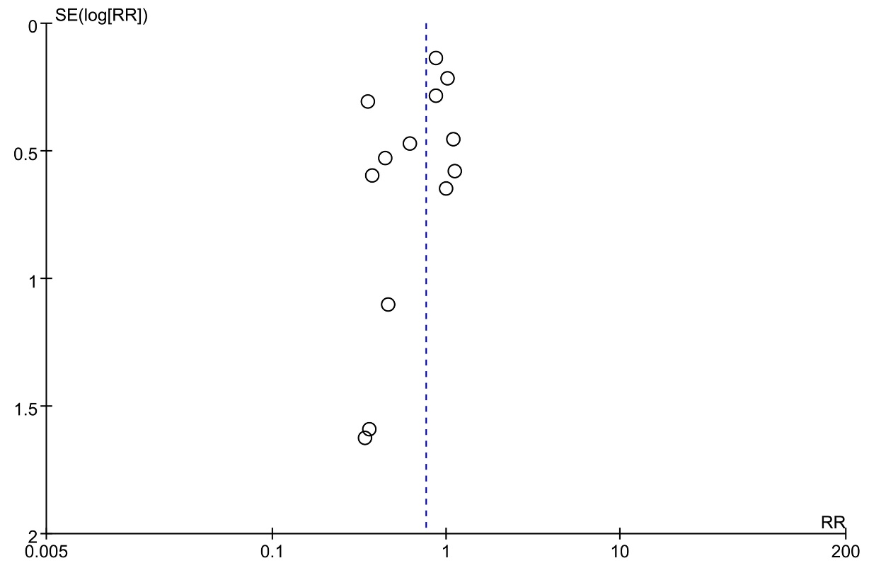
Figure S1 Funnel plot comparing mortality between NIPPV group and control group by Log risks ratio. RR: Risk Ratio, SE: Standard Error
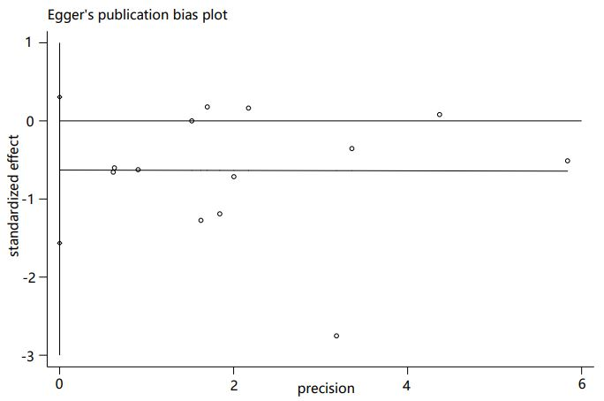
Figure S2 The egger regression test for mortality

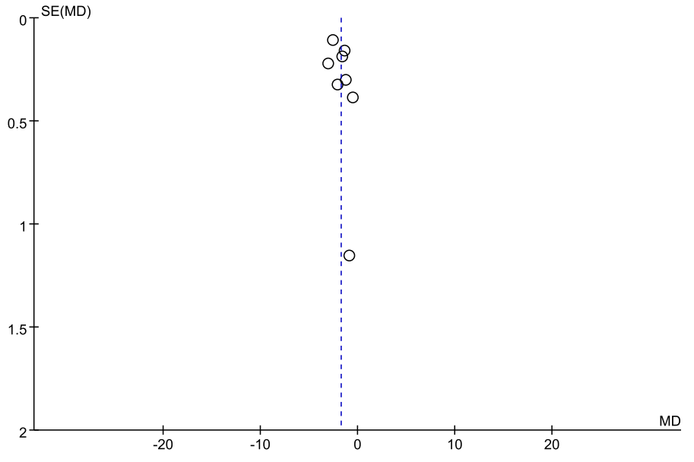
Figure S3 Funnel plot comparing frequency of hospitalization between NIPPV and control group by mean difference. MD: Mean Difference, SE: Standard Error
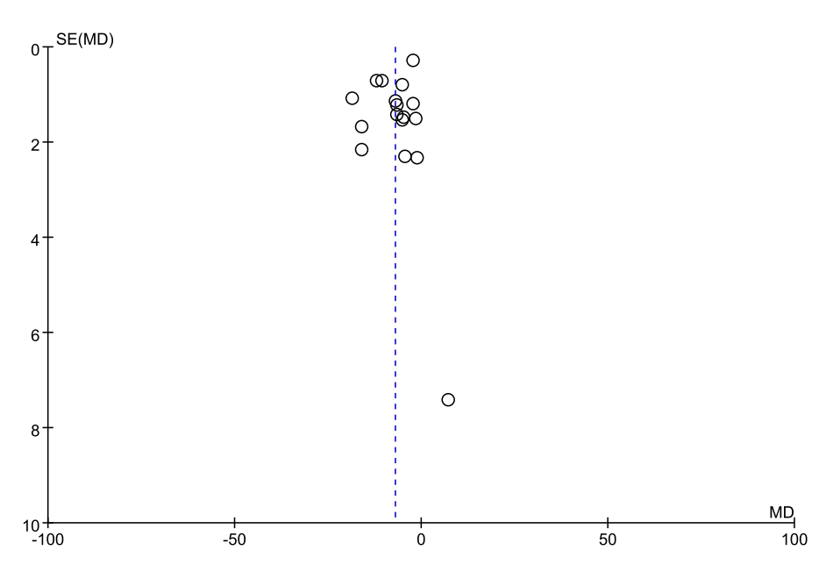
Figure S4 Funnel plot comparing endpoint PaCO2 between NIPPV and control group by mean difference. MD: Mean Difference, SE: Standard Error

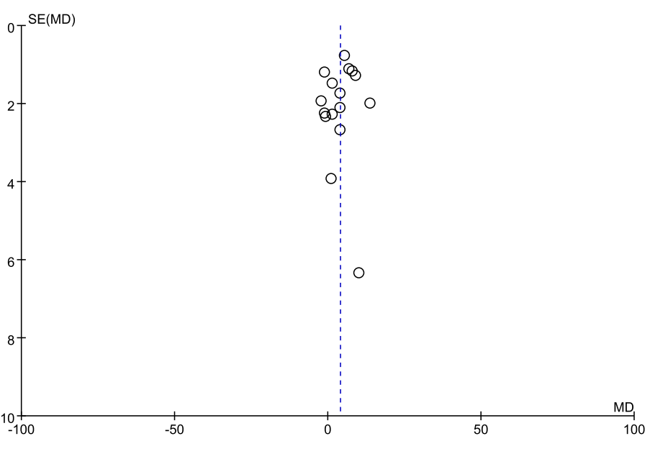
Figure S5 Funnel plot comparing endpoint PaO2 between NIPPV and control group by mean difference. MD: Mean Difference, SE: Standard Error
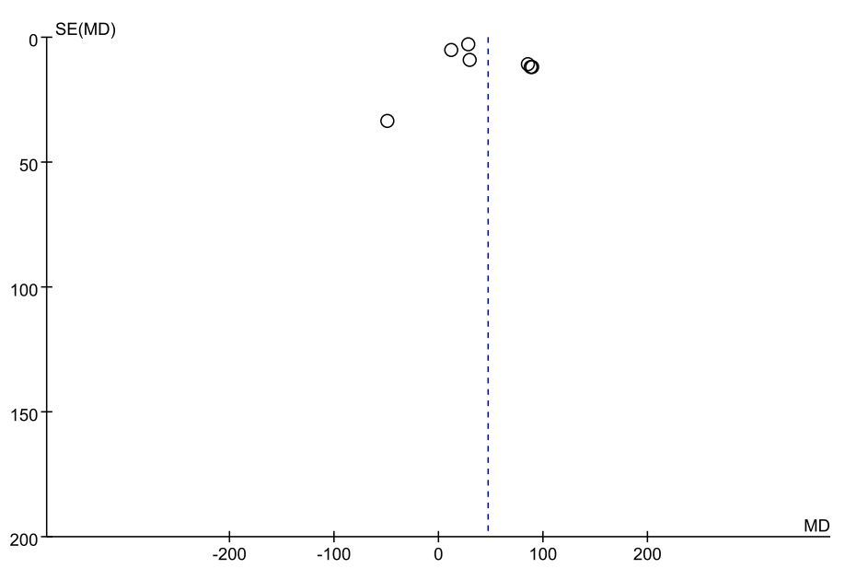
Figure S6 Funnel plot comparing 6-MWD between NIPPV and control group by mean difference. MD: Mean Difference, SE: Standard Error

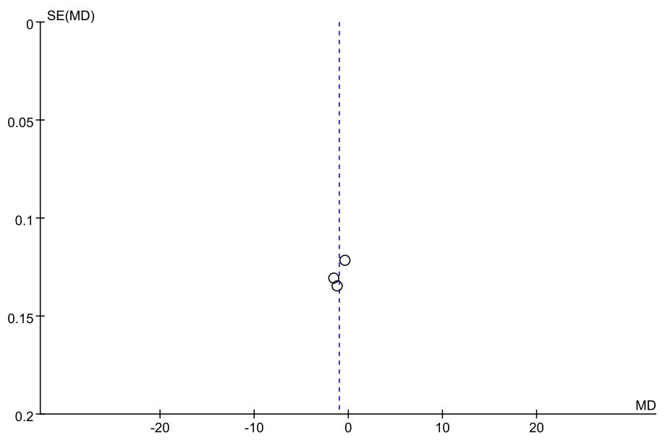
Figure S7 Funnel plot comparing MRC-dyspnea between NIPPV group and control group by mean difference. MD: Mean Difference, SE: Standard Error
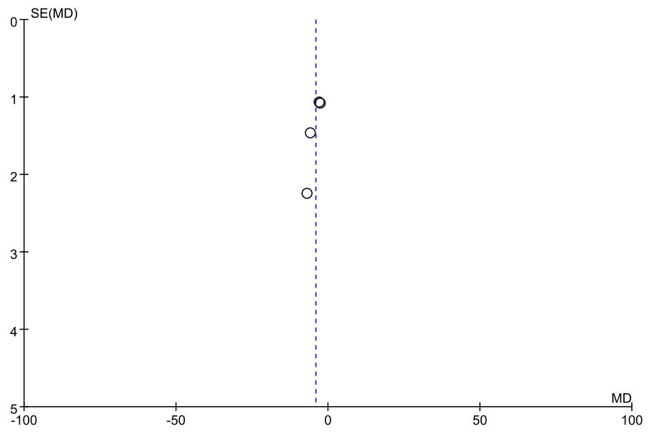
Figure S8 Funnel plot comparing SGRQ between NIPPV group and control group by mean difference. MD: Mean Difference, SE: Standard Error

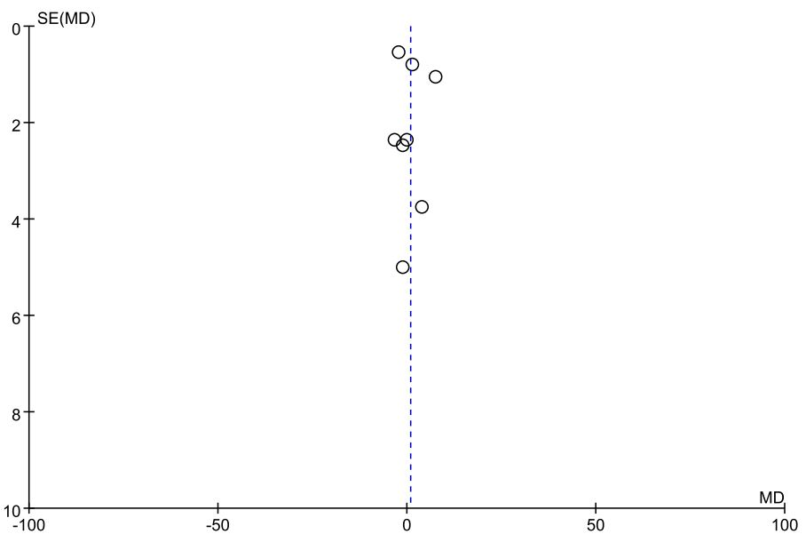
Figure S9 Funnel plot comparing FEV1% predicted between NPPV and control group by mean difference. MD: Mean Difference, SE: Standard Error

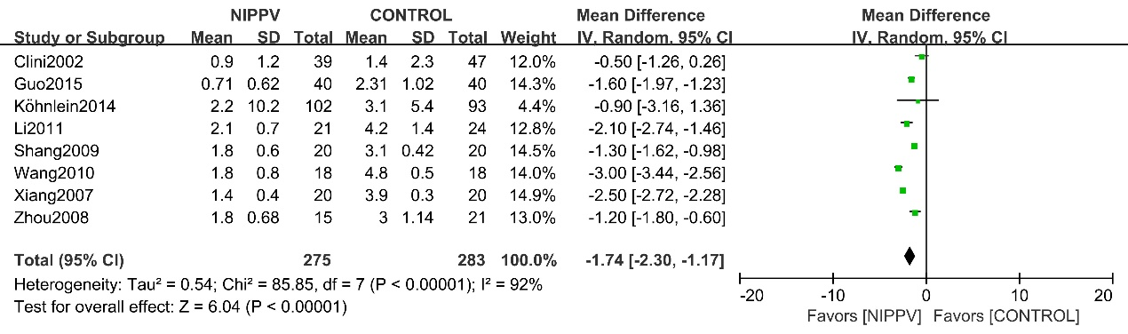
Figure S10 Forest plot comparing frequency of hospital admissions between NIPPV and control group. CI: Confidence Interval, M-H: Mantel-Haenszel
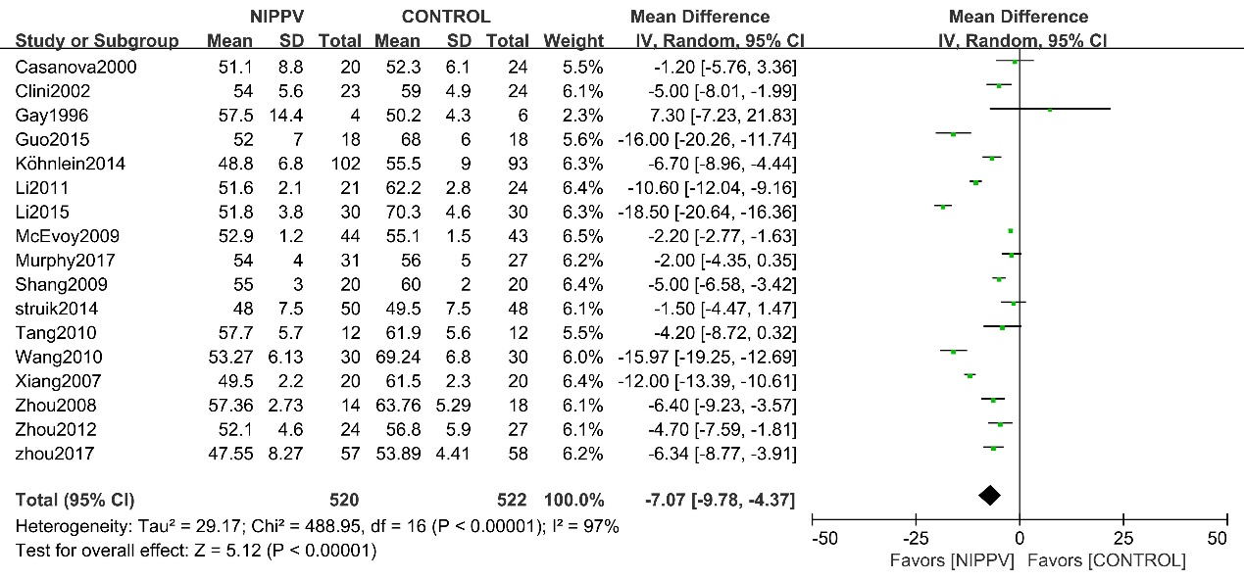

Figure S11 Forest plot comparing endpoint PaCO2 between NIPPV and control group

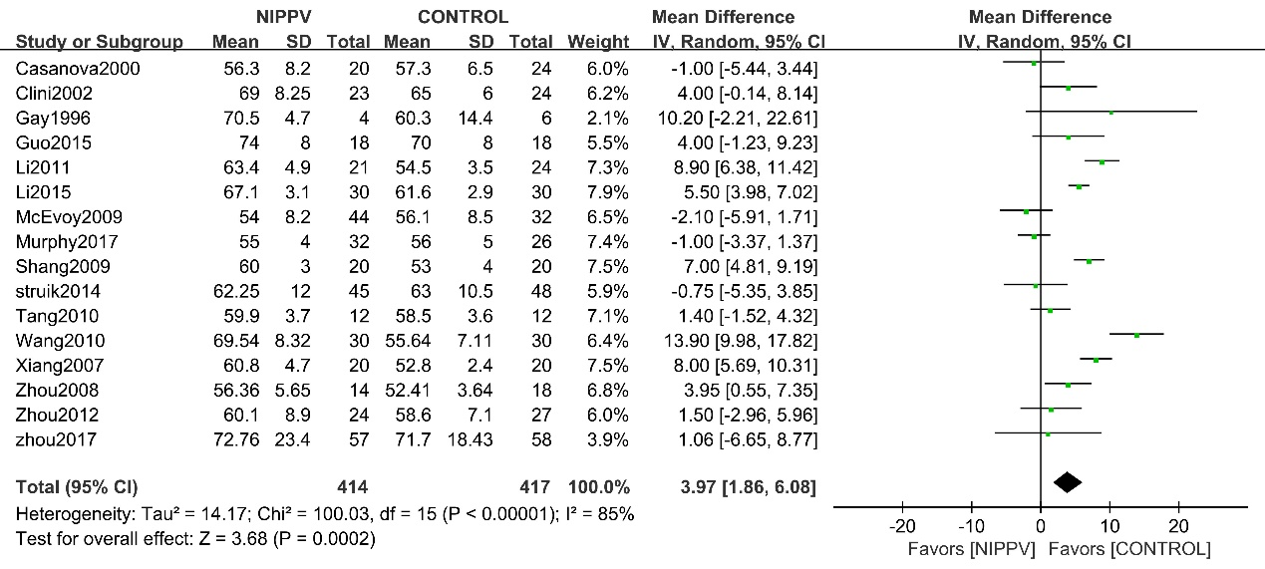

Figure S12 Forest plot comparing endpoint PaO2 between NIPPV group and control group

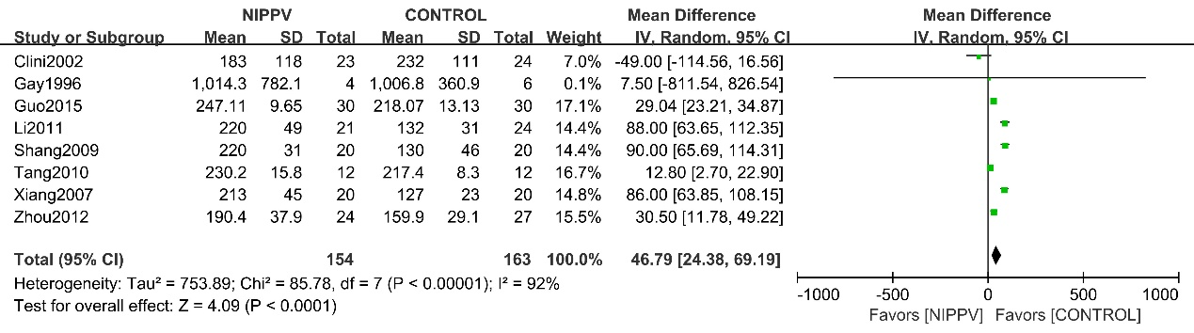

Figure S13 Forest plot comparing 6-MWD between NIPPV and control group

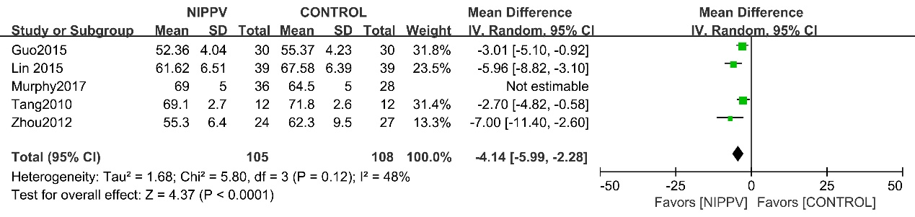

Figure S14 Forest plot comparing SGRQ between NIPPV and control group

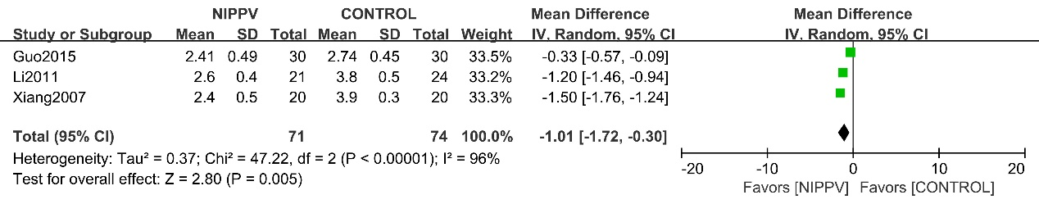

Figure S15 Forest plot comparing MRC-dyspnea scale between NIPPV and control group

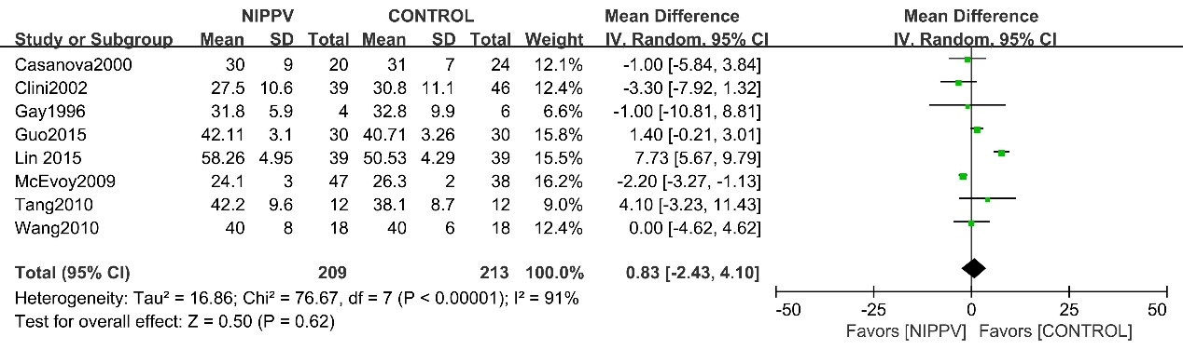

Figure S16 Forest plot comparing FEV1% pred between NIPPV and control group

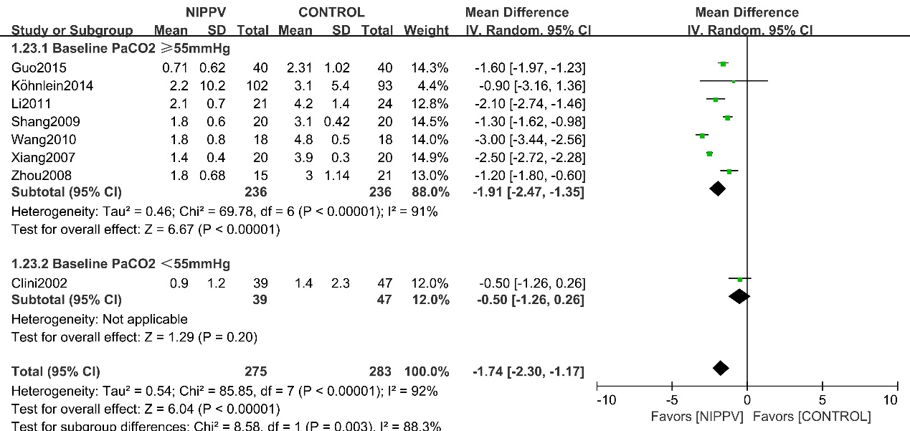

Figure S17 Subgroup analysis forest plot according to baseline PaCO2 level comparing frequency of hospital admissions between NIPPV and control group

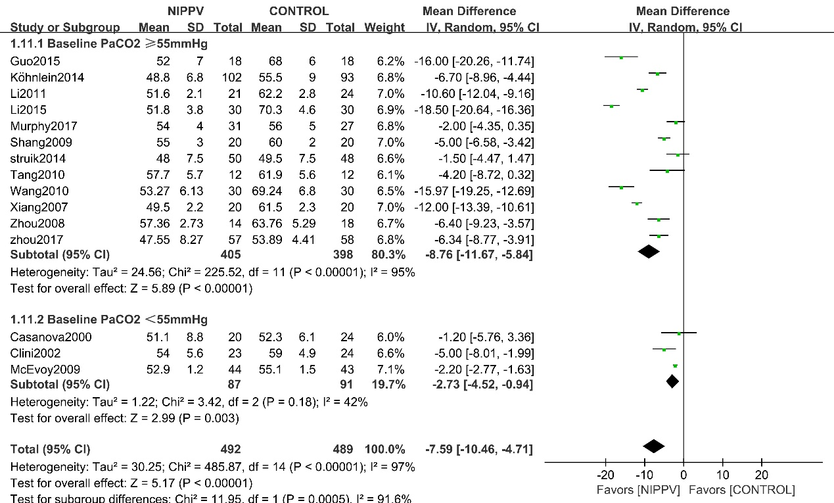

Figure S18 Subgroup analysis forest plot according to baseline PaCO2 level comparing end point PaCO2 between NIPPV and control group
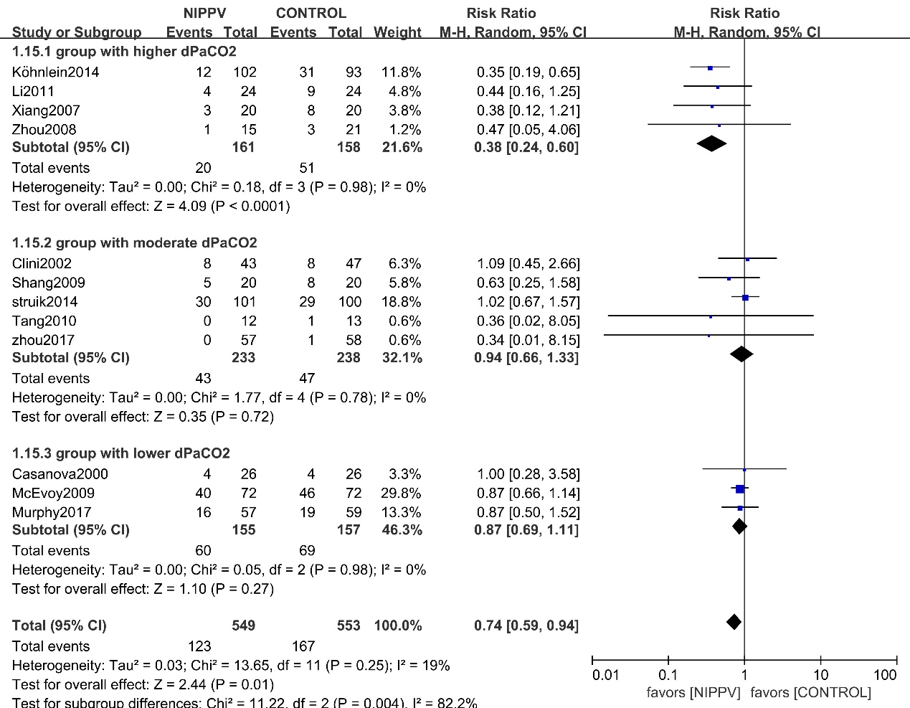

Figure S19 Three subgroups analysis forest plot according to degree of dPaCO2 comparing mortality between NIPPV and control group

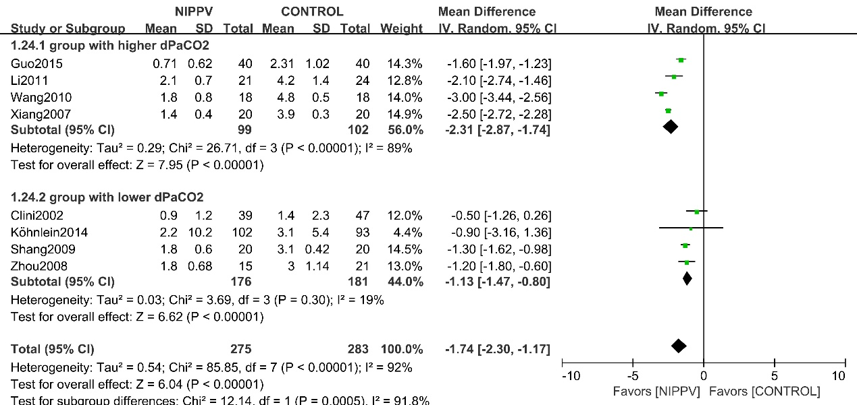

Figure S20 Subgroup analysis forest plot according to degree of dPaCO2 comparing frequency of hospital admissions between NIPPV and control group

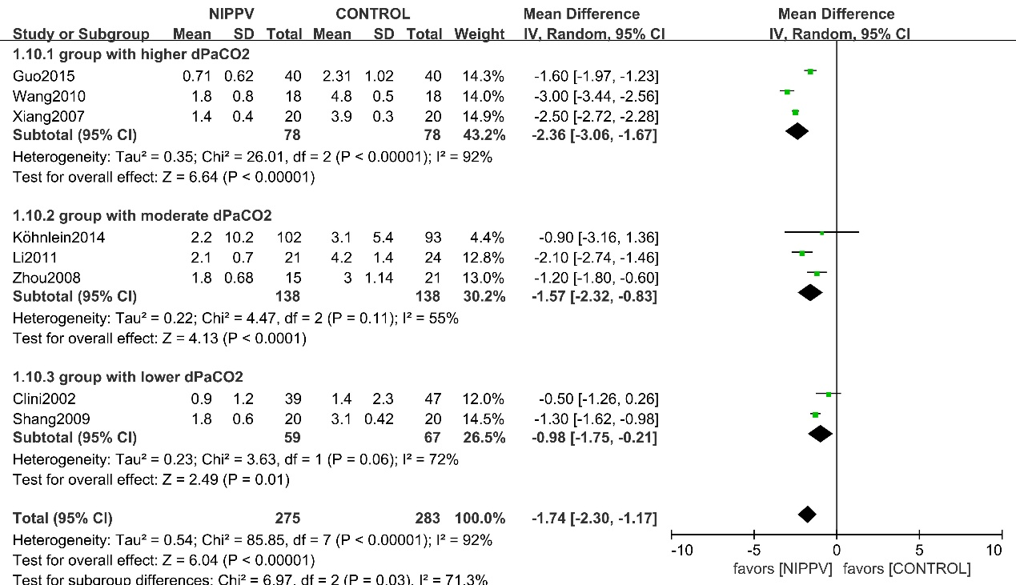

Figure S21 Three subgroups analysis forest plot according to degree of dPaCO2 comparing frequency of hospital admissions between NIPPV and control group

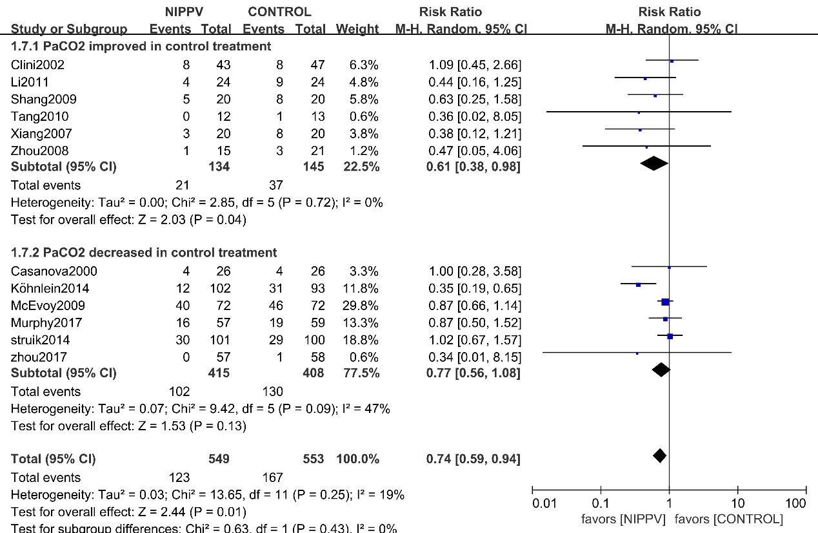

Figure S22 Subgroup analysis forest plot according to changing of PaCO2 in control treatment group comparing mortality between NIPPV and control group
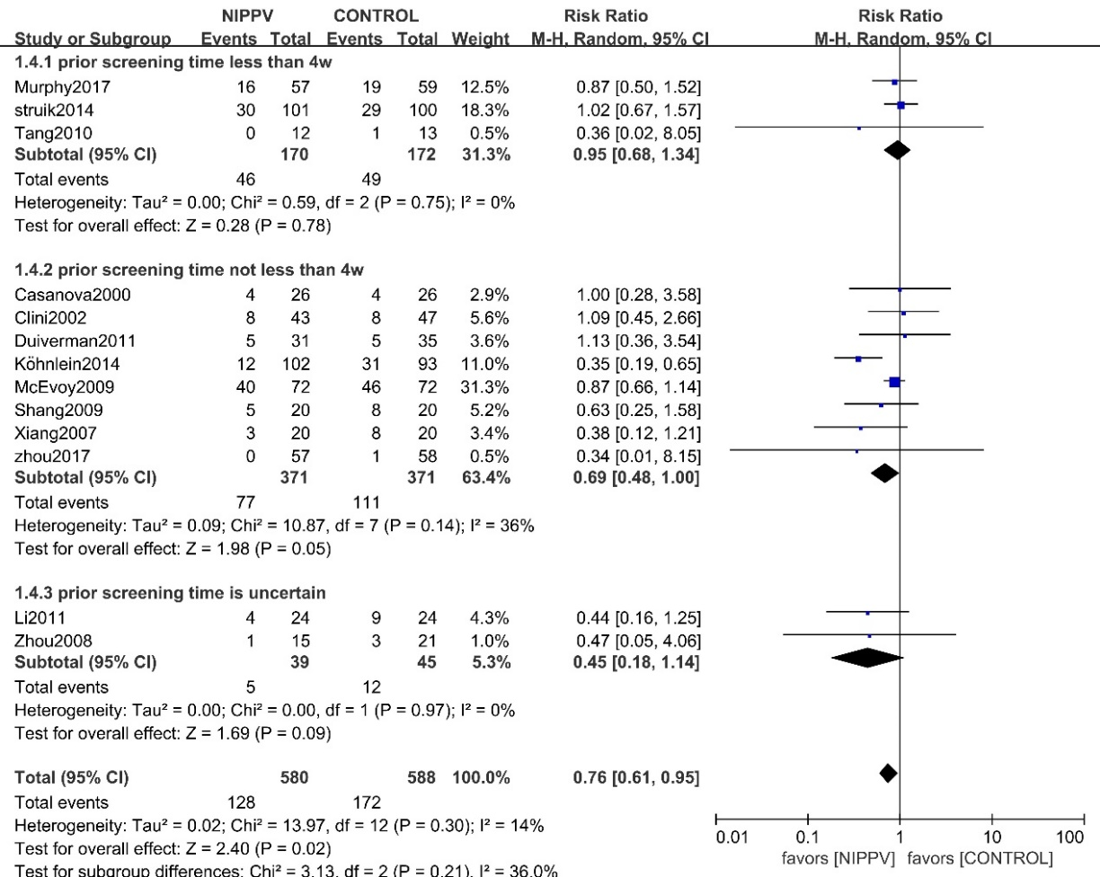
Figure S23 Subgroup analysis forest plot according to prior screening time comparing mortality between NIPPV and control group

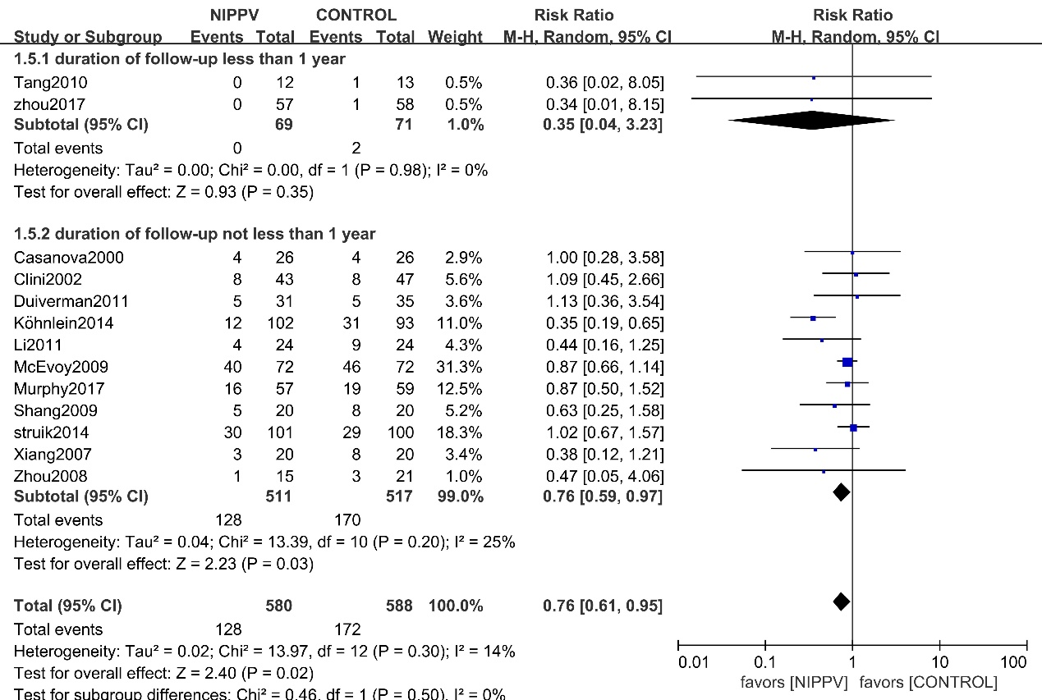
Figure S24 Subgroup analysis forest plot according to duration of follow up comparing mortality between NIPPV and control group

