ORIGINAL RESEARCH

[Zhiwei Huang] et al

Protective eﬀects of chitosan-bilirubin nanoparticles against ethanol-induced gastric ulcer
Zhiwei Huang^{1, 2, 3 †}, Yannan Shi^{2, †}, Hengcai Wang^{2, †}, Changju Chun³, Longwang Chen^{1, 4}, Kang Wang^{1, 4}, Zhongqiu Lu^{1, 4}, Yingzheng Zhao^{2,} *, Xinze Li^{1, 4} *
¹ Department of Emergency, the First Affiliated Hospital of Wenzhou Medical University, Wenzhou 325035, People’s Republic of China.
² School of Pharmaceutical Sciences, Wenzhou Medical University, Wenzhou 325035, People’s Republic of China.
³ Research Institute of Pharmaceutical Sciences, College of Pharmacy, Chonnam National University, Gwangju 61186, Republic of Korea.
⁴ Wenzhou Key Laboratory of emergency and disaster medicine, Wenzhou 325035, People’s Republic of China.
† These authors contributed equally to this work.
* Correspondence: Xinze Li; Yingzheng Zhao;
Wenzhou Medical University, University Town, Chashan, Wenzhou, Zhejiang, 325035, People’s Republic of China.
Email: lxzpharm@163.com; zhaoyingzpha@126.com;
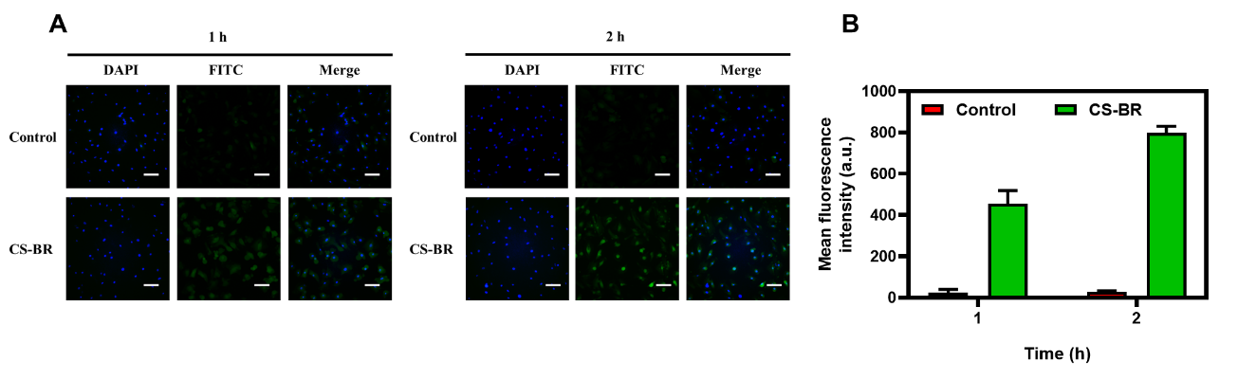
Figure S1. The cellular uptake of CS-BR in vitro. (A) Cellular uptake of gastric epithelial cells detected by fluorescent microscope. Scale bar = 20 μm. (C) The mean fluorescence intensity of each group. Data are expressed as the mean ± SD (n=3).

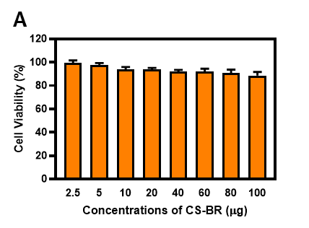
Figure S2. (A) The viability of gastric epithelial cells after incubation with the different concentrations of chitosan for 24 h. Data are expressed as the mean ± SD (n=3).

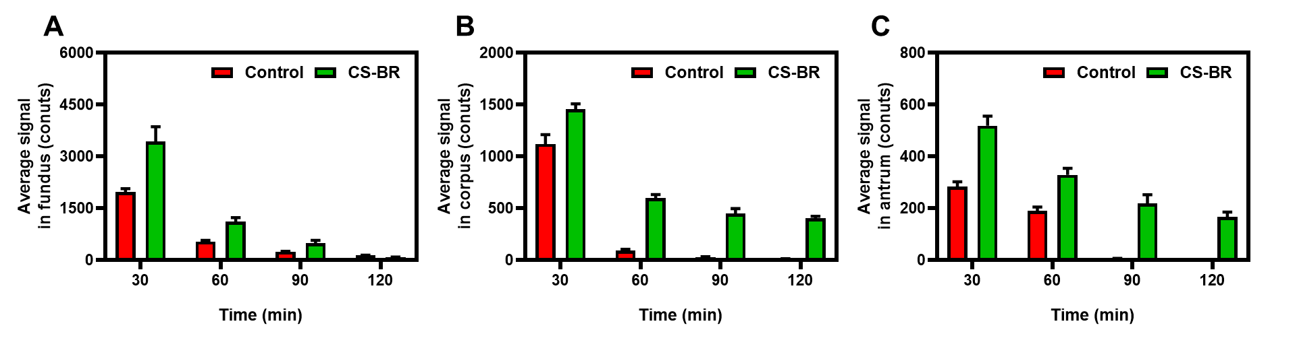
Figure S3. The semi-quantitation of fluorescent intensity in the (A) fundus, (B) corpus, and (C) antrum of gastric tissue after fluorescein isothiocyanate (FITC)–labeled CS-BR or free FITC (as the control) at predetermined times. Data are expressed as the mean ± SD (n=3).

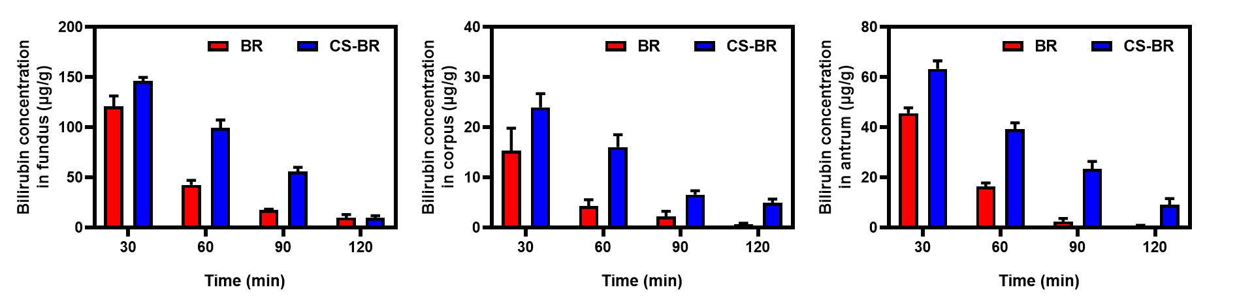
Figure S4. The concentration of bilirubin (BR) in the (A) fundus, (B) corpus, and (C) antrum of gastric tissue after oral administration with BR or CS-BR at different time points. Data are expressed as the mean ± SD (n=3).

