Biodegradable Materials with Disulfide-Bridged-Framework Confine Photosensitizers for Enhanced Photo-Immunotherapy
Dongbei Li¹, Fangman Chen³, Cheng Cheng¹, Haijun Li^{2, *} and Xudong Wei^{1, *}

¹Department of Hematology, Affiliated Tumor Hospital of Zhengzhou University, Henan Cancer Hospital, 127 Dongming Road, Zhengzhou City, Henan Province, China;
²Department of Clinical Laboratory, The First Affiliated Hospital of Zhengzhou University, Zhengzhou, Henan 450052, China;
³School of Biomedical Engineering (Suzhou), Division of Life Sciences and Medicine, University of Science and Technology of China, 96 Jinzhai Road, Hefei 230026, China
*These authors contributed equally to this work.
Correspondence:
Xudong Wei,
Department of Hematology, Affiliated Tumor Hospital of Zhengzhou University, Henan Cancer Hospital, 127 Dongming Road, Zhengzhou City, Henan Province, China.
E-mail addresses: xudongwei@zzu.edu.cn.
Haijun Li,
Department of Clinical Laboratory, The First Affiliated Hospital of Zhengzhou University, Zhengzhou, Henan 450052, China.
E-mail: navylizz@sina.com

Figure S1. Figure S1. Notes: (a) Emission spectra of FL and SSNs@FL. (b) Emission spectra of AD and SSNs@AD. (c) Size of SNs, SSNs, SSNs@FL, SSNs@AD, and SSNs@Ce6.
Abbreviations: FL, fluorescein; SSNs@FL, fluorescein-loading disulfide-bond-bridged organosilica nanoparticles; AD, adriamycin; SSNs@AD, adriamycin-loading disulfide-bond-bridged organosilica nanoparticles; SNs, inorganic silica nanocarrier; SSNs, disulfide-bond-bridged organosilica nanoparticles; SSNs@FL, fluorescein-loading disulfide-bond-bridged organosilica nanoparticles; SSNs@AD, adriamycin-loading disulfide-bond-bridged organosilica nanoparticles; SSNs@Ce6, chlorin e6-loading disulfide-bond-bridged organosilica nanoparticles.

Figure S2. TEM image of SNs.
Abbreviations: SNs, inorganic silica nanocarrier.

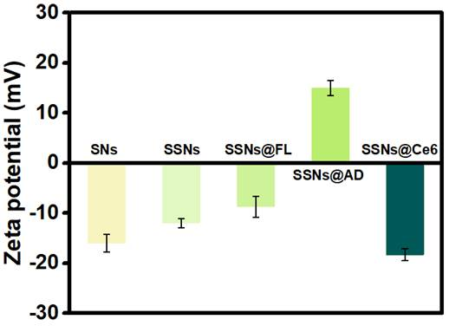
Figure S3. Zeta potential of SNs, SSNs, SSNs@FL, SSNs@AD, and SSNs@Ce6.
Abbreviations: SNs, inorganic silica nanocarrier; SSNs, disulfide-bond-bridged organosilica nanoparticles; SSNs@FL, fluorescein-loading disulfide-bond-bridged organosilica nanoparticles; SSNs@AD, adriamycin-loading disulfide-bond-bridged organosilica nanoparticles; SSNs@Ce6, chlorin e6-loading disulfide-bond-bridged organosilica nanoparticles.

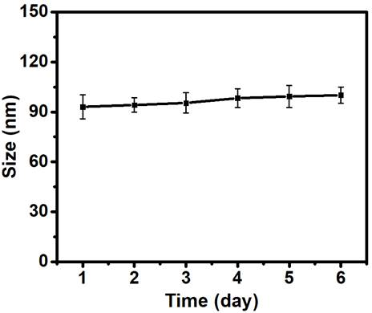
Figure S4. Colloidal stability of SSNs@Ce6 in DMEM plus 50% FBS for 7 days.
Abbreviations: SSNs@Ce6, chlorin e6-loading disulfide-bond-bridged organosilica nanoparticles; DMEM, dulbecco’s modified eagle medium; FBS, fetal bovine serum.

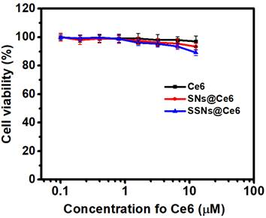

Figure S5. Cytotoxicity of free Ce6, SNs@Ce6, and SSNs@Ce6 against 4T1 in dark.
Abbreviations: SNs, inorganic silica nanocarrier; SNs@Ce6, chlorin e6-loading inorganic silica nanocarrier; SSNs@Ce6, chlorin e6-loading disulfide-bond-bridged organosilica nanoparticles.

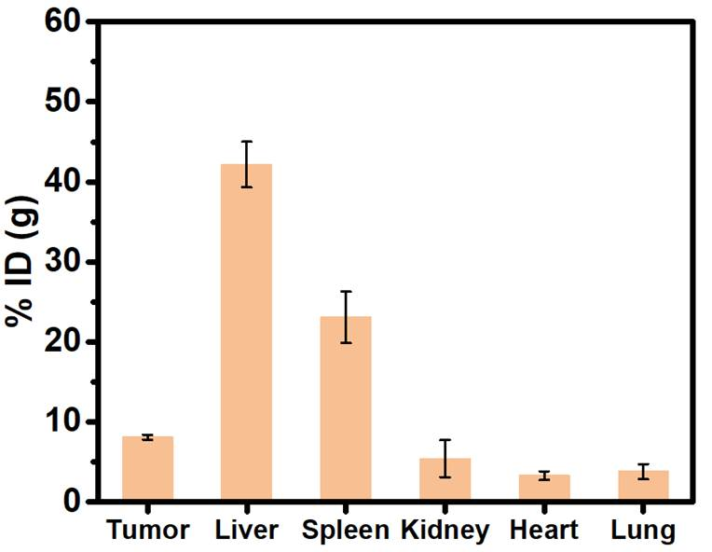
Figure S6. Biodistribution of SSNs@Ce6 in 4T1-tumor-bearing mice.
Abbreviations: SSNs@Ce6, chlorin e6-loading disulfide-bond-bridged organosilica nanoparticles.

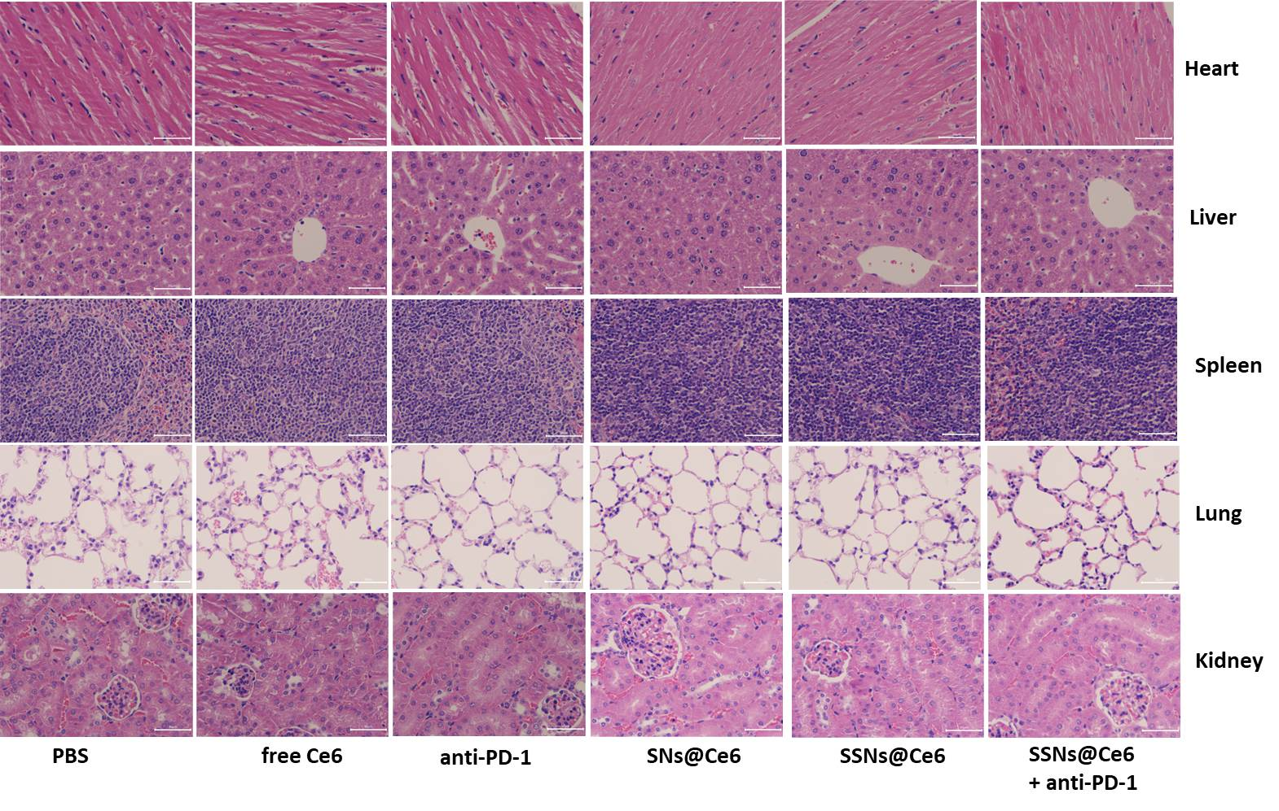
Figure S7. H &E staining image of heart, liver, lung, spleen, and kidney from each group. Scale bars are 50 μm.
Abbreviations: Ce6, chlorin e6; SNs, inorganic silica nanocarrier; SNs@Ce6, chlorin e6-loading inorganic silica nanocarrier; SSNs@Ce6, chlorin e6-loading disulfide-bond-bridged organosilica nanoparticles.

